MASON RAMSEY ANNOUNCES THE “FALLS INTO PLACE TOUR”

TOUR KICKS OFF THIS SPRING WITH STOPS IN NEW YORK CITY, BOSTON, AUSTIN AND MORE
AFTER TAKING THE STAGE AT EUROPE’S BIGGEST COUNTRY MUSIC FESTIVAL, C2C

17-YEAR-OLD PHENOM CELEBRATES NORTH AMERICAN TOUR WITH NEW SINGLE
“HERE ALL DAY” OUT JANUARY 26

ARTIST PRESALE BEGINS JANUARY 9TH AT 10AM CST
PUBLIC ON-SALE BEGINS JANUARY 12TH AT 10AM LOCAL

COMING-OF-AGE EP FALLS INTO PLACE AVAILABLE EVERYWHERE NOW
DOWNLOAD/STREAM FALLS INTO PLACE

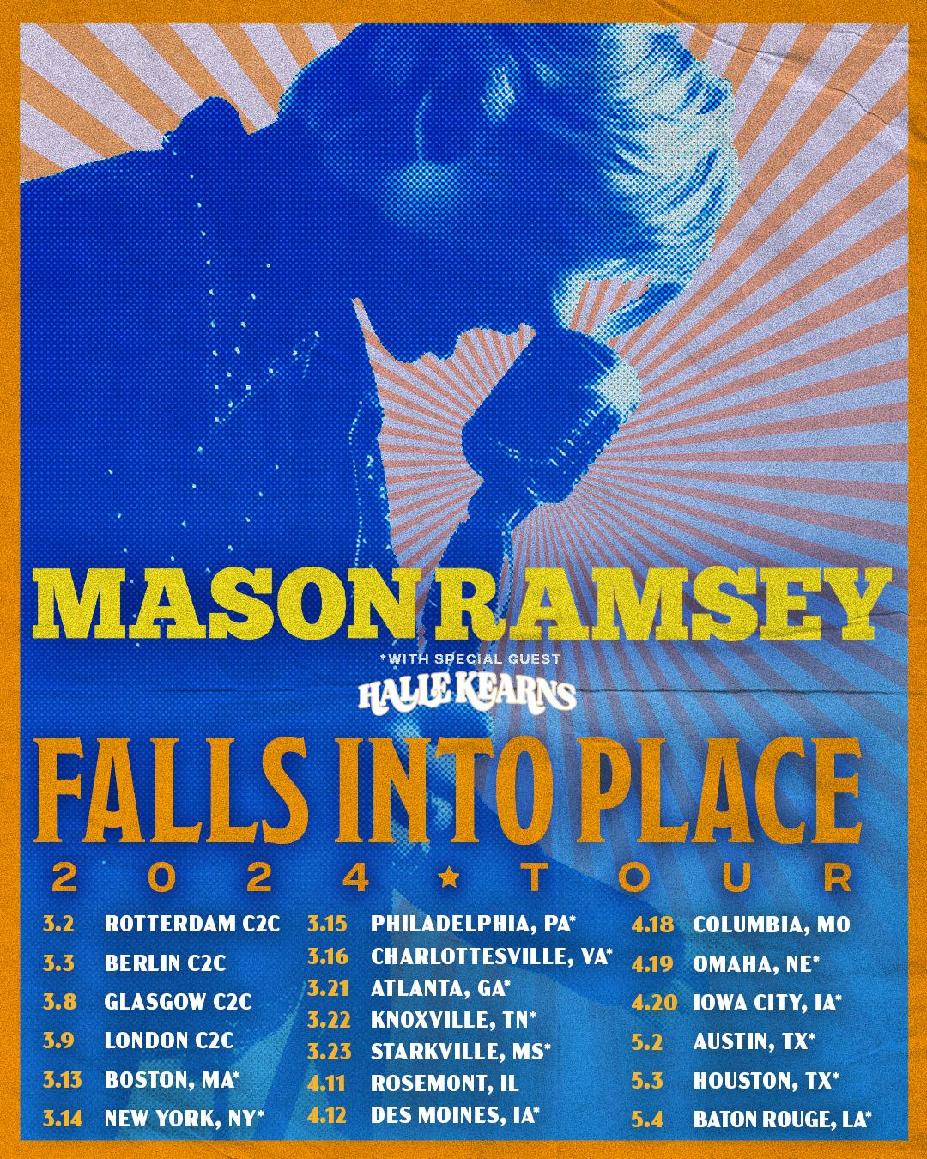
DOWNLOAD ASSETS HERE

(New York, NY- January 8, 2024) – 17-year-old phenom, Mason Ramsey announces the North American Falls Into Place tour. Ramsey celebrates the tour announcement with new single, “Here All Day,” written alongside Cooper Alan, out everywhere January 26th.

The tour kicks off March 13th in Boston with stops in New York City, Philadelphia, Austin and more. Artist presale begins January 9th at 10am CST (PW: FALLSINTOPLACE) and public on-sale begins January 12th at 10am local time. The North American tour follows the young sensation’s performances at Europe’s biggest country music festival, C2C: Country to Country alongside the likes of Brad Paisley, Jake Owen, Alana Springsteen and more.

“Falls Into Place Tour”
*Support from Halle Kearns

MARCH
13 - Boston, MA @ Brighton Music Hall *
14 - New York, NY @ Gramercy Theatre *
15 - Philadelphia, PA @ World Cafe Live *
16 - Charlottesville, VA @ Jefferson Theatre *
21 - Atlanta, GA @ Eddie’s Attic *
22 - Knoxville, TN @ Open Chord *
23 - Starkville, MS @ Rick’s Cafe *

APRIL
11 - Rosemont, IL @ Joe’s Live
12 - Des Moines, IA @ Wooly’s *
18 - Columbia, MO @ Blue Note
19 - Omaha, NE @ Barnato *
20 - Iowa City, IA @ Wildwood *

MAY
2 - Austin, TX @ 3Ten at ACl Live *
3 - Houston, TX @ Bronze Peacock *
4 - Baton Rouge, LA @ Texas Club *

The 15-stop trek is the follow up of his coming-of-age EP, Falls Into Place. The five-song project marked his first studio collection since 2019, and a new era for the breakout singer-songwriter. Available across all streaming platforms and digital retailers, listen to Falls Into Place here.

On the latest project, Ramsey “sharpened his chops and returned with a deeper voice and some deeper lyrics,” applauds PEOPLE, as proven in the heartfelt hometown ballad “Reasons To Come Home,” the up-tempo romantic fun of “She Got It Outta Me,” and optimistic honky-tonk rocker “Next Right Thing.” Matching coming-of-age themes and personal growth with Ramsey’s famous pure-Country charm, the global star now “older and more reflective,” according to Billboard, is credited as a co-writer on all but one track.

Since catapulting onto the Country music scene as the youngest major label Country artist signed in the genre in nearly two decades at 11, Ramsey has already delivered two acclaimed EPs, earned a Gold-certified single, headlined two tours in addition to supporting a Las Vegas residency, surpassed 300 million global streams since 2018 and has gone viral once again with a nostalgic ‘then & now’ performance clip from the famed Grand Ole Opry stage with over 22 million views.

ABOUT MASON RAMSEY
As the youngest major label Country artist signed in the genre in nearly two decades, MASON RAMSEY continues his fast-track to stardom after being discovered singing in an aisle at his local Walmart. Ramsey’s new music illustrates how far he’s come – the differences prove instantly apparent as his voice boasts with the kind of confidence only gained through experience and his songwriting brims with unfiltered truth buoyed by intimate creativity.
Praised by THE NEW YORK TIMES as delivering "a stylistically diverse country and roots music EP,” the ATLANTIC RECORDS artist’s debut FAMOUS EP (Atlantic Records/Big Loud Records) spawned a hit single of the same name which scored a #4 spot on Billboard’s Hot Country Songs Chart. In addition to making his debut at the famed Grand Ole Opry, the Golconda, IL-bred phenom has also performed at several high-profile festivals including CMA FEST, COACHELLA, iHEARTCOUNTRY FESTIVAL, and STAGECOACH. He has made high-profile TV performances on ELLEN, GOOD MORNING AMERICA, and TODAY; as well as esteemed award show appearances on the CCMA AWARDS, CMA AWARDS, CMT MUSIC AWARDS, and GRAMMY AWARDS.

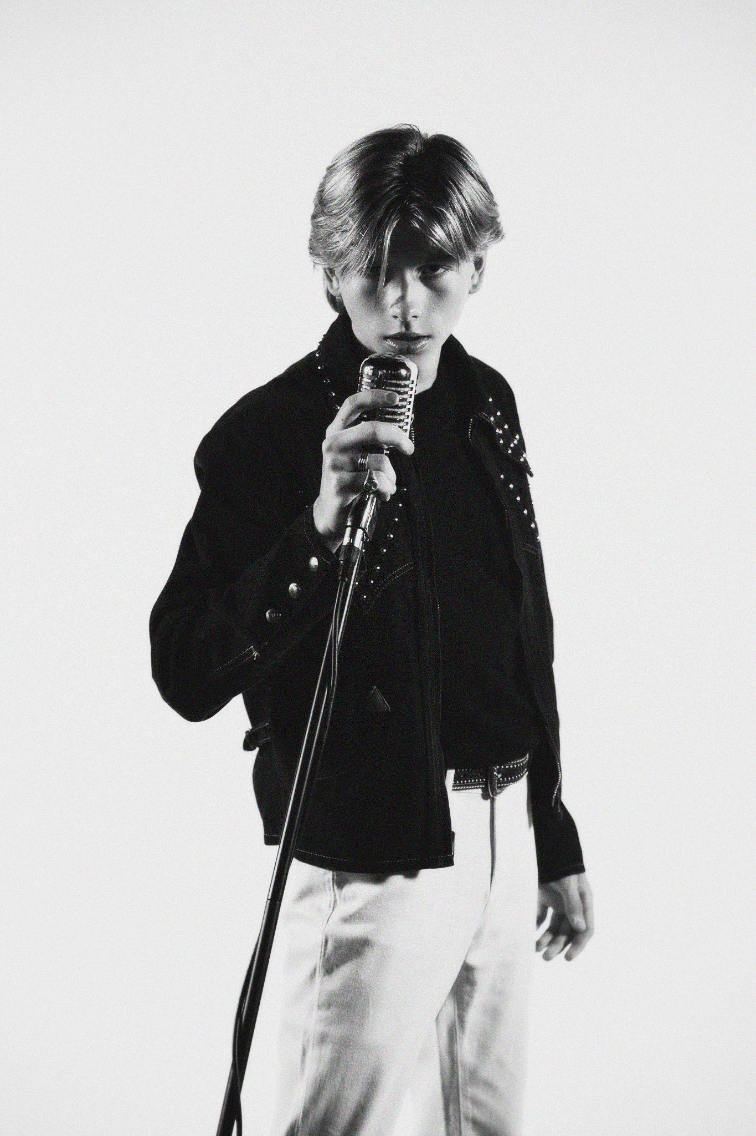
(Press Photo Credit – Libby Danforth; DOWNLOAD HI-RES PHOTOS)

Connect with Mason Ramsey:
INSTAGRAM | TWITTER | FACEBOOK | TIKTOK
For all Mason Ramsey press inquiries, please contact:
Taylor Apel | Taylor.Apel@atlanticrecords.com
Jason Davis | Jason.Davis@atlanticrecords.com
# # #

