DROP NEW TRACK ‘WHITE RIBBONS’ ACCOMPANIED BY OFFICIAL VISUALIZER
LISTEN |WATCH
DEBUT ALBUM ‘MADRA’ OUT JANUARY 26th VIA FAIR YOUTH/ATLANTIC
UK TOUR ANNOUNCED FOR JANUARY/FEBRUARY 2024
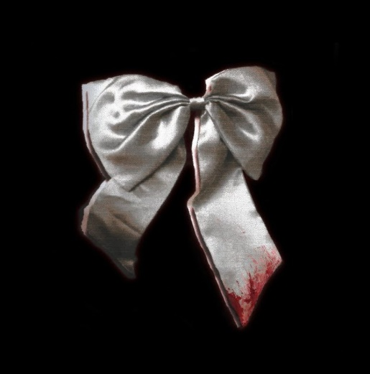 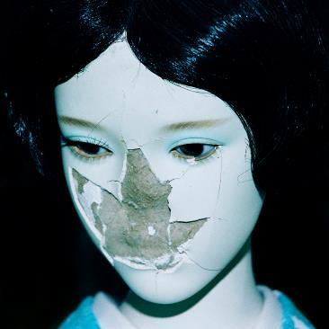
Hi-Res Artwork + Press Images

“NewDad’s first full-length shows them expanding on their indie-pop roots, adding extra gnarly post-punk bite and more sophisticated textures to their updated mix of The Cure, Slowdive and Curve” - Uncut
“A compelling mix of alt-pop, folk balladry and all manner of fuzzball spookiness" - Record Collector
“NewDad are the Irish shoegazers trying to set out their own generational path” - Rolling Stone UK

“The way in which NewDad’s music untangles the minutiae of major life changes has won them the hearts of a young, devoted following to whom they are somewhere between friends and emergent rock heroes – awe-inspiring and aspirational, but also accessible” - NME

“A debut album of formidable heights” - Dork

Entering 2024 as one of Ireland’s brightest new bands following a slew of hype from the likes of NME (check out their recent cover feature), Rolling Stone UK, Uncut and 6 Music, NewDad offer out ‘White Ribbons’ - the final installment ahead of the release of their anticipated debut album ‘Madra’, set for release on January 26 through Fair Youth/Atlantic.

Spending the bulk of last year advancing their status as one of Ireland’s most anticipated alt/rock bands, ‘White Ribbons’ dials back the bands’ fuzzy sound, instead, laying bare singer/guitarist Julie Dawson’s wounded songwriting over ghostly, melancholic undertones. Following a number of track drops over recent months - ‘In My Head’, ‘Angel’, ‘Let Go’ and ‘Nightmares’ - ‘White Ribbons’ serves as the last offering ahead of their debut release. Speaking of the track, Julie says - “This song is about how no matter how much shit you put your body through, it always finds a way to fix itself, and that’s a very beautiful thing. ‘White Ribbons’ is a metaphor for my skin; something that always heals my wounds. It’s like a promise to my body that I will be kinder to myself.”

The band’s debut album, Madra (meaning “dog” in Irish), is an 11-song, guitar-stacked visceral outing, as singer/guitarist Julie Dawson embarks on a journey of self-exploration, self-sabotage, and reflection. Soaked in dysfunction, Madra searches for solace in pain, tackling themes of bullying (‘Where I Go’), self-medication/depression (‘Madra’, ‘Let Go’), destruction (‘Change My Mind’, ‘White Ribbons’), codependency (‘Nosebleed’) and resistance (‘Nightmares’). The album artwork, photographed by Irish creative, Joshua Gordon, shows a broken doll that serves as a metaphor for the album’s themes of fragility and vulnerability.
Most recently, Julie sat down with 6 Music’s Huw Stepehens for a round table 2023 round-up (listen here). The band will tour the UK in Feb/March, taking in London’s KOKO on 5 March.

Madra track listing
Angel
Sickly Sweet
Where I Go
Change My Mind
In My Head
Nosebleed
Let Go
Dream Of Me
Nightmares
White Ribbons
Madra

UK & Ireland Tour

FEBRUARY 2024
24 - Leeds - Belgrave Music Hall SOLD OUT
25 - Manchester - Band on The Wall SOLD OUT
26 - Glasgow - St Luke’s
28 - Dublin - Button Factory SOLD OUT
29 - Dublin - Button Factory

MARCH 2024
2 - Birmingham - O2 Institute
3 - Bristol - Trinity
5 - London - Koko

FOLLOW NEWDAD:
official website | instagram | facebook | youtube | soundcloud | twitter | tiktok

PRESS CONTACT
Christina.Kotsamanidis@atlanticrecords.com

