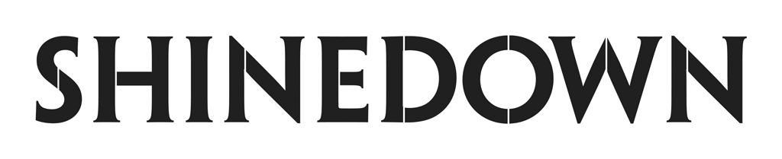
Shinedown To Perform Their Mainstream Hit
“A Symptom Of Being Human”
On Live with Kelly and Mark
Labor Day Monday, September 4th
Check Local Listings For Air Time

The Revolutions Live Tour Kicks Off
This Sunday, September 3rd

PRESS HERE To Watch New Roundtable Interview
Shinedown x Papa Roach x Spiritbox

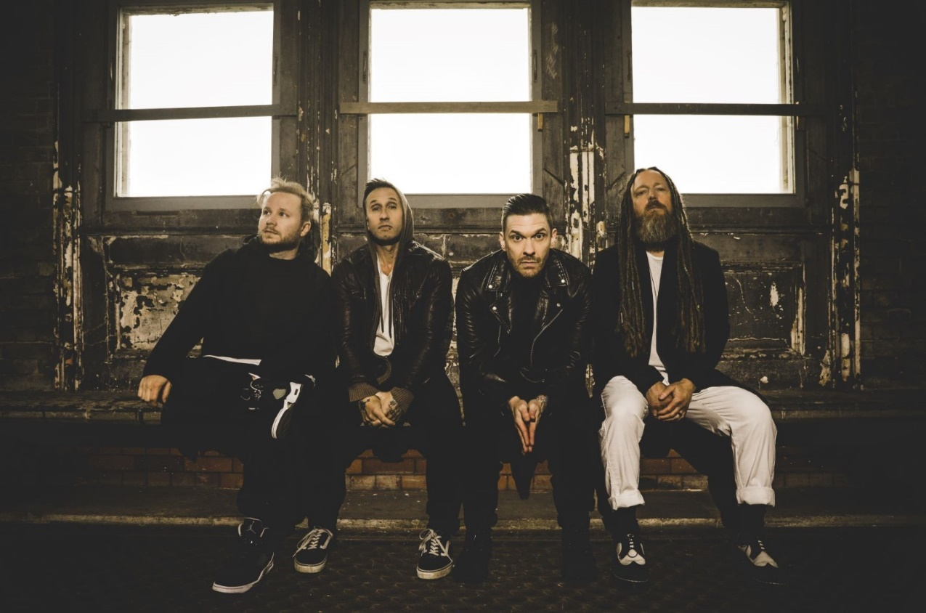
(Photo Credit: Sanjay Parikh)

“Sometimes I’m in a room where I don’t belong / And the house is on fire and there’s no alarm / And the walls are melting too / How ‘bout you? / I’ve never been the favorite / Thought I’d seen it all / ‘till I got my invitation to the lunatic ball / And my friends are coming too / How ‘bout you?”
- “A Symptom Of Being Human”

NEW YORK, NY – September 1, 2023 – Multi-platinum, chart-topping band Shinedown will perform their mainstream radio hit “A Symptom Of Being Human” on Live with Kelly and Mark on Labor Day, this Monday, September 4th as the show heads into their season premiere week. Check your local listings for air time or visit https://livewithkellyandmark.com.

Shinedown is also kicking off the fall leg of The Revolutions Live Tour with support from Papa Roach and Spiritbox this Sunday, September 3rd in St. Louis as they continue to tour behind their hit album Planet Zero. The 25-date outing, co-produced by Live Nation and FPC Live, spreads across the U.S. before wrapping October 20th in Denver. In addition, Shinedown is bringing their epic live show to select festivals this fall for headlining sets. Full tour routing below. For tickets and more info, visit www.shinedown.com.

Ahead of the tour's launch, Shinedown front man Brent Smith, Papa Roach front man Jacoby Shaddix and Spiritbox members Courtney LaPlante (vocals) and Mike Stringer (guitar) gathered for an in-depth roundtable conversation, where they spoke candidly about their personal connections and how they teamed up for the tour, their musical journeys, creating setlists, healthy band competition, being a woman in music, and so much more. PRESS HERE to watch.

While Shinedown is the most successful rock radio band of all time, holding the record for the most mainstream rock #1s in Billboard history, they also believe that music is universal and doesn’t have to be put in a genre box. With a message about how we are all a work in progress, “A Symptom Of Being Human” continues to resonate with listeners and climb at Hot AC radio, where it is nearing Top 15. Shinedown’s exploration of the resilience of the human spirit, experiences with mental health, and the importance of empathy shine through in the track reminding us that we are more similar than we are different. PRESS HERE to watch the official music video for “A Symptom Of Being Human.” Shinedown has also released a variety of remixes for the hit song: PRESS HERE to listen to the pop remix, PRESS HERE to listen to the acoustic version, and PRESS HERE for the piano version. Check out recent interview features on “A Symptom Of Being Human” with USA Today and PEOPLE.

SHINEDOWN 2023 LIVE DATES:
The Revolutions Live Tour w/ Papa Roach and Spiritbox
September 3 – St. Louis, MO @ Hollywood Casino Amphitheatre
September 4 – Kansas City, MO @ T-Mobile Center
September 6 – Cuyahoga Falls, OH @ Blossom Music Center
September 8 – Burgettstown, PA @ The Pavilion at Star Lake
September 9 – Blue Ridge Rock Festival @ The Virginia International Raceway *
September 12 – Clarkston, MI @ Pine Knob Music Theatre
September 13 – Syracuse, NY @ St. Joseph's Health Amphitheater at Lakeview
September 15 – Ocean City, MD @ Ocean City Bike Fest *
September 16 – Camden, NJ @ MMRBQ at Freedom Mortgage Pavilion *
September 19 – Gilford, NH @ Bank of New Hampshire Pavilion
September 21 – Bangor, ME @ Maine Savings Amphitheater
September 23 – Mansfield, MA @ Xfinity Center
September 24 – Newark, NJ @ Prudential Center
September 26 – Simpsonville, SC @ CCNB Amphitheatre at Heritage Park
September 27 – Atlanta, GA @ Lakewood Amphitheatre
September 29 – Tampa, FL @ MIDFLORIDA Credit Union Amphitheater
September 30 – Hollywood, FL @ Hard Rock Live
October 3 – Franklin, TN @ FirstBank Amphitheater
October 5 – Rogers, AR @ Walmart AMP
October 6 – Allen, TX @ Credit Union of Texas Event Center
October 8 – The Woodlands, TX @ The Cynthia Woods Mitchell Pavilion
October 9 – San Antonio, TX @ Freeman Coliseum
October 12 – Phoenix, AZ @ Talking Stick Resort Amphitheatre
October 13 – Las Vegas, NV @ MGM Grand Garden Arena
October 15 – Irvine, CA @ FivePoint Amphitheatre
October 17 – Salt Lake City, UT @ USANA Amphitheater
October 19 – Albuquerque, NM @ Isleta Amphitheater
October 20 – Denver, CO @ Ball Arena

* indicates festival date

ABOUT SHINEDOWN
Multi-platinum band Shinedown – Brent Smith [vocals], Zach Myers [guitar], Eric Bass [bass, production], and Barry Kerch [drums] – embody the kind of creative dynamism, constant evolution, singular vision, and an uncompromising honesty that transcends boundaries. The record-breaking band, known for their timely messages behind their chart-topping songs that resonate with not only their global audience and the rock community, but our culture at large, has achieved astronomical success with over 6.5 billion global streams, 20 #1 rock hits, 15 platinum and gold singles, platinum or gold certification for every album, and 10 million albums sold worldwide. Shinedown have also become an essential cultural force as evidenced by their major media acclaim and participation in the prestigious 92Y Talks series. The band was named #1 on Billboard’s Greatest Of All Time Mainstream Rock Artists Chart, after notching the most ever #1s (18) in the 40-year history of the Mainstream Rock Songs Chart. Their latest album Planet Zero debuted in the Top 5 on the Billboard 200 Chart and the Official UK Albums Chart, and at #1 on six other Billboard charts including Top Album Sales, Rock, Hard Rock, and Alternative Albums Charts.

FOLLOW SHINEDOWN
Facebook | Instagram | TikTok | Twitter | Website | Atlantic Records

For more information on Shinedown, please contact:

Press Here
Linda Carbone / linda@presshereproductions.com
Carla Senft / carla@pressherepublicity.com
Bari Lieberman / bari@pressherepublicity.com

