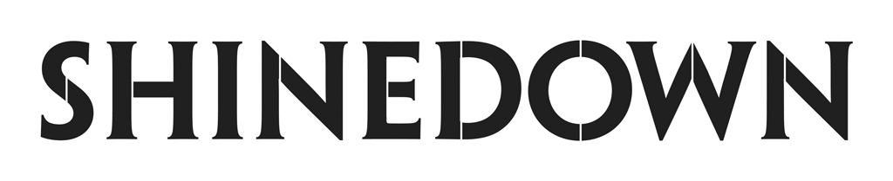
Lands Another Record-Setting #1 at Active Rock with “A Symptom Of Being Human”
as the Crossover Hit Rises at Alternative Radio
and Impacts Top 40

Honored by Mediabase as the Greatest Rock Band in History with the Most No. 1’s, Top 5’s and
Top 10’s on the Active Rock Chart

Announces WME Global Representation

Nominated for Rock Artist of the Year and
Rock Song of the Year at iHeartRadio Music Awards

(Photo Credit: Sanjay Parikh)

January 23, 2024 – Multi-platinum band Shinedown has topped the charts once again with their current single “A Symptom Of Being Human” officially landing at #1 at Active Rock. This marks Shinedown’s record-breaking 21st No. 1 song on the Mediabase Active Rock Chart and extends their record for the most No. 1’s in the history of Billboard’s Mainstream Rock Airplay chart with 19 total. The crossover hit is also moving up the Alternative charts, currently sitting at #12, and now impacting at Top 40 radio nationwide, all following its Top 15 run at Hot AC in 2023. PRESS HERE to read an exclusive feature with Rolling Stone on “A Symptom Of Being Human,” Shinedown’s focus on human connection, and more.

To commemorate their status as the greatest rock band in history, Mediabase presented Shinedown with an award for the most No. 1’s, Top 5’s and Top 10’s in Mediabase Active Rock Chart history. The band has also earned multiple nominations at this year’s iHeartRadio Music Awards with nods for Rock Artist of the Year and Rock Song of the Year for their previous #1 “Dead Don’t Die.” Shinedown’s official photographer Sanjay Parikh is also up for Favorite Tour Photographer, a fan-voted award, for the band’s massively successful Revolutions Live Tour – PRESS HERE to vote for Sanjay.

“We are beyond grateful, and truly astonished and humbled, to be given this incredible record-breaking title,” shares Shinedown front man Brent Smith. “Thank you everyone at Mediabase, Active Rock Radio, and all of the program directors across America. I have said it before and I will say it again, in Shinedown we only have one boss…it just happens to be everyone in the audience. We love you Shinedown Nation!!! Long live terrestrial radio.”

Shinedown has always believed that music is universal and doesn’t have to be put in a genre box, as evidenced by “A Symptom Of Being Human” resonating with all listeners with its uplifting and important message about how we are all a work in progress. The band’s exploration of the resilience of the human spirit, experiences with mental health, and the importance of empathy shine through in the track reminding us that we are more similar than we are different. PRESS HERE to watch the official music video for “A Symptom Of Being Human” and PRESS HERE to download/stream. Collectively, “A Symptom Of Being Human,” the fourth #1 single from the band’s acclaimed seventh studio album Planet Zero (Atlantic Records), has amassed over 40 million streams across all versions of the song including a pop remix, acoustic version, and piano version.

In other exciting news, WME has announced signing Shinedown for worldwide representation. In addition to working with long-standing agent Ron Opaleski in the United States and Canada, the WME global partnership now includes Lucy Dickins and her international team. Along with their outstanding chart success, Shinedown is also a top touring act, selling out countless amphitheaters and arenas and headlining every major rock festival across North America with their electrifying and acclaimed live show.

Shinedown recently took the internet by storm with a viral moment featuring elder super fan/grandma, Lauri Norris, rocking out front row at one of their shows on 2023’s Revolutions Live Tour. The official video, posted by Sanjay, has amassed over 15 million views on TikTok and IG Reels combined with additional tens of millions of views across both platforms by fans and other accounts who are sharing it with inspiring, positive reaction videos and comments. The overwhelming response sent Shinedown’s 2008 platinum single “Sound of Madness” back to the top of the iTunes Rock Chart and top 10 on the iTunes all songs chart. PRESS HERE to watch on TikTok, PRESS HERE to watch on Instagram. The feel-good moment is proving age is just a number when it comes to music and fandom!

Above: Shinedown (L-R: Brent Smith, Barry Kerch, Eric Bass, Zach Myers) with
iHeartRadio’s Alissa Pollack, EVP Global Music Marketing and Strategy
Photo Credit: Sanjay Parikh

ABOUT SHINEDOWN
Multi-platinum band Shinedown – Brent Smith [vocals], Zach Myers [guitar], Eric Bass [bass, production], and Barry Kerch [drums] – embody the kind of creative dynamism, constant evolution, singular vision, and uncompromising honesty that transcends boundaries. The record-breaking band, known for their timely and timeless messages behind their chart-topping songs that resonate with not only their global audience and the rock community, but our culture at large, has achieved astronomical success since its inception over two decades ago with 21 #1 Active Rock hits, 15 platinum and gold singles, platinum or gold certification for all of their albums, billions of global streams, and 10 million albums sold worldwide. Shinedown has also become an essential cultural force as evidenced by their major media acclaim, with looks including USA Today, PEOPLE, HuffPost, Forbes, Salon, Consequence, Men’s Journal, Buzzfeed, Interview Magazine, and Grammy.com, participation in the prestigious 92Y Talks series, and national TV performances. The band was named #1 on Billboard’s Greatest Of All Time Mainstream Rock Artists Chart, notching the most ever #1s (19) in the 40-year history of the Mainstream Rock Songs Chart, making Shinedown the biggest rock radio band in history. Their latest album, 2022’s Planet Zero, debuted in the Top 5 on the Billboard 200 Chart and the Official UK Albums Chart and at #1 on six other Billboard charts including Top Album Sales, Rock, Hard Rock, and Alternative Albums Charts, and has spawned 4 #1 rock singles.

FOLLOW SHINEDOWN
Facebook | Instagram | TikTok | X/Twitter | Website | Atlantic Records

For more information on Shinedown, please contact:

Press Here
Linda Carbone / linda@presshereproductions.com
Bari Lieberman / bari@pressherepublicity.com
Carla Senft / carla@pressherepublicity.com

