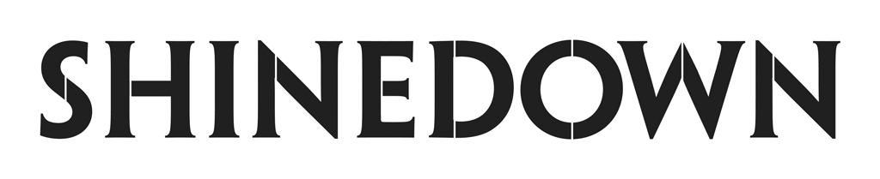

Releases Pop Remix For
Top 20 Hot AC Single
“A Symptom Of Being Human”

PRESS HERE to Listen

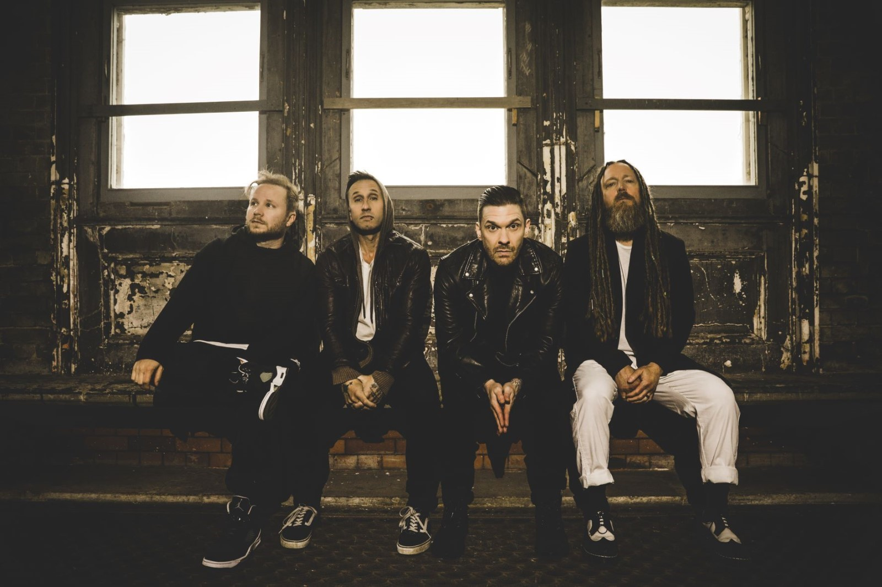
(Photo Credit: Sanjay Parikh - PRESS HERE to download high-res assets)

NEW YORK, NY – June 23, 2023 – Multi-platinum, chart-topping band Shinedown has released “A Symptom Of Being Human (Pop Remix),” an up-tempo, propulsive re-imagining of their current Top 20 Hot AC hit. PRESS HERE to listen, and check out front man Brent Smith’s exclusive interview about it with PEOPLE HERE.

While Shinedown is the most successful rock radio band of all time, holding the record for the most mainstream rock #1s in Billboard history, they also believe that music is universal and doesn’t have to be put in a genre box. With a message about how we are all a work in progress, “A Symptom of Being Human” gets a pop remix as it continues to resonate with listeners and climb at Hot AC where it is currently #17. It is also #1 on SiriusXM’s The Pulse Countdown for the third week in a row.

Shinedown’s exploration of the resilience of the human spirit, experiences with mental health, and the importance of empathy can be found in “A Symptom of Being Human.” With poetic lyrics like “Sometimes I’m in a room where I don’t belong / And the house is on fire and there’s no alarm / And the walls are melting too / How ‘bout you? / I’ve never been the favorite / Thought I’d seen it all / ‘till I got my invitation to the lunatic ball / And my friends are coming too / How ‘bout you?,” the song beautifully captures the idea that it’s the up-and-down journey of life that is the common ground between us. PRESS HERE to watch the official music video, and check out more in Shinedown's feature with USA Today.

The band will be playing select live dates in July, following a sold-out U.S. arena tour earlier this year (after which the band donated $1 from every ticket sold - approximately $150,000 - to the American Foundation for Suicide Prevention.) They will kick off The Revolutions Live Fall Tour on September 3rd. For tickets and all tour details, please visit www.shinedown.com.

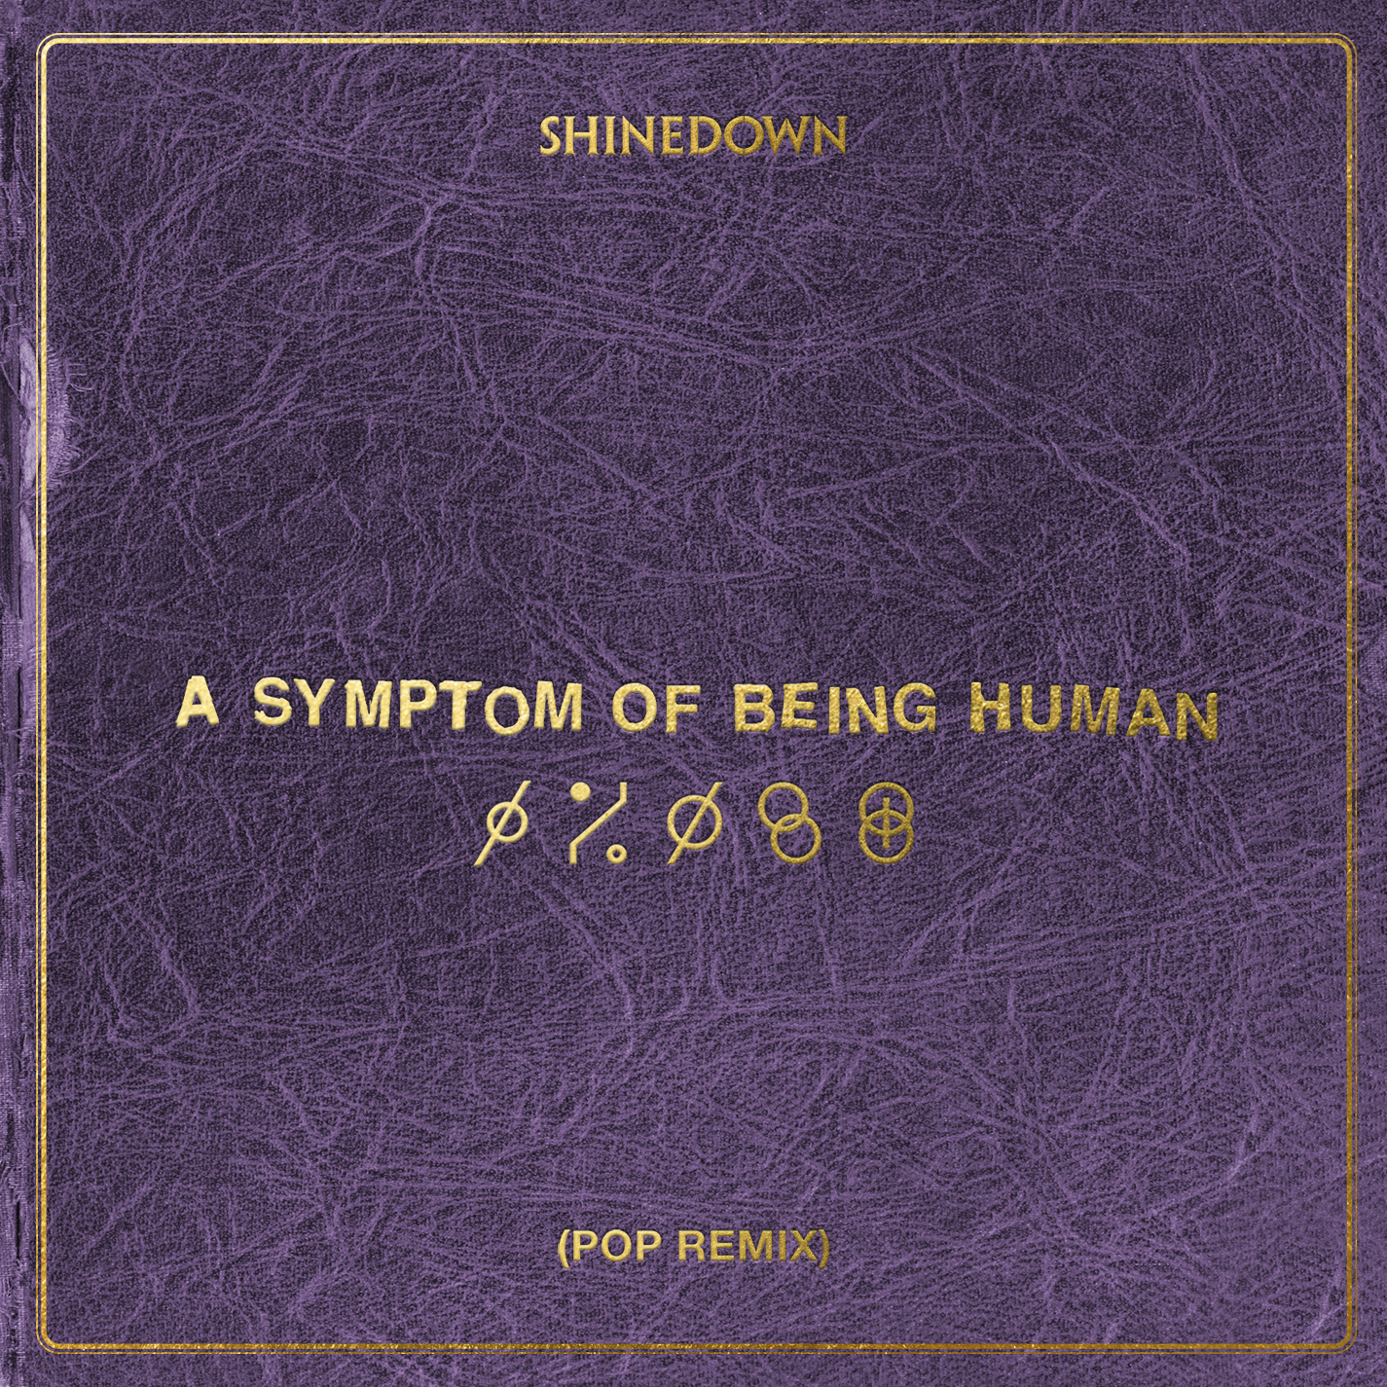
“A Symptom Of Being Human (Pop Remix)” Single Art

SHINEDOWN 2023 LIVE DATES:

July 14 – Fargo, ND @ Red River Valley Fair ^$
July 16 – Madison, WI @ The Sylvee +&
July 17 – Green Bay, WI @ EPIC Events Center +$$
July 20 – Monticello, IA @ Jones County Fair *##
July 21 – Gary, IN @ Hard Rock Live ^$$
July 23 – Niagara Falls, ON @ Fallsview Casino Resort ^$$
September 3 – St Louis, MO @ Hollywood Casino Amphitheatre #
September 4 – Kansas City, MO @ T-Mobile Center #
September 6 – Cuyahoga Falls, OH @ Blossom Music Center #
September 8 – Burgettstown, PA @ The Pavilion at Star Lake #
September 9 – Blue Ridge Rock Festival @ The Virginia International Raceway *^
September 12 – Clarkston, MI @ Pine Knob Music Theatre ~
September 13 – Syracuse, NY @ St. Joseph's Health Amphitheater at Lakeview #
September 15 – Ocean City, MD @ Ocean City Bike Fest*^
September 16 – Camden, NJ @ Freedom Mortgage Pavilion +
September 19 – Gilford, NH @ Bank of New Hampshire Pavilion #
September 21 – Bangor, ME @ Maine Savings Amphitheater #
September 23 – Mansfield, MA @ Xfinity Center #
September 24 – Newark, NJ @ Prudential Center #
September 26 – Simpsonville, SC @ CCNB Amphitheatre at Heritage Park #
September 27 – Atlanta, GA @ Lakewood Amphitheatre #
September 29 – Tampa, FL @ MIDFLORIDA Credit Union Amphitheater #
September 30 – Hollywood, FL @ Hard Rock Live #
October 3 – Franklin, TN @ FirstBank Amphitheater #
October 5 – Rogers, AR @ Walmart AMP #
October 6 – Allen, TX @ Credit Union of Texas Event Center #
October 8 – Houston, TX @ The Cynthia Woods Mitchell Pavilion #
October 9 – San Antonio, TX @ Freeman Coliseum #
October 12 – Phoenix, AZ @ Talking Stick Resort Amphitheatre #
October 13 – Las Vegas, NV @ MGM Grand Garden Arena #
October 15 – Irvine, CA @ FivePoint Amphitheatre #
October 17 – Salt Lake City, UT @ USANA Amphitheater #
October 19 – Albuquerque, NM @ Isleta Amphitheater #
October 20 – Denver, CO @ Ball Arena #

Tour Date Key
# Papa Roach and Spiritbox supporting
~ Spiritbox supporting
$ Saint Asonia and Sleep Theory supporting
& Zero 9:36 and Sleep Theory
## Saint Asonia supporting
$$ Sleep Theory supporting
* Festival date, with no support, just Shinedown
^ Not a Live Nation & FPC Live Produced Date
+ An Intimate Night with Shinedown

ABOUT SHINEDOWN
Multi-platinum band Shinedown - Brent Smith [vocals], Zach Myers [guitar], Eric Bass [bass, production], and Barry Kerch [drums] embody the kind of creative dynamism, constant evolution, singular vision, and an uncompromising honesty that transcends boundaries. The record-breaking band, known for their timely messages behind their chart-topping songs that resonate with not only their global audience and the rock community, but our culture at large, has achieved astronomical success with over 6.5 billion global streams, 20 #1 rock hits, 15 platinum and gold singles, platinum or gold certification for every album, and 10 million albums sold worldwide. Shinedown have also become an essential cultural force as evidenced by their major media acclaim and participation in the prestigious 92Y Talks series. The band is currently named #1 on Billboard’s Greatest Of All Time Mainstream Rock Artists Chart, after notching the most ever #1s (18) in the 40-year history of the Mainstream Rock Songs Chart. Their latest album Planet Zero debuted in the Top 5 on the Billboard 200 Chart and the Official UK Albums Chart, and at #1 on six other Billboard charts including Top Album Sales, Rock, Hard Rock, and Alternative Albums Charts.

FOLLOW SHINEDOWN
Facebook | Instagram | TikTok | Twitter | Website | Atlantic Records

For more information on Shinedown, please contact:

Press Here
Linda Carbone / linda@presshereproductions.com
Carla Senft / carla@pressherepublicity.com
Amanda Curtis / amanda@pressherepublicity.com

Atlantic Records
Glenn Fukushima / Glenn.Fukushima@300elektra.com

