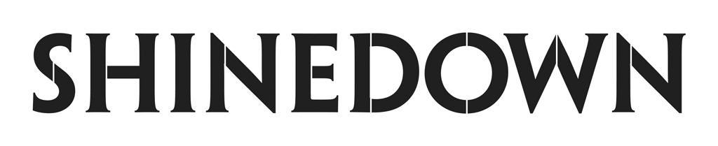

Releases Music Video For
New Hot AC Single “A Symptom Of Being Human”

PRESS HERE to Watch

The Revolutions Live Tour Kicks off April 3

Hit Album Planet Zero Out Now

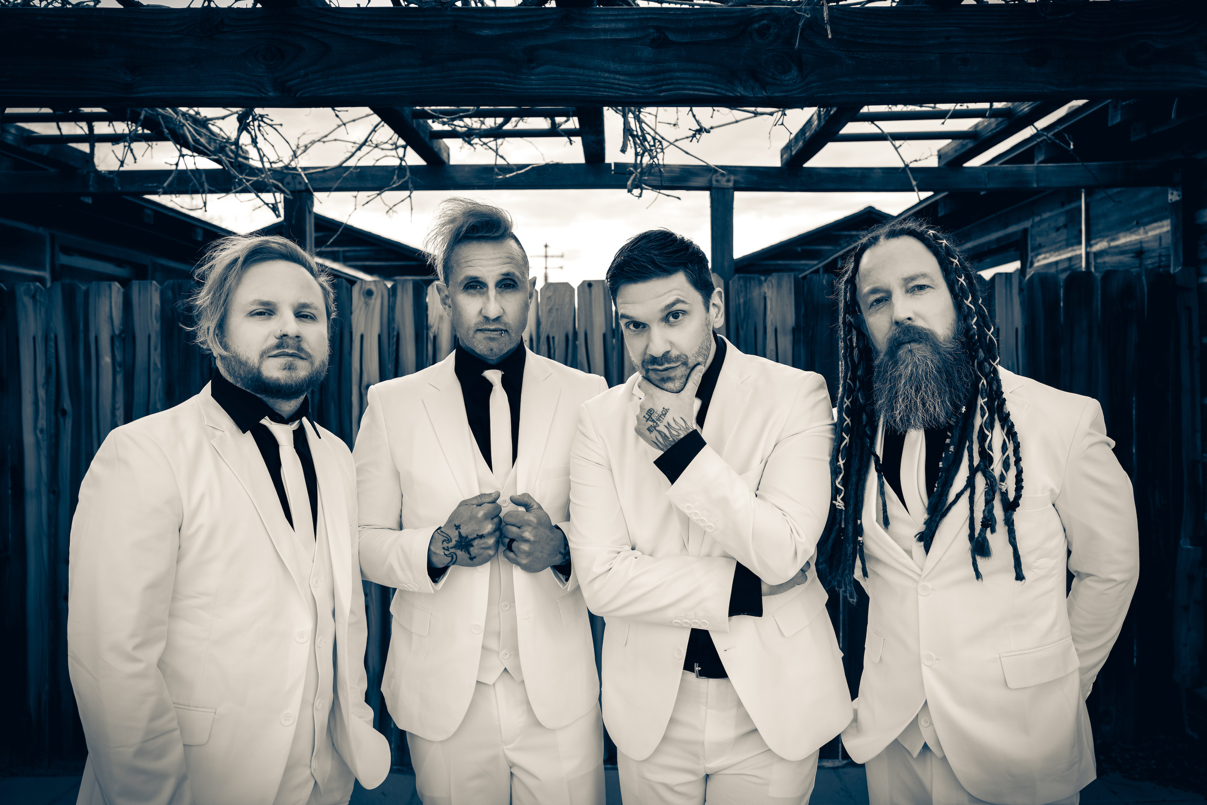

(Photo Credit: Sanjay Parikh)

“Sometimes I’m in a room where I don’t belong
And the house is on fire and there’s no alarm / And the walls are melting too
How ‘bout you?
I’ve never been the favorite / Thought I’d seen it all
‘Till I got my invitation to the lunatic ball / And my friends are coming too
How ‘bout you?”

NEW YORK, NY – February 22, 2023 – Multi-platinum, chart-topping band Shinedown has released their latest music video for new Hot AC single “A Symptom Of Being Human,” a standout track from their critically acclaimed album Planet Zero. Unfolding with gentle acoustic guitar, soaring strings, delicate piano, and a powerful vocal delivery from front man Brent Smith, “A Symptom Of Being Human” celebrates the beauty of our individual differences and embraces the ups and downs of life, while showcasing Shinedown’s gift for making us feel connected through our common humanity. PRESS HERE to watch the cinematic video, directed by Lewis Cater.

“‘A Symptom Of Being Human’ is a deep breath in the face of an ever-changing world. Everyone’s story is different. As human beings, we are all unique, and that’s what makes us individuals. We will all experience highs, and lows in our lifetime. We will all be put to the test, and the challenges of everyday life. So embrace it, don’t run away from it. Live every moment to the fullest, and don’t worry… It’s all just A Symptom Of Being Human,” says front man Brent Smith.

Shinedown’s 24-date The Revolutions Live U.S. Tour will kick off April 3rd with support from fellow chart-toppers Three Days Grace and From Ashes to New. Tickets are on sale now at LiveNation.com.Full tour routing below. For all show/ticketing details please visit www.shinedown.com. The band will also play the Blue Ridge Rock Festival at The Virginia International Raceway in Alton, VA this September.

The Planet Zero album also features pop-rock anthem and #1 rock hit "Daylight," which PEOPLE called “the most powerful of pop-rock songs created to remind us that we are truly all in this together." The band's video for “Daylight,” set to the Amazon Original version of the song, is a love letter to their fans and shows the impact that the song’s message – that you are never alone - had during Shinedown’s sold-out Planet Zero World Tour. PRESS HERE to watch.

Shinedown also recently released a music video for current fast-rising rock single "Dead Don't Die,"a rousing declaration of survival and an anthem about the resilience of the human spirit after trying times.

Planet Zero boldly confronts the societal forces that perpetuate divisiveness while offering a restorative path forward through empathy and open conversation - ultimately serving as a reminder that it is our human connections that matter the most. The album debuted in the Top 5 on the Billboard 200 Chart and the Official UK Albums Chart, and at #1 on six other Billboard charts including Top Album Sales, Rock, Hard Rock, and Alternative Albums Charts. Shinedown are currently nominated for two iHeartRadio Music Awards for Rock Artist of the Year and Rock Song of the Year for "Planet Zero."

SHINEDOWN TOUR DATES 2023

April 3 – Saginaw, MI @ The Dow Event Center
April 4 – Cincinnati, OH @ Heritage Bank Center
April 7 – Bridgeport, CT @ Total Mortgage Arena
April 8 – State College, PA @ Bryce Jordan Center
April 10 – Wilkes-Barre, PA @ Mohegan Sun Arena
April 12 – Huntington, WV @ Mountain Health Arena
April 14 – Jacksonville, FL @ Vystar Veterans Memorial Arena
April 15 – Orlando, FL @ Amway Center
April 17 – Savannah, GA @ Enmarket Arena
April 19 – Huntsville, AL @ Von Braun Center
April 21 – Memphis, TN @ FedExForum
April 22 – Baton Rouge, LA @ Raising Cane's River Center
April 24 – Tulsa, OK @ BOK Center
April 25 – Lincoln, NE @ Pinnacle Bank Arena
April 27 – Ft. Wayne, IN @ Allen County War Memorial Coliseum
April 29 – Milwaukee, WI @ Fiserv Forum
April 30 – Minneapolis, MN @ Target Center
May 3 – Bozeman, MT @ Brick Breeden Fieldhouse
May 6 – Spokane, WA @ Spokane Arena
May 7 – Everett, WA @ Angel of the Winds Arena
May 9 – Portland, OR @ Moda Center
July 14 – Fargo, ND @ Red River Valley Fair
July 20 – Monticello, IA @ Jones County Fair
September 7 – 10 – Blue Ridge Rock Festival @ The Virginia International Raceway *^

*Festival, no Three Days Grace and From Ashes to New
^Not a Live Nation & FPC Live Produced Date

ABOUT SHINEDOWN
Multi-platinum band Shinedown - Brent Smith [vocals], Zach Myers [guitar], Eric Bass [bass, production], and Barry Kerch [drums] - have cemented their status as one of the most vital and forward-thinking powerhouses in modern rock, embodying the kind of creative dynamism, constant evolution, singular vision, and an uncompromising honesty that transcends boundaries. The record-breaking band, known for their timely messages behind their chart-topping songs that resonate with not only their global audience and the rock community, but our culture at large, has achieved astronomical success with over 6.5 billion global streams, 19 #1 rock hits, 15 platinum and gold singles, platinum or gold certification for every album, and 10 million albums sold worldwide. Shinedown have also become an essential cultural force as evidenced by their major media acclaim and participation in the prestigious 92Y Talks series. The band is currently named #1 on Billboard’s Greatest Of All Time Mainstream Rock Artists Chart, after notching the most ever #1s (18) in the 40-year history of the Mainstream Rock Songs Chart with a string of consecutive #1 hit singles including "Daylight," "Planet Zero" “Atlas Falls,” “GET UP,” ATTENTION ATTENTION,” “MONSTERS,” and “DEVIL”, and landed each of their 29 singles in the Top 10 on Billboard’s Mainstream Rock Chart, tied with Foo Fighters for most out of any artist in history.

2018’s acclaimed album ATTENTION ATTENTION, a story album that confronts such complex matters as mental health and the resolve of the human spirit, was certified RIAA Gold and debuted in the Top 5 on the Billboard 200, simultaneously hit #1 on Billboard's Alternative, Top Rock and Hard Rock Albums Charts and led to five iHeart Radio Music Award nominations. Its accompanying 2021 feature film, directed by Bill Yukich (Beyoncé, Metallica), is a riveting visual counterpart to the album’s narrative, weaving its 14 songs into a provocative and thought-provoking cinematic journey that illuminates yet another dimension of their limitless creativity.

Hailed for their high-octane live shows, explosive rock ‘n’ roll spirit, thought-provoking lyrics, and melodic sensibility, Shinedown continues to engender diehard love from millions of global fans and has racked up countless sold-out arena tours and festival headlining sets propelled by the undeniable power of front man Brent Smith’s voice.

FOLLOW SHINEDOWN
Facebook | Instagram | TikTok | Twitter | Website | Atlantic Records

Shinedown PR Contact:

Press Here
Linda Carbone / linda@presshereproductions.com
Carla Senft / carla@pressherepublicity.com
Amanda Curtis/ amanda@pressherepublicity.com

Atlantic Records
Glenn Fukushima / glenn.fukushima@atlanticrecords.com

