FOR IMMEDIATE RELEASE
JANUARY 17, 2024

SIR CHLOE IS BACK WITH “SEVENTEEN”

NEW SINGLE HERALDS BIGGEST NORTH AMERICAN HEADLINE TOUR TO DATE

“THE SAVORY TOUR” BEGINS MARCH 10 IN TORONTO

HIGHLIGHTS INCLUDE SOLD-OUT SHOWS IN WEST HOLLYWOOD, WASHINGTON, DC, BROOKLYN, AND AUSTIN

“SEVENTEEN” AVAILABLE NOW VIA ATLANTIC RECORDS
LISTEN HERE

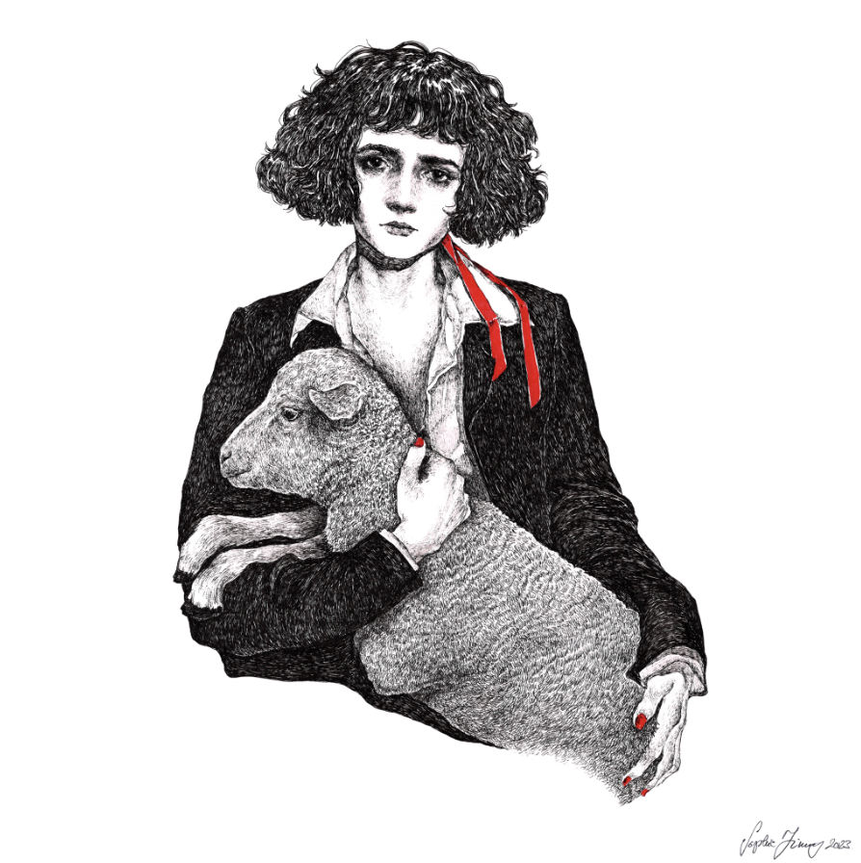
DOWNLOAD HI-RES IMAGE

Sir Chloe – the acclaimed project of vocalist, songwriter, and guitarist Dana Foote – returns with the electrifying new single, “Seventeen,” available now via Atlantic Records HERE.

Sir Chloe will mark the arrival of “Seventeen” – and herald more new music to come – with a hugely anticipated North American headline tour – the band’s biggest live run to date. “The Savory Tour” gets underway March 10 at Toronto, ON’s Axis Club and then continues into mid-April. A number of dates are already long sold out, including West Hollywood, CA’s Troubadour (March 30), Washington, DC’s The Atlantis (April 11), Brooklyn, NY’s Music Hall of Williamsburg (April 13), and Austin, TX’s Antone’s (April 22), with second shows added by popular demand in both Washington, DC and Brooklyn. Special guests include Daffo. For complete details and remaining ticket availability, please visit www.sirchloemusic.com/tour.

SIR CHLOE
“THE SAVORY TOUR” 2024

MARCH
10 – Toronto, ON – Axis Club (SOLD OUT)
11 – Detroit, MI – El Club
12 – Chicago, IL – Lincoln Hall
13 – Milwaukee, WI – Vivarium
15 – St Louis, MO – Blueberry Hill (SOLD OUT)
16 – Kansas City, MO – Madrid Theatre
18 – Minneapolis, MN – Fine Line
20 – Boulder, CO – Fox Theatre
21 – Denver, CO – Marquis Theater
25 – Seattle, WA – The Crocodile
26 – Portland, OR – Wonder Ballroom
28 – Roseville, CA – Goldfield Trading Post Roseville
29 – Santa Ana, CA – The Observatory
30 – West Hollywood, CA – Troubadour (SOLD OUT)
31 – San Francisco, CA – The Independent (SOLD OUT)

APRIL
2 – Los Angeles, CA – Lodge Room Highland Park
10 – Washington, DC – The Atlantis
11 – Washington, DC – The Atlantis (SOLD OUT)
13 – Brooklyn, NY – Music Hall of Williamsburg (SOLD OUT)
14 – Brooklyn, NY – Music Hall of Williamsburg
17 – Cambridge, MA – The Sinclair (SOLD OUT)
18 – Philadelphia, PA – The Foundry (SOLD OUT)
20 – Nashville, TN – Exit/In
22 – Austin, TX – Antone’s (SOLD OUT)
23 – Dallas, TX – Dada Dallas
24 – Houston, TX – White Oak Music Hall (SOLD OUT)
26 – Atlanta, GA – The Loft
27 – Charlotte, NC – Neighborhood Theatre (SOLD OUT)

# # #

“Seventeen” follows Sir Chloe’s acclaimed debut album, I Am The Dog, available everywhere now HERE. Produced by GRAMMY® Award-winner John Congleton (Lana Del Rey, St. Vincent, Angel Olsen) with songwriting contributions from Teddy Geiger (Caroline Polachek, Sylvan Esso, Lizzo) and Sarah Tudzin (Weyes Blood, Amen Dunes, Slowdive), the album includes such thrillingly paradoxical singles as “Should I,” “Salivate,” “Hooves,” and “Know Better,” the latter of which proved a favorite at Triple A radio outlets nationwide.

Anchored by Foote’s emotional songcraft and dynamic voice, I Am The Dog was met by critical applause around the world including NPR, Rolling Stone, and with The Line of Best Fit declaring it “Sir Chloe’s most developed and intricate release to date” in a 9-out-of-10 review, adding, “The tongue-in-cheek and aloof record finds its roots in covert sapphic, and paradoxical narratives, kaleidoscopic soundscapes and cool, grunge-fueled vocals. Complete with obscure and frank lyricism, I Am The Dog staples itself as a strong entry amongst this year’s releases.” “A fast-paced and cool sound that should only be played at max volume,” raved Flaunt. “Foote’s voice is effortless, unbothered, yet emotionally vigorous.” “It’s grungy, it’s shoegazey, it’s weird,” wrote DIY. “It’s not afraid to go off-piste. It’s full of guitar lines that are simultaneously super clean and gut-wrenching…Sir Chloe have perfectly grasped the entire concept of anticipation, building up and dropping out at the flick of a switch, never sticking to the status quo.”

ABOUT SIR CHLOE
Now boasting over 500M worldwide streams, Dana Foote put Sir Chloe together in college to serve as her senior thesis, going on to write the band’s first major hits in “Michelle“ (211M) and “Animal“ (93M) on the floor of her dorm room. Sir Chloe’s 2020 EP, Party Favors, was recorded in a warehouse that the band transformed into a recording space with just one hundred dollars and sheer will. Following the success of the EP (which earned over 200M global streams) and two additional singles in 2022, Sir Chloe – which consists of Foote, Emma Welch, Teddy O’Mara, Palmer Foote, and Austin Holmes – toured arenas with Portugal. The Man and alt-J, supported Pixies, Phoenix and Beck, and headlined two tours of their own in the United States and Europe, with sold-out stops in New York, Los Angeles, London, Paris, Amsterdam, and more. In addition, Foote has been profiled in such publications as Vogue and PAPER, was featured in a recent campaign for Harry Styles’ Pleasing lifestyle brand and is also slated to be in an upcoming modeling campaign for Prada.

Sir Chloe celebrated the whirlwind success of I Am The Dog with “I Am The Tour,” highlighted by sold-out headline dates in North America and Europe, as well a special guest run on the epic Phoenix and Beck co-headline tour alongside Japanese Breakfast, Weyes Blood, and Jenny Lewis. In addition, last year saw Sir Chloe premiere the mesmerizing single, “Home Where,” available now via Atlantic Records HERE.

# # #

CONNECT WITH SIR CHLOE
OFFICIAL | FACEBOOK | INSTAGRAM | SPOTIFY | TIKTOK | TWITTER | YOUTUBE

CONTACT
Jessica Nall / Jessica.Nall@atlanticrecords.com
Libby Kober / Libby.Kober@atlanticrecords.com

