FOR IMMEDIATE RELEASE
FEBRUARY 9, 2024

FOREST BLAKK - “LONG STORY SHORT”

ACCLAIMED SINGER/SONGWRITER & “PATRON SAINT” OF LOVE IS BLIND TO RELEASE ACCOMPANYING HEARTFELT VIDEO ON VALENTINES DAY

BLAKK WILL JOIN JAMES ARTHUR ON HIS BITTER SWEET LOVE TOUR ACROSS ALL U.S AND CANADA DATES - KICKING OFF APRIL 30TH IN OAKLAND, CA

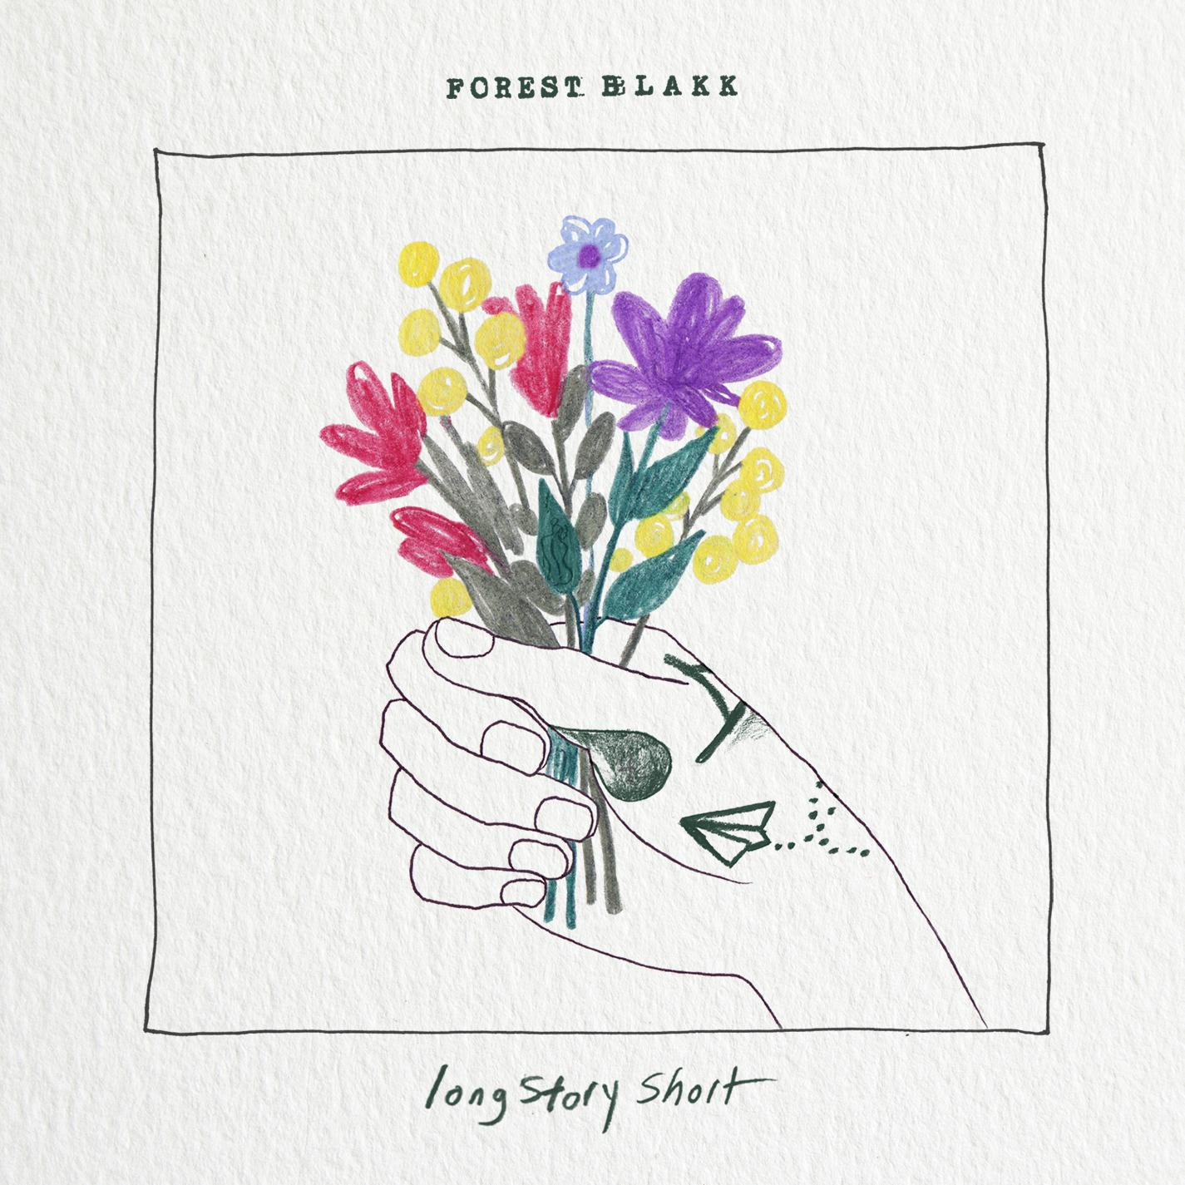
DOWNLOAD HIGH-RES IMAGES/ART HERE

STREAM “LONG STORY SHORT”: LINK

“In a world of awkward smiles and words that never quite make it, this song is for the ones who struggle to say those three simple words... It's the fumbled sentences, the blushing faces, and the moments of eye contact that seem to last a lifetime. Long Story Short – I love you... even if the words don't come out right.” - FOREST BLAKK

Acclaimed singer/songwriter Forest Blakk returns with the heartfelt new single “Long Story Short,” accompanied by a lyric video – watch/stream here. Arriving just in time for Valentine’s Day, Blakk’s first offering of 2024 is written alongside and produced by Nolan Sipe (Calum Scott, MAX) with an official music video, directed by Taylor Kelly (Kelsea Ballerini, Gabby Barrett), set to arrive next week on February 14th.

Blakk is set to join James Arthur on his Bitter Sweet Love Tour as direct support for the United States and Canada dates, kicking off April 30th in Oakland, CA at Fox Theater. See here for all upcoming tour info - https://www.forestblakk.com/tour/.

Blakk has spent his career soundtracking love stories of all kinds, most recently including his own with “Love Somebody Again” and “I Choose You” – the latter having arrived just days after his Nashville wedding to Tooley Jones in a beautiful ceremony covered exclusively by PEOPLE Magazine (read here). Both songs follow last year’s intimate and relatable Every Little Detail EP, featuring his breakout Platinum-certified smash single “If You Love Her,” which alone has amassed over 450 million total global streams, earned Blakk his official US chart debut on Billboard’s Emerging Artists chart, his national US TV debut on ABC’s Live with Kelly & Ryan, top 30 placement on the Hot AC radio chart & saw the singer/songwriter collaborate with Meghan Trainor on a stunning duet version. Meanwhile, Blakk’s follow-up single “Fall Into Me” (co-written alongside Matchbox Twenty front man Rob Thomas and Gregg Wattenberg) reached top 30 on the Hot AC radio chart and Gold-certification status in his native Canada, in addition to being featured in a perfectly fitting ad campaign for Kay Jewelers. His songs have also become a staple of Netflix’s hit show Love is Blind – having been named the “patron saint” of the show by creators with the Los Angeles Times pointing out “(Blakk’s) earnest mid-tempo love songs turn up on ‘Love is Blind’ nearly as often as hosts Nick and Vanessa Lachey.”

Highlighted as one of PEOPLE Magazine’s “talented emerging artists making their mark on the musical landscape” and deemed an “artist on the rise” by Billboard, Blakk made his debut with his 2018 EP Minutes and follow-up 2020 sophomore EP Sideways – the latter of which saw Blakk collaborate with the likes of Will IDAP (Train, Florida Georgia Line), Nick Long (King Princess), Carl Ryden (Ricky Martin, David Guetta), Ollie Green (Freya Ridings, Gavin James) & more to tell a love story through an incredibly realistic and candid lens. The 6-track collection featured singles “I Wish I Knew” (deemed an “introspective look at love and love lost” by American Songwriter) and uplifting anthem of resilience “Put Your Hands Up,” which debuted on an episode of ABC’s Grey’s Anatomy. A compelling live performer, Blakk has toured extensively supporting NEEDTOBREATHE, Gavin James, Dean Lewis & earlier this year embarked on a sold out 17-date North American headline tour.

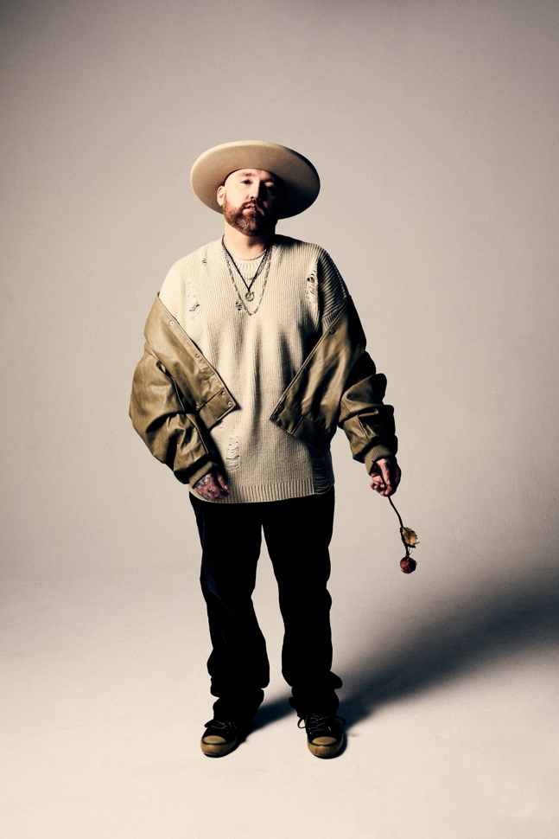
DOWNLOAD HIGH-RES IMAGES

CONNECT WITH FOREST BLAKK:
FORESTBLAKK.COM |TIKTOK | TWITTER | FACEBOOK | INSTAGRAM | YOUTUBE | PRESS ASSETS

CONTACT:
TED.SULLIVAN@ATLANTICRECORDS.COM

