FRED AGAIN.. LINKS WITH LIL YACHTY & OVERMONO
ON NEW SINGLE
“stayinit”

LISTEN HERE
WATCH THE OFFICIAL VISUALISER HERE

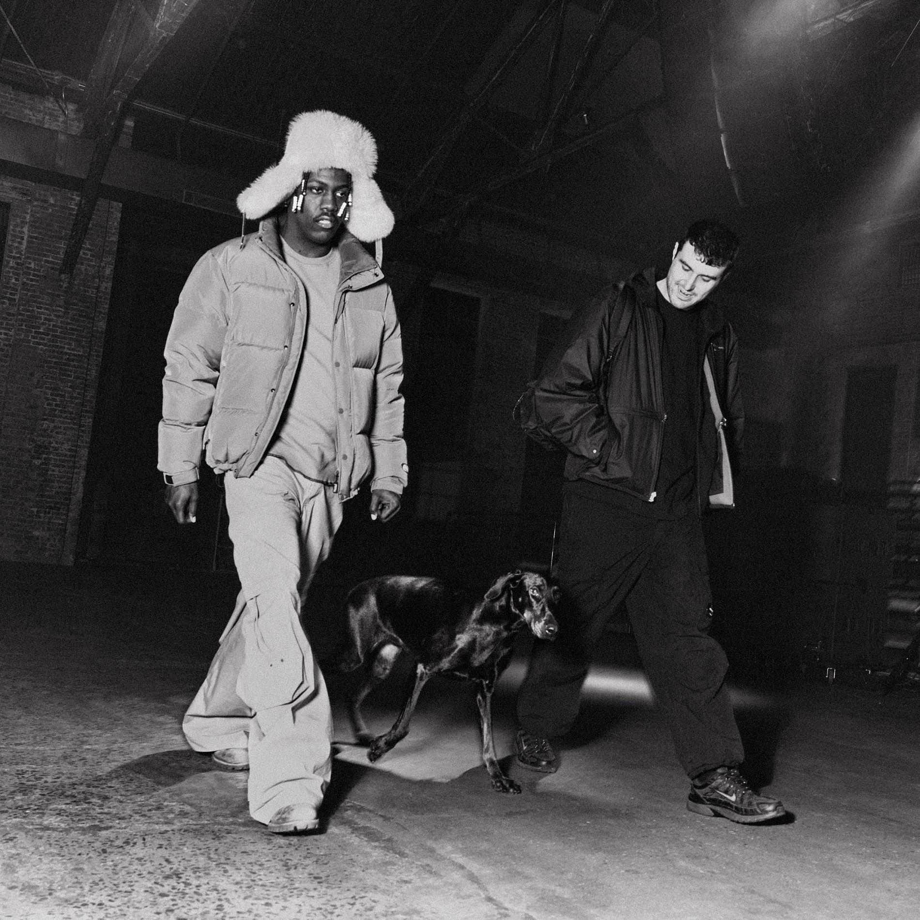

Fred again.. has joined forces with Lil Yachty and Overmono on new single, “stayinit” - Listen HERE.

Coming fresh off the back of a bumper 2023 that culminated in Fred playing sold-out shows in New York (x3 at Forest Hills Stadium) and LA (x9 at Shrine Expo Hall), plus 5x sold-out shows at London’s Alexandra Palace and a sold-out EU tour, “stayinit” lands as the latest in Fred again..’s series of USB records.

It follows December’s "leavemealone" alongside Baby Keem, "ten" with Jozzy and tender summer anthem, "adore u" - a moving collaboration with Obongjayar, and Fred’s highest charting UK single to date (#4).

“stayinit” also marks the first time Fred has collaborated with mercurial, GRAMMY-nominated US rapper, Lil Yachty and UK dance music prodigies, Overmono, whose critically-acclaimed debut LP, Good Lies, peaked at #11 on the Official Albums Chart on release last spring.

Performed live alongside both Lil Yachty and Overmono for the first time during an impromptu pop-up rave and later during a broadcast from The Lot Radio in New York earlier this month, “stayinit” marks the start of another busy year for Fred again.. - look out for more soon.

“stayinit” is out now: https://fredagain.lnk.to/stayinit

CONNECT WITH Fred again..
OFFICIAL SITE / INSTAGRAM / TIK TOK / SOUNDCLOUD

CONNECT WITH OVERMONO:
OFFICIAL SITE / INSTAGRAM / FACEBOOK / SOUNDCLOUD

CONNECT WITH LIL YACHTY:
OFFICIAL SITE / INSTAGRAM / X / TIK TOK / FACEBOOK

