KNOX SHARES “ME, MYSELF, & YOUR EYES”

ADDS A WEST COAST RUN TO HIS SOLD OUT HEADLINE TOUR
“THE ‘I’M SO GOOD AT BEING ALONE TOUR”

“NOT THE 1975” CURRENTLY CHARTING AT TOP 40 & HOT AC RADIO

LISTEN TO “ME, MYSELF, & YOUR EYES” HERE
WATCH OFFICIAL LYRIC VIDEO HERE

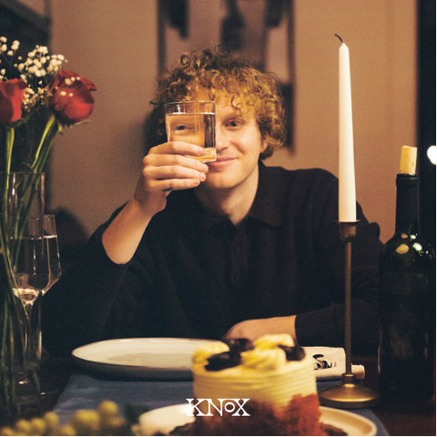
DOWNLOAD HI-RES ARTWORK HERE

Nashville-based alt pop artist Knox continues to keep fans busy this year with his latest single release, “Me, Myself, & Your Eyes,” available via Atlantic Records HERE.

Knox also recently announced a west coast run of his sold-out, debut headline tour, “The I’m So Good At Being Alone Tour.” Shows are set to kick off in April starting in Saint Paul, MN with stops in cities such as Los Angeles, Dallas, Phoenix and more. Support throughout will continue to come from Atlantic label mate maryjo. For updates, please visit www.musicbyknox.com.

Alongside all of his releases and announcements, Knox also celebrates the success of his viral fan favorite song, “Not The 1975,” which is currently #26 at Top 40 and #23 at Hot AC Radio.
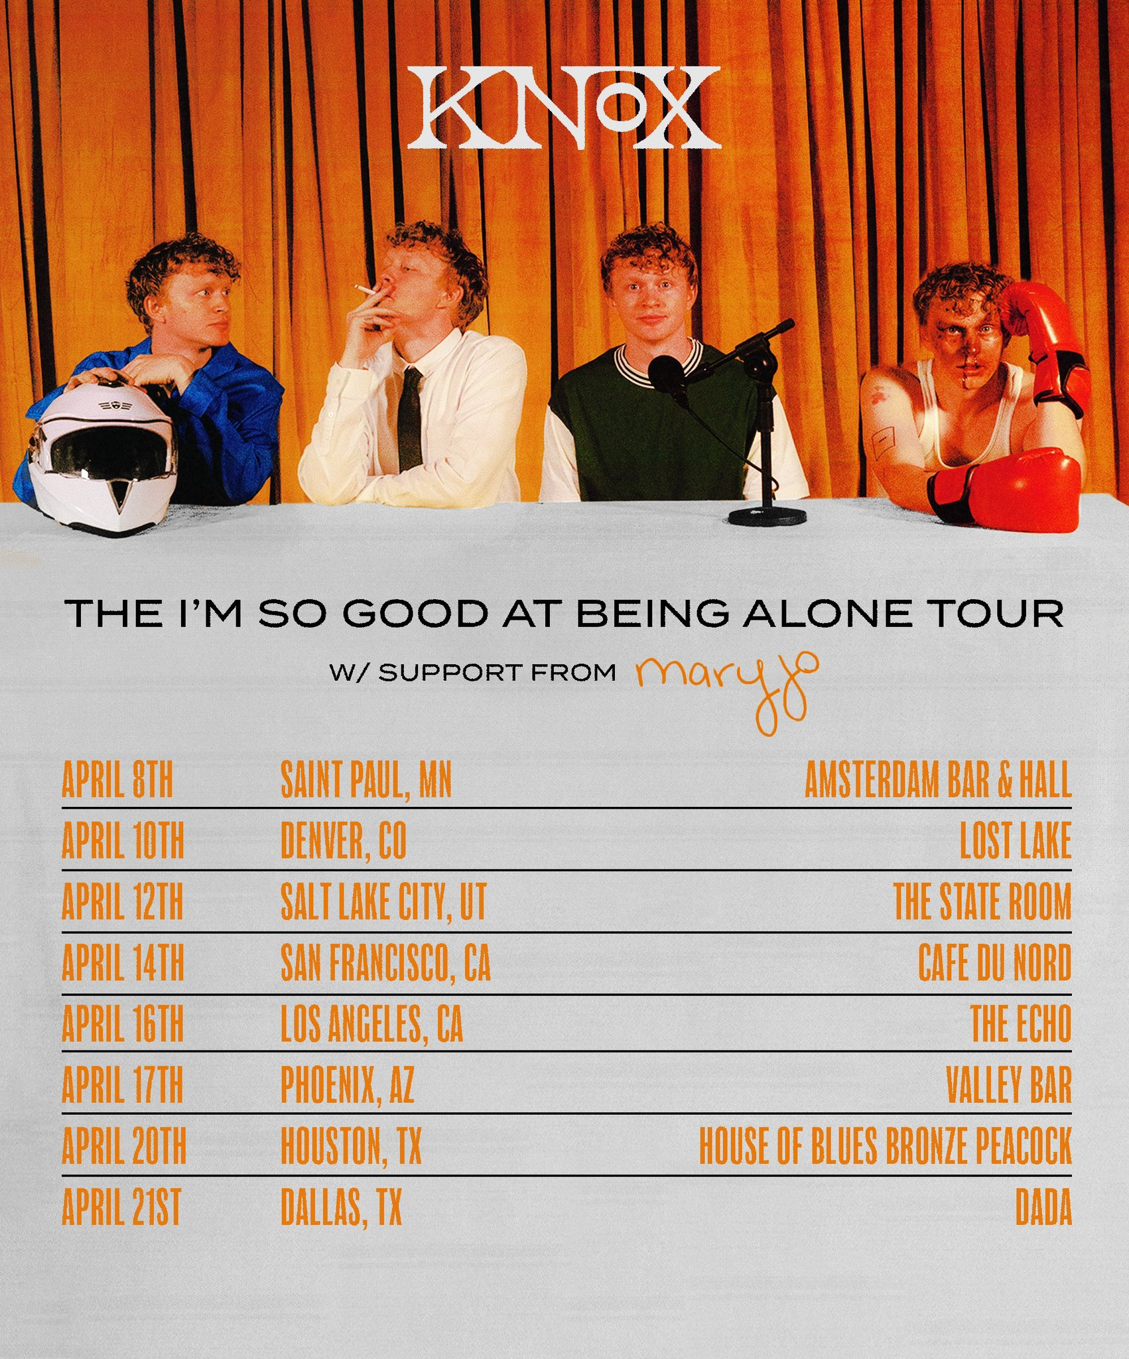
DL ad mat HERE

KNOX
ON TOUR 2024

APRIL
08 – Saint Paul, MN – Amsterdam Bar & Hall
10 – Denver, CO – Lost Lake
12– Salt Lake City, UT – The State Room
14 – San Francisco, CA – Cafe Du Nord
16 – Los Angeles, CA – The Echo
17 – Phoenix, AZ – Valley Bar
20 – Houston, TX – House of Blues Bronze Peacock
21 – Dallas, TX – Dada

# # #

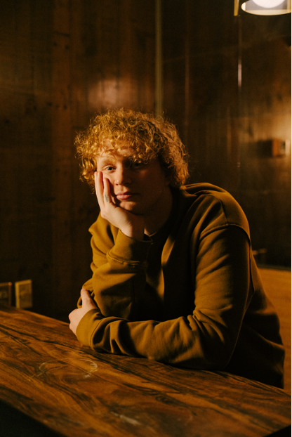
DL press photos HERE – credit Chase Denton // Working Holiday

ABOUT KNOX:
Growing up, Knox knew he had an interest in music more than the average kid. His teenage years were sound tracked by artists such as Fall Out Boy & Ed Sheeran, and the summer before he started college, Knox taught himself guitar. He began playing open mic nights and by his sophomore year, his musical ambitions were so all-consuming that he dropped out of school, moved in with his grandma and saved up money to move to Nashville. He made the leap in January 2019.

Knox used Covid isolation to work on his craft. The focus paid off: Knox signed a publishing deal in 2022 but was struck with the urge to record songs he had been working on. The result was How to Lose a Girl in 7 Songs, Knox’s debut EP, released February 2023. Knox filmed TikToks featuring his song “Sneakers”, and 1 amassed nearly 2M views overnight. “Sneakers” now has over 31M streams. Another fan favorite track, “Not The 1975," can be seen on the Top 40 and Hot AC radio charts, and is featured on Knox’s latest EP, “I’m So Good At Being Alone?” released October 2023.

Knox has since been touring, opening for the Band Camino, Nightly, and Boys Like Girls and most recently performing on his own sold out headline tour. “I'm 6 states away from home and there’s a thousand people in the audience that are singing the song that I wrote with my friends in my bedroom. That's when it gets you, when you see people connecting to something that I made with my best friends. It’s the most unreal feeling in the world.”

# # #

CONNECT WITH KNOX
WEBSITE | INSTAGRAM | TIKTOK | SPOTIFY | YOUTUBE

Press Contact: gabrielle.reese@atlanticrecords.com

