FOR IMMEDIATE RELEASE
FEBRUARY 15, 2024

ROYAL & THE SERPENT AND GAYLE TEAM UP AGAINST EX BOYFRIENDS EVERYWHERE FOR “kinda smacks”

ROYAL & THE SERPENT EMBARKING ON
NORTH AMERICAN RUN SUPPORTING AVRIL LAVIGNE
BEGINNING IN MAY

GAYLE SUPPORTING P!NK’S SUMMER CARNIVAL 2024
UK + EUROPE DATES BEGINNING IN JUNE

LISTEN TO “kinda smacks” HERE

DOWNLOAD ASSETS HERE
PHOTO CREDIT: SJ SPRENG

RIAA Gold-certified singer-songwriter Royal & the Serpent has joined forces with GRAMMY® award-nominated, multiplatinum-certified artist GAYLE for the brand new, vengeful collaborative single, “kinda smacks,” available everywhere now via Atlantic Records – Listen HERE. An official visualizer premieres today at YouTube – Watch HERE.

"kinda smacks" is Royal's first release following her RAT TRAP series of double-sided singles, released throughout 2023. She also wrapped her first ever headline tour late last year, after opening for artists such as Demi Lovato and Fall Out Boy. Next up is an eagerly anticipated run as special guest on Avril Lavigne’s Greatest Hits Tour, beginning May 22 at Vancouver, BC’s Rogers Arena and continuing into early June. For full details and ticket information, please see www.royalandtheserpent.com/tour.

"kinda smacks" is GAYLE's first release of the year and follows her single "i don't sleep as good as i used to." She wrapped her headline The Scared But Trying Tour late last year, after opening for several dates on P!nk's Europe tour and Taylor Swift's Eras Tour. This year will see GAYLE return to Europe and the United Kingdom as support on P!NK’s Summer Carnival 2024, beginning June 11 at Cardiff, UK’s Principality Stadium and then continuing through July. For complete details and ticket information, please see www.gayleofficial.com/tour.

ROYAL & THE SERPENT
TOUR 2024

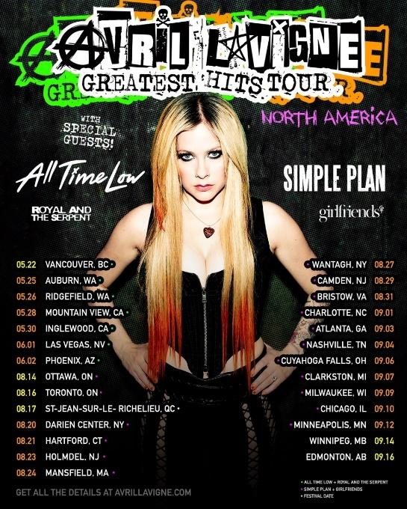

MAY
22 – Vancouver, BC – Rogers Arena
25 – Auburn, WA – White River Amphitheatre
26 – Ridgefield, WA – RV Inn Style Resorts Amphitheater
28 – Mountain View, CA – Shoreline Amphitheater
30 – Inglewood, CA – Kia Forum

JUNE
1 – Las Vegas, NV – MGM Grand Garden Arena
2 – Phoenix, AZ – Talking Stick Resort Amphitheatre

All Dates w/ Avril Lavigne Greatest Hits Tour

# # #

GAYLE
TOUR 2024

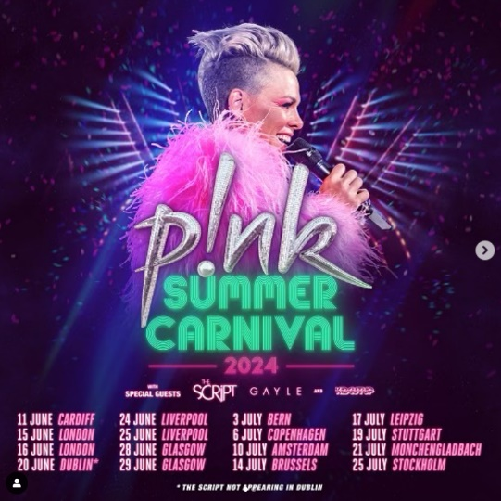

JUNE
11 – Cardiff, UK – Principality Stadium
15 – London, UK – Tottenham Hotspur Stadium
16 – London, UK – Tottenham Hotspur Stadium
20 – Dublin, Ireland – Aviva Stadium
24 – Liverpool, UK – Anfield Stadium
25 – Liverpool, UK – Anfield Stadium
28 – Glasgow, UK – Hampden Park
29 – Glasgow, UK – Hampden Park

JULY
3 – Bern, Switzerland – Wankdorf Stadium
6 – Copenhagen, Denmark – Parken Stadium
10 – Amsterdam, Netherlands – Johan Cruijff Arena
14 – Brussel, Belgium – King Baudouin Stadium
17 – Leipzig, Germany – Red Bull Arena
19 – Stuttgart, Germany – Mercedes Benz Arena
21 – Mönchengladbach, Germany – Borussia-Park
25 – Stockholm, Sweden – Friends Arena

All Dates w/ P!NK Summer Carnival 2024

# # #

ABOUT ROYAL & THE SERPENT
Royal & the Serpent is an artist entirely unafraid to bare the deepest and darkest parts of her psyche. After making her Atlantic Records debut with the 2020 EP, get a grip – highlighted by the RIAA Gold-certified single “Overwhelmed,” which spent 22 weeks on Billboard’s “Alternative Airplay” chart – the L.A.-based singer-songwriter revealed even more of her frenetic inner world in 2022 with IF I DIED WOULD ANYONE CARE and Happiness Is An Inside Job. Royal introduced fans to the “royalverse” in 2023, dropping 4 EPs, titled RAT TRAPs, throughout last year. RAT TRAP I: the blueprint features the powerfully inspiring, fan favorite LGBTQ+ anthem, “One Nation Underdogs.” Her unfiltered songwriting has proved wildly resonant to her ever-growing fanbase—and led to such triumphs as touring with Fall Out Boy, Demi Lovato, grandson, PVRIS, and soon with Avril Lavigne.

Originally from New Jersey, Royal started in dance and theatre, and first took up guitar at age 14, then relocated to L.A. at age 18. While working as a bartender, Royal soon started self-releasing her music, beginning with her spellbinding 2017 single “Temperance.” Thanks to the buzz behind songs like 2019’s “Weddings & Funerals” and “Salvador Dali” – as well as her electrifying live show – she eventually inked a deal with Atlantic and released “Overwhelmed” in the early days of Covid lockdown.

# # #

ABOUT GAYLE
GAYLE made a triumphant arrival with the 2022 release of her debut EP, a study of the human experience volume one, highlighted by the 4x RIAA Platinum-certified hit “abcdefu.” Named among the “Best Songs of 2022” by Billboard, Rolling Stone, and UPROXX, the track proved a worldwide sensation, spending nine consecutive weeks at #1 on Billboard’s “Global 200” while peaking at #3 on the US ”Hot 100” after three straight weeks atop Top 40 radio charts nationwide. “abcdefu” later earned GAYLE her first-ever GRAMMY® Award nomination (for “Song of the Year”), an ever-increasing list of global honors and accolades that include an American Music Awards nomination for “New Artist Of The Year,” a People’s Choice Awards nomination for “The New Artist of 2022,” a Kids’ Choice Awards nomination for “Favorite Breakthrough Artist,” two 2022 MTV EMAs nominations, two MTV Video Music Awards nominations, being named a Billboard Music Awards finalist, and featured placement on both Billboard’s influential “21 Under 21” list and Variety’s 2022 “Power of Young Hollywood” Impact List.

2023 proved a landmark year for GAYLE, highlighted by a string of new music including “butterflies,” featured on BARBIE THE ALBUM, Atlantic Records’ chart-topping musical companion to the Academy Award-nominated film, Barbie, starring Margot Robbie and Ryan Gosling as Barbie and Ken and distributed by Warner Bros. Pictures. In addition, the 19-year-old songstress shared such high-profile collaborations as co-writing Kelly Clarkson’s smash ballad, “me,” as well as a feature on Lauren Spencer Smith’s acclaimed “Fantasy (with GAYLE & Em Beihold).”

GAYLE celebrated with her biggest ever North American headline run, The Scared But Trying Tour, as well as a series of North American stadium shows as special guest on the blockbuster Taylor Swift | The Eras Tour, top-billed festival appearances, and special guest role on P!NK’s Summer Carnival 2023. This year will see GAYLE return to Europe and the United Kingdom as support on P!NK’s Summer Carnival 2024, beginning June 11 at Cardiff, UK’s Principality Stadium and then continuing through July. For complete details and ticket information, please see www.gayleofficial.com/tour.

CONNECT WITH ROYAL & THE SERPENT
OFFICIAL | FACEBOOK | INSTAGRAM | TWITTER | YOUTUBE

ROYAL & THE SERPENT PRESS CONTACTS
Jessica Nall / Jessica.Nall@atlanticrecords.com
Gabby Reese / Gabrielle.Reese@atlanticrecords.com

CONNECT WITH GAYLE
OFFICIAL | DISCORD | FACEBOOK | INSTAGRAM | TIKTOK | TWITTER | YOUTUBE

GAYLE PRESS CONTACT
Christina Kotsamanidis / Christina.Kotsamanidis@atlanticrecords.com

