FOR IMMEDIATE RELEASE
FEBRUARY 21, 2024

SUGAR PIT DEMANDS FAIR WAGES WITH GRITTY NEW ANTHEM “PAY ME”

GENRE-BUSTING VOCALIST, MULTI-INSTRUMENTALIST AND PRODUCER SHARES LABEL DEBUT SINGLE

“PAY ME” AVAILABLE NOW VIA ATLANTIC RECORDS/GOOD LUCK HAVE FUN

LISTEN HERE

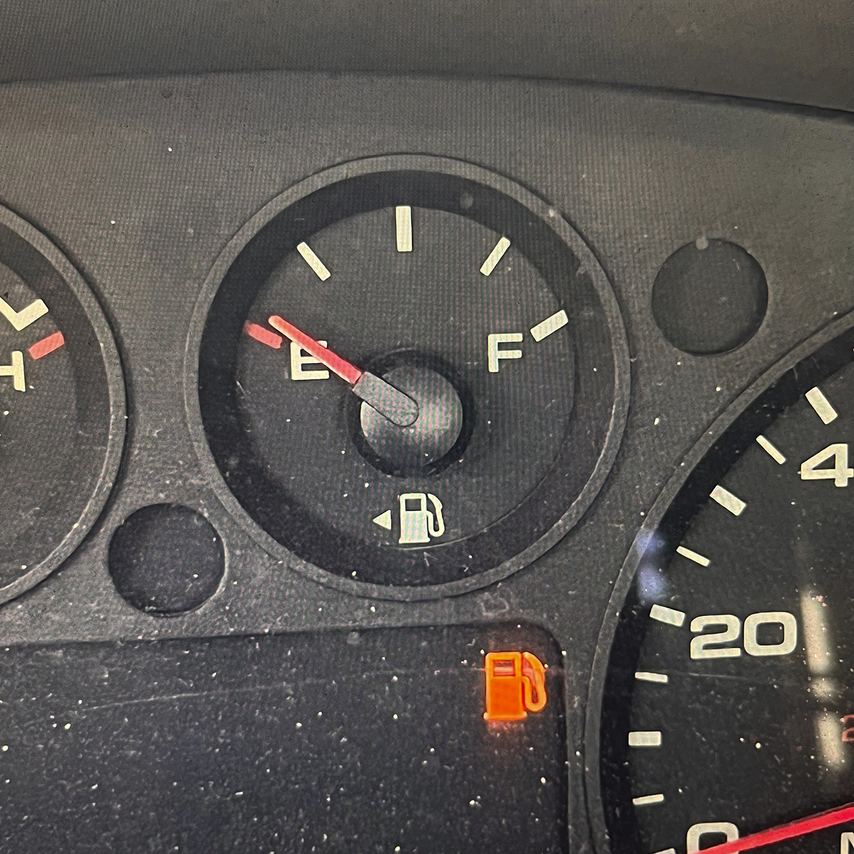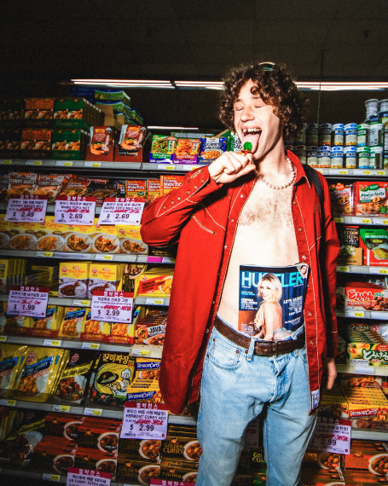
DOWNLOAD ASSETS HERE

Freak-pop vocalist, multi-instrumentalist and producer, Sugar Pit, has shared his vitriolic label debut single, “Pay Me,” available now via Atlantic Records/Good Luck Have Fun.

Heralded in a series of short-form teasers showcasing the struggles of the working class in his current home base of Los Angeles, “Pay Me” sees Sugar Pit – the grimey brainchild of Carbondale, IL-based artist Kian Stevens-Winston – unleashing a punked-out diatribe in which he bitterly observes, “You say we are one big family at this establishment, but you’re wearing a Burberry jacket and I can’t afford my rent!” The rancorous anthem builds to a cathartic scream and a squealing guitar lead before one final roar, “F*ck you, pay me for my time!”

“I wrote it after work one day,” says Sugar Pit. “I was frustrated by the average pay from being a valet, a barista, and a music teacher. I even interviewed to be a birthday clown once! I was sick of how much I worked, yet I still wasn’t able to cover all of my expenses. It’s the broke life so many people my age know about.”

Sugar Pit – who recently made his New York City live debut with a sold-out performance at the famed Mercury Lounge and last weekend stole the show at the eclectic My Slutty Valentine Fest in Los Angeles – will celebrate “Pay Me” with a wide-ranging live schedule that includes house parties and showcase gigs across the country. Complete details will be announced soon.

Musically mangling the boundaries between garage rock, alternative, indie, punk, and pop, Sugar Pit’s songs veer from uncomfortable confessions to undeniable celebrations of life at its most uninhibited. Sugar Pit was born when 15-year-old Kian Stevens-Winston transformed his Southern Illinois bedroom into a D.I.Y. creative hub where he made music, artwork, promo videos, and even handcrafted stage props and merch. As a student at Drexel University, Stevens-Winston doubled down on Sugar Pit with countless house shows and marathon recording sessions. Most of his last semester there was spent in his dorm room, crafting his style-defining 2020 debut EP, Defense Mechanism.

Following graduation, Stevens-Winston relocated to Los Angeles where he burned through “a bunch of random shitty part-time jobs” while also dropping such increasingly popular singles as “Why I Come Back Home” and “Supply/Demand.” Sugar Pit went viral in 2023 with Stevens-Winston being ejected from his job at a local Walmart in a video soundtracked by his breakthrough ode to menial labor, “Customer Service.” Named as one of The Needle Drop’s “Top Songs of 2023,” the track earned Sugar Pit over 1M worldwide streams (and more than 7M views on TikTok), paving the way for his Task Master EP and new deal with Atlantic Records. Now, with “Pay Me” and the imminent arrival of his long awaited debut album, Sugar Pit is fully focused on what’s next, ready as ever to share his music – and mania – with the world.

“I’m just trying to put every part of myself on the table,” says Sugar Pit. “I’m voicing those thoughts you have while you’re sitting in traffic alone; I’m saying everything you never get to. My message is to let the freakiest parts of yourself out.”

ABOUT SUGAR PIT
If all of your wildest dreams, weirdest desires, and whackiest proclivities collided at high speed on an empty Midwest freeway in the middle of the night, it might sound like Sugar Pit. The vocalist, multi-instrumentalist, and producer a.k.a. Kian Stevens-Winston issues an invitation to live as freely as possible—both creatively and personally. Kian grew up in the tiny Southern Illinois town of Carbondale. Creating Sugar Pit at the age of fifteen, he transformed his bedroom into a D.I.Y. creative hub where he made music, artwork, promo videos, and even handcrafted stage props and merch. As a student at Drexel University, Kian doubled down on Sugar Pit with countless house shows and marathon recording sessions. He spent most of his last semester in his dorm room, crafting the 2020 Defense Mechanism EP. Relocating to Los Angeles, he burned through “a bunch of random shitty part-time jobs” as he dropped singles a la “Why I Come Back Home” and “Supply/Demand.” In 2023, he went viral when he got kicked out of Wal-Mart in a video soundtracked by “Customer Service.” The latter popped off with north of 1 million Spotify streams, paving the way for his Task Master EP and a deal with Atlantic Records. For as much as he musically mangles the boundaries between garage rock, alternative, indie, punk, and pop, his lyrics also jump from uncomfortable confessions to undeniable celebrations of life at its most uninhibited. There’s no mistaking what’s on his mind when you listen to him now.

# # #

CONNECT WITH SUGAR PIT
INSTAGRAM | TIKTOK | YOUTUBE

CONTACT
Jessica Nall // Jessica.Nall@atlanticrecords.com

