MULTI-PLATINUM ALT-ROCK TRIO WALLOWS RETURN WITH NEW SINGLE
“YOUR APARTMENT”

ACCOMPANIED BY OFFICIAL MUSIC VIDEO
WATCH HERE

“ARE YOU BORED YET (FEAT. CLAIRO)" SECURES TRIPLE PLATINUM CERTIFICATION

LISTEN TO “YOUR APARTMENT” HERE
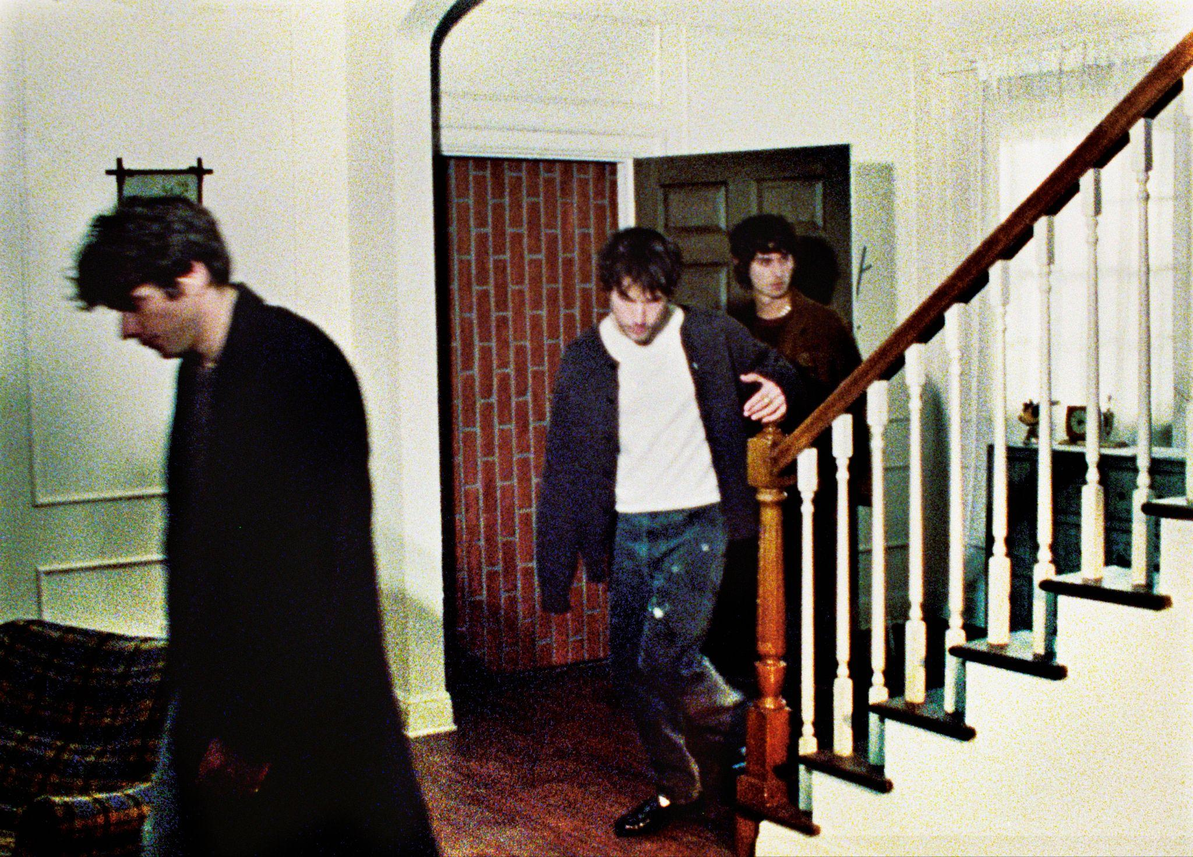
CREDIT AIDAN ZAMIRI // DOWNLOAD HI-RES PRESS IMAGE + ARTWORK ​
Multi-platinum alt-rock trio Wallows makes a bold return to music with "Your Apartment," available now HERE. Sonically frenetic and lyrically introspective, the track is the band’s first new release since their 2022 Sophomore album Tell Me That It’s Over.
The band says, “We’re so excited and eager to be releasing music for the first time in nearly two years. It’s the longest we’ve been silent and it feels good to finally be back. This is the first song from our new album that fully came together lyrically quite some time ago now, so it feels right that it gets heard first.”
Co-written by Wallows and Nate Mercereau (Andre 3000, Shawn Mendes) and produced by previous Wallows collaborator John Congleton (St. Vincent, Sharon Van Etten), the highly anticipated single is accompanied by an official music video directed by Nina Ljeti – WATCH HERE.
In addition to their latest single release, Wallows celebrates a monumental achievement as their hit single "Are You Bored Yet? (Feat. Clairo)" recently achieved triple Platinum certification in the United States. Originally featured on their debut album Nothing Happens (which has also been certified Gold), the song continues to resonate with audiences worldwide and amassing Gold/Platinum certifications in over 10 other countries.
MORE ON WALLOWS:
Wallows (composed of Dylan Minnette, Braeden Lemasters and Cole Preston) have been best friends since the age of 11. They began playing music together in the LA music program Join the Band almost two decades ago and haven’t stopped since. In March 2022, the band released their Sophomore album, Tell Me That It’s Over, produced by 3x GRAMMY Award-winner Ariel Rechtshaid (Vampire Weekend, Haim, Adele). TMTIO saw Wallows continuing on their ever-evolving journey of sonic exploration, fusing a vast array of musical ideas – from lo-fi post-punk and indie-folk to early ’90s dance-pop psychedelia – into their own one-of-a-kind creative vision.

TMTIO marked the full-length follow-up to Wallows’ hugely popular 2019 debut album, Nothing Happens, produced by GRAMMY Award-winner John Congleton (St. Vincent, Sharon Van Etten). The album proved to be one of that year’s highest streamed debuts. In the live space, Wallows have headlined sold out shows around the globe and have performed at marquee festivals such as Coachella, Lollapalooza, Reading and Leeds, and more. With new music now here, stay tuned for news on their return to the stage.

CONNECT WITH WALLOWS
WALLOWSMUSIC.COM I FACEBOOK I TWITTER I YOUTUBE I INSTAGRAM | TIK TOK | PRESS SITE

PRESS CONTACTS
COREY BREWER | COREY.BREWER@ATLANTICRECORDS.COM
KELLY MCWILLIAM |KELLY.MCWILLIAM@ATLANTICRECORDS.COM
GABRIELLE REESE | GABRIELLE.REESE@ATLANTICRECORDS.COM

