ATLANTIC RECORDS ANNOUNCES THE SIGNING OF RISING RAP SENSATION, BABYFXCE E, AND COMMEMORATES WITH THE RELEASE OF ‘THE X TAPE DELUXE’, OUT TODAY

DOWNLOAD HI-RES IMAGE

FLINT, MI LYRICIST NAMED ONE OF AUDIOMACK’S “10 RAPPERS YOU SHOULD KNOW RIGHT NOW” AND APPLE MUSIC’S “ARTISTS YOU NEED TO KNOW”

LISTEN TO THE 'X TAPE DELUXE’ HERE
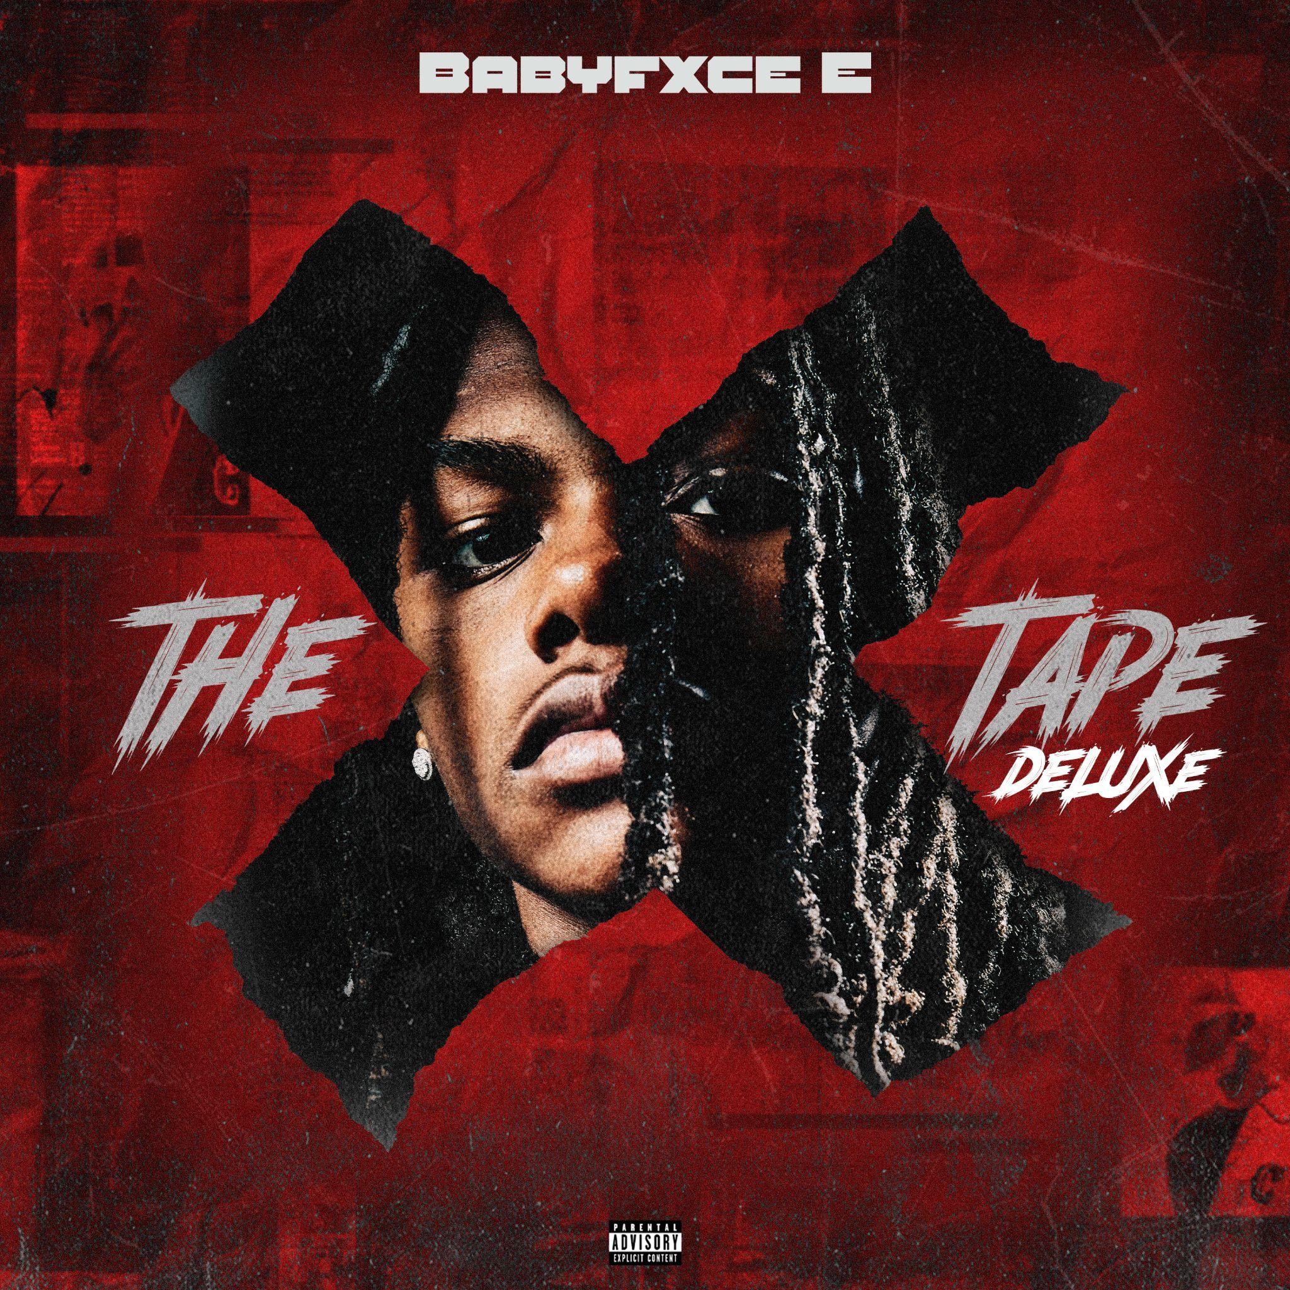
DOWNLOAD HI-RES ARTWORK

CATCH E’S APPEARANCES ON:
From The Block (Freestyle)
Bodega Talks
trshmag
In The Field
Back of the Class
Major Stage
On The Radar

Today, Atlantic Records has announced the signing of the incredibly talented, star-in-the-making, Babyfxce E. The announcement comes with the unveiling of the deluxe version of his previous release, The X Tape. The 9 track mixtape is available now HERE.

Babyfxce E started the year off strong, earning a spot in Apple Music's Artists to Watch program as well as being named one of Audiomack’s “10 Rappers You Should Know Right Now.” Hailing from Flint, MI, the rapper has already accumulated over 25 million streams, landing him on major playlists like Spotify’s Rap Caviar and being named The Source’s Track of the Week. Babyfxce E has received accolades from tastemakers such as Akademiks and has earned critical acclaim from publications like Pitchfork and The FADER.

His recent video for "Kentucky Love'' with Bfb Da Packman and KrispyLife Kidd was trending in the Top 20 on YouTube after release and remained in the Top 30 for multiple weeks. E took the stage as direct support to Luh Tyler on his My Vision Tour and opened up for OHGEESY on his “GW2'' Tour @ The Shelter in Detroit, MI. He can currently be seen as direct support on tour with BabyTron.

The X Tape (Deluxe) Tracklist:
- Tell The Truth
- Full Body K
- Keep It P ft. Lil Darius
- Ready
- Mama Said ft. Sleazy World
- County Time
- Feds Watching
- It's Us ft. Luh Tyler
- Meet Me At The Top

E’s undeniable delivery balances unbreakable bars with unpredictable melodies, placing him in a lane of his own out of the Midwest and on his way towards a mainstream breakthrough at full speed. After stacking up millions of streams and views and notching critical acclaim, he adopts the mindset of his hometown to tell an underdog story all his own.
“If you're from Flint, you're just a strong-minded person, for real. “We’ve got a lot more to prove than everybody else does. The music scene can be tough, and you know the struggle in general. If you can make it here, you can make it anywhere.”
Though E primarily resided with his mother, sister, and two brothers on the North side of Flint, he maintained a close relationship with his dad. Pops frequently brought him on fishing and hunting trips, giving his son an appreciation for the outdoors. Beyond a passion for the woods, he embraced hip-hop as a kid. He not only listened to the likes of YoungBoy Never Broke Again and Lil Baby, but he also studied Michigan heavyweights a la Rio Da Yung OG, Sada Baby, and Tee Grizzley. At the urging of a close friend, he stepped into the recording booth for the first time and left his buddies impressed with the results in 2021.
At the top of 2022, he initially gained traction with “Six Flags.” It paved the way for projects such as Life Of The Reaper and Its Wit a X. The latter boasted the standout “D Rose,” which generated 1.1 million YouTube views and counting. Of the latter, The FADER raved, “The punchlines come flying at such a rapid pace you’ll feel like you ended up in a boxing gym.” He carried this momentum into 2023 with “Master P,” “Last Laugh,” a show stopping turn on BabyTron’s “Waffle House,” “Hypebeast,” and “12:45 in Detroit,” which Pitchfork noted “feels like a breakout track; you’ll have a new favorite punchline every time you listen.”
# # #
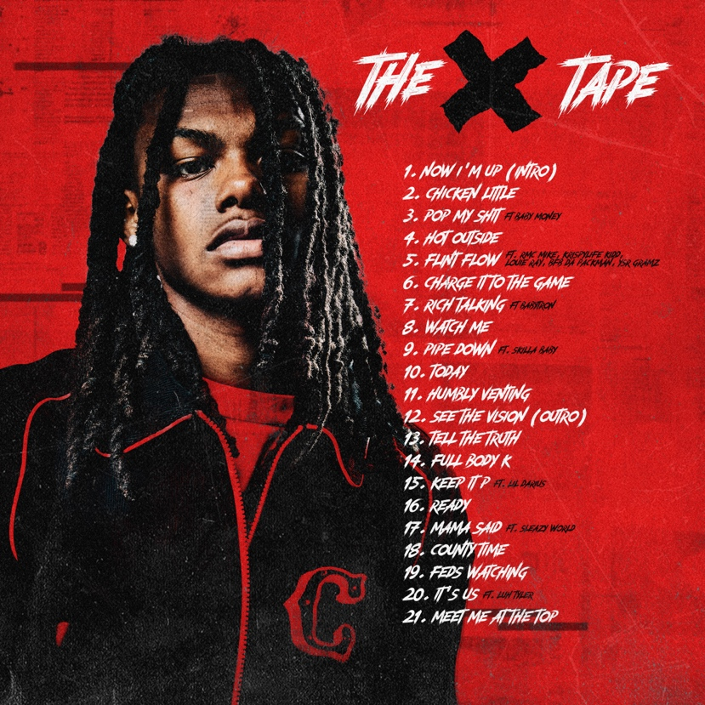
DOWNLOAD HI-RES ARTWORK

# # #

CONNECT WITH BABYFXCE E:
INSTAGRAM | TIKOK |YOUTUBE | TWITTER | WEBSITE

FOR ALL BABYFXCE E PRESS INQUIRIES, PLEASE CONTACT:
COREY BREWER | COREY.BREWER@ATLANTICRECORDS.COM

