FOR IMMEDIATE RELEASE
MARCH 15, 2024

GLOBAL SUPERSTAR CARDI B IS HERE WITH HER SECOND RELEASE OF THE MONTH “ENOUGH (MIAMI)”

ACCOMPANIED BY A HIGH-OCTANE COMPANION VISUAL SHOT IN MIAMI

FOLLOW-UP TO CARDI’S VIRAL “LIKE WHAT (FREESTYLE)” RELEASED EARLIER THIS MONTH

COMES ON THE HEELS OF HER ICONIC APPEARANCE AT THE LEGENDARY VANITY FAIR
OSCARS AFTER PARTY

WATCH/SHARE “ENOUGH (MIAMI)”
DOWNLOAD/STREAM “ENOUGH (MIAMI)”

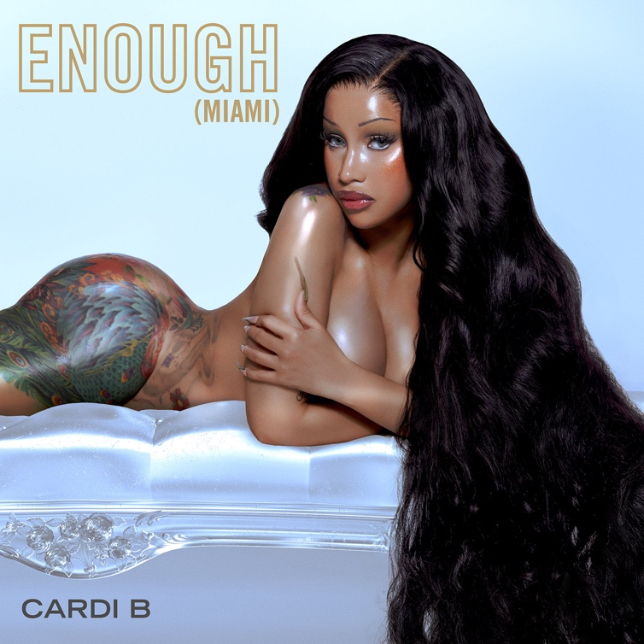
Photo Credit: Brian Ziff
DOWNLOAD HI-RES ARTWORK

GRAMMY® Award-winning, Diamond selling superstar Cardi B is here with her latest release “Enough (Miami).” The blazing track is a street anthem in the making and the perfect record to kick off the spring break season. “Enough (Miami)” is accompanied by a high-octane companion visual (directed by: Patience Harding) and comes on the heels of Cardi’s earlier release this month, “Like What (Freestyle).” Prior to the release of “Enough (Miami),” Cardi released a viral teaser that now has accumulated 27.5M+ views, 4.5M+ likes, 44K+ comments, 231.5K+ favorites, and 9K+ creates via TikTok and still growing quickly.

Both records serve as the follow-up to last year’s iconic collaboration with Megan Thee Stallion, “Bongos.” Prior to “Bongos,” the pair released the historic and viral sensation, “WAP.” “WAP (Feat. Megan Thee Stallion)” affirmed Cardi B as one of Apple Music’s most popular artists of all time, earning the platform’s highest-ever debut by a female artist as well as the fastest song in Apple Music history by a female artist to peak at #1. It also went on to go #1 on the Billboard Hot 100 and peaked at #1 on rhythmic radio and peaked at #2 on urban radio. “WAP” also won Favorite Song - Rap / Hip-Hop at the American Music Awards and won Best Collaboration and Video of the Year at the BET Awards. It was also nominated for Collaboration of the Year at the American Music Awards, nominated for five categories at the MTV Video Music Awards, and nominated for Best Music Video at the iHeart Music Awards. The visual has now reached over 523M views and the audio now has over 3.2B streams.

Cardi B is among the most significant musical artists of all time, regardless of genre, gender, or generation- all accomplished in less than a decade. Some of her accolades include the most #1 singles (5) on the Billboard Hot 100, the first lead artist to top the Billboard Global 200 with an album that has sold 100M certified units, the most diamond-certified songs (3) by the RIAA, and the most songs with a billion streams on Spotify including the most-streamed female rap album. In 2023, Cardi is staying quite active with her feature in a Beats By Dre ad last May and her collaboration with Whipshots saw a new flavor release for the fall: Pumpkin Spice. Cardi and Offset also appeared in McDonald’s 2023 Super Bowl Commercial, announcing the first-ever celebrity duo meal.

# # #

ABOUT CARDI B

Cardi B is among the most significant musical artists of all time, regardless of genre, gender, or generation- all accomplished in less than a decade. Among her seemingly unstoppable list of accomplishments, she stands as the highest-certified female rapper of all time on the RIAA’s “Top Artists (Digital Singles)” ranking, the female rap artist with the most RIAA diamond certifications, and the only female rapper with multiple billion-streamers on Spotify, where her chart-topping, GRAMMY® Award-winning, 4x RIAA platinum-certified debut album, Invasion of Privacy, remains the most streamed album by a female rap artist to date. All 13 tracks on Invasion of Privacy are now certified at least Platinum, and the smash 2018 album also includes the history-making Diamond-certified “Bodak Yellow.” Her extensive list of awards, nominations, and high-profile honors currently includes nine total GRAMMY® Award nominations, eight Billboard Music Awards, six Guinness World Records, five Spotify One Billion Streams Awards, two ASCAP Songwriter of the Year Awards, eight ASCAP Pop Music Awards, 23 ASCAP Rhythm & Soul Music Awards, six American Music Awards, four MTV Video Music Awards, three iHeartRadio Titanium Awards, six BET Awards, 14 BET Hip Hop Awards, inclusion on TIME’s “TIME100: The 100 Most Influential People of 2018,” being named Entertainment Weekly’s 2018 “Entertainer of the Year” and Billboard’s 2020 “Woman of the Year,” along with countless other triumphs. Last year, she was named as iconic lifestyle brand Playboy’s first-ever Creative Director in Residence and founding member of Playboy’s creator-led platform. Since then, Cardi B’s has been on countless features including Platinum-certified single, “Tomorrow 2” with Glorilla, and Gold-certified “Put It On The Floor” with Latto.

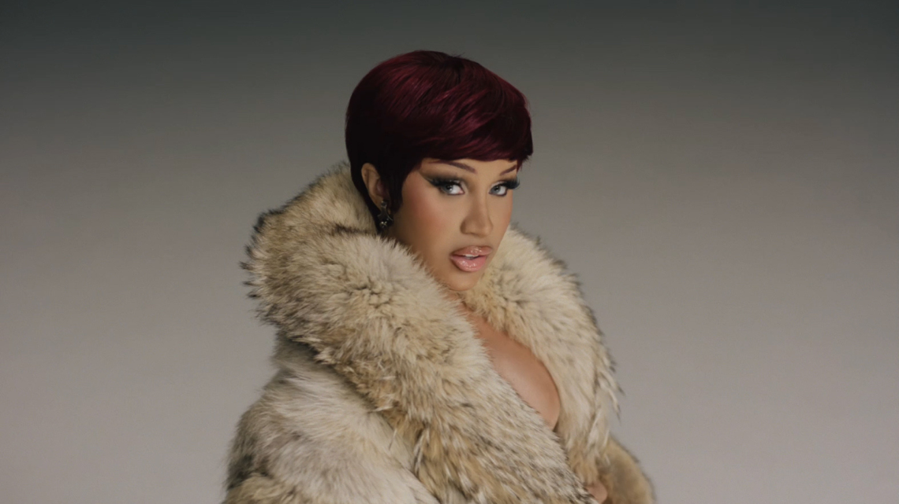

CONNECT WITH CARDI B:
CARDIBOFFICIAL.COM | TWITTER | INSTAGRAM | SOUNDCLOUD | ATLANTIC RECORDS

PRESS CONTACT:
Ashley Kalmanowitz | Ashley.Kalmanowitz@atlanticrecords.com

