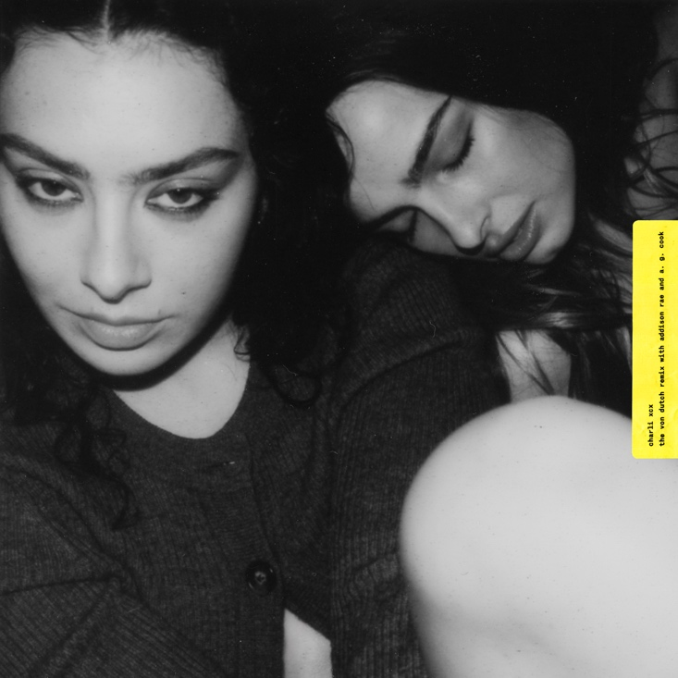

“The push-and-pull between vulnerability and braggadocio is at the heart of XCX6” - The FACE

Charli XCX today releases ‘The Von dutch Remix with Addison Rae & A. G. Cook’.

You can listen HERE.

The effervescent rework of Charli’s recent smash hit single maintains the frenetic energy of the original with A. G. Cook’s signature brand of idiosyncratic production adding a new dimension to proceedings while Charli and Addison go back and forth on vocals.

‘Von dutch’, the brash and synth heavy first taste of Charli’s highly anticipated new album ‘BRAT’, arrived last month to much acclaim, being named ‘Best New Track’ by Pitchfork and described as “delightfully rambunctious” by Billboard. You can watch the Torso-directed video HERE.

Charli’s sixth studio album ‘BRAT’ is the eagerly awaited follow up to 2022’s ‘CRASH’, which reached number 1 on the UK’s official album chart, and promises to be an exhilarating club record built around high art references and social commentary: a new era both musically and visually. You can pre-save ‘BRAT’ HERE and pre-order the vinyl HERE.

Last month saw Charli throw a momentous Boiler Room in New York’s Brooklyn to launch her new campaign with A. G. Cook, George Daniel, EASYFUN and Doss. The show broke the record for the most ever RSVPs to a Boiler Room event, with over 40k people registering to attend. Featuring special guest appearances from the likes of Addison Rae and Julia Fox, the show has easily become one of the viral moments of the year and found the likes of PAPER Magazine lavishing praise on the “sweaty, floor-rattling rave we’ll be referencing for years to come”.

Alongside her new album, Charli has been working on multiple film & TV projects following the breakout success of her Barbie soundtrack contribution ‘Speed Drive’ last year. She is co-executive producing the score for the A24 film ‘Mother Mary’ with Jack Antonoff and also producing original music for Benito Skinner’s series ‘Overcompensating’ on Prime Video. In addition, Charli will star in the Daniel Goldhaber remake of 1978 cult horror film ‘Faces of Death’.

Avant-pop and electronic superstar Charli XCX has become an iconic figure in the arts, having helped expand the landscape of popular music over the last decade by seamlessly traversing the underground and mainstream with her artistic output. Over the course of a trailblazing career, the multi-hyphenate creative has earned critical acclaim for her innovative style and entrepreneurial spirit and seen her forward-thinking approach reshape pop culture in the process.

Her lasting impact was cemented last year when Charli was honoured with the Visionary Award at the annual Ivor Novellos in London, while she also received the Powerhouse Award at Billboard’s Women In Music ceremony earlier this month in Los Angeles.

Charli XCX assets can be found HERE.

##

https://www.instagram.com/charli_xcx/
https://twitter.com/charli_xcx

