FOR IMMEDIATE RELEASE
MARCH 1, 2024

FOREST BLAKK ANNOUNCES UNDONE (LOVE & LOSS) EP
+ NEW SONG “YOU WERE MINE” OUT NOW

NEW EP FROM ACCLAIMED SINGER/SONGWRITER & “PATRON SAINT” OF LOVE IS BLIND ARRIVES APRIL 19TH VIA ATLANTIC RECORDS

JOINING JAMES ARTHUR ON BITTER SWEET LOVE TOUR ACROSS ALL U.S AND CANADA DATES - KICKING OFF APRIL 30TH IN OAKLAND, CA

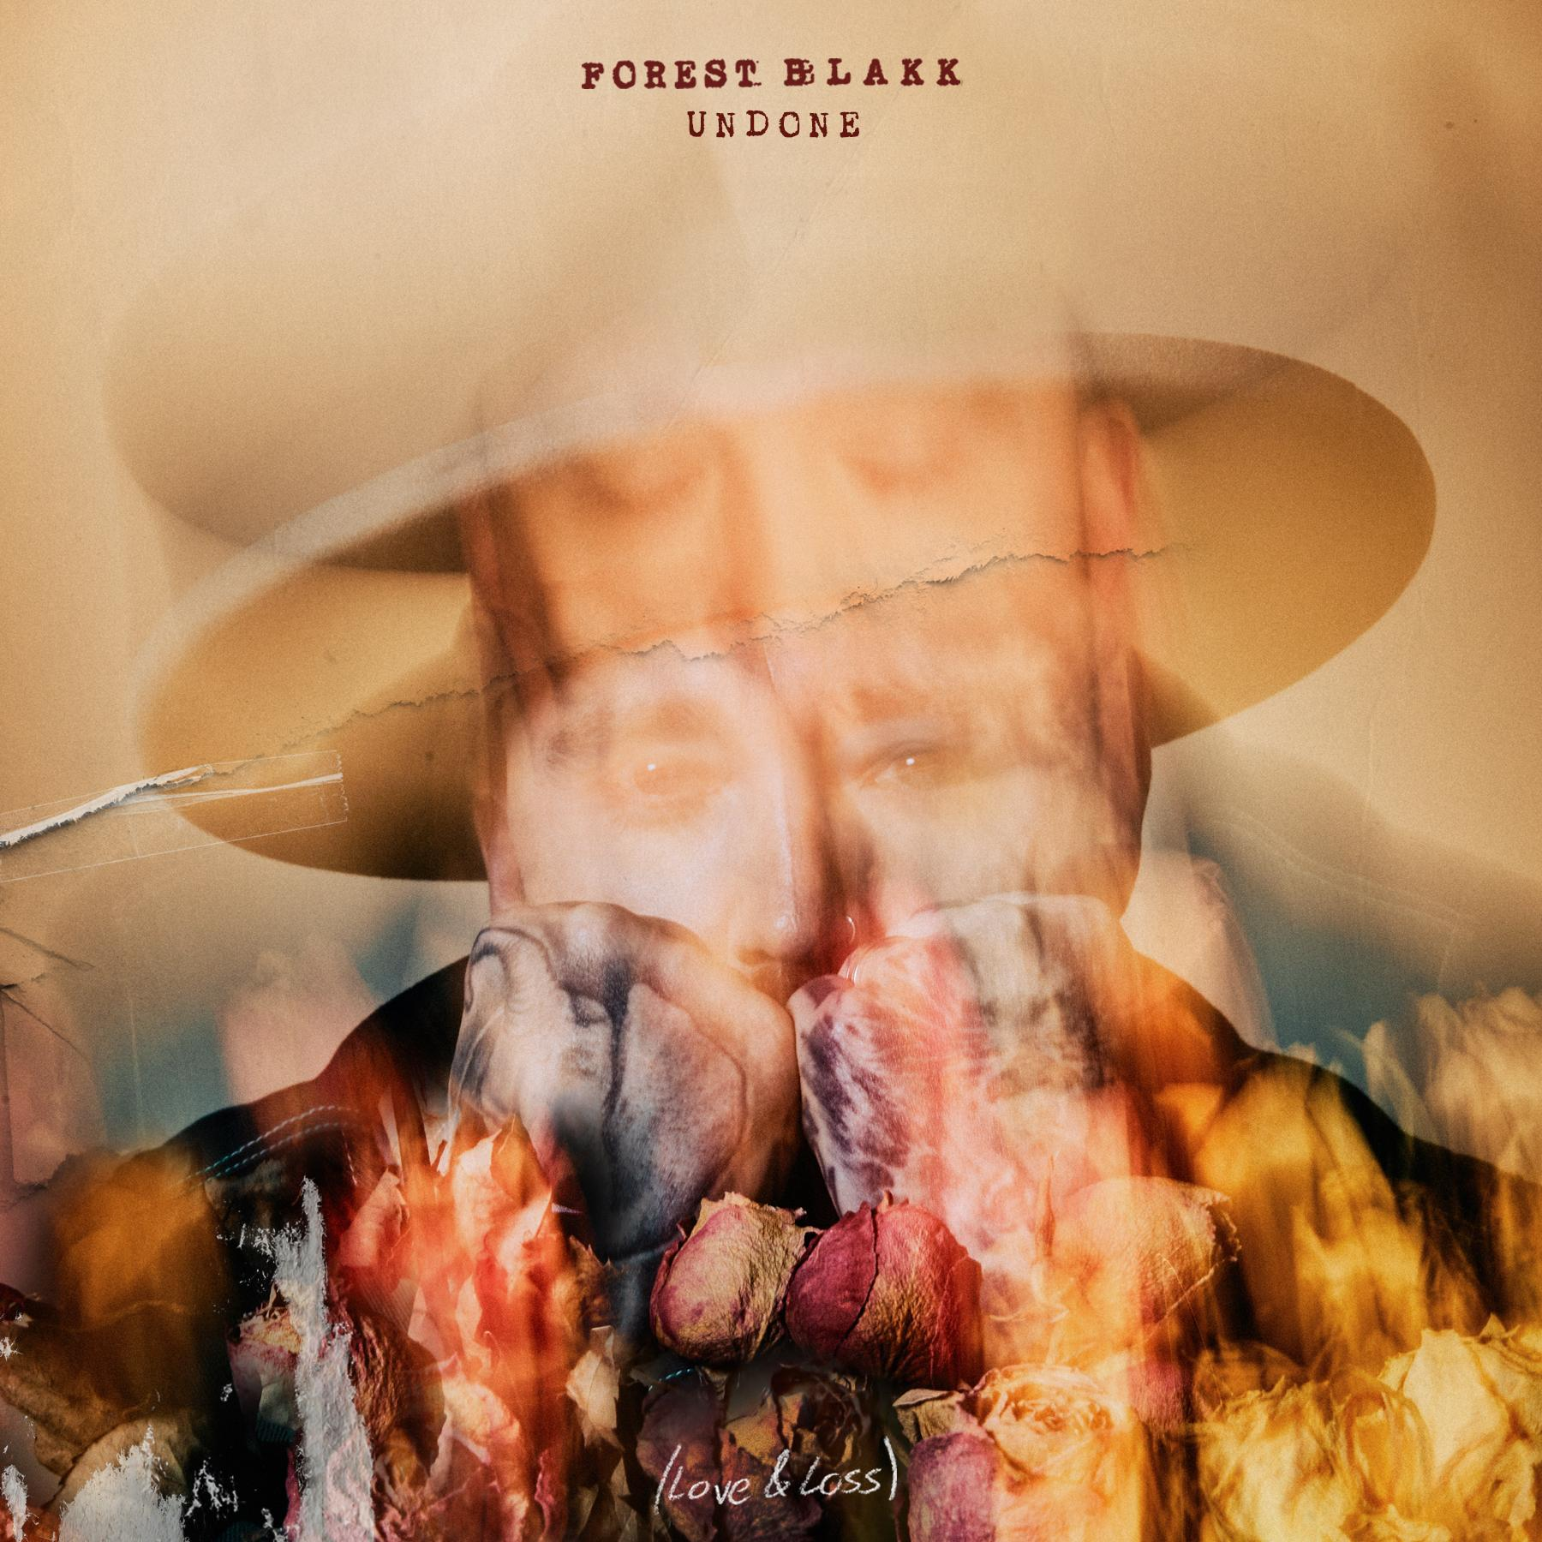
DOWNLOAD HIGH-RES IMAGES/ART HERE

STREAM “YOU WERE MINE”: LINK
PRE-SAVE UNDONE (LOVE & LOSS) EP: LINK

‘“You Were Mine" is a song born from the ache of losing a dear friend of mine, far too soon. It’s a song for everyone who has ever lost someone they deeply loved and cared about. Each lyric echoes the pain that still lingers, the questions that remain unanswered, and the overwhelming flood of emotions that we continue to grapple with. But amidst the sorrow, there's solace in the memories of those very people. Each one of those memories wraps around us like a warm blanket, offering comfort in the times we miss them most. I suppose grief can sometimes be seen as a gift, never letting us lose sight of those who once graced our lives. To my dearest Lissy, I was lucky you were mine!”- FOREST BLAKK

Acclaimed singer/songwriter Forest Blakk has announced his new EP Undone (Love & Loss), arriving April 19th via Atlantic Records. Previewed today by touching new track “You Were Mine,” the collection will also include recently released single “Love Somebody Again” – both of which are slated to join much of Blakk’s discography as featured music on Netflix’s Love Is Blind next week. Blakk’s catalog has become somewhat of a sonic-staple, with him having been named the “patron saint” of the show by creators with the Los Angeles Times pointing out “(Blakk’s) earnest mid-tempo love songs turn up on ‘Love is Blind’ nearly as often as hosts Nick and Vanessa Lachey.”

Next month will see Blakk join James Arthur as direct support on his Bitter Sweet Love Tour across the United States and Canada, kicking off April 30th in Oakland, CA with stops in Los Angeles, CA at The Wiltern on May 1st and New York City at Central Park/Rumsey Playfield on May 17th . For full routing visit forestblakk.com/tour.

Blakk has spent his career soundtracking love stories of all kinds, most recently including his own with “Love Somebody Again” and “I Choose You” – the latter having arrived just days after his Nashville wedding to Tooley Jones in a beautiful ceremony covered exclusively by PEOPLE Magazine (read here). Both songs followed 2022’s intimate and relatable Every Little Detail EP, having featured his breakout Platinum-certified smash single “If You Love Her,” which alone has amassed over 470 million total global streams, earned Blakk his official US chart debut on Billboard’s Emerging Artists chart, his national US TV debut on ABC’s Live with Kelly & Ryan, top 30 placement on the Hot AC radio chart & saw the singer/songwriter collaborate with Meghan Trainor on a stunning duet version. Meanwhile, Blakk’s follow-up single “Fall Into Me” (co-written alongside Matchbox Twenty front man Rob Thomas and Gregg Wattenberg) reached top 30 on the Hot AC radio chart and Gold-certification status in his native Canada, in addition to being featured in a perfectly fitting ad campaign for Kay Jewelers.

Highlighted as one of PEOPLE Magazine’s “talented emerging artists making their mark on the musical landscape” and deemed an “artist on the rise” by Billboard, Blakk made his debut with his 2018 EP Minutes and follow-up 2020 sophomore EP Sideways – the latter of which saw Blakk collaborate with the likes of Will IDAP (Train, Florida Georgia Line), Nick Long (King Princess), Carl Ryden (Ricky Martin, David Guetta), Ollie Green (Freya Ridings, Gavin James) & more to tell a love story through an incredibly realistic and candid lens. The 6-track collection featured singles “I Wish I Knew” (deemed an “introspective look at love and love lost” by American Songwriter) and uplifting anthem of resilience “Put Your Hands Up,” which debuted on an episode of ABC’s Grey’s Anatomy. A compelling live performer, Blakk has toured extensively supporting NEEDTOBREATHE, Gavin James, Dean Lewis & earlier this year embarked on a sold out 17-date North American headline tour.

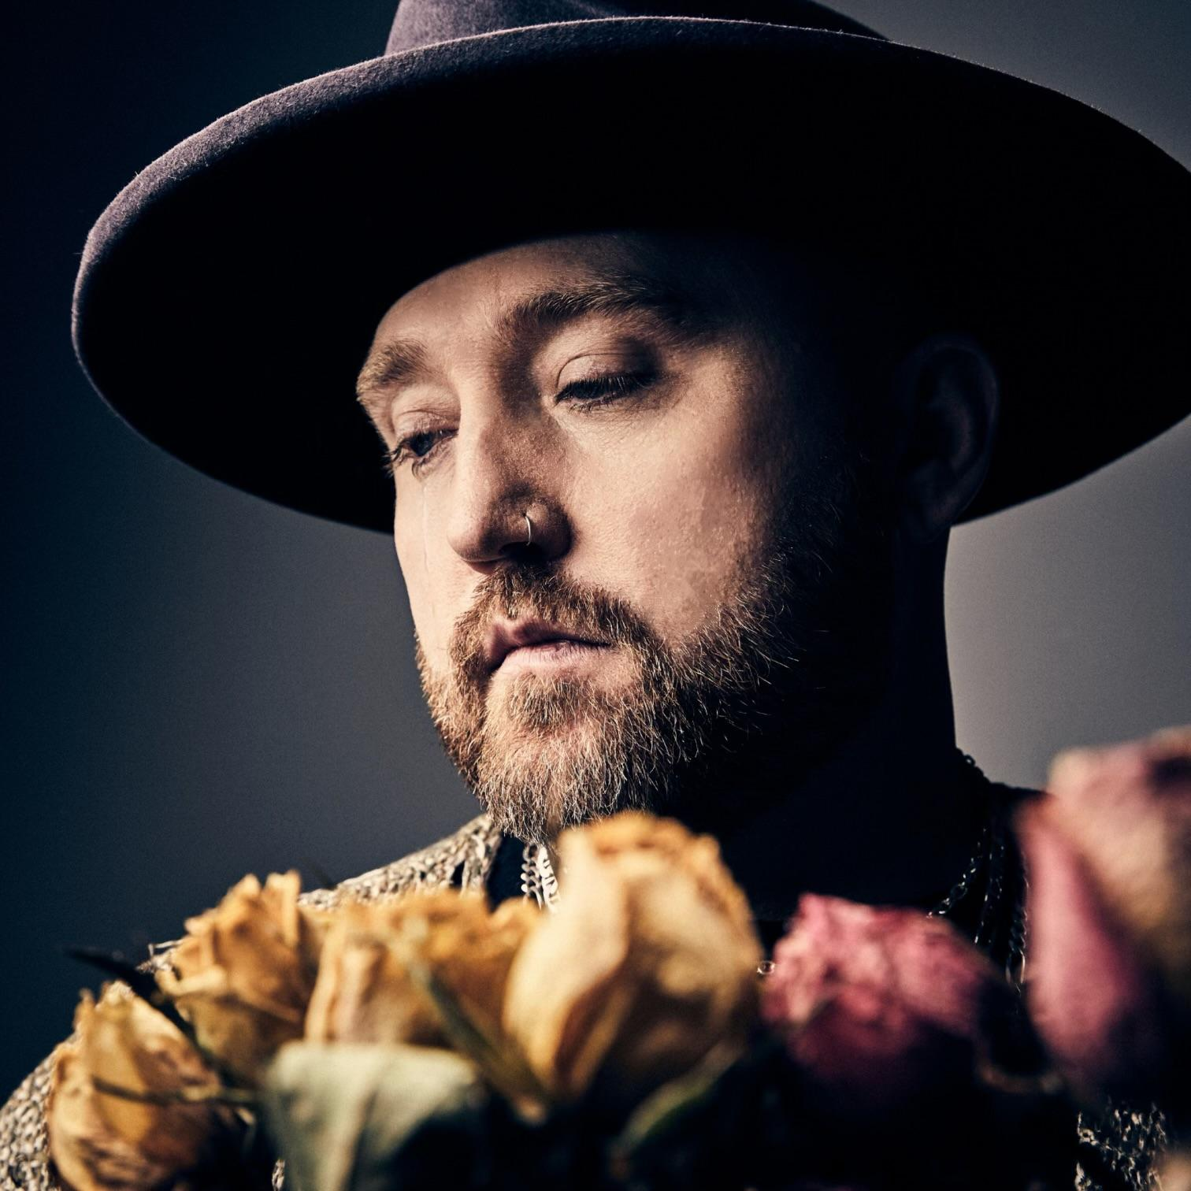
DOWNLOAD HIGH-RES IMAGES

CONNECT WITH FOREST BLAKK:
FORESTBLAKK.COM |TIKTOK | TWITTER | FACEBOOK | INSTAGRAM | YOUTUBE | PRESS ASSETS

CONTACT:
TED.SULLIVAN@ATLANTICRECORDS.COM

