FOR IMMEDIATE RELEASE
MARCH 1, 2024 (9a EST)

GALANTIS, DAVID GUETTA & 5 SECONDS OF SUMMER RELEASE “LIGHTER”

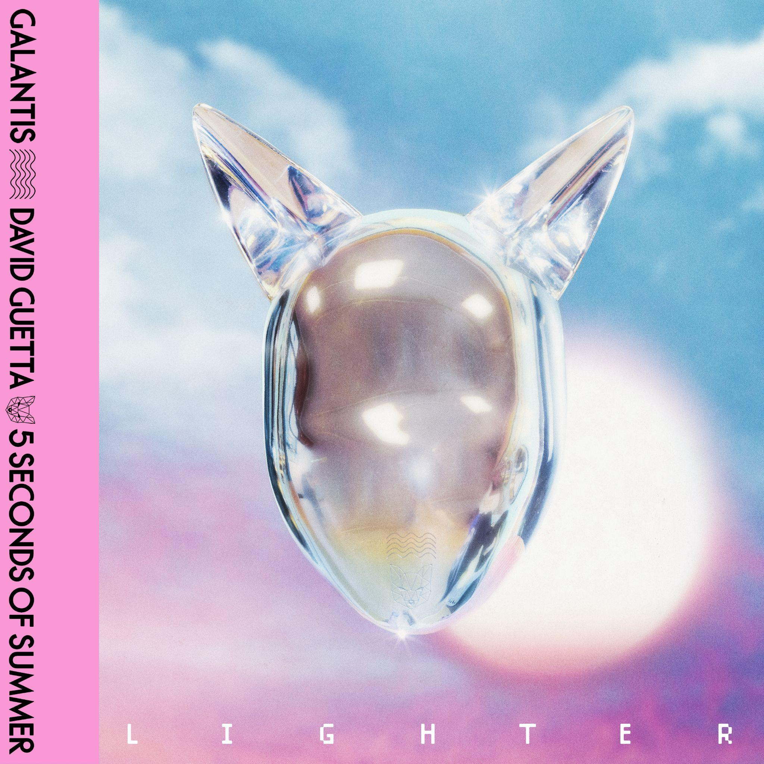
DOWNLOAD HIGH-RES IMAGES/ARTWORK

STREAM “LIGHTER”: https://galantis.lnk.to/Lighter

“one of the most influential and untamed voices in modern music” – GRAMMY.com

Internationally-acclaimed dance music powerhouse Galantis, superstar DJ/producer David Guetta & multi-platinum pop-rock band 5 Seconds of Summer have joined forces for new single “Lighter.” The soaring collaboration (available now via Big Beat Records) has created an incredible buzz among fans on social media over the past week, teased via a viral mailing of mysterious red dice and title-revealing candles to superfans around the world. The single marks the first new music release from 5 Seconds of Summer in over a year and hot on the tail of David Guetta’s record-breaking hits with the likes of Kim Petras, Bebe Rexha & more.

“Lighter” marks yet another massive team up between Galantis and David Guetta, notably following their gold-certified collaborative single “Heartbreak Anthem” with Little Mix that proved a global sensation, spending 10 weeks on the Billboard Global 200 chart and 13 consecutive weeks in the top 10 on the UK Official Chart.

“‘Lighter’ is a special song because the creative momentum between myself, David and 5SOS aligned so well – we let the collaboration flow into a piece of music that feels emotional and timeless. Michael (Clifford) is such a music lover very much like me, and working closely with him on producing the live elements like strings, guitar and drums was very inspiring. And it’s always great working with David, after the amazing response we had with ‘Heartbreak Anthem’ it’s exciting to be putting out another big record together.” – Christian Karlsson (Galantis)

2023 saw the release of a blockbuster collection of singles and collaborations from Galantis, ushering in a hotly anticipated fourth album era which will mark the first full-length since 2020’s Church. “Lighter” follows “Dreamteam” with Neon Trees and “Little Bit Yours” with Hannah Boleyn, the latter of which is currently charting #13 on US Dance radio. The album is also due to feature “Koala” which was declared “another dance hit” by American Songwriter and “BANG BANG! (My Neurodivergent Anthem)” which Rolling Stone praised as “an upbeat festival-ready banger” alongside a candid statement from Christian Karlsson revealing his ADHD diagnosis and neurodivergent journey.

One of dance music's most dynamic and in-demand live performers, Galantis has sold out countless venues around the world and has thrilled crowds across the global festival circuit. This year will mark the third-annual return to Brooklyn Mirage for Midsommar on June 22nd and 23rd following Miami Music Week performances at DAER Nightclub on March 23rd and Surfcomber Hotel on March 24th. For full live routing and ticket information please visit wearegalantis.com/tour.

***

ABOUT GALANTIS:
Galantis is the dance music project of Christian Karlsson (aka Bloodshy). Their RIAA gold-certified debut album Pharmacy reached No. 1 on the Billboard Dance album chart on the strength of gold-certified single “Peanut Butter Jelly” and 3x platinum certified smash “Runaway (U & I)” – the latter of which earned a GRAMMY nomination for “Best Dance Recording” – while 2017’s sophomore album The Aviary (featuring platinum-certified single “No Money”) saw a top 10 debut in 23 countries. The third Galantis album, 2020’s Church, featured the chart-topping gold-certified single “Faith” with country music icon Dolly Parton featuring Mr. Probz, which saw a #1 debut on Billboard’s Dance/Electronic Chart before quickly reaching #1 on the Dance/Mix Show Airplay Chart where it remained for 5 weeks. Meanwhile, gold-certified collaborative single “Heartbreak Anthem” with David Guetta & Little Mix proved a global sensation, spending 10 weeks on the Billboard Global 200 chart and 13 consecutive weeks in the top 10 on the UK Official Chart. Galantis has received over 5 billion cumulative worldwide streams and over 1.8 billion video views to date.

Karlsson has been at the helm of Galantis since 2009 before officially debuting the project at 2014’s Coachella Valley Music and Arts Festival. His career has spanned across the musical genres of punk-rock, hip-hop and pop – including work as one half of acclaimed production duo Bloodshy & Avant and one third of indie pop band Miike Snow. Karlsson’s songwriting/production credits have included the likes of Madonna, Kylie Minogue, Katy Perry and extensive work with Britney Spears (including “Toxic” which earned a GRAMMY for “Best Dance Recording” and her widely acclaimed 2007 album Blackout). As Galantis, he has crafted remixes for the likes of Coldplay, Selena Gomez, Ed Sheeran, Sam Smith & more. Declared “pop’s mastermind producer” by UPROXX, “eternally effervescent” by Billboard and “one of the most influential and untamed voices in modern music” by GRAMMY.com, the Swedish-born artist continues to evolve and push the boundaries of songwriting within the world of dance music and beyond.

​​ABOUT DAVID GUETTA:
DJ/producer/artist David Guetta is a musical trailblazer and an international icon. Currently the #4 most streamed artist on Spotify globally with 2x GRAMMY Awards, 13x GRAMMY nominations, 7x UK number 1 singles, over 40 billion global streams, 50 million records sold worldwide, and over 70 million monthly Spotify listeners to his name, he has been voted the world’s best DJ in the DJ Mag ‘Top 100’ four times and won the accolade for best electronic artist at the MTV Europe Music Awards. The French producer has collaborated with some of the world’s biggest stars including SIA, Nicki Minaj, Rihanna, Justin Bieber, Black Eyed Peas, Shakira, Ariana Grande, Kid Cudi, J Balvin, Becky Hill, RAYE and many more. Additionally, he was named #1 Producer by 1001Tracklists, as well as this year he won ‘Producer of the Year’ award by the BRITs in recognition of his production successes. As he continues to dominate the global charts and play some of the most exciting sets of his career, all while expanding his creative vision, exploring new sounds and evolving as an artist, David Guetta demonstrates time and time again why he is the most cherished electronic artist of our generation.

ABOUT 5 SECONDS OF SUMMER:
Hailing from Sydney, Australia, 5 Seconds of Summer (5SOS) comprised of Luke Hemmings (vocals/guitar), Michael Clifford (vocals/guitar), Calum Hood (vocals/bass) and Ashton Irwin (vocals/drums) have brought pure rock energy to pop music over the past 12 years, releasing 5 number one albums, selling over 15 million units and 6 million concert tickets globally. While rooted in pop punk DNA, 5SOS have pushed the boundaries of traditional alternative pop music, taking influencers from wide-spanning genres throughout their career which is reflected sonically in the unique music they make. 5SOS continue to bring a new wave of depth and dimension to their industrial and harmony-driven sound and are always evolving their music with every album they release.

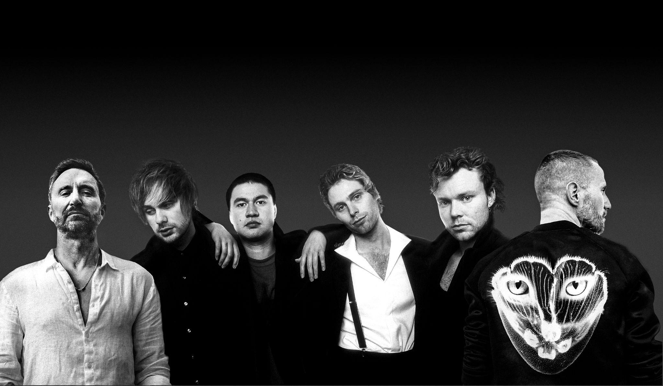
DOWNLOAD HIGH-RES IMAGES/ARTWORK

CONTACT:
Ted Sullivan | Ted.Sullivan@atlanticrecords.com

