MELANIE MARTINEZ ANNOUNCES EU/UK LEG OF THE TRILOGY TOUR

DATES BEGIN SEPTEMBER 18 IN DUBLIN, IRELAND

AMBITIOUS LIVE RUN TO SHOWCASE EVOLUTION OF MARTINEZ’S ALTER EGO “CRY BABY” PERFORMED LIVE, INCLUDING HITS FROM ALL THREE OF HER GROUNDBREAKING TOP 10 ALBUMS: CRY BABY, K-12, AND PORTALS

PRESALES BEGIN MONDAY, MARCH 25 AT 10AM (LOCAL)
GENERAL ONSALE BEGINS THURSDAY, MARCH 28 AT 10AM (LOCAL)

COMPLETE DETAILS AVAILABLE NOW AT WWW.THETRILOGYTOUR.COM

NORTH AMERICAN DATES GET UNDERWAY MAY 10
AT SEATTLE, WA’S CLIMATE PLEDGE ARENA

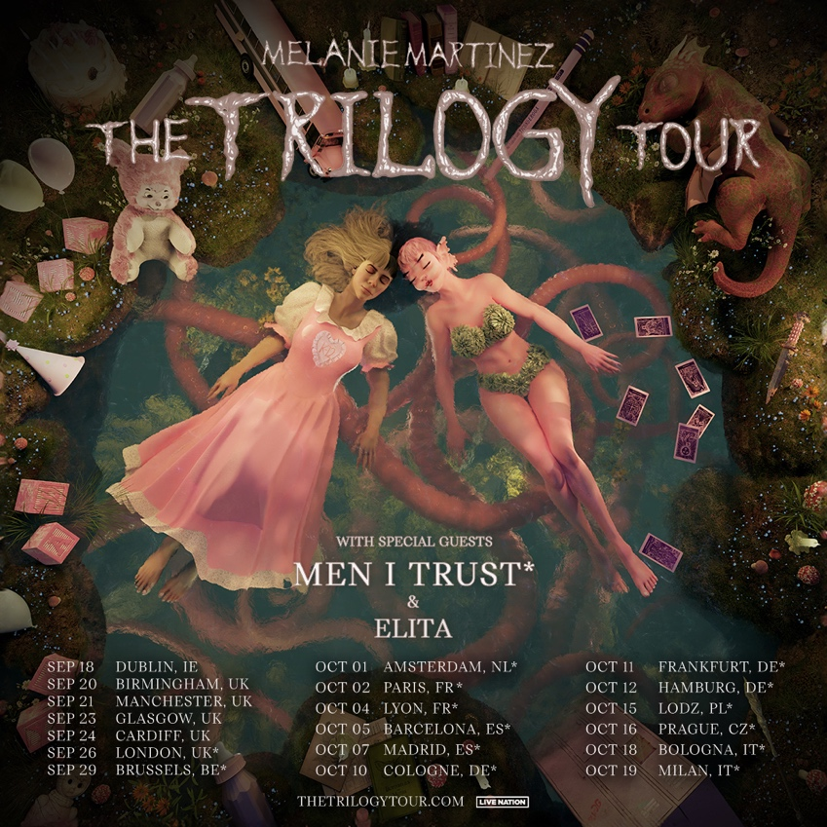
DOWNLOAD HI-RES ADMAT + PRESS PHOTOS

Multiplatinum alternative-pop phenom Melanie Martinez has announced the eagerly awaited EU/UK leg of The Trilogy Tour, getting underway September 18 at Dublin, Ireland’s 3Arena and then visiting the UK, Belgium, the Netherlands, France, Spain, Germany, Poland, Czech Republic, and Italy through mid-October. Support includes Men I Trust on select dates and Elita across the whole tour.

Fans can visit TheTrilogyTour.com now to sign up for presale access. Artist presales begin Monday, March 25 at 10am (local) and general on-sales start Thursday, March 28 (local). For complete details and ticket availability, please visit WWW.THETRILOGYTOUR.COM.

Her most ambitious concert tour to date, The Trilogy Tour will see the evolution of Martinez’s alter ego “Cry Baby” performed live, featuring hits from all three of her groundbreaking Top 10 albums, Cry Baby, K-12, and Portals, which have together earned over 14B worldwide streams to date. The Trilogy Tour officially gets underway May 10 at Seattle WA’s Climate Pledge Arena and then visits arenas across North America through late-June.

Mastercard cardholders have special access to presale tickets in France, Netherlands, Belgium & Italy starting from 10am on Tuesday 26th March. Preferred ticket access is available to Mastercard cardholders in the UK on Thursday 28th March at 10am. Visit www.priceless.com/music to find out more.

Martinez – who recently wrapped her acclaimed PORTALS Tour, which played to sold-out houses around the globe from last summer though February – will also be among the top stars performing at such annual festivals as Manchester, TN’s Bonnaroo (June 15), Chicago, IL’s Lollapalooza (August 1-4) and Montreal, QC’s Osheaga 2024 (August 2).

The PORTALS Tour celebrated the arrival of Martinez’s new album, PORTALS, available now in an expanded deluxe digital edition featuring three additional tracks HERE. Hailed by Rolling Stone as an “effortlessly inventive, mature record” from “an artist unafraid to start from scratch and tackle complex, difficult ideas,” the album proved Melanie’s highest charting debut on the Billboard 200 upon its March 2023 release, arriving at #2 with 142,000 equivalent album units earned in its first week – Martinez’s third consecutive Billboard 200 Top 10 album debut. PORTALS further debuted at #1 on Billboard’s “Current Alternative Albums,” “Current Pop Albums,” “Top Album Sales,” “Current Album Sales,” “Internet Albums,” “Digital Albums,” and “Top Alternative/Rock Albums” charts, along with a #2 debut on the “Top Vinyl Albums” chart. An instant global sensation, the album proved Martinez’s first #1 album debut in Australia, also landing at #1 in New Zealand, #2 in the UK, #3 in Canada and Ireland, and top 10 chart placements in Germany, The Netherlands, Belgium, and Spain.

PORTALS includes the hit singles, “VOID” and “DEATH,” both of which made history as Martinez’s first original songs to debut on the Billboard “Hot 100.” “DEATH” is joined by a cinematic companion video – directed, conceived, and costume designed by Martinez herself – which trended #1 on YouTube’s Trending “Top Music Videos” chart and now boasts over 36M official views. The song was first teased with a series of eerie clips revealing the rebirth of Martinez’s character “Cry Baby,” quickly sparking a frenzy of theories and garnering over 115M views across all socials. The track and its compelling companion visual earned praise from the likes of Billboard, which raved, “The avant-garde pop auteur creates bold, expansive worlds with each project…While the dramatic five-minute track can be connected to her artistic reawakening, the kinetic drums and electronic elements will also make listeners feel reborn, too.”

Martinez also recently partnered with boutique fragrance company Flower Shop Perfumes Co. to launch a new four-fragrance collection, Portals Parfums. With pre-sales launched at 11:00 a.m. on November 1, the direct-to-consumer scents completely sold out late the following evening, in less than 48 hours. Portals Parfums follows Martinez’s wildly successful 2016 debut fragrance, Cry Baby Perfume Milk, which quickly sold out and can now be found only on reseller platforms for up to $2,000 a bottle. Working with IFF perfumers Natasha Côté, Patty Hidalgo, and Laurent Le Guernec, Martinez was deeply involved in all aspects of development for the new fragrance collection. Much like Cry Baby Perfume Milk, which arrived creatively packaged in a replica vintage baby bottle, Portals Parfums comes in a striking art sculptured bottle at a full one-foot tall, with a many-eyed creature head that opens like a nesting doll to reveal four glass vials inside. Transporting the wearer to different worlds with just a little spritz, each unique scent is designed to reflect the four classical elements: Water of Intuition, Air of Clarity, Fiery Passion, and Earthy Abundance. Portals Parfums is currently sold out. To be informed of a restock and other product launches visit PortalsParfums.com. The Portals Parfums fragrance collection will serve as a foundation for other Portals products, including a broad collection of scented candles.

# # #

MELANIE MARTINEZ
THE TRILOGY TOUR

MAY
10 – Seattle, WA – Climate Pledge Arena
12 – Oakland, CA – Oakland Arena
14 – Palm Desert, CA – Acrisure Arena at Greater Palm Springs
15 – Inglewood, CA – Kia Forum
17 – Las Vegas, NV – MGM Grand Garden Arena
18 – Salt Lake City, UT – Delta Center
21– Denver, CO – Ball Arena
23 – Houston, TX – Toyota Center
24 – Austin, TX – Moody Center
25 – Dallas, TX – American Airlines Center
28 – Duluth, GA – Gas South Arena
29 – Orlando, FL – Kia Center
31 – Raleigh, NC – PNC Arena

JUNE
1 – Baltimore, MD – CFG Bank Arena
3 – Philadelphia, PA – Wells Fargo Center
5 – New York, NY – Madison Square Garden
6 – New York, NY – Madison Square Garden
7 – Boston, MA – TD Garden
9 – Toronto, ON – Scotiabank Arena
11 – Minneapolis, MN – Target Center
13 – Columbus, OH – Nationwide Arena
14 – Detroit, MI – Little Caesars Arena
15 – Manchester, TN – Bonnaroo Music & Arts Festival *
18 – Tampa, FL – Amalie Arena
19 – Sunrise, FL – Amerant Bank Arena
22 – Ft. Worth, TX – Dickies Arena
23 – San Antonio, TX – Frost Bank Center
25 – Phoenix, AZ – Footprint Center
27 – Anaheim, CA – HONDA Center

AUGUST
1 – 4 Chicago, IL - Lollapalooza*
2 – Montreal, QC – Osheaga 2024 *

SEPTEMBER
18 – Dublin, IE – 3Arena
20 – Birmingham, UK – Utilita Arena
21 – Manchester, UK – Co-op Arena
23 – Glasgow, UK – OVO Hydro
24 – Cardiff, UK – Utilita Arena
26 – London, UK – The O2
29 – Brussels, BE – Forest National

OCTOBER
1 – Amsterdam, NL – Ziggo Dome
2 – Paris, FR – AccorArena
4 – Lyon, FR – LDLC Arena
5 – Barcelona, ES – Palau Sant Jordi**
7 – Madrid, ES – WiZink Centre**
10 – Cologne, DE – Lanxess Arena
11 – Frankfurt, DE – Festhalle
12 – Hamburg, DE – Barclays Arena
15 – Lodz, PL – Atlas Arena
16 – Prague, CZ – O2 Arena
18 – Bologna, IT – Unipol Arena
19 – Milan, IT – Mediolanum Forum

* Festival Performance
** Tickets go on sale on Wed, Mar 27
# # #

About Live Nation Entertainment
Live Nation Entertainment (NYSE: LYV) is the world’s leading live entertainment company comprised of global market leaders: Ticketmaster, Live Nation Concerts, and Live Nation Sponsorship. For additional information, visit www.livenationentertainment.com.

MEDIA CONTACTS:

Melanie Martinez
Gabrielle Reese (tour) | Gabrielle.Reese@atlanticrecords.com

Live Nation Concerts (US)
Monique Sowinski | moniquesowinski@livenation.com
Nadine Peña | nadinepena@livenation.com

To apply for media credentials for show coverage:
livenation.com/pressrequests

CONNECT WITH MELANIE MARTINEZ
OFFICIAL | FACEBOOK | INSTAGRAM |TIKTOK | TWITTER | YOUTUBE

