MASON RAMSEY SHARES OFFICIAL VIDEO FOR VIRAL SONG “BLUE OVER YOU”

THE TRANSFORMATIVE SINGLE HAS NOW AMASSED OVER 3 MILLION STREAMS

VIDEO PREMIERED TODAY ON NICKMUSIC

KICKS OFF NORTH AMERICAN FALLS INTO PLACE TOUR NEXT WEDNESDAY IN BOSTON

WATCH HERE | DOWNLOAD/STREAM HERE

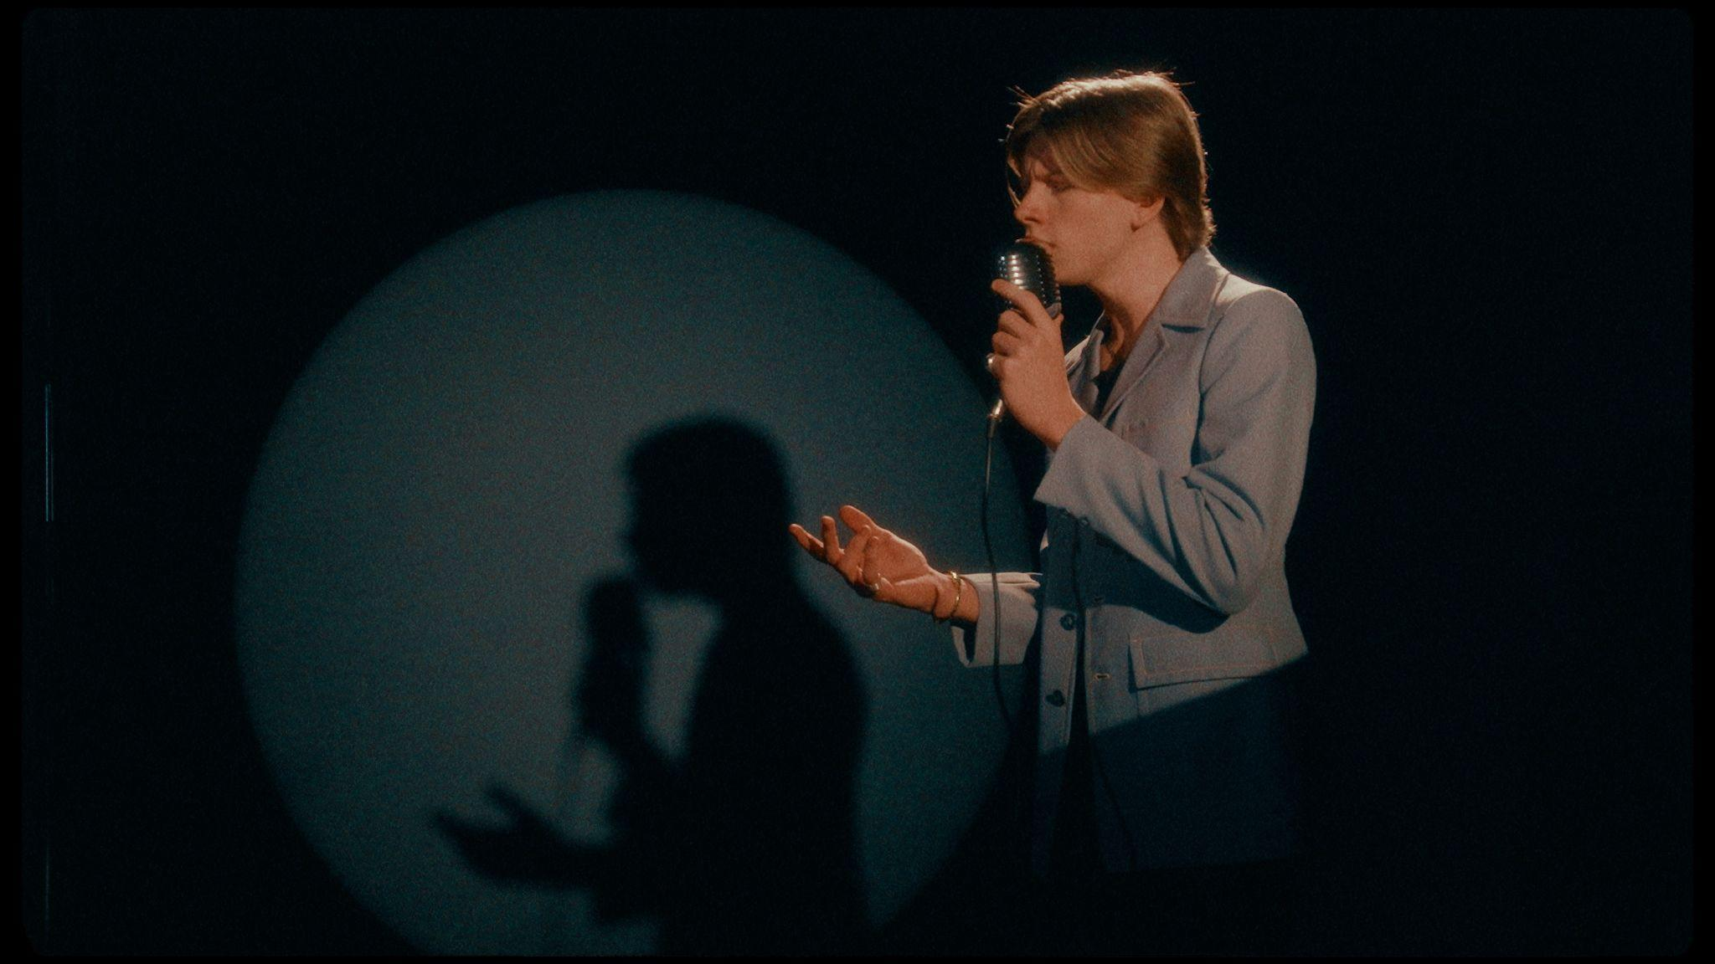
DOWNLOAD PRESS ASSETS HERE
"”Blue Over You” is about someone I truly cared for that unfortunately didn't feel the same way. When I took this song to my producer, I really felt everything and put all my emotions into it. In the song, you’ll hear influences of Elvis, Hank Williams, Jim Croce and Roy Orbison. I'm subconsciously inspired by music in the 60’s since I was raised by my grandparents and it is what I grew up listening to. The raw emotion and the influences of the 60’s, naturally pulled this song together.”
-MASON RAMSEY

[CREDIT: WORKING HOLIDAY]
DOWNLOAD PRESS ASSETS HERE
# # #

Connect with Mason Ramsey:
INSTAGRAM | TWITTER | FACEBOOK | TIKTOK

For all Mason Ramsey press inquiries, please contact:
Taylor Apel | Taylor.Apel@atlanticrecords.com
Jason Davis | Jason.Davis@atlanticrecords.com

