FOR IMMEDIATE RELEASE
MARCH 8, 2024

SHAINA TAUB CELEBRATES INTERNATIONAL WOMEN’S DAY WITH THE RELEASE OF
“KEEP MARCHING” FROM NEW ORIGINAL BROADWAY MUSICAL SUFFS

SUFFS BEGINS PERFORMANCES AT THE MUSIC BOX THEATRE ON MARCH 26TH

LISTEN TO “KEEP MARCHING” HERE
WATCH THE PERFORMANCE VIDEO HERE

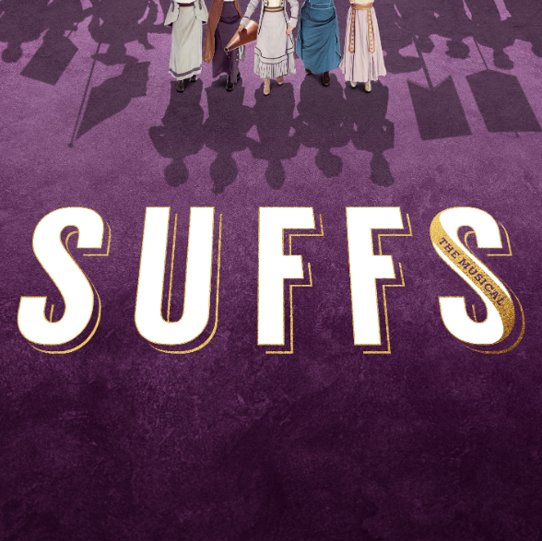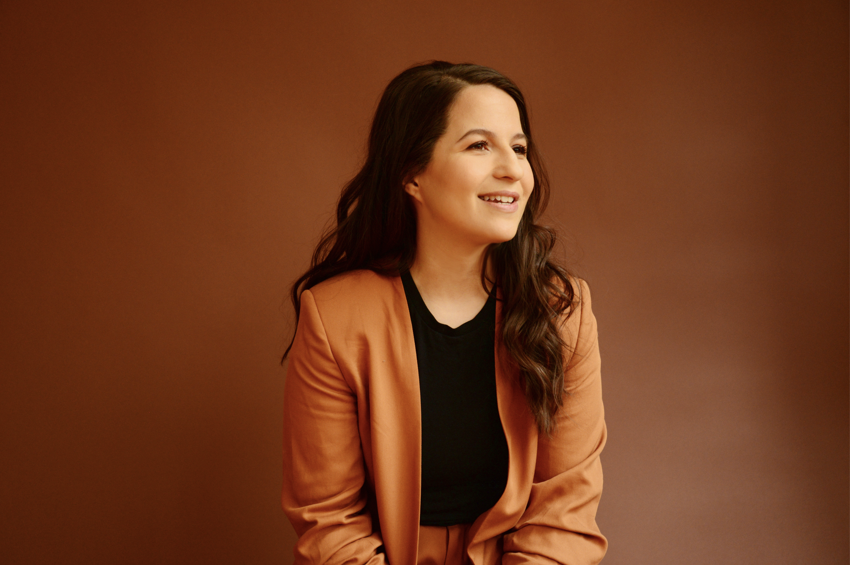
DOWNLOAD ASSETS HERE

“Shaina Taub belongs to a breed of performers who, apart from being artists, are gravitational forces around whom others cluster like filings to a magnet. There may be no such thing as too much Shaina Taub.”
– THE NEW YORK TIMES

“To call Taub — who sings, acts, plays piano and accordion and is published, like [Lin-Manuel] Miranda, by Warner Chappell — prolific would be an extreme understatement.”
– BILLBOARD

To celebrate International Women’s Day, award-winning singer-songwriter Shaina Taub has released the official audio recording of her stripped-down version of “Keep Marching,” the empowering finale track from her groundbreaking new Broadway musical Suffs, which begins performances at the Music Box Theatre on March 26th and opens on April 18th. “Keep Marching” is available now on all streaming platforms – Listen HERE.

Previously released alongside tickets for Suffs going on sale to the public, the stunning performance video for “Keep Marching” can be streamed on YouTube HERE.

“In writing the new finale for Suffs’ Broadway run, I wanted to imagine what the suffragists might say to us if they could reach through time and talk to us here in 2024,” said Shaina Taub. “If they could see us here feeling cynical and disillusioned about our democracy, feeling frustrated about the lack of progress and the cyclical nature of these fights - what would they say? I imagine they would give us a pep talk, a warning, a blessing."

From the singular mind of Shaina Taub, this “remarkable, epic new musical” (Variety) boldly explores the victories and failures of a struggle for equality that’s far from over. Suffs stars book writer, composer, and lyricist Shaina Taub in the role of Alice Paul, making her only the second woman in history to write the book, music, lyrics and star in her own Broadway musical. Taub is an Obie Award-winning, Emmy Award-nominated songwriter and winner of the Kleban Prize, the Fred Ebb Award, the Jonathan Larson Grant, and the NYCLU's Michael Friedman Freedom Award for activism. She created and starred in acclaimed musical adaptations of Twelfth Night and As You Like It at Shakespeare in the Park, has released three solo albums, and is currently signed to Atlantic Records.

ABOUT SUFFS

It’s 1913 and the women’s movement is heating up in America, anchored by the suffragists — “Suffs,” as they call themselves — and their relentless pursuit of the right to vote. Reaching across and against generational, racial, and class divides, these brilliant, flawed women entertain and inspire us with the story of their hard-won victory in an ongoing fight. So much has changed since the passing of the Nineteenth Amendment over a century ago, and yet we’re reminded sometimes we need to look back, in order to march fearlessly into the future.

Suffs will star book writer, composer, and lyricist Shaina Taub in the role of Alice Paul, making her only the second woman in history to write the book, music, lyrics and star in her own Broadway musical. Suffs will also star Tony Award winner Nikki M. James (The Book of Mormon) as Ida B. Wells, Tony Award nominee Jenn Colella (Come From Away) as Carrie Chapman Catt, Grace McLean (Natasha, Pierre and The Great Comet of 1812) as President Woodrow Wilson, Hannah Cruz (MCC’s The Connector) as Inez Milholland, Kim Blanck (Signature Theatre's Octet) as Ruza Wenclawska, Anastacia McCleskey (Waitress) as Mary Church Terrell, Ally Bonino (Broadway debut) as Lucy Burns, Tsilala Brock (The Book of Mormon National Tour) as Dudley Malone, Nadia Dandashi (Broadway debut) as Doris Stevens, and Tony Award nominee Emily Skinner (Side Show) as Alva Belmont/Phoebe Burn.

Rounding out the company are Hawley Gould (Lincoln Center Theater’s Camelot) as the Alternate for Alice Paul, Jaygee Macapugay (Here Lies Love) as Mollie Hay, and Laila Drew (Broadway debut) as Phyllis Terrell/Robin. The ensemble will feature Dana Costello (Pretty Woman) as well as Jenna Bainbridge, Monica Tulia Ramirez, and Ada Westfall making their Broadway debuts. The cast will also include Christine Heesun Hwang (Les Misérables National Tour), Chessa Metz (Broadway debut), Kirsten Scott (Jersey Boys), Housso Semon (Girl From The North Country), and D'Kaylah Unique Whitley (Dear Evan Hansen).

Suffs will feature book, music and lyrics by Kleban Prize, Fred Ebb Award, and Jonathan Larson Grant recipient Shaina Taub, direction by Tony Award nominee Leigh Silverman (Violet), choreography by Mayte Natalio (How to Dance in Ohio), scenic design by Tony Award nominee Riccardo Hernández (Jagged Little Pill), costume design by Tony Award winner Paul Tazewell (Hamilton), lighting design by Tony Award nominee Lap Chi Chu (Camelot), sound design by Jason Crystal (Sweeney Todd) with associate Sun Hee Kil (Choir Boy), orchestrations by Tony Award winner Michael Starobin (Next to Normal), music supervision and music direction by Andrea Grody (The Band’s Visit), and casting by Heidi Griffiths and Kate Murray (Soft Power). 101 Productions, Ltd. will serve as General Manager.

Jill Furman and Rachel Sussman will serve as lead producers of Suffs, with Hillary Rodham Clinton and Malala Yousafzai serving as two of the musical’s producers.

Suffs was originally developed and produced at The Public Theater in 2022 (Artistic Director, Oskar Eustis; Executive Director, Patrick Willingham; Director of Public Theater Productions, Mandy Hackett).

Tickets, starting at $49, are on sale now and can be purchased at SuffsMusical.com, through Telecharge.com, or by calling (800) 447-7400 or (212) 239-6200.

CONNECT WITH SHAINA TAUB
WEBSITE | INSTAGRAM | YOUTUBE | FACEBOOK | PRESS ASSETS

CONNECT WITH SUFFS
WEBSITE | INSTAGRAM | X | TIKTOK | YOUTUBE | FACEBOOK

PRESS CONTACT:
ANDREW GEORGE | ANDREW.GEORGE@ATLANTICRECORDS.COM

