FOR IMMEDIATE RELEASE
MARCH 14, 2024

ATLANTIC RECORDS RAISES THE CURTAIN ON THE NOTEBOOK

THE NOTEBOOK (ORIGINAL BROADWAY CAST RECORDING) IS THE COMPANION TO THE NEW MUSICAL BASED ON THE BESTSELLING NOVEL BY NICHOLAS SPARKS THAT INSPIRED THE BELOVED FILM

OPENING TONIGHT AT BROADWAY’S SCHOENFELD THEATRE, THE NOTEBOOK FEATURES MUSIC AND LYRICS BY
MULTIPLATINUM SINGER-SONGWRITER INGRID MICHAELSON AND BOOK BY PLAYWRIGHT BEKAH BRUNSTETTER

“LEAVE THE LIGHT ON” PERFORMED BY RYAN VASQUEZ AND ORIGINAL BROADWAY CAST
OUT NOW ALONGSIDE IN-STUDIO PERFORMANCE VIDEO
LISTEN HERE | WATCH HERE

THE NOTEBOOK (ORIGINAL BROADWAY CAST RECORDING)
ARRIVES EVERYWHERE ON FRIDAY, APRIL 19TH
WITH PRE-ORDERS AVAILABLE NOW HERE

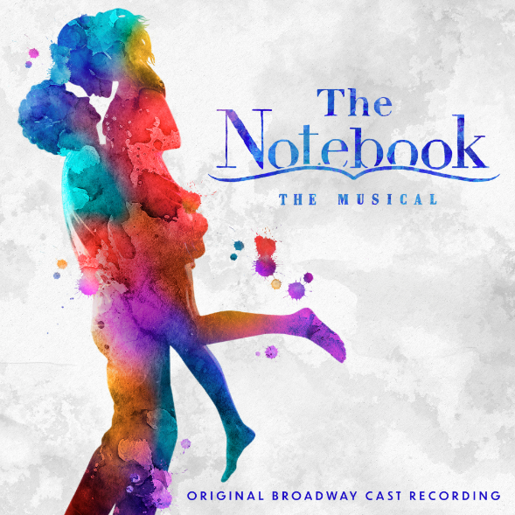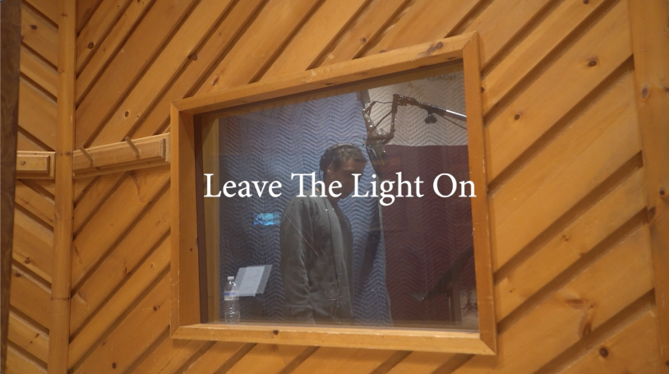
DOWNLOAD ASSETS HERE

Ahead of the show’s opening night this evening, Atlantic Records has announced the upcoming release of The Notebook (Original Broadway Cast Recording), the official companion to the acclaimed new musical with a score by singer-songwriter Ingrid Michaelson and based on the beloved film, arriving everywhere on Friday, April 19th. The album is now available for pre-order HERE.

The Notebook (Original Broadway Cast Recording) is heralded by today’s premiere of “Leave The Light On,” performed by Ryan Vasquez (Hamilton, Waitress), who plays the character of Middle Noah, and the Original Broadway Cast of The Notebook – Listen HERE. The first official cast recording arrives alongside an in-studio performance video featuring Vasquez – Watch HERE.

Based on the bestselling novel by Nicholas Sparks that inspired the iconic film, The Notebook – which opened last night at Broadway’s Schoenfeld Theatre – features music and lyrics by multiplatinum singer-songwriter Ingrid Michaelson and a book by playwright Bekah Brunstetter (writer and producer on NBC’s This Is Us, The Cake). Produced by Kevin McCollum and Kurt Deutsch, The Notebook is directed by Michael Greif (Dear Evan Hansen, Next to Normal, RENT) and Schele Williams (Aida, The Wiz), with choreography by Katie Spelman (Associate Choreographer on Moulin Rouge! The Musical).

The cast of The Notebook features Tony Award®-winner Maryann Plunkett as Older Allie, Dorian Harewood as Older Noah, Joy Woods as Middle Allie, Ryan Vasquez as Middle Noah, Jordan Tyson as Younger Allie, John Cardoza as Younger Noah, Andréa Burns as Mother/Nurse Lori, Carson Stewart as Johnny/Fin. Playing various roles are Yassmin Alers, Alex Benoit, Chase Del Rey, Hillary Fisher, Jerome Harmann-Hardeman, Dorcas Leung, Happy McPartlin, Juliette Ojeda, Kim Onah, Charles E. Wallace and Charlie Webb.

The Notebook (Original Broadway Cast Recording) continues Atlantic Records’ long-running string of landmark Original Broadway Cast Recordings, including 2015’s GRAMMY® Award-winning, RIAA Diamond-certified milestone, “Hamilton (Original Broadway Cast Recording),”2017’s GRAMMY® Award-winning “Dear Evan Hansen (Original Broadway Cast Recording)” and 2021’s GRAMMY® Award-winning “Jagged Little Pill (Original Broadway Cast Recording).”

While Michaelson has released nine studio albums, including multiple gold and platinum singles over her 17-year career, this marks her first Cast Recording.

Ingrid Michaelson said, “Writing this musical has been one of the greatest joys in my life. I am beyond excited to welcome everyone into our world.”

Grammy-winning producer of The Notebook Kurt Deutsch said, “I have been making Original Cast Recordings for the past 25 years, but The Notebook is my first time lead-producing a Broadway show, and has been a labor of love for over eight years. Bringing this cast recording to life, along with Ingrid and our dream team of actors and musicians, is a dream come true.”

"Ever since seeing an early performance of The Notebook in Chicago in 2022, we've wanted to work with Ingrid, Kurt, Kevin and their amazing team on this album,” said GRAMMY® Award-winning Atlantic Records President, A&R Pete Ganbarg. “Ingrid's music for the show is both emotionally powerful and heartbreakingly beautiful. We can't wait to share this cast recording with the world."

ABOUT THE NOTEBOOK THE MUSICAL
Allie and Noah, two people from different worlds, share a lifetime of love despite the forces that threaten to pull them apart in a deeply moving portrait of the enduring power of love. Based on the book that has sold millions of copies worldwide and a film that is one of the highest-grossing romantic dramas of all-time, the musical adaptation of The Notebook comes to Broadway following a critically acclaimed world premiere engagement at Chicago Shakespeare Theater in the fall of 2022. Chris Jones of the Chicago Tribune called The Notebook “absolutely gorgeous - not to be missed,” and Steven Oxman of the Chicago Sun-Times called it “superb – a stage musical for the ages.”

The Notebook features scenic design by David Zinn and Brett J. Banakis, costume design by Paloma Young, lighting design by Ben Stanton, sound design by Nevin Steinberg, hair and wig design by Mia Neal, and projection design by Lucy Mackinnon. The production’s music supervisor is Carmel Dean, who also collaborated on arrangements with Ingrid Michaelson and on orchestrations with John Clancy, and the music director is Geoffrey Ko. Casting by The Telsey Office, Patrick Goodwin, CSA.

For tickets and more information, visit www.NotebookMusical.com.

CONNECT WITH THE NOTEBOOK THE MUSICAL
WEBSITE | FACEBOOK | INSTAGRAM | TIKTOK | X | YOUTUBE

THE NOTEBOOK (OBCR) PRESS CONTACT:
ANDREW GEORGE | ANDREW.GEORGE@ATLANTICRECORDS.COM

THE NOTEBOOK PRESS CONTACTS:
ADRIAN BRYAN-BROWN | ABROWN@BBBWAY.COM
MICHELLE FARABAUGH | MFARABAUGH@BBBWAY.COM
COLLEEN DONAHUE | CDONAHUE@BBBWAY.COM

