FOR IMMEDIATE RELEASE
MARCH 8, 2024

SIR CHLOE HERALDS BIGGEST HEADLINE TOUR TO DATE
WITH “OVER AGAIN”

“THE SAVORY TOUR” GETS UNDERWAY MARCH 10
WITH SOLD-OUT SHOW AT TORONTO’S AXIS CLUB

HIGHLIGHTS INCLUDES SOLD-OUT SHOWS AT THE TROUBADOUR IN LOS ANGELES
AND MUSIC HALL OF WILLIAMSBURG IN NEW YORK

“OVER AGAIN” AVAILABLE NOW VIA ATLANTIC RECORDS
LISTEN HERE

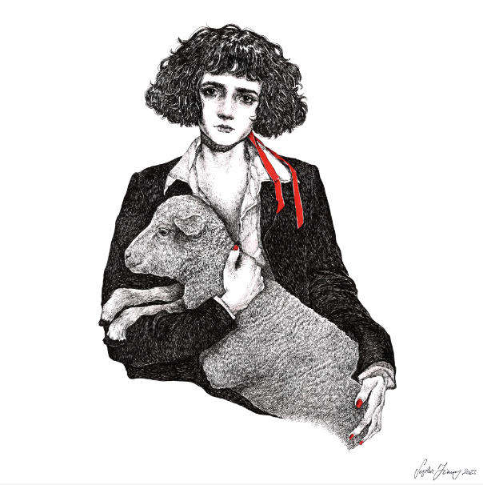
DOWNLOAD HI-RES IMAGE

Sir Chloe – the acclaimed project of vocalist, songwriter, and guitarist Dana Foote – returns with the exhilarating new single, “Over Again,” available now via Atlantic Records HERE.

“Over Again” marks the latest in a series of mesmerizing new releases that also includes “Seventeen” and “Home Where,” the latter of which earned praise from such outlets as FLOOD, which hailed the track as “yet another stunning single,” adding, “‘Home Where’ exhibits Sir Chloe’s softer, less fuzzed-out side in lieu of more refined production details (well, at least until the blown-out, grungy chorus).”

Sir Chloe will celebrate “Over Again” – and the promise of more new music to come – with an eagerly awaited North American headline tour – the band’s biggest live run thus far. “The Savory Tour” gets underway March 10 with a sold-out show at Toronto, ON’s Axis Club and then continues into early June. Most dates are long sold out, with highlights including Denver, CO’s Marquis Theater (April 21), Seattle, WA’s The Crocodile (April 25), West Hollywood, CA’s Troubadour (March 30), San Francisco, CA’s The Independent (March 31), Washington, DC’s The Atlantis (April 10, 11), Brooklyn, NY’s Music Hall of Williamsburg (April 13), and Austin, TX’s Antone’s (April 22). Special guests include Daffo and Deux Visages on select dates. In addition, Sir Chloe will join Carly Rae Jepsen, Peach Pit, and Beach Fossils for a top-billed festival appearance at Seattle, WA’s Day In, Day Out, set for Friday, July 12. For complete details and remaining ticket availability, please visit www.sirchloemusic.com/tour.

SIR CHLOE
“THE SAVORY TOUR” 2024

MARCH
10 – Toronto, ON – Axis Club (SOLD OUT)
11 – Detroit, MI – El Club (SOLD OUT)
12 – Chicago, IL – Lincoln Hall (SOLD OUT)
13 – Milwaukee, WI – Vivarium (SOLD OUT)
15 – St Louis, MO – Blueberry Hill (SOLD OUT)
16 – Kansas City, MO – Madrid Theatre
18 – Minneapolis, MN – Fine Line (SOLD OUT)
20 – Boulder, CO – Fox Theatre
21 – Denver, CO – Marquis Theater (SOLD OUT)
25 – Seattle, WA – The Crocodile (SOLD OUT)
26 – Portland, OR – Wonder Ballroom
28 – Roseville, CA – Goldfield Trading Post Roseville
29 – Santa Ana, CA – The Observatory
30 – West Hollywood, CA – Troubadour (SOLD OUT)
31 – San Francisco, CA – The Independent (SOLD OUT)

APRIL
2 – Los Angeles, CA – Lodge Room Highland Park
10 – Washington, DC – The Atlantis (SOLD OUT)
11 – Washington, DC – The Atlantis (SOLD OUT)
13 – Brooklyn, NY – Music Hall of Williamsburg (SOLD OUT)
14 – Brooklyn, NY – Music Hall of Williamsburg
17 – Cambridge, MA – The Sinclair (SOLD OUT)
18 – Philadelphia, PA – The Foundry (SOLD OUT)
20 – Nashville, TN – Exit/In
22 – Austin, TX – Antone’s (SOLD OUT)
23 – Dallas, TX – Dada Dallas (SOLD OUT)
24 – Houston, TX – White Oak Music Hall (SOLD OUT)
26 – Atlanta, GA – The Loft
27 – Charlotte, NC – Neighborhood Theatre (SOLD OUT)

MAY
29 – Providence, RI – Fete Music Hall
30 – Baltimore, MD – Baltimore Soundstage

JUNE
1 – Harrisburg, PA - Harrisburg Midtown Arts Center (HMAC) Capitol Room
2 – Asbury Park, NJ – Asbury Park Lanes

JULY
12 - Seattle, WA – Day In, Day Out *

* FESTIVAL APPEARANCE

# # #

Sir Chloe’s acclaimed debut album, I Am The Dog, is available everywhere now HERE. Produced by GRAMMY® Award-winner John Congleton (Lana Del Rey, St. Vincent, Angel Olsen) with songwriting contributions from Teddy Geiger (Caroline Polachek, Sylvan Esso, Lizzo) and Sarah Tudzin (Weyes Blood, Amen Dunes, Slowdive), the album includes such thrillingly paradoxical singles as “Should I,” “Salivate,” “Hooves,” and “Know Better,” the latter of which proved a favorite at Triple A radio outlets nationwide.

Anchored by Foote’s emotional songcraft and dynamic voice, I Am The Dog was met by critical applause around the world including NPR, Rolling Stone, and with The Line of Best Fit declaring it “Sir Chloe’s most developed and intricate release to date” in a 9-out-of-10 review, adding, “The tongue-in-cheek and aloof record finds its roots in covert sapphic, and paradoxical narratives, kaleidoscopic soundscapes and cool, grunge-fueled vocals. Complete with obscure and frank lyricism, I Am The Dog staples itself as a strong entry amongst this year’s releases.” “A fast-paced and cool sound that should only be played at max volume,” raved Flaunt. “Foote’s voice is effortless, unbothered, yet emotionally vigorous.” “It’s grungy, it’s shoegazey, it’s weird,” wrote DIY. “It’s not afraid to go off-piste. It’s full of guitar lines that are simultaneously super clean and gut-wrenching…Sir Chloe have perfectly grasped the entire concept of anticipation, building up and dropping out at the flick of a switch, never sticking to the status quo.”

Now boasting over 500M worldwide streams, Dana Foote put Sir Chloe together in college to serve as her senior thesis, going on to write the band’s first major hits in “Michelle“ (211M) and “Animal“ (93M) on the floor of her dorm room. Sir Chloe’s 2020 EP, Party Favors, was recorded in a warehouse that the band transformed into a recording space with just one hundred dollars and sheer will. Following the success of the EP (which earned over 200M global streams) and two additional singles in 2022, Sir Chloe – which consists of Foote, Emma Welch, Teddy O’Mara, Palmer Foote, and Austin Holmes – toured arenas with Portugal. The Man and alt-J, supported Pixies, Phoenix and Beck, and headlined two tours of their own in the United States and Europe, with sold-out stops in New York, Los Angeles, London, Paris, Amsterdam, and more. In addition, Foote has been profiled in such publications as Vogue and PAPER.

Sir Chloe celebrated the whirlwind success of I Am The Dog with “I Am The Tour,” highlighted by sold-out headline dates in North America and Europe, as well a special guest run on the epic Phoenix and Beck co-headline tour alongside Japanese Breakfast, Weyes Blood, and Jenny Lewis.

# # #

CONNECT WITH SIR CHLOE
OFFICIAL | FACEBOOK | INSTAGRAM | SPOTIFY | TIKTOK | TWITTER | YOUTUBE

CONTACT
Jessica Nall / Jessica.Nall@atlanticrecords.com
Libby Kober / Libby.Kober@atlanticrecords.com

