FOR IMMEDIATE RELEASE
MARCH 8, 2024

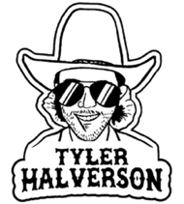

TYLER HALVERSON SHARES “ANYBODY BUT YOU”

ACCLAIMED SOUTH DAKOTA TROUBADOUR SHARES NEW SINGLE

HERALDING EAGERLY AWAITED DEBUT PERFORMANCES AT
WILLIE NELSON’S LUCK REUNION (MARCH 14) AND NASHVILLE’S GRAND OLE OPRY (APRIL 12)

LISTEN TO “ANYBODY BUT YOU” | WATCH OFFICIAL VISUALIZER HERE

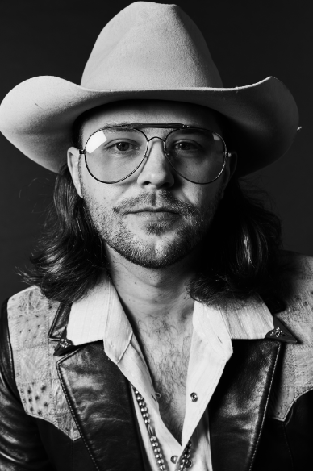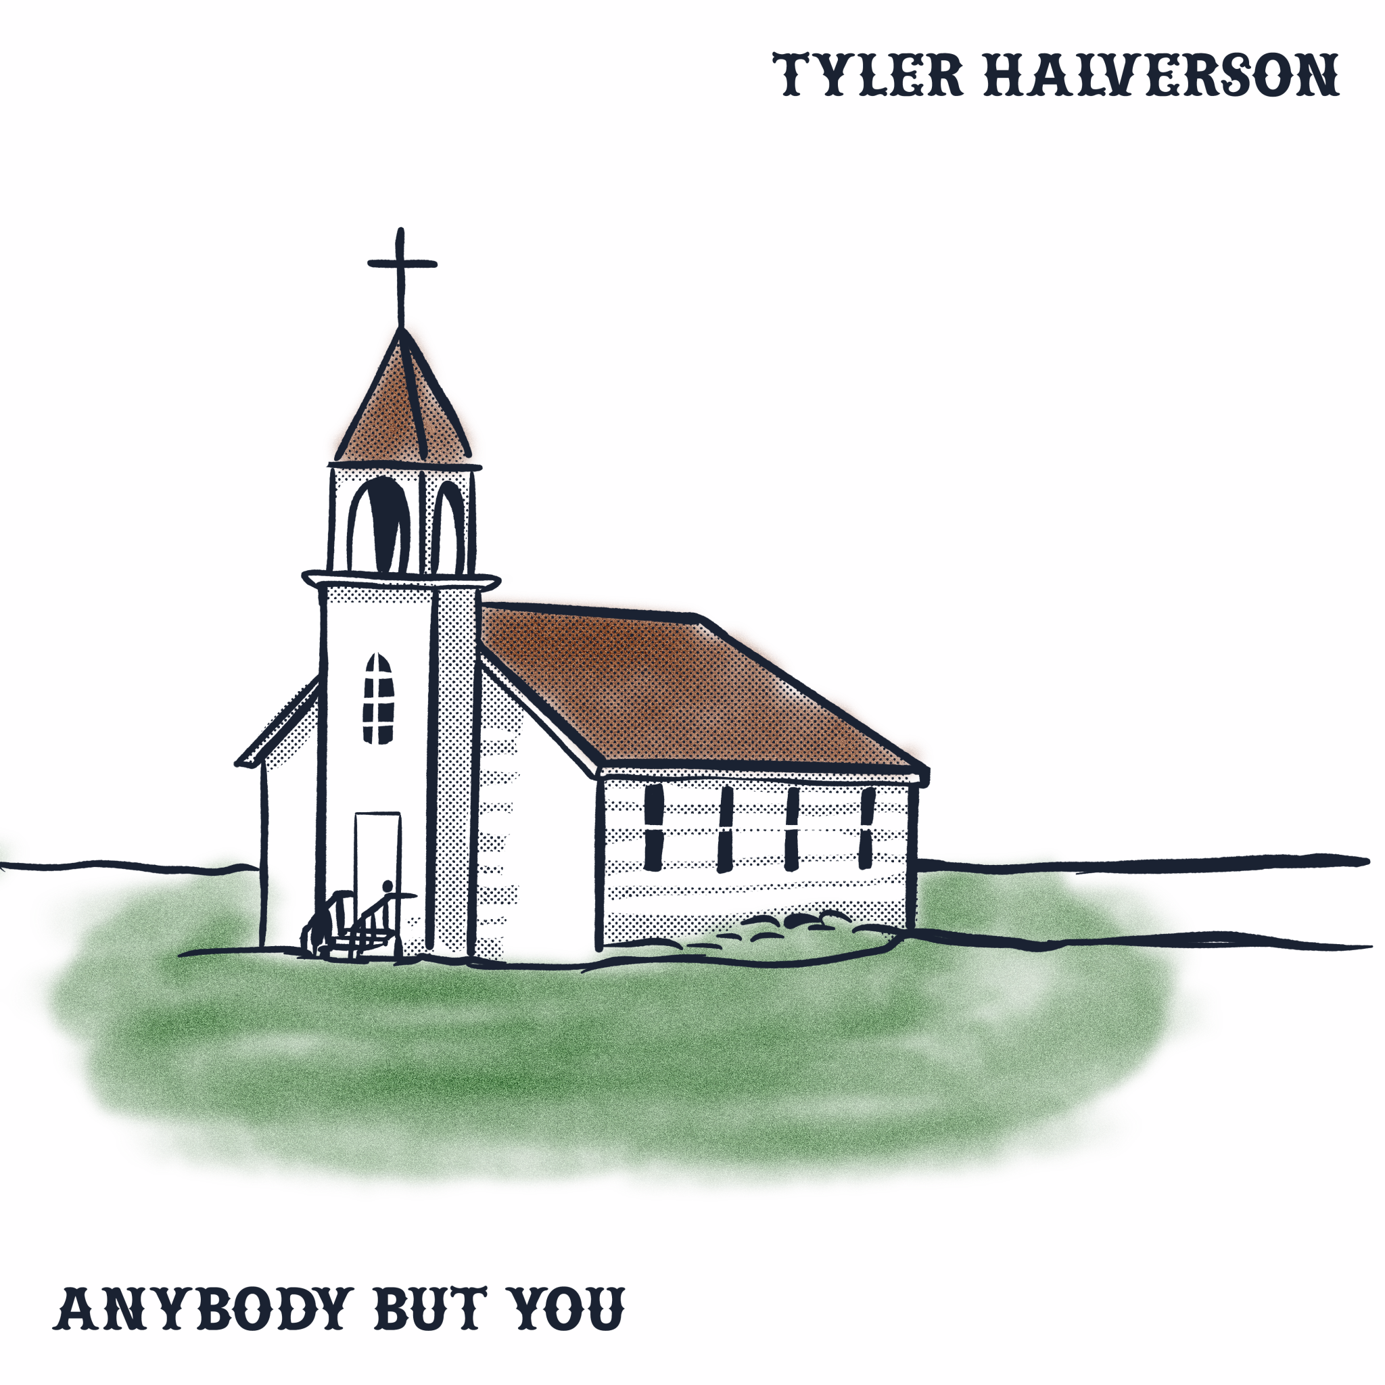
DOWNLOAD ASSETS HERE

“Tyler Halverson knows how to infuse his folk/country/rock songs with a little bit of psychedelia…This guy has been on a roll and he’s only gonna keep rising.” – BROOKLYN VEGAN

South Dakota troubadour Tyler Halverson returns with his latest single, “Anybody But You,” available everywhere now via Atlantic Records HERE. Co-written with the late singer-songwriter/musician Keith Gattis (Dwight Yoakam, George Strait, Kenny Chesney), the track is accompanied by an official visualizer premiering today at YouTube HERE.

“‘Anybody But You’ is that God sent kind of love,” says Halverson. “The kind that comes along and never leaves. It’s a special song written with the late Keith Gattis after a couple Coors Lights. I am proud of this song and forever grateful for someone like Keith to learn from and have in my corner.”

“Anybody But You” continues a seemingly non-stop run of singles from Halverson, including his first release of 2024, “Takes 8,” praised by Whiskey Riff as “the ideal rodeo anthem” and joined by both an official music video (streaming HERE) and acoustic studio performance (streaming HERE). Last year saw such acclaimed releases as “Tiffany Blue” (his duet with rising country singer-songwriter Carter Faith), “Yella Rose,” “As They Did,” “Her,’ “Cut You Loose,” and the boisterous “Run Wild,” all joined by official music videos streaming HERE.

Hailed by Country Swag as “the real deal,” Halverson will be among the stars performing at Willie Nelson’s annual Luck Reunion, set for March 14 in Luck, TX. Halverson – who has spent much of the past year on the road, including his biggest headline run thus far and dates supporting Shane Smith and the Saints and Ian Munsick – will then visit Fort Worth, TX’s famed Billy Bob’s Texas (March 30), followed by his long awaited debut at Nashville, TN’s historic Grand Ole Opry on Tuesday, April 16 alongside country superstar Terri Clark and the one and only Gary Mule Deer. Additional dates will be announced. For updates, please visit tylerhalverson.com/shows. Tyler Halverson is represented by legendary Nashville manager Erv Woolsey (George Strait, LeeAnn Womack) and Allen Mitchell of The Erv Woolsey Company.

ABOUT TYLER HALVERSON
Born and raised in the tiny town of Canton, SD (pop. 3054), Tyler Halverson isn’t just any cowboy. He’s got the hat and the boots, but he also plays a mean guitar and writes an even meaner tune. He has no problem bouncing around the country chasing adventure and is telling his different kind of cowboy tale with his self-described “Western Amerijuana Music,” bridging honest storytelling with songcraft inspired by country powerhouses Garth Brooks, George Strait, and Hayes Carll as much as Boyz II Men, Taking Back Sunday, and The Used.

Halverson fell in thrall to music at an early age, receiving his first guitar while in middle school. A local bluegrass festival convinced him to focus on music, throwing down at 4H and FFA festivals before heading to Nashville to attend the prestigious Belmont University. Upon graduation, he decided to hit the road and spent an extended run traveling around South Dakota, Montana, and Wyoming, all the while writing and playing his songs on social media. Halverson’s original approach caught fire with a string of independent releases including “Beer Garden Baby,” “Mac Miller,” and “Your Bar Now” (with Kylie Frey), amassing tens of millions of streams. Now, with “Anybody But You” and more new music still to come, Tyler Halverson is eager to take the next step on what has already proven an amazing journey.

“I’m finding myself,” says Tyler Halverson. “I feel like I’m an artist and I’m finally about to do something.”

# # #

TYLER HALVERSON
ON TOUR 2024

MARCH
8 – Helotes, TX – Floore's Country Store
9 – Corpus Christi, TX – Concrete Street Amphitheater
14 – Luck, TX – Luck Reunion
29 – Sour Lake, TX – The Revenant
30 – Fort Worth, TX – Billy Bob’s Texas

APRIL
16 – Nashville, TN – Grand Ole Opry

MAY
4 – Indianola, IA – Spring Revelry ^
31 – Chicago, IL – The Salt Shed ^

JUNE
8 – Deadwood, SD – Holiday Inn Resort Deadwood Mountain Grand *

* w/ Ian Munsick
^ w/ Turnpike Troubadours

# # #

CONNECT WITH TYLER HALVERSON
OFFICIAL | FACEBOOK| INSTAGRAM | TIKTOK | TWITTER | YOUTUBE | LINKTREE

PRESS CONTACT
Jessica Nall // Jessica.Nall@atlanticrecords.com

