FOR IMMEDIATE RELEASE
MARCH 1, 2024

TEENAGE DISASTER RETURNS WITH “EPITAPH”

CUTTING-EDGE ARTIST/PRODUCER SHARES MENACING NEW SINGLE
AND SELF-ANIMATED OFFICIAL VIDEO

LISTEN TO “EPITAPH” | WATCH OFFICIAL MUSIC VIDEO

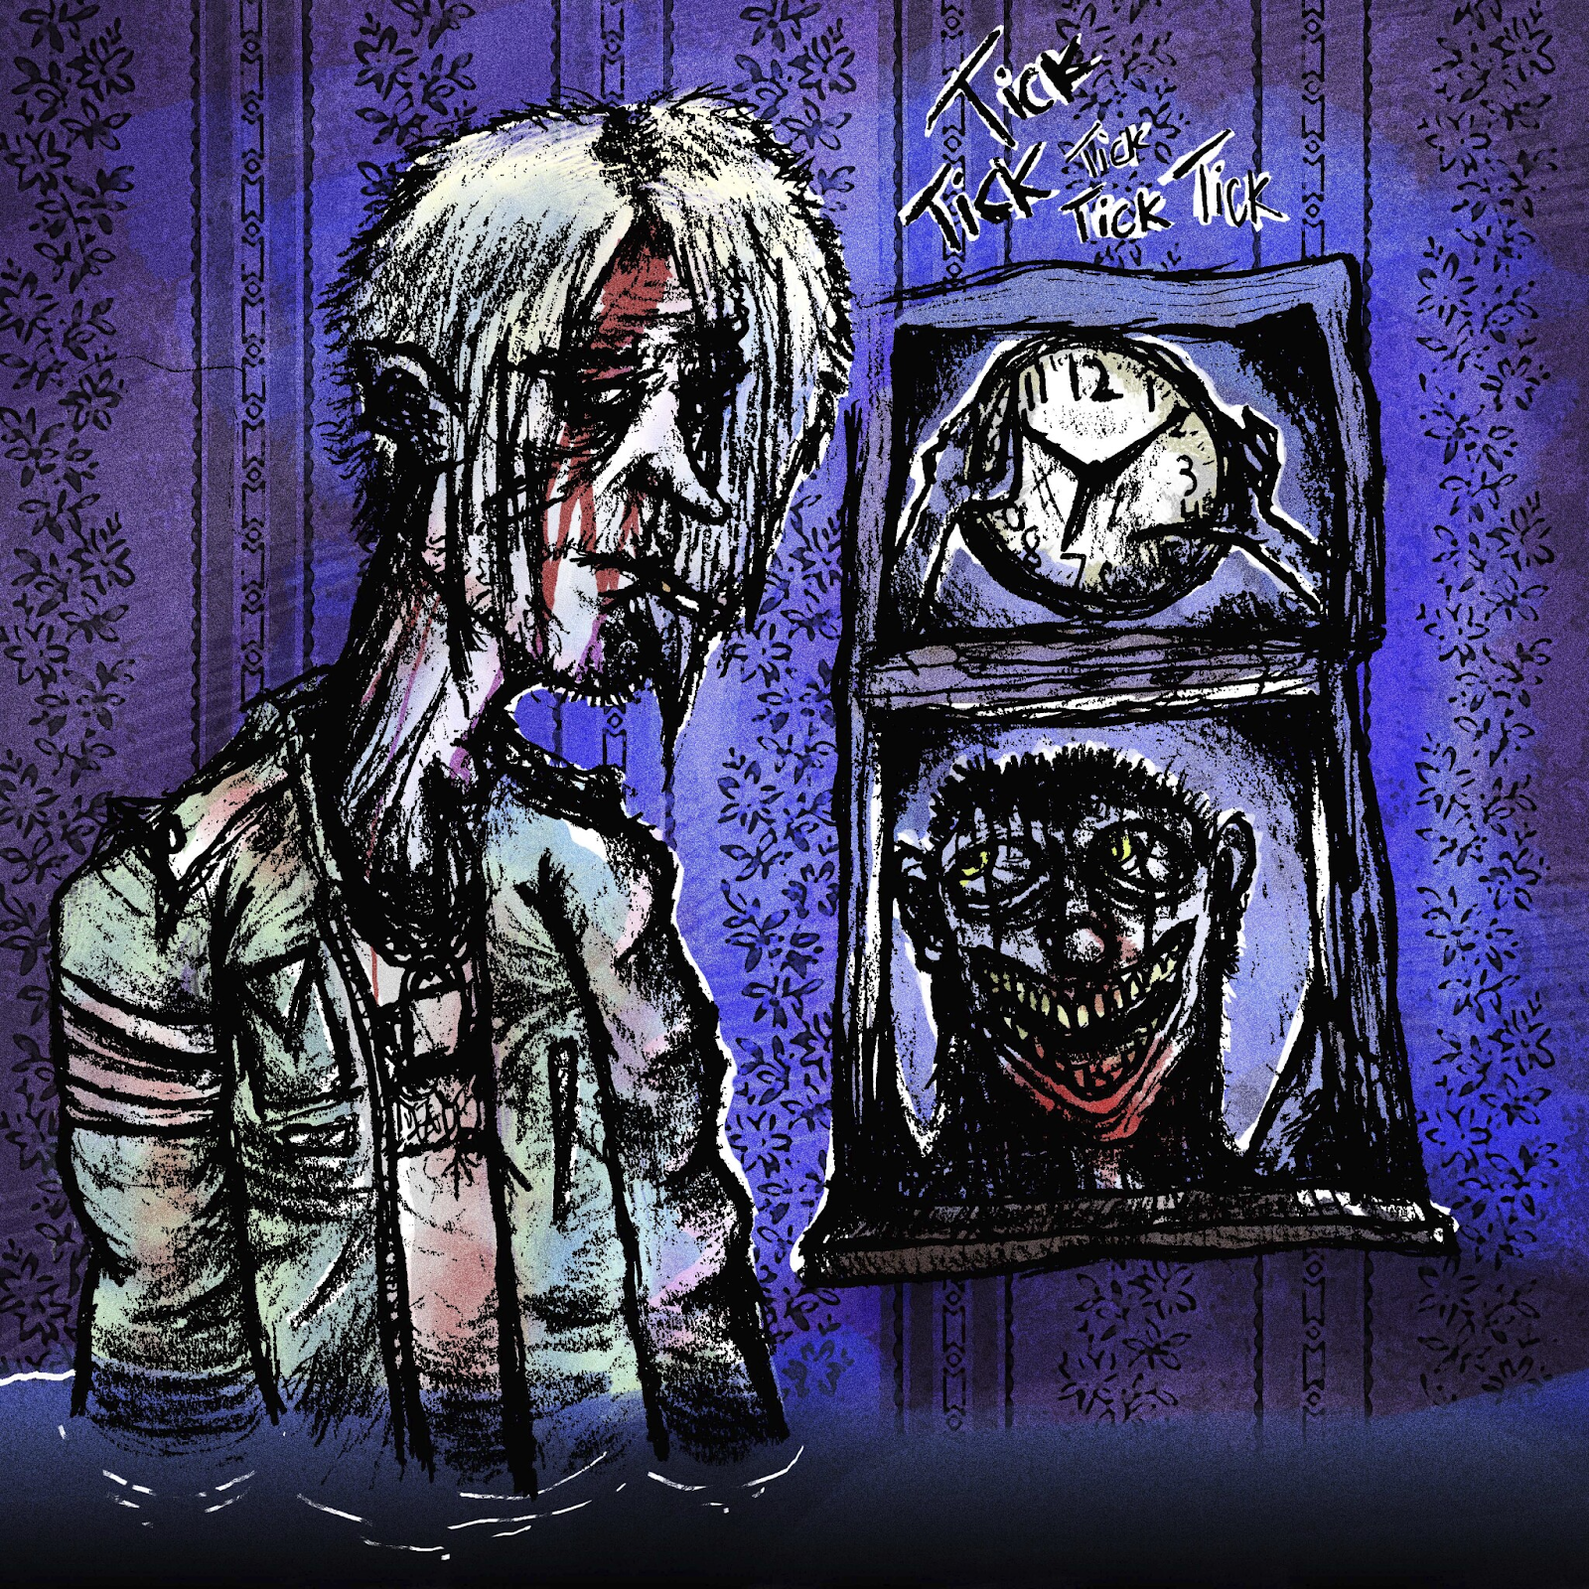
DOWNLOAD HI-RES ARTWORK

“Raw and primal, a buzzsaw sound that feels part hyperpop, part Atari Teenage Riot.”
– ANALOGUE TRASH

Cutting-edge artist/producer Teenage Disaster returns today with his menacingly melancholic new single, “Epitaph,” available now via Atlantic Records HERE. An official music video premieres today at YouTube HERE.

“Epitaph” marks the latest chapter in a new era for Teenage Disaster – a.k.a. Humboldt County, CA native Thorne Baker – following the recent premiere of the lacerating “Sorry For Being Me.” Last year saw the rising artist earn acclaim for such angst-driven tracks as “IT’S ALIVE,” “Victim,” and “Haylo,” all of which are joined by self-directed, edited, and animated videos streaming now HERE. Additional original animations and illustrations can be found on his TikTok HERE.

Hailed by Rolling Stone for his “shambling, fuck-off rock, angsty guitar missiles, and ominous hip-hop, often from the perspective of threatening characters (killers, criminals, creeps, corpses, the usual),” Teenage Disaster grew up in a home full of horror film paraphernalia, inspiring him to create his own captivating and often disturbing music, artwork, and animations. 2022 saw the arrival of his extraordinary debut album, CREEP, highlighted by such provocative singles as “Doubt,” “RELOAD (Feat. Afourteen),” “MASK (Feat. BLCKK),” “Chop Chop,” and “Takes 2 To Kill Me.” Teenage Disaster continued his dark musical offensive with a show-stopping run of live dates supporting Atlantic Records labelmate Sueco. Additional dates will be announced. For updates, please visit www.teenagedisaster.com.

# # #

CONNECT WITH TEENAGE DISASTER
OFFICIAL WEBSITE | INSTAGRAM | TIKTOK | TWITTER | YOUTUBE

CONTACT
Jessica Nall // jessica.nall@atlanticrecords.com

