WALLOWS ANNOUNCE HIGHLY ANTICIPATED THIRD ALBUM;
MODEL OUT MAY 24

UNVEILS TITLE OF UPCOMING NEW SINGLE;
“CALLING AFTER ME” ARRIVING MARCH 21

READ ROLLING STONE EXCLUSIVE INTERVIEW HERE

PREORDER/PRESAVE MODEL HERE
WATCH ALBUM TRAILER HERE

MODEL ALBUM COVER BY AIDAN ZAMIRI // DOWNLOAD HI-RES ARTWORK
Multi-platinum alt-rock trio Wallows have announced their highly anticipated third studio album, Model, following their triumphant return with the release of "Your Apartment” last month. The John Congleton-produced album arrives May 24th via Atlantic Records and is available for pre-order/pre-save now HERE. Model will be available physically on standard clear vinyl, limited edition “sunset” vinyl (lemon, tangerine & apple three-color mix) exclusively in Wallows’ web store, CD, and clear cassette.
The band broke the news by sharing an official album trailer this morning - WATCH HERE. Additionally, the trailer features a sneak peak of audio from their second single off the album, “Calling After Me,” which will be released on March 21st. Stay tuned for the rest of the track list to be revealed soon.
Wallows recently sat down for an exclusive interview with Rolling Stone, offering fans a glimpse into their creative process, personal insights, and the inspiration behind their upcoming album. Read the interview HERE.
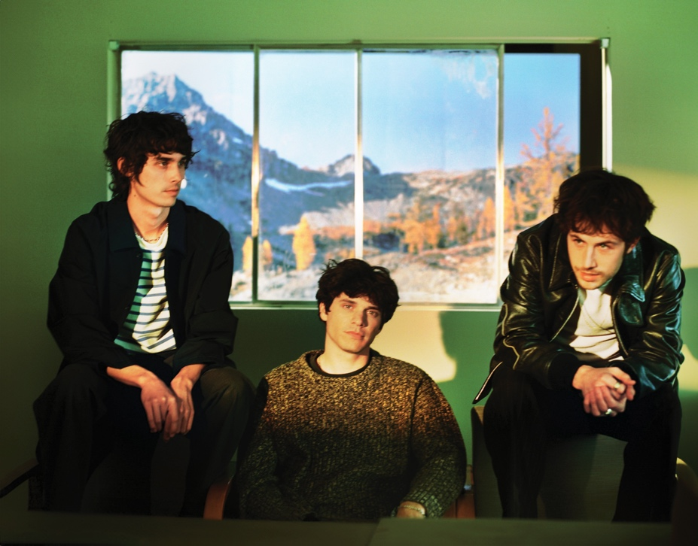
CREDIT AIDAN ZAMIRI // DOWNLOAD HI-RES PRESS IMAGE

MORE ON WALLOWS:
Wallows (composed of Dylan Minnette, Braeden Lemasters and Cole Preston) have been best friends since the age of 11. They began playing music together in the LA music program Join the Band almost two decades ago and haven’t stopped since. In March 2022, the band released their Sophomore album, Tell Me That It’s Over, produced by 3x GRAMMY Award-winner Ariel Rechtshaid (Vampire Weekend, Haim, Adele). TMTIO saw Wallows continuing on their ever-evolving journey of sonic exploration, fusing a vast array of musical ideas – from lo-fi post-punk and indie-folk to early ’90s dance-pop psychedelia – into their own one-of-a-kind creative vision.

TMTIO marked the full-length follow-up to Wallows’ hugely popular 2019 debut album, Nothing Happens, produced by GRAMMY Award-winner John Congleton (St. Vincent, Sharon Van Etten). The album proved to be one of that year’s highest streamed debuts. In the live space, Wallows have headlined sold out shows around the globe and have performed at marquee festivals such as Coachella, Lollapalooza, Reading and Leeds, and more. With new music now here, look out for news on their return to the stage.

CONNECT WITH WALLOWS
WALLOWSMUSIC.COM I FACEBOOK I TWITTER I YOUTUBE I INSTAGRAM | TIK TOK | PRESS SITE

PRESS CONTACTS
COREY BREWER | COREY.BREWER@ATLANTICRECORDS.COM
KELLY MCWILLIAM |KELLY.MCWILLIAM@ATLANTICRECORDS.COM
GABRIELLE REESE | GABRIELLE.REESE@ATLANTICRECORDS.COM

