FOR IMMEDIATE RELEASE
APRIL 8, 2024

MULTI-PLATINUM SUPERSTARS JASON DERULO AND MICHAEL BUBLÉ
LIFT THE CURTAIN ON “SPICY MARGARITA” OFFICIAL MUSIC VIDEO

ACTION-PACKED NEW VISUAL PREMIERES TODAY

DERULO’S RIAA GOLD-CERTIFIED NEW ALBUM, NU KING, AVAILABLE NOW HERE

LISTEN TO “SPICY MARGARITA” HERE | WATCH OFFICIAL MUSIC VIDEO HERE

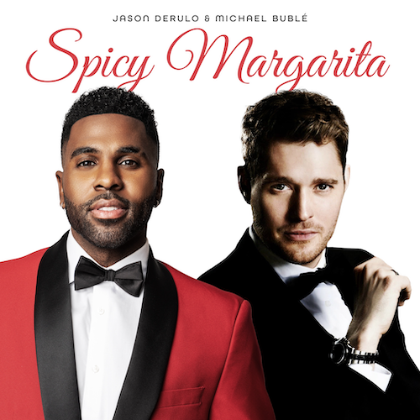
DOWNLOAD HI-RES ARTWORK HERE

Multi-Platinum global superstars Jason Derulo and Michael Bublé have unveiled the official music video for their collaborative smash, “Spicy Margarita.” Co-directed by Derulo, the action-packed visual premieres today on YouTube HERE. The music video was filmed at Voltaire at The Venetian Resort Las Vegas, which is also home of Derulo’s upcoming Las Vegas residency beginning May 17.

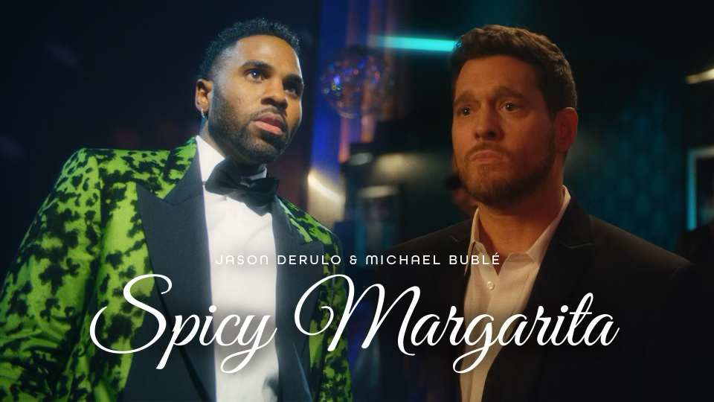

The first-ever musical collaboration from the two chart-topping international icons, “Spicy Margarita” is available now via Atlantic Records HERE. The fiery track – which includes a sample from Dean Martin’s “Sway,” famously covered by Bublé on his 2003 debut studio album and now boasting 415M global streams to date – follows Bublé’s recent appearance on the premiere episode of Derulo’s new podcast series, On The Road, co-hosted by Sincere Show and available now via all leading podcast providers. The duo celebrated their fiery collaboration with an unforgettable late night TV performance on ABC’s Jimmy Kimmel Live!, streaming now HERE.

“Spicy Margarita” is among the countless hits featured on Derulo’s blockbuster new album, Nu King, available everywhere now HERE. The 27-track collection – which received immediate RIAA Gold certification upon its release last month – marks the indefatigable star’s boldest work yet and first full-length release since 2015, gathering such worldwide hit singles as “Take You Dancing,” “Slow Low,” “Swalla (Feat. Nicki Minaj & Ty Dolla $ign),” “Love Not War (Feat. Nuka),” Lifestyle (Feat. Adam Levine),” “Hands On Me (Feat. Meghan Trainor),” “Acapulco,” “When Love Sucks (Feat. Dido),” alongside an array of newly recorded fan favorites.

Derulo is currently traveling on the “Nu King World Tour,” with dates in the United Kingdom, Ireland, Germany, Austria, Czech Republic, Italy, Switzerland, and Spain slated through August. Derulo’s residency at Voltaire at The Venetian Resort begins May 17 and continues through July. Voltaire, the newest nightlife sensation in Las Vegas, is a uniquely inspired venue that offers non-stop entertainment from headliners to cabaret, and provides guests an evening that is elevated, transformative, but most of all, fun. Voltaire, inspired by creator Michael Gruber and designed by Emmy and Tony Award winning production designer Derek McLane, brings to life a modern-day art deco fantasy, making it the perfect venue for this theatrical music video. For complete details, please visit www.jasonderulo.com/tour.

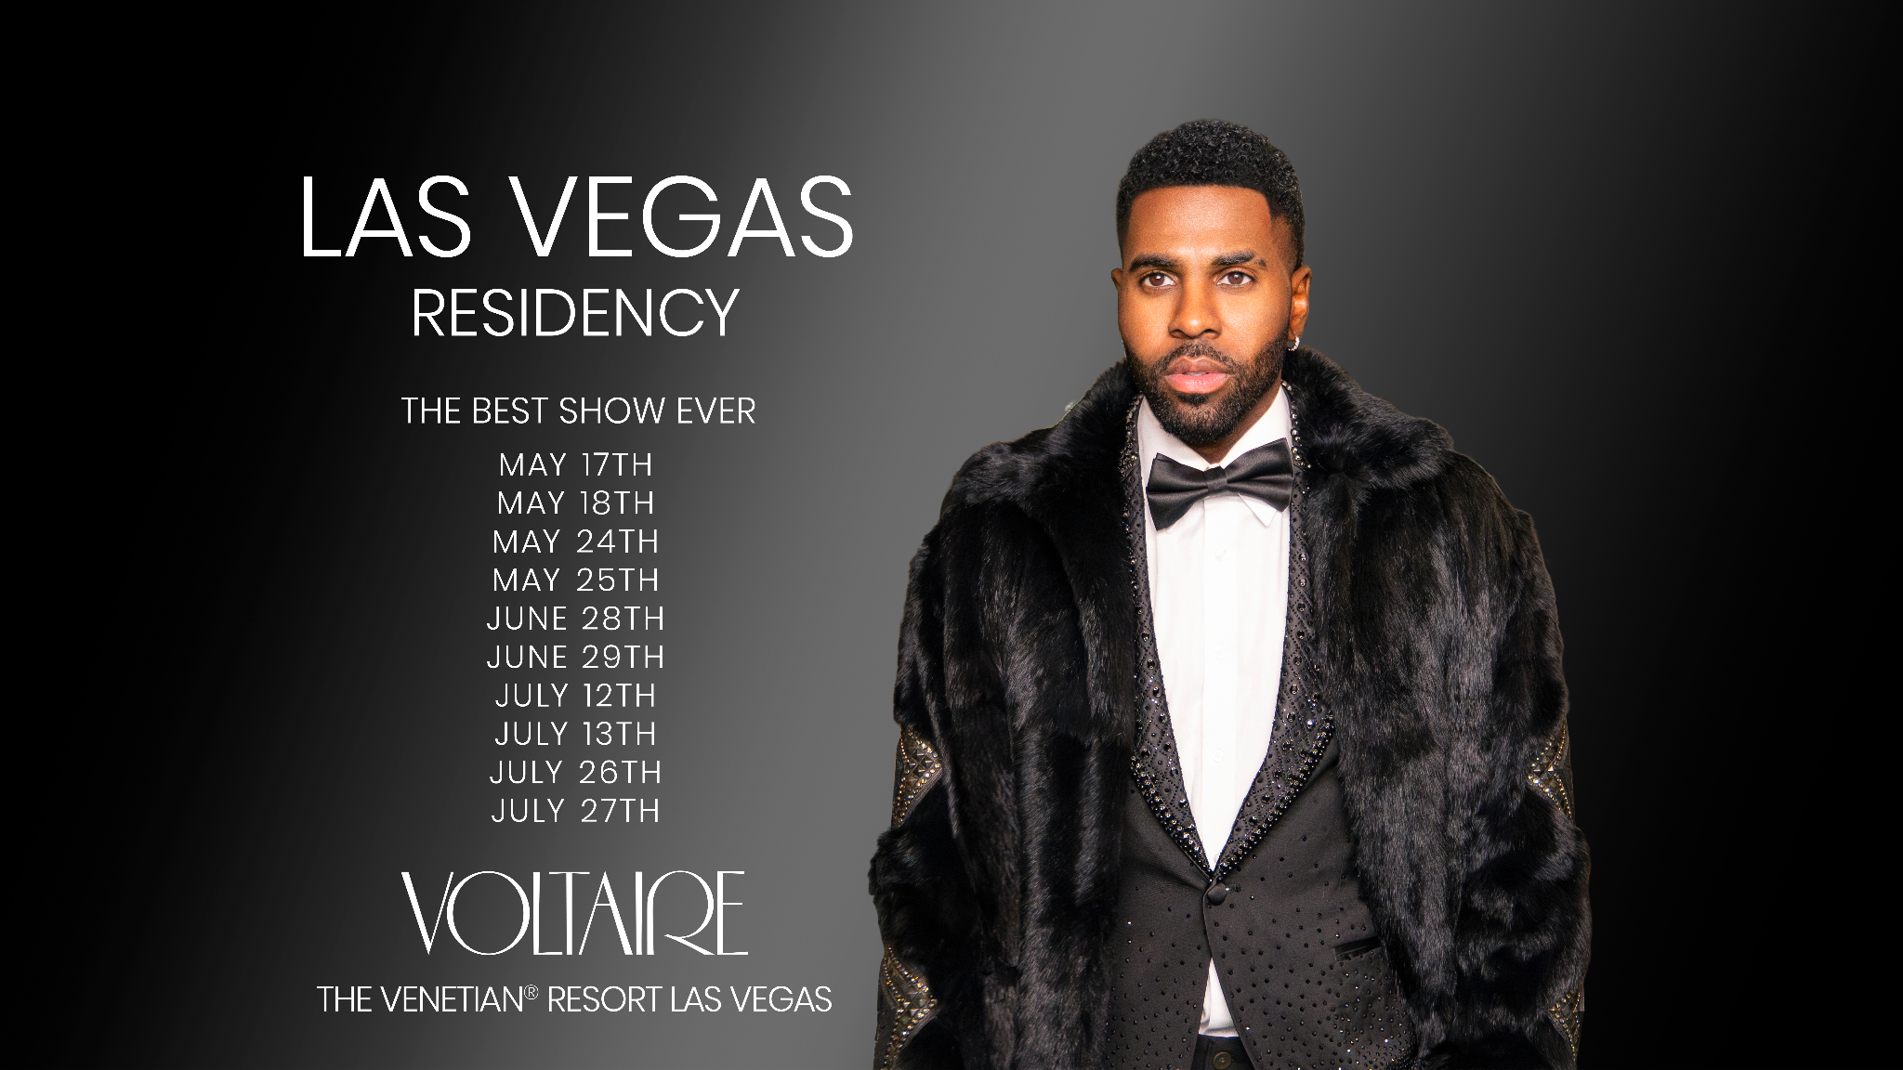

# # #

ABOUT JASON DERULO
Jason Derulo may be recognizable worldwide as a Multi-Platinum singer and songwriter, visionary entrepreneur, best-selling author, committed philanthropist, and engaging presence, but his story starts unassumingly. The self-described “kid from a Haitian family in Miami” has quietly and consistently grinded to emerge as one of his generation’s most prolific stars. Generating tens of billions of streams and reaching a $100 million net worth, Derulo’s global sales exceed 250 million singles with dozens of Multi-Platinum and Platinum certifications for smashes such as “Wiggle (Feat. Snoop Dogg),” “Take You Dancing,” “Talk Dirty (Feat. 2 Chainz),” “Whatcha Say,” and more. Derulo has three songs streamed over 1 billion times each under his belt, namely “Swalla (Feat. Nicki Minaj & Ty Dolla $ign),” “Want To Want Me,” and “Savage Love (Laxed – Siren Beat) [with Jawsh 685],” the latter of which claimed the #1 spot on the Billboard “Hot 100” in addition to toppling charts in 16 countries. With nearly 200 million followers across platforms, Derulo notably remains the fourth most-followed male on TikTok and 11th biggest account overall. Derulo has also appeared in various films and television series, including Spinning Gold and Empire. His portfolio encompasses ownership stakes in Rocket Car Wash, Pro Volleyball Federation, and the Omaha Supernovas. Derulo also penned the bestselling book Sing Your Name Out Loud: 15 Rules for Living Your Dream and created the UZO graphic novel in collaboration with Z2 Comics.

ABOUT MICHAEL BUBLÉ
Michael Bublé has sold more than 75 million albums worldwide over the course of his extraordinary career and has enjoyed enormous success as one of the top touring artists of all time. With a career that includes five GRAMMY® Awards, 15 JUNO Awards, stars on the Hollywood Walk of Fame and Canada’s Walk of Fame, six Multi-Platinum albums, and over 14 billion global streams, Bublé has spent the past two decades deeply committed to not only keep the flames of the Great American Songbook alive and well – to not only breathe new life into them – but to bring his singular style, vocal power, and passion to timeless tunes that he loves. Bublé released his self-titled debut album on Reprise Records in 2003, followed by a series of Multi-Platinum, #1 albums including Call Me Irresponsible (2007), Crazy Love (2009), To Be Loved (2013), Love (2018), and Christmas (2011). Bublé’s 11th studio album, HIGHER (2022), marked his ninth Top 10 on Billboard’s “Top Album Sales” chart and seventh consecutive studio album to debut in the Top 3. Known for his world-class showmanship and spectacular concert production, he has performed sold out shows in over 30 countries. With unstoppable talent, energy and a voice that is equally at home singing standards, pop, swing, jazz, R&B, and comedy, Michael Bublé takes his audiences on a special journey every night – singing his heart out, serenading them with beautiful love songs, making them laugh, cry, and dance – to give them an evening they will never forget.

# # #

CONNECT WITH JASON DERULO
OFFICIAL | FACEBOOK | INSTAGRAM | TIKTOK | TWITTER | YOUTUBE

CONNECT WITH MICHAEL BUBLÉ
WEBSITE | FACEBOOK | INSTAGRAM | TWITTER | YOUTUBE

PRESS CONTACT FOR JASON DERULO
FAIRLEY MCCASKILL | FAIRLEY.MCCASKILL@ATLANTICRECORDS.COM
SANDI MENDELSON | SMENDELSON@HMIEAST.COM

PRESS CONTACT FOR MICHAEL BUBLÉ
GABI HOLLANDER | GABI.HOLLANDER@FULLCOV.COM

