FOR IMMEDIATE RELEASE
APRIL 4, 2024

ARDEN JONES DROPS age tape 13

CALIFORNIA SINGER-SONGWRITER SHARES NEWEST INSTALLMENT
IN ONGOING SERIES OF 3-SONG PROJECTS

UPCOMING LIVE SCHEDULE INCLUDES RECENTLY ANNOUNCED HEADLINE TOUR
AND BOYWITHUKE’S LUCID DREAMS TOUR
WITH STOPS AT NY’S TERMINAL 5 AND NASHVILLE’S MARATHON MUSIC WORKS

age tape 13 AVAILABLE NOW VIA VNCLM_ X ATLANTIC RECORDS
LISTEN HERE

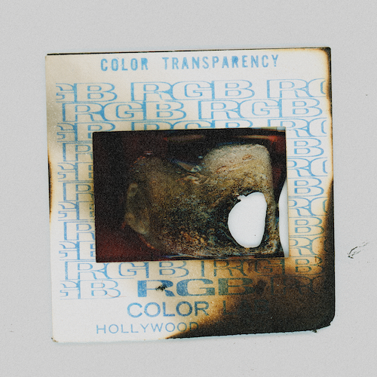
DOWNLOAD ASSETS HERE

California-based singer-songwriter Arden Jones has shared age tape 13, the latest chapter in his groundbreaking age tape series of three-song releases shared on the first Thursday of each month. Today’s release is highlighted by the energetic “not this time,” produced by Grant Sayler (Sueco, Charli XCX) and YOG$ (Healy, Quinn XCII), alongside “i’m fine i’m great” and “might be love.” age tape 13 is available now via vnclm_ x Atlantic Records HERE.

The age tape series returned earlier this year with age tape 10, featuring “hard enough to stay alive,” produced by Captain Cuts (UPSAHL, Carly Rae Jepsen), as well as “indigo,” produced by Jason Suwito (Imagine Dragons, k.flay), and “count me in,” an exhilarating collaboration with California-based electronic trio Łaszewo (Matthew Ehrlich, Keeva Bouley, Justin De La Fuente). age tape 11 followed, highlighted by the anthemic “been here before,” along with “in between” and “living a lie.” Last month’s age tape 12 includes the upbeat “confessions,” produced by Johnny Simpson (Lauv, Ava Max), alongside the new fan favorites, “switch” and “all about u.”

“we took a long time trying to figure out how we were gonna roll out all this new music and just couldn’t get away with how much fun age tapes were,” says Jones. “so here you go – age tapes are back for 2024.”

Arden will embark on a headline tour and also join BoyWithUke on his Lucid Dreams Tour beginning May 1 at Boston, MA’s House of Blues, followed by stops in New York City, Nashville, Austin and more. For updates, please visit www.ardenjonesmusic.com/tour.

ARDEN JONES
LIVE 2024

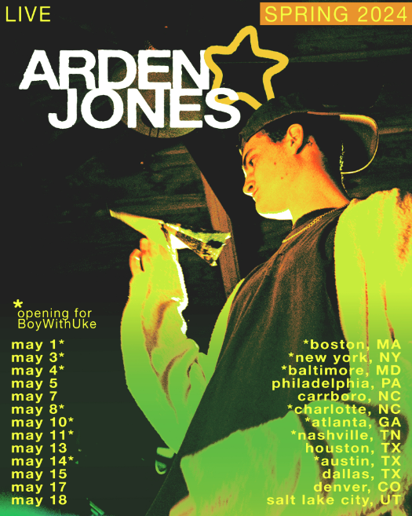

MAY
1 – Boston, MA – House of Blues Boston ^
3 – New York, NY – Terminal 5 ^
4 – Baltimore, MD – Rams Head Live! ^
5 – Philadelphia, PA – PhilaMOCA
7 – Carrboro, NC – Cats Cradle Back Room
8 – Charlotte, NC – The Fillmore Charlotte ^
10 – Atlanta, GA – The Eastern ^
11 – Nashville, TN – Marathon Music Works ^
13 – Houston, TX – Secret Group
14 – Austin, TX – Stubb's Waller Creek Amphitheater ^
15 – Dallas, TX – Three Links
17 – Denver, CO – Globe Hall
18 – Salt Lake City, UT – Kilby Court

^ w/ BoyWithUke Lucid Dreams Tour

MORE ON ARDEN JONES:
Known for an irresistible pop approach that bottles the sunshine of an endless California summer, Arden Jones has already earned over 353M worldwide streams, more than 25M video views, and 1.2M monthly Spotify listeners, jump started by hugely popular tracks such as his vnclm_ x Atlantic Records single, “SMILE,” as well as viral hit, “Parallel Parking.” 2022 saw Jones kick off his groundbreaking age tape series, a string of ten unique releases shared on the first Thursday of every month throughout the year. Named among PEOPLE’s 2022 “Talented Emerging Artists You Should Be Listening to All Summer Long,” Jones – who has shared stages with fellow breakout stars such as JVKE, QUINN XCII, Tai Verdes, Thomas Headon, and Chelsea Cutler – continues to make waves in the industry.

CONNECT WITH ARDEN JONES
WEBSITE | INSTAGRAM | SPOTIFY | TIKTOK | TWITTER | YOUTUBE

For press inquiries, please contact:
Jessica Nall // Jessica.Nall@atlanticrecords.com
Gabrielle Reese // Gabrielle.Reese@atlanticrecords.com

