FOR IMMEDIATE RELEASE
APRIL 4, 2024

AVA MAX KICKS OFF NEW ERA WITH “MY OH MY”

MULTI-PLATINUM GLOBAL POP ICON SHARES EAGERLY AWAITED NEW ANTHEM

RELEASES ALONGSIDE OFFICIAL MUSIC VIDEO

LISTEN TO “MY OH MY” | WATCH OFFICIAL MUSIC VIDEO

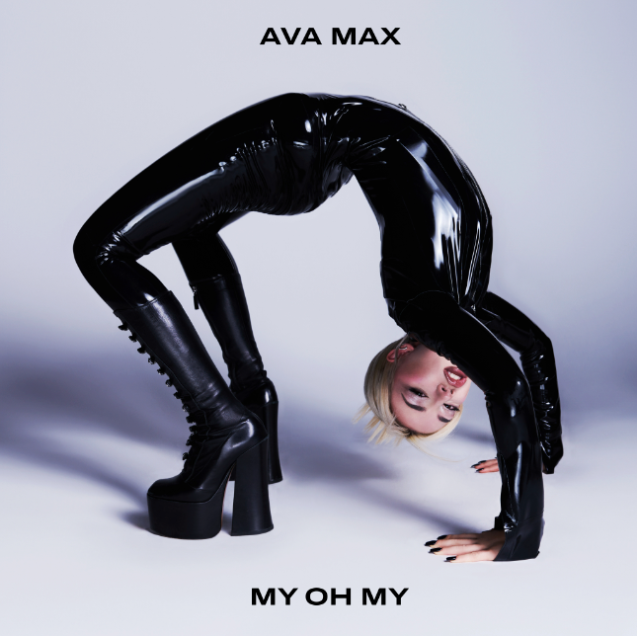
DOWNLOAD HI-RES ASSETS

Multi-Platinum global pop sensation Ava Max continues her incredible 2024 with today’s premiere of the spectacular new single, “My Oh My,” available now via Atlantic Records HERE. The track is produced by Inverness (Royal & the Serpent, ONE OK ROCK) and co-written by Ava with J Bach, Sam Martin, and Charles Roberts Nelsen. The track releases alongside an official music video directed by Hunter Moreno and choreographed by Matt Steffanina, which made its broadcast premiere on MTV Live, MTVU, MTV Biggest Pop and on the Paramount Times Square billboards – Watch HERE. In addition, "My Oh My” was featured in coverage for MLB’s 2024 Opening Day on the MLB Network and their affiliated social media accounts – Watch HERE.

The ideal anthem to kick off a night on the town, “My Oh My” marks the latest in a seemingly unstoppable string of dance-pop hits from Ava Max including the recently released smash, Kygo with Ava Max’s “Whatever,” the latter of which has already earned over 115M global streams since its January arrival, with the track peaking this week at #8 on UK airplay. Declared by Billboard as “an undeniable club smash,” the track – which reached #1 in Kygo’s native Norway and the top 10 in several countries, including Belgium, Bulgaria, Croatia, and Sweden – is joined by an official music video now boasting over 18M views HERE. What’s more, Ava and Kygo teamed up for an exhilarating late night TV live performance of “Whatever” on ABC’s Jimmy Kimmel Live! - Watch HERE.

“My Oh My” marks Ava’s first solo single release since last year’s acclaimed sophomore album, Diamonds & Dancefloors. The album – which of course followed Ava’s RIAA Platinum-certified blockbuster debut, 2020’s Heaven & Hell – is highlighted by passionately self-assured singles as “Ghost,” “One of Us,” “Cold As Ice,” “Dancing’s Done,” “Weapons,” “Maybe You’re The Problem,” and “Million Dollar Baby,” the latter of which is joined by an official music video, directed by Andrew Donoho (Khalid, Janelle Monae, Paul McCartney), currently boasting over 41M views HERE. In addition, her worldwide #1, RIAA Platinum-certified collaboration with Tiësto, “The Motto,” with the official music video amassing over 165M views – Watch HERE.

What’s more, Ava’s “Choose Your Fighter” was among the fan favorites featured on Barbie The Album, Atlantic Records’ GRAMMY® Award-winning, worldwide chart-topping musical companion to the critically acclaimed Barbie, starring Margot Robbie and Ryan Gosling as Barbie and Ken and distributed by Warner Bros. Pictures. In addition, 2023 saw Ava partner with Brazilian DJ Alok for the global dance hit, “Car Keys (Ayla),” joined by an official companion video streaming HERE.

Last year also saw Ava embark on her biggest world tour to date, with a sold out EU/UK run including stops in the UK, Belgium, France, the Netherlands, Norway, Switzerland, Italy, Portugal, Germany, Spain, and Finland. North American dates were highlighted by stops at such vaunted venues as New York’s Irving Plaza and Los Angeles’ The Fonda Theatre.

# # #

CONNECT WITH AVA MAX
OFFICIAL | FACEBOOK | INSTAGRAM | TIKTOK | TWITTER | YOUTUBE

PRESS CONTACTS
Ashley Kalmanowitz / Ashley.Kalmanowitz@atlanticrecords.com
Kelly McWilliam / Kelly.McWilliam@atlanticrecords.com

