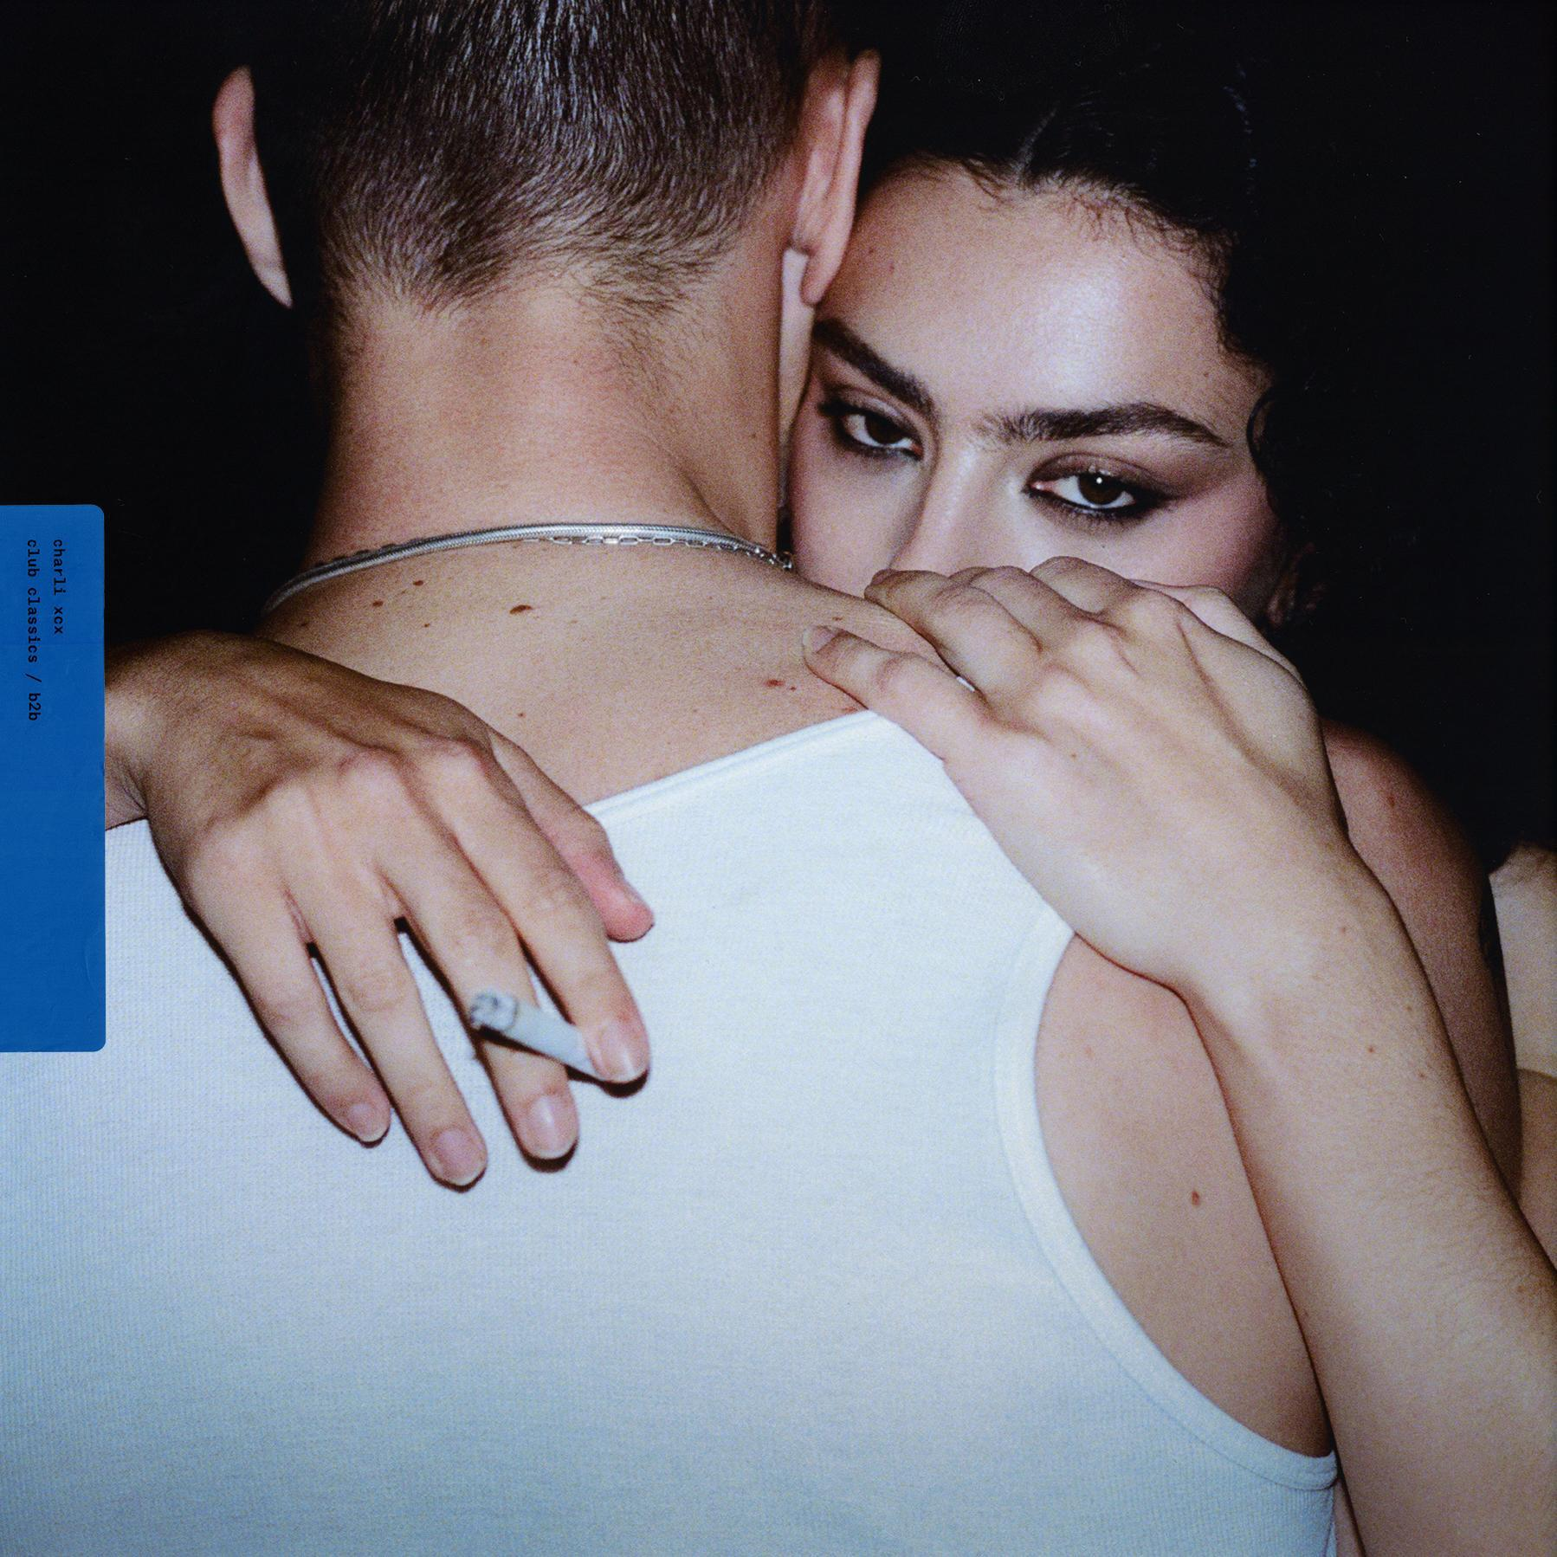

“The push-and-pull between vulnerability and braggadocio is at the heart of XCX6” - The FACE

Charli XCX today releases ‘Club classics’ and ‘B2b’ - two new singles from her highly anticipated forthcoming new album ‘BRAT’.

You can listen to ‘Club classics’ and ‘B2b’ HERE.

‘BRAT’, Charli’s sixth studio album, will be released on Friday 7th June with the full tracklist now available below. You can pre-order the album HERE (including a number of new physical variations of ‘BRAT’) and pre-save the album HERE.

‘Von dutch’, the brash and synth heavy first taste of the album, arrived in February with Pitchfork naming it ‘Best New Track’ and Billboard describing it as “delightfully rambunctious”. You can watch the Torso-directed video HERE.

Charli also recently unveiled ‘The Von dutch Remix with Addison Rae & A. G. Cook’, an effervescent rework of the smash hit single featuring A. G. Cook’s signature brand of idiosyncratic production and Charli and Addison going back and forth on vocals. You can listen HERE.

Charli threw a momentous Boiler Room in New York’s Brooklyn in February to launch the ‘BRAT’ campaign with A. G. Cook, George Daniel, Finn Keane and Doss. The show broke the record for the most ever RSVPs to a Boiler Room event, with over 40k people registering to attend. Featuring special guest appearances from the likes of Addison Rae and Julia Fox, the show has easily become one of the viral moments of the year. You can watch the full stream of ‘Boiler Room & Charli XCX Presents: PARTYGIRL’ HERE.

‘BRAT’ is the eagerly awaited follow up to 2022’s ‘CRASH’, which reached number 1 on the UK’s official album chart, and promises to be an exhilarating club record built around high art references and social commentary.

Alongside her new album, Charli has been working on multiple film & TV projects following the breakout success of her Barbie soundtrack contribution ‘Speed Drive’ last year. She is co-executive producing the score for the A24 film ‘Mother Mary’ with Jack Antonoff and also producing original music for Benito Skinner’s series ‘Overcompensating’ on Prime Video. In addition, Charli will star in the Daniel Goldhaber remake of 1978 cult horror film ‘Faces of Death’.

Avant-pop and electronic superstar Charli XCX has become an iconic figure in the arts, having helped expand the landscape of popular music over the last decade by seamlessly traversing the underground and mainstream with her artistic output. Over the course of a trailblazing career, the multi-hyphenate creative has earned critical acclaim for her innovative style and entrepreneurial spirit and seen her forward-thinking approach reshape pop culture in the process.

Her lasting impact was cemented last year when Charli was honoured with the Visionary Award at the annual Ivor Novellos in London, while she also received the Powerhouse Award at Billboard’s Women In Music ceremony in Los Angeles in March.

Charli XCX assets can be found here.

‘BRAT’ Tracklist:

1. 360
2. Club classics
3. Sympathy is a knife
4. I might say something stupid
5. Talk talk
6. Von dutch
7. Everything is romantic
8. Rewind
9. So I
10. Girl, so confusing
11. Apple
12. B2b
13. Mean girls
14. I think about it all the time
15. 365

Charli XCX 2024 Tour Dates:

Sat 01/06/24 - Barcelona, Spain - Primavera (Live) - Sold Out
Fri 07/06/24 - London, UK - Outernet (PARTY GIRL DJ Set) - Sold Out
Tue 11/06/24 - New York, NY - Knockdown Center (Live) - Sold Out
Wed 12/06/24 - Chicago, IL - Radius (Live) - Sold Out
Sat 15/06/24 - Los Angeles, CA - Shrine (Live) - Sold Out
Wed 19/06/24 - Mexico City, Mexico - Club Loo Loo (PARTY GIRL DJ Set) - Sold Out
Fri 21/06/24 - Sao Paulo, Brazil - Club Zig (PARTY GIRL DJ Set) - Sold Out

[‘BRAT’ Artwork]

##

https://www.charlixcx.com/
https://www.instagram.com/charli_xcx/
https://twitter.com/charli_xcx

##

