JACK HARLOW RECLAIMS THE THRONE AS “LOVIN ON ME”
RETURNS TO NUMBER ONE ON BILLBOARD HOT 100

WORLDWIDE HIT SINGLE TOPS CHART FOR THE FOURTH WEEK BREAKING HARLOW’S PREVIOUS CAREER RECORD SET BY HIS 2022 BLOCKBUSTER SONG “FIRST CLASS”

- BECOMES ONLY THE SECOND RAPPER IN HISTORY TO HAVE A #1 SONG ON THE BILLBOARD HOT 100 FOUR YEARS IN A ROW
- BECOMES THE THIRD ARTIST TO HAVE THREE NO. 1 HITS THAT HAVE EACH RULED FOR DOUBLE-DIGIT WEEKS
- “LOVIN ON ME” BECOMES ONE OF THE BIGGEST BILLBOARD HOT 100 HITS OF THE DECADE

COMPANION VISUAL DIRECTED BY AIDAN CULLEN REMAINS TOP #2 MUSIC VIDEO ON YOUTUBE WITH NEARLY 60M VIEWS TO DATE

DOWNLOAD/STREAM "LOVIN ON ME"
WATCH OFFICIAL VISUAL

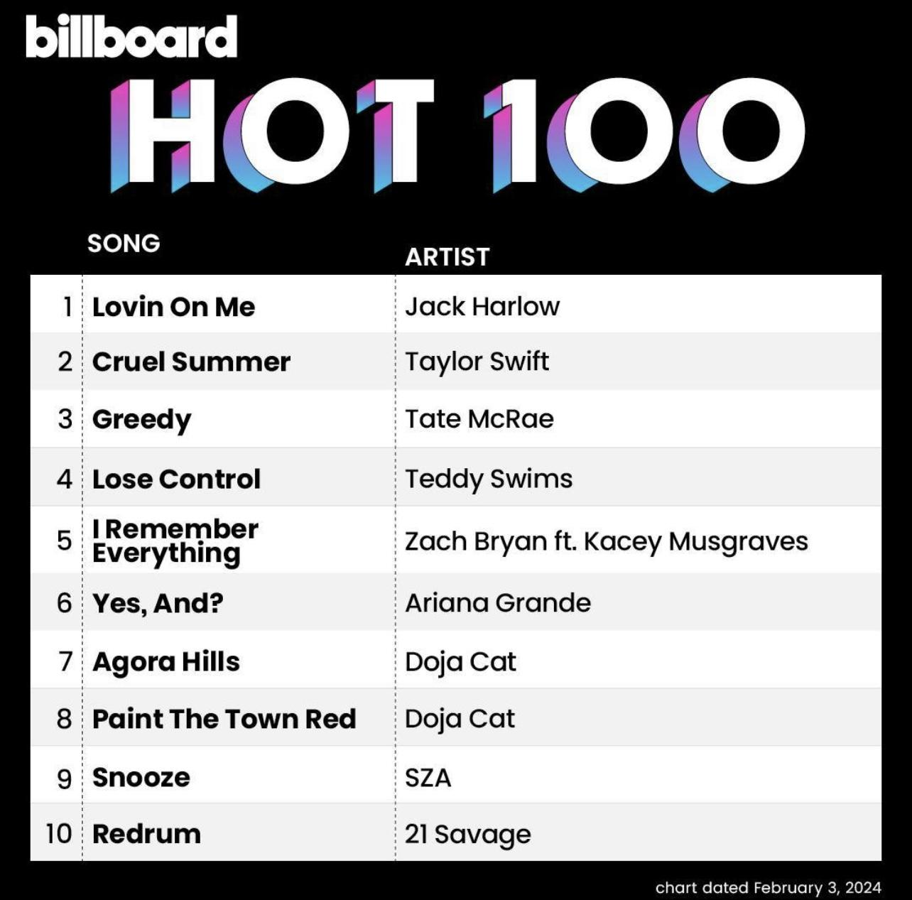

* * *

ABOUT JACK HARLOW
Hailed as the “hitmaker of tomorrow” by Variety, multiple GRAMMY-nominated rapper/actor/entrepreneur/philanthropist Jack Harlow is one of music’s brightest stars. The Louisville, KY native boasts six GRAMMY Award nominations, three #1 singles, over 30 RIAA platinum certifications, and over 10 billion career streams to date. Harlow released his critically acclaimed, RIAA platinum certified debut album, THATS WHAT THEY ALL SAY, in December 2020, which featured the chart-topping, worldwide hit, “WHATS POPPIN,” which earned him his first GRAMMY nomination for “Best Rap Performance,” along with a wide array of other award nominations.

The Generation Now/Atlantic Records superstar reached even greater heights in May 2022, with his Gold-certified sophomore album, COME HOME THE KIDS MISS YOU, highlighted by the Platinum-certified lead single “Nail Tech” and the chart topping, multiple-GRAMMY-nominated single “First Class,” which made a spectacular debut at atop the Billboard “Hot 100,” marking his first solo #1 single, while earning the biggest streaming week of 2022. In April 2023, Harlow surprised fans with his third studio album, Jackman., which critics praised as his most mature and in-depth body of work to date.

Harlow has graced the covers of Rolling Stone, GQ, Forbes, Variety, Complex, SPIN, Footwear News and XXL’s coveted Freshman Class issue, and brought his captivating live show to TV with performances on Saturday Night Live, The Tonight Show Starring Jimmy Fallon, Jimmy Kimmel Live!, MTV Video Music Awards, BET Awards and Kids Choice Awards, to name a few.

In May 2023, Harlow made his passion for reinvesting, uplifting, and supporting organizations aiming to make his hometown of Louisville, KY a better place official by launching The Jack Harlow Foundation. Later that month, the multi-faceted superstar made his big screen debut starring in the remake of the cultural classic ‘White Men Can’t Jump.’

For all press inquiries, please contact:
Jason Davis – jason.davis@atlanticrecords.com

* * *

PRESS IMAGE – Photo Credit: Cian Moore
*please use only this image: hi-res original & cropped available here*

