16-YEAR-OLD PRODIGAL SINGER-SONGWRITER JAKE KOHN SHARES “DREAMS” – LATEST SINGLE VIA LOCKELAND SPRINGS/ATLANTIC RECORDS

LISTEN HERE | WATCH LIVE VIDEO HERE

FOLLOWS STIRRING DEBUT RELEASES “HARD AS STONE” + “FROSTBITE”

ON TOUR THIS SPRING WITH 49 WINCHESTER + SIERRA FERRELL

"Every once in a while, a voice comes along that makes you sit up and pay attention. Virginia-born Americana prodigy Jake Kohn has such a voice... This is the voice that earned him a standing ovation at his Grand Ole Opry debut last fall, and he deserved it."
– AMERICAN SONGWRITER

“…one of Virginia's most talked-about prodigies…”
– HOLLER

“Jake Kohn is a name you’re going to want to remember over the next few years”
– WHISKEY RIFF

“…destined for greatness…”
– NASHVILLE.COM

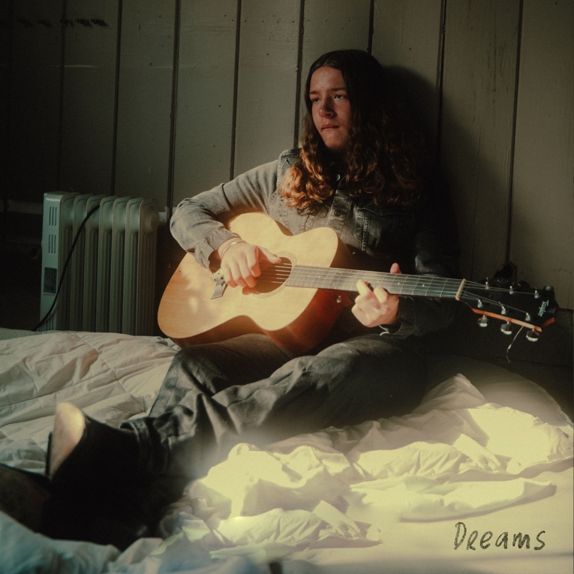
download hi-res artwork HERE

March 8, 2024 – Today, 16-year-old Appalachia native and rising talent Jake Kohn shares “Dreams,” marking his third-ever single release via Lockeland Springs/Atlantic Records – listen here + watch “Dreams (From The Arcade)” here.

“Dreams” is yet another testament to Kohn’s ability to capture any listeners’ attention with soul-stirring lyricism accompanied by his rich, raspy baritone. On perhaps his most earnest song yet, Kohn embraces a striking vulnerability that sets him apart from other singer-songwriters.

Earlier this week he launched a live performance of the new track in partnership with Appalachia Untold – a lifestyle brand which highlights original music from across the region (watch here).

“Dreams” follows Jake’s second released track, “Hard as Stone” – listen here + watch live performance here – which arrived to instant critical acclaim and excitement in January. His first official release “Frostbite” arrived in November of last year, after a live version filmed in Charleston, West Virginia amassed over 1.2M views on YouTube.

Upon release, Whiskey Riff praised Jake’s “raw, powerful vocals” and Holler proclaimed the young artist “one of Virginia’s most talked-about prodigies.”

Born in Winchester, VA – birthplace of Patsy Cline – Jake grew up influenced by country legends like Merle Haggard and Johnny Cash. At age 11, after being gifted a guitar from his great-grandmother, he taught himself how to play chords from a poster on his wall.

Five years later, Jake regularly goes viral on TikTok and YouTube, amassing 10M+ views across both platforms. Jake’s stunning live rendition of “Frostbite,” performed during his Grand Ole Opry debut in the fall of 2023, filled the storied theatre with his robust, soulful voice and elicited a standing ovation (watch a clip of the performance here) – before inking his Lockeland Springs/Atlantic Records deal backstage later that evening.

This spring, Jake will support 49 Winchester and Sierra Ferrell on select shows across the east coast and southeast, stopping at storied clubs including 9:30 Club (Washington, DC), Union Transfer (Philadelphia, PA), and The Ritz (Raleigh, NC); all upcoming dates are enclosed below.

Stay tuned for much more to come from this artist to watch.

ABOUT JAKE KOHN:
He’s been called an old soul as much as his given name. His talent has been described with such phrases as “once in a lifetime” and “lightning in a bottle.” Jake Kohn appears to be your average 16-year-old boy, but when his voice fills the room, it becomes clear why he signed to Lockeland Springs/Atlantic Records at such a young age.

It’s not surprising fans draw comparisons to artists like Joe Cocker and Janis Joplin when they hear that rich, raspy baritone, but perhaps the more inexplicable characteristic of Jake’s music is his songwriting. If you didn’t know better, you would swear Jake has experienced all the trials and tribulations of a full life. His songwriting may not be autobiographical, but it paints an accurate picture of the struggles and hardships many Americans face, particularly those in Appalachia.

Born in Winchester, Virginia, home of Patsy Cline, Jake is no stranger to country music. While Jake doesn’t come from a musical background, he grew up listening to legends like Merle Haggard and Johnny Cash with his father, Erick. At 11 years old, Jake was gifted a guitar from his great-grandmother. He taught himself to play chords from a poster on his wall. His mentor, Buddy Dunlap, would allow Jake to come and play at his barn, teaching him some tricks of the trade along the way. It was this same year, Jake discovered one of his biggest songwriting influences, Justin Townes Earle. Jake continues to draw inspiration from his music and guitar style.

Jake will tell you he penned his first “good” song at 12 years old. With the support of his mother, Maria, he began playing live shows locally, often at places he otherwise isn’t old enough to get into. Jake began receiving encouragement from local artists such as Logan Moore from Low Water Bridge Band.

It was through posting his music on YouTube that his manager, Ashley Wells, found a performance of that first “good” song he ever wrote, “Fraterville, TN.” With her help, Jake began traveling outside of Virginia for shows. Earlier this year, Jake’s video for “Frostbite” went viral. He has been on an upward trajectory since. At 15, he had already developed a following and was being approached by industry professionals.
It’s exciting to see what’s in store for Jake’s future. One thing’s for sure. He’s not slowing down any time soon.

UPCOMING TOUR DATES:
* Supporting 49 Winchester
# Supporting Sierra Ferrell

APRIL
4 – Prestonsburg, KY @ Mountain Arts Center *
5 – Louisville, KY @ Mercury Ballroom *

MAY
9 – Atlanta, GA @ The Eastern #
10 – Charleston, SC @ Charleston Music Hall #
11 – Raleigh, NC @ The Ritz #
12 – Charlotte, NC @ The Fillmore Charlotte #
14 – Philadelphia, PA @ Union Transfer #
22 – Washington, DC @ 9:30 Club #

