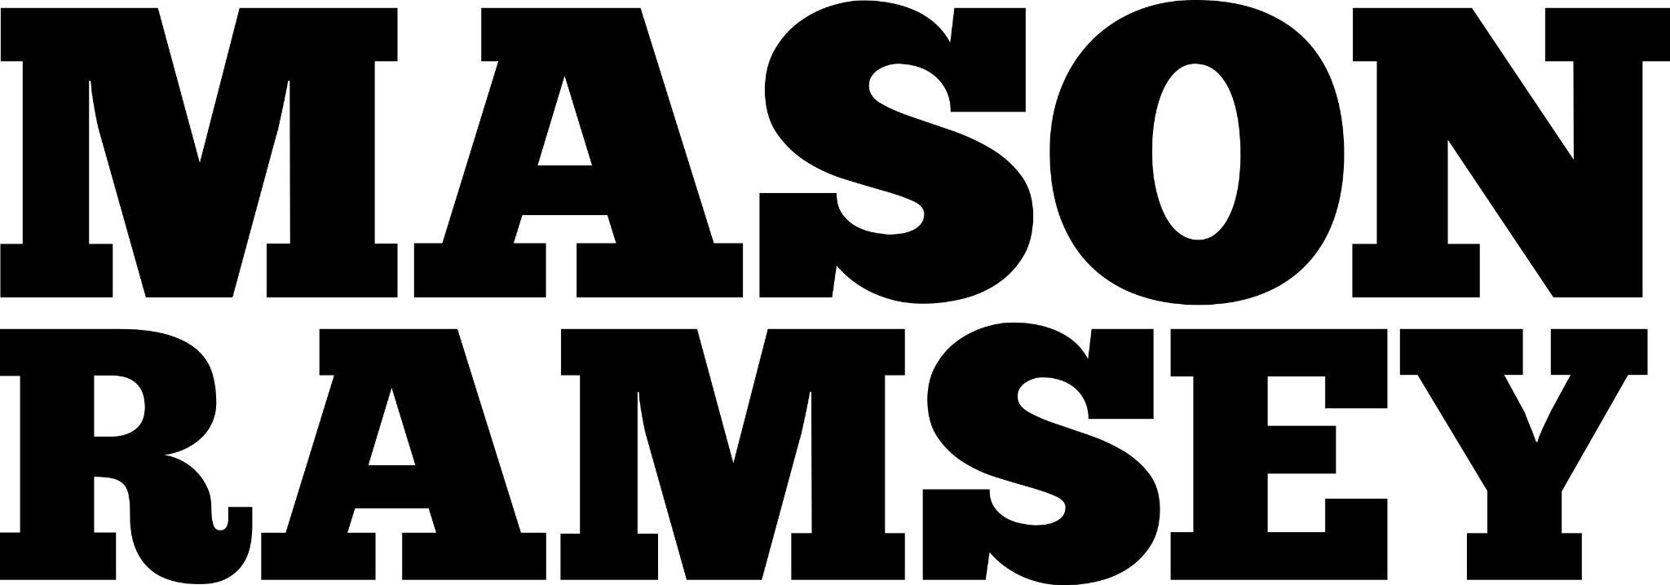

MASON RAMSEY SHARES NEW SONG “SOMETHING YOU CAN HOLD”

LATEST SINGLE CONTINUES THE COUNTRY SINGER’S NEW CHAPTER FOLLOWING FAN-FAVORITE “BLUE OVER YOU”

“SOMETHING YOU CAN HOLD” | “BLUE OVER YOU”

THE COUNTRY SENSATION BOASTS NEARLY HALF A BILLION CAREER STREAMS TO DATE

CURRENTLY TOURING NORTH AMERICA ON HIS SOLD-OUT FALLS INTO PLACE TOUR
& SET TO PERFORM AT CMA FEST THIS SUMMER

“Mason Ramsey is all grown up, and more timeless than ever” - THE TENNESSEAN

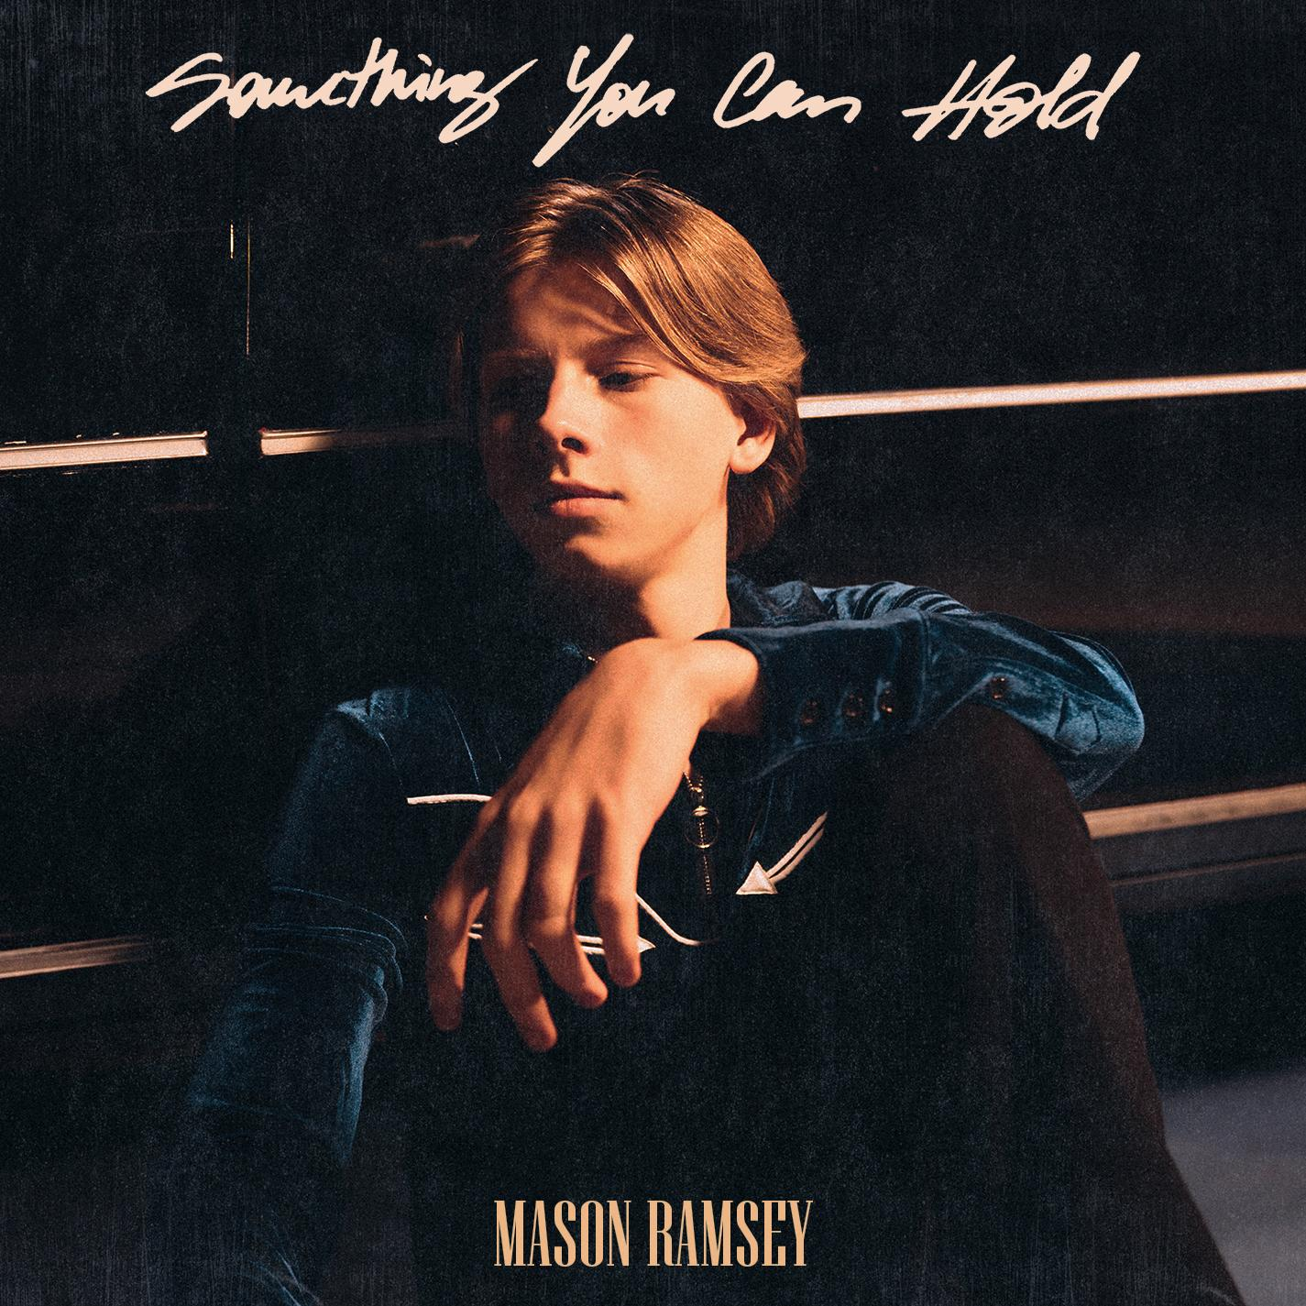
DOWNLOAD PRESS ASSETS HERE

(New York, NY- April 26, 2024) – Country sensation Mason Ramsey shares new single, “Something You Can Hold,” available everywhere now via Atlantic Records.

The new song serves as a follow up to the transformative single, “Blue Over You” which flaunted Mason’s new sound and elevated vocals and has amassed nearly 15M streams worldwide since release.

"Something You Can Hold" is a song of hope and inspiration in this crazy world. Life can throw a lot at you, but we should always push through. It's so important to have people by your side to support you through the ups and downs. I really believe one of life's greatest gifts is having real connections with those around us."
-MASON RAMSEY

Earlier this year, Ramsey embarked on his sold out Falls Into Place tour with stops in New York City, Boston, Philadelphia, Austin and more. The North American tour follows the young sensation’s performances at Europe’s biggest country music festival, C2C: Country to Country alongside the likes of Brad Paisley, Jake Owen, Alana Springsteen and more.

The 15-stop trek served as the follow up of his coming-of-age EP, Falls Into Place. The five-song project marked his first studio collection since 2019, and a new era for the breakout singer-songwriter. Available across all streaming platforms and digital retailers, listen to Falls Into Place here.

On the latest project, Ramsey “sharpened his chops and returned with a deeper voice and some deeper lyrics,” applauds PEOPLE, as proven in the heartfelt hometown ballad “Reasons To Come Home,” the up-tempo romantic fun of “She Got It Outta Me,” and optimistic honky-tonk rocker “Next Right Thing.” Matching coming-of-age themes and personal growth with Ramsey’s famous pure-Country charm, the global star now “older and more reflective,” according to Billboard, is credited as a co-writer on all but one track.

Since catapulting onto the Country music scene as the youngest major label Country artist signed in the genre in nearly two decades at 11, Ramsey has already delivered two acclaimed EPs, earned a Gold-certified single, headlined two tours in addition to supporting a Las Vegas residency, surpassed 300 million global streams since 2018 and has gone viral once again with a nostalgic ‘then & now’ performance clip from the famed Grand Ole Opry stage with over 22 million views.

“Falls Into Place Tour”
*Support from Halle Kearns

MAY
2 - Austin, TX @ 3Ten at ACl Live
3 - Houston, TX @ Bronze Peacock *
4 - Baton Rouge, LA @ Texas Club *
10 - Denver, CO @ Grizzly Rose*
11 - Colorado Springs, CO @ Boot Barn Hall*

JUNE
7 - Nashville, TN @ CMA Fest
15 - Shelbyville, KY

[CREDIT: WORKING HOLIDAY]
DOWNLOAD PRESS ASSETS HERE
# # #

Connect with Mason Ramsey:
INSTAGRAM | TWITTER | FACEBOOK | TIKTOK

For all Mason Ramsey press inquiries, please contact:
Taylor Apel | Taylor.Apel@atlanticrecords.com
Jason Davis | Jason.Davis@atlanticrecords.com

