FOR IMMEDIATE RELEASE
APRIL 10, 2024

ALT-POP RENEGADE NOGA EREZ IS BACK WITH “VANDALIST”

POWERFUL NEW TRACK HERALDS HUGELY ANTICIPATED THIRD STUDIO ALBUM,
DUE LATER THIS YEAR VIA NEON GOLD/ATLANTIC

LISTEN TO “VANDALIST” HERE

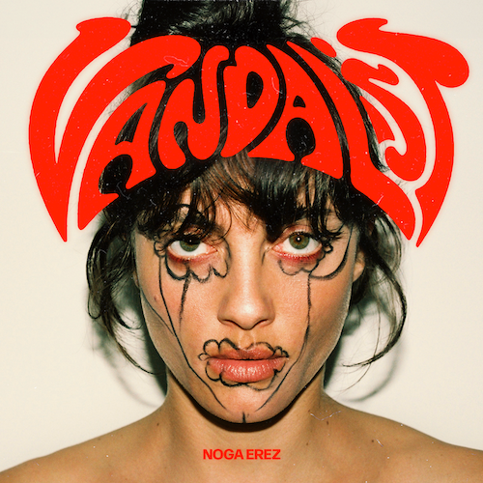
DOWNLOAD HI-RES ASSETS HERE // PRESS PHOTO CREDIT: YANIV EDRY

Alt-pop songstress Noga Erez has shared her powerhouse new single, “Vandalist,” available now via Neon Gold/Atlantic Records HERE. Produced by ROUSSO, Justin Raisen & Erez, “Vandalist” heralds the acclaimed global star’s eagerly awaited third studio album, arriving later this year.

“‘Vandalist’ is a musical middle finger,” says Erez, “a song born out of frustration and a need to vent. This song is my response to those who try to define me based on false assumptions and ignorance. I hope this track resonates with anyone else feeling angry or fed up with the world's hypocrisy.”

“Vandalist” continues a dazzling string of singles from Erez, including the recently released “Come Back Home” and “Quiet,” the latter of which was created by Erez and ROUSSO exclusively for the opening credits to last summer’s Netflix action thriller, Heart of Stone, starring Gal Gadot, Jamie Dornan and Alia Bhatt. The explosive track was met by worldwide praise, with Stereogum hailing it as “marked by classic spy movie elements like surf-rock guitars and sweeping symphonic sounds.”
“Quiet” marked Erez’s first new music since her smash 2022 single, “NAILS,” which premiered on The Zane Lowe Show, followed by a blockbuster new spin featuring 4x GRAMMY® Award-winning superstar Missy Elliott, “NAILS (Feat. Missy Elliott).” The exclusive remix quickly earned critical applause from such outlets as Consequence of Sound, which declared it a “shredding new rendition.”

Noga Erez and ROUSSO first joined forces with 2017’s Off The Radar, earning worldwide acclaim and a fast-growing international fan following. 2021’s KIDS proved a natural evolution and even greater success as well as garnering a legion of famous fans that includes Billie Eilish, Britney Spears, Marion Cotillard, Katy Perry, Hayley Williams, Dove Cameron, Robbie Williams, Sofi Tukker, Meghan Trainor, Gal Gadot, and Finneas, the latter of whom declared it “one of the best albums I’ve ever heard.”

KIDS spawned an array of innovative tracks – including “End of the Road” and “VIEWS (Feat. Reo Cragun & ROUSSO),” which were featured across a wide range of film, TV, and promotional campaigns including NBC’s Good Girls, Apple’s Dickinson, Netflix’s Sex/Life, Russian Doll, Resident Alien, How To Sell Drugs Online (Fast), Orange 5G, Vodafone, ESPN and more.

Erez has cemented her position as a boundary-pushing artist, consistently reinventing herself with each new project. Her live performances are known for their infectious energy and dynamic stage presence, captivating audiences and leaving a lasting impact on all who experience her music first-hand. From sold-out headline concerts (including a packed hometown show at Tel Aviv’s legendary Menora Arena) to show-stopping festival sets at Bonnaroo, Primavera Sound, Austin City Limits, Outside Lands, and Lollapalooza (to name only a few). Named among the rising stars selected to join YouTube Music’s global artist development program, Foundry, Erez marked the exhilarating KIDS with dramatic live performances on ABC’s Jimmy Kimmel Live! and NBC’s The Kelly Clarkson Show, sold-out headline shows at such legendary venues as New York City’s Bowery Ballroom and Los Angeles, CA’s El Rey Theatre, and an unforgettable pair of dates as special guest to Florence and the Machine at NYC’s world-famous Madison Square Garden. Now, with the arrival of “Vandalist” and the promise of her long awaited third album, Noga Erez is poised to affirm her one-of-a-kind place among the innovative and formidable alt-pop artists of the modern era.

CONNECT WITH NOGA EREZ
OFFICIAL SITE | INSTAGRAM | TIKTOK | TWITTER | YOUTUBE

For press inquiries, please contact:
Kelly McWilliam / Kelly.McWilliam@atlanticrecords.com

