FOR IMMEDIATE RELEASE
APRIL 19, 2024

ATLANTIC RECORDS PRESENTS THE NOTEBOOK (ORIGINAL BROADWAY CAST RECORDING)
AVAILABLE NOW ON ALL PLATFORMS

OFFICIAL VIDEO FOR “MY DAYS” PERFORMED BY JOY WOODS ALSO PREMIERES TODAY
WATCH HERE

CAST RECORDING IS THE COMPANION TO THE NEW BROADWAY MUSICAL
BASED ON THE BESTSELLING NOVEL BY NICHOLAS SPARKS
THAT INSPIRED THE BELOVED FILM

NOW PLAYING AT THE SCHOENFELD THEATRE ON BROADWAY,
THE NOTEBOOK FEATURES MUSIC AND LYRICS BY MULTIPLATINUM SINGER-SONGWRITER INGRID MICHAELSON
AND A BOOK BY PLAYWRIGHT BEKAH BRUNSTETTER

INGRID MICHAELSON AND JOY WOODS TO APPEAR ON NBC’S THE KELLY CLARKSON SHOW ON APRIL 25TH

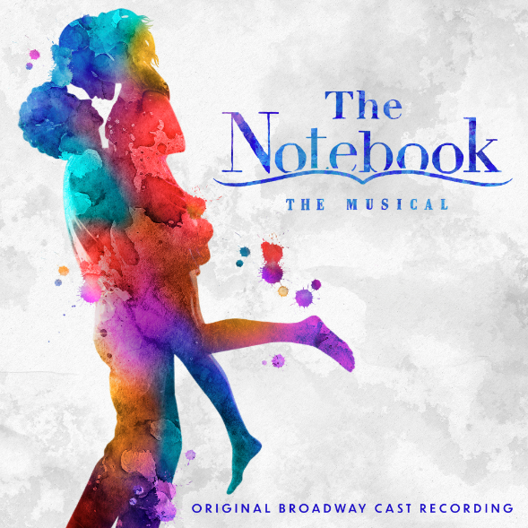
DOWNLOAD ASSETS HERE

Atlantic Records has officially released The Notebook (Original Broadway Cast Recording), the official companion to the acclaimed new musical based on the bestselling novel by Nicholas Sparks that inspired the iconic film, with a score that Vanity Fair calls “strikingly beautiful” by multiplatinum singer-songwriter Ingrid Michaelson, available now HERE.

The Notebook (Original Broadway Cast Recording) includes such highlights as “My Days,” performed by Joy Woods as Middle Allie, and is joined by an official performance video which premiered earlier today on People, directed by Michaelson – Watch HERE. Next week will see Woods perform “My Days,” alongside an interview with Michaelson, on a very special episode of NBC’s The Kelly Clarkson Show, set for Thursday, April 25.

Announced ahead of the show’s opening last month, The Notebook (Original Broadway Cast Recording) was first heralded with “Leave The Light On,” performed by Ryan Vasquez (Hamilton, Waitress), who plays the character of Middle Noah, and the Original Broadway Cast of The Notebook – Listen HERE. The official cast recording arrived alongside an in-studio performance video featuring Vasquez streaming now – Watch HERE.

Now playing at Broadway’s Schoenfeld Theatre, The Notebook features music and lyrics by singer-songwriter Ingrid Michaelson and a book by playwright Bekah Brunstetter (writer and producer on NBC’s This Is Us, The Cake). Produced by Kevin McCollum and Kurt Deutsch, The Notebook is directed by Michael Greif (Dear Evan Hansen, Next to Normal, RENT) and Schele Williams (Aida, The Wiz), with choreography by Katie Spelman (Associate Choreographer on Moulin Rouge! The Musical).

The cast of The Notebook features Tony Award®-winner Maryann Plunkett as Older Allie, Dorian Harewood as Older Noah, Joy Woods as Middle Allie, Ryan Vasquez as Middle Noah, Jordan Tyson as Younger Allie, John Cardoza as Younger Noah, Andréa Burns as Mother/Nurse Lori, Carson Stewart as Johnny/Fin. Playing various roles are Yassmin Alers, Alex Benoit, Chase Del Rey, Hillary Fisher, Jerome Harmann-Hardeman, Dorcas Leung, Happy McPartlin, Juliette Ojeda, Kim Onah, Charles E. Wallace and Charlie Webb.

The Notebook (Original Broadway Cast Recording) continues Atlantic Records’ long-running string of landmark Original Broadway Cast Recordings, including 2015’s GRAMMY® Award-winning, RIAA Diamond-certified milestone, “Hamilton (Original Broadway Cast Recording),”2017’s GRAMMY® Award-winning “Dear Evan Hansen (Original Broadway Cast Recording)“ and 2021’s GRAMMY® Award-winning “Jagged Little Pill (Original Broadway Cast Recording).”

The Notebook marks the first score and Original Cast Recording from Ingrid Michaelson, following nine studio albums and multiple gold and platinum singles over her 17-year career. Her work on The Notebook quickly received acclaim from such outlets as Entertainment Weekly, which raved, “If Michaelson's lyrics alone don't make theatergoers tear up, then her soaring orchestrations certainly will.” “Ingrid Michaelson’s music and lyrics express the gamut of emotions beautifully” wrote New York Stage Review, while the Chicago Tribune noted, “There are two main reasons why this show works. Most important is the songwriter Ingrid Michaelson, who might be a Broadway newcomer but whose lyrics eschew mawkish pitfalls in favor of simple, direct communication of intense but familiar emotions through melody and song.”

“Writing this musical has been one of the greatest joys in my life,” said Michaelson. “I am beyond excited to welcome everyone into our world.”

GRAMMY® Award-winning producer of The Notebook Kurt Deutsch said, “I have been making Original Cast Recordings for the past 25 years, but The Notebook is my first time lead-producing a Broadway show, and has been a labor of love for over eight years. Bringing this cast recording to life, along with Ingrid and our dream team of actors and musicians, is a dream come true.”

“Ever since seeing an early performance of The Notebook in Chicago in 2022, we’ve wanted to work with Ingrid, Kurt, Kevin and their amazing team on this album,” said GRAMMY® Award-winning Atlantic Records President, A&R Pete Ganbarg. ”Ingrid’s music for the show is both emotionally powerful and heartbreakingly beautiful. We can’t wait to share this cast recording with the world.”

ABOUT THE NOTEBOOK THE MUSICAL
Allie and Noah, two people from different worlds, share a lifetime of love despite the forces that threaten to pull them apart in a deeply moving portrait of the enduring power of love. Based on the book that has sold millions of copies worldwide and a film that is one of the highest-grossing romantic dramas of all-time, the musical adaptation of The Notebook comes to Broadway following a critically acclaimed world premiere engagement at Chicago Shakespeare Theater in the fall of 2022. Chris Jones of the Chicago Tribune called The Notebook ”absolutely gorgeous – not to be missed,” and Steven Oxman of the Chicago Sun-Times called it “superb – a stage musical for the ages.”

The Notebook features scenic design by David Zinn and Brett J. Banakis, costume design by Paloma Young, lighting design by Ben Stanton, sound design by Nevin Steinberg, hair and wig design by Mia Neal, and projection design by Lucy Mackinnon. The production’s music supervisor is Carmel Dean, who also collaborated on arrangements with Ingrid Michaelson and on orchestrations with John Clancy, and the music director is Geoffrey Ko. Casting by The Telsey Office, Patrick Goodwin, CSA.

For tickets and more information, visit www.NotebookMusical.com.

CONNECT WITH THE NOTEBOOK THE MUSICAL
WEBSITE | FACEBOOK | INSTAGRAM | TIKTOK | X | YOUTUBE

THE NOTEBOOK (OBCR) PRESS CONTACT:
ANDREW GEORGE | ANDREW.GEORGE@ATLANTICRECORDS.COM

THE NOTEBOOK PRESS CONTACTS:
ADRIAN BRYAN-BROWN | ABROWN@BBBWAY.COM
MICHELLE FARABAUGH | MFARABAUGH@BBBWAY.COM
COLLEEN DONAHUE | CDONAHUE@BBBWAY.COM

