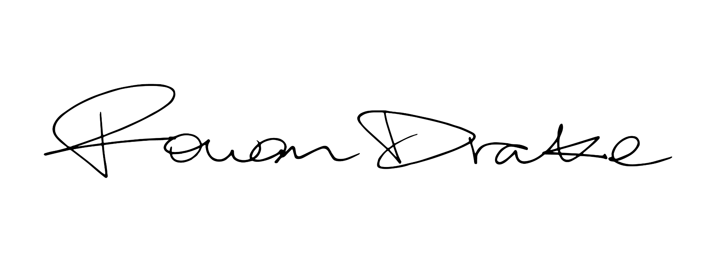

ROWAN DRAKE STEPS INTO A NEW CHAPTER WITH “WHY”

RISING SINGER-SONGWRITER SET TO TOUR ALONGSIDE X AMBASSADORS
KICKING OFF MAY 4TH IN SAN DIEGO

LISTEN TO “WHY” | WATCH OFFICIAL VISUALIZER

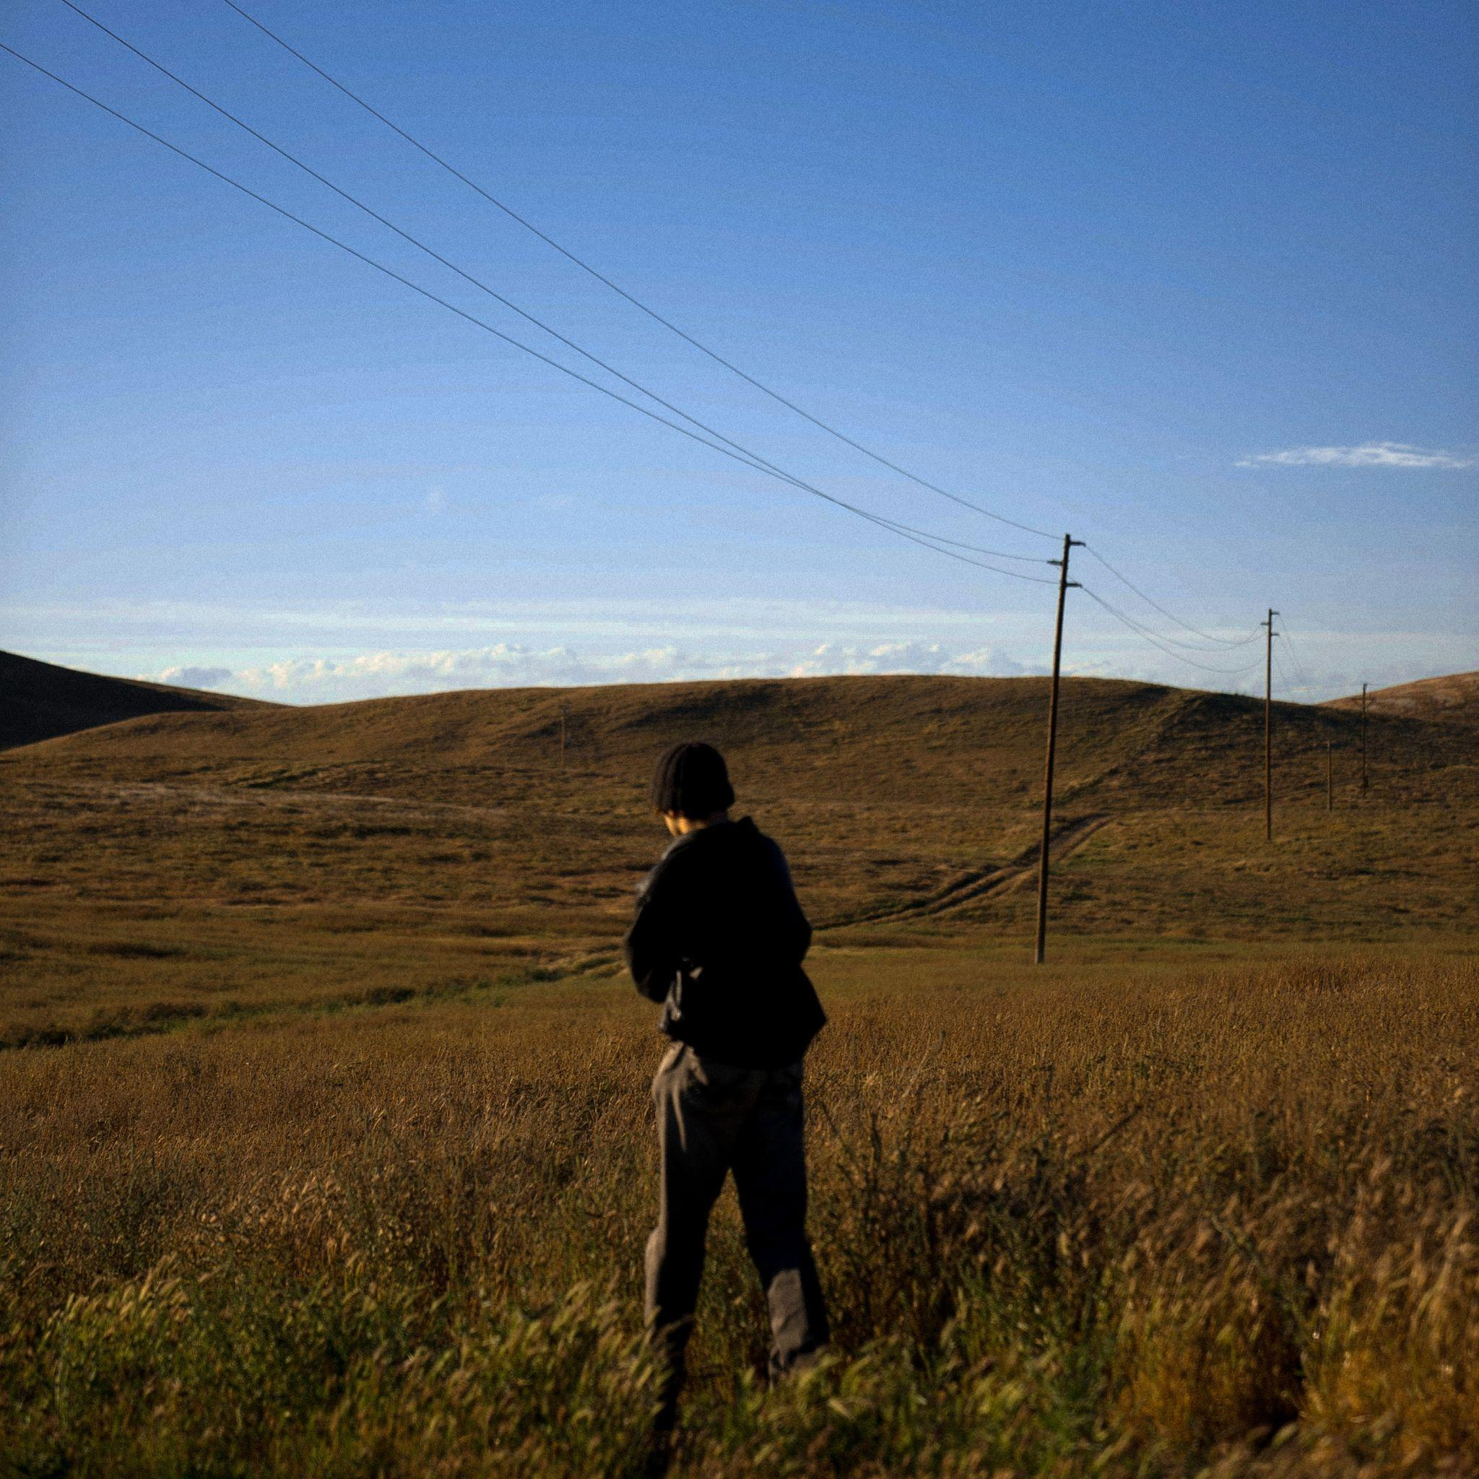
DOWNLOAD PRESS ASSETS HERE

Singer-songwriter Rowan Drake heralds a new chapter with the immersive, heart-rending track, “Why,” produced alongside Jonny Shorr (GAYLE, Catie Turner) and accompanied by an official visualizer - watch HERE.

"'Why’ is the beginning of a chapter of music born from longing and confusion. It’s a pattern I noticed in my life of destroying beautiful things that threatened to occupy the space my past lover holds. Even as she pushes forward with great force into her new life, I seem to cling to her from afar and refuse to allow new people or joys into my life. `Why’ is me questioning my devotion to someone who has clearly chosen to turn away from me. But yet my cycle of holding on continues."
-ROWAN DRAKE

This summer, Rowan will tour alongside the multi-platinum trio, X Ambassadors for the Townie North American Tour kicking off on May 4th in San Diego, CA. See below for full tour routing.

Rowan’s new music follows his debut EP, Dear Ella, featuring heartbreaking and reflective tracks such as “Would You Do It Again?” and “Elephant In The Room” the latter of which was named a “song you need to know” by Rolling Stone.

As he built up his body of work, Rowan has worked with the likes of producer Davin Kingston (John Legend, Joshua Bassett), who helped create the piano-laced and kaleidoscopic sound of “2 People,” and experienced a major breakthrough with “Abandonment Issues”—a quietly spellbinding piece of storytelling, matching his graceful guitar strumming and airy yet potent vocal performance with sudden bursts of hard-hitting beats.

TOWNIE NORTH AMERICAN TOUR
SUPPORTING X AMBASSADORS

May 4 - San Diego, CA @ The Observatory North Park
May 5 - Pioneertown, CA @ Pappy & Harriet’s
May 7 - San Luis Obispo, CA @ Fremont Theater
May 8 - San Francisco, CA @ August Hall
May 10 - Portland, OR @ The Hawthorne Theatre
May 11 - Seattle, WA @ The Showbox
May 13 - Salt Lake City, UT @ The Depot
May 14 - Denver, CO @ The Ogden Theatre
May 15 - Colorado Springs, CO @ Pikes Peak Center
May 17 - Omaha, NE @ Slowdown
May 18 - Minneapolis, MN @ Varsity Theater
May 19 - Des Moines, IA @ Wooly’s
May 21 - Chicago, IL @ House of Blues Chicago
May 22 - Grand Rapids, MI @ Elevation
May 24 - Detroit, MI @ Saint Andrew’s Hall
May 25 - Milwaukee, WI @ The Rave / Eagles Club
May 26 - Cleveland, OH @ House of Blues Cleveland
May 28 - Millvale, PA @ Mr. Smalls Theatre
May 29 - Philadelphia, PA @ Brooklyn Bowl Philadelphia
May 31 - New York, NY @ Irving Plaza
June 1 - Ithaca, NY @ State Theatre of Ithaca
June 2 - Boston, MA @ Paradise Rock Club
June 4 - Washington, DC @ 9:30 Club
June 5 - Norfolk, VA @ The NorVa
June 7 - Charlotte, NC @ The Underground
June 8 - Atlanta, GA @ Buckhead Theatre
June 9 - Nashville, TN @ The Basement East
June 11 - Dallas, TX @ Granada Theater
June 12 - Austin, TX @ Mohawk
June 14 - Phoenix, AZ @ The Van Buren
June 15 - Los Angeles, CA @ The Fonda Theatre

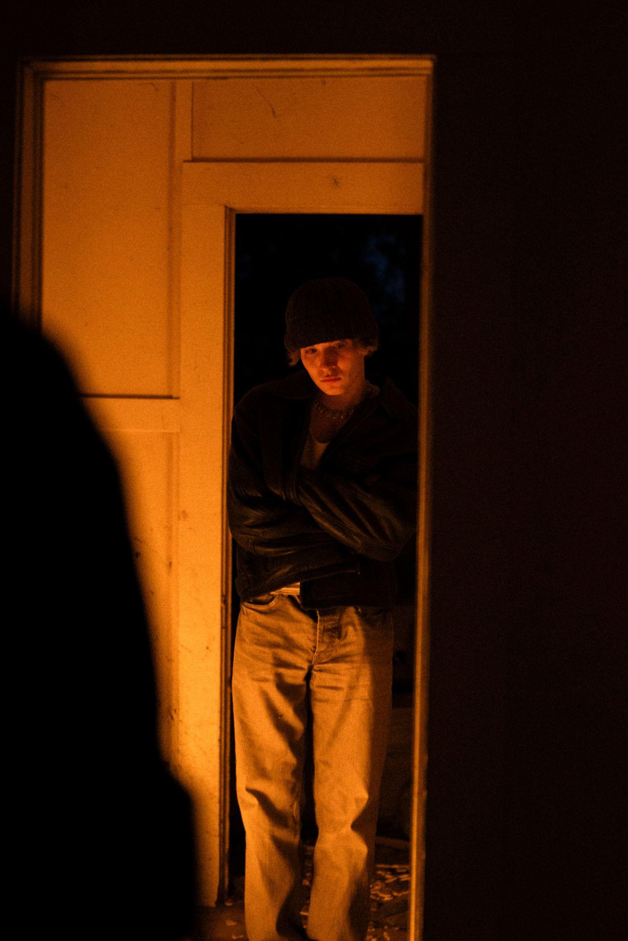
DOWNLOAD PRESS ASSETS HERE
[CREDIT: OMAR GOMEZ]

# # #

ABOUT ROWAN DRAKE
With over 50M global streams to date, rising singer-songwriter Rowan Drake has long used songwriting as a space for transforming his feelings into unexpected beauty. Growing up in the small college town of Ithaca, New York, Rowan first discovered the power of that outlet when, at age 15, a devastating accident ended his dream of becoming a competitive snowboarder. After devoting nearly all his life to his snowboarding career, Rowan began exploring his innate musicality by dreaming up his own hypnotic form of pop – moody, immersive, and fearlessly confessional, merging the intense introspection of classic singer-songwriters with a more forward-thinking sonic aesthetic.

Praised by Billboard for his “feathery vocal approach, paired with meaty guitar strums and canned strings, yielding a surprisingly affecting declaration that doesn’t lose any luster on replay listen,” Rowan’s vulnerable track “Abandonment Issues,” also received a spot on their “10 Cool New Pop Songs,” column. In 2022, Rowan released his heartbreaking and reflective debut EP, Dear Ella, featuring standout tracks “Would You Do It Again?” and “Elephant In The Room” the latter of which was named a “song you need to know” by Rolling Stone.

In 2024, Rowan returns with new music serving as a continuation of his story.

CONNECT WITH ROWAN DRAKE
WEBSITE | FACEBOOK | INSTAGRAM | TIKTOK | YOUTUBE

CONTACT
Taylor Apel | Taylor.Apel@atlanticrecords.com

