SIA AND PARIS HILTON TEAM UP ON
“FAME WON’T LOVE YOU”

SIA’S NEW ALBUM REASONABLE WOMAN DUE OUT MAY 3, 2024

(“Fame Won’t Love You” artwork — download HERE)

Today, Sia and Paris Hilton release their first-ever collaborative track “Fame Won’t Love You.” It follows a run of singles from Sia with other hitmakers like “Incredible” ft. Labrinth and “Dance Alone” ft. Kylie, in addition to the poignant solo ballad “I Forgive You.” All four of these songs are on Sia’s upcoming album Reasonable Woman, out May 3, 2024 via Atlantic Records.

“Fame Won’t Love You” marks the union of two global icons as they create an anthem with a powerful message about prioritizing relationships over fame. On the chorus their distinctive voices join together in an epic fashion as they profess, ”little dreams come crashing / let them wave in passing / because fame won’t love you like a mother, like a brother should.” This is just the start of their working relationship as Sia serves as executive producer of Paris’ upcoming album.

CLICK HERE TO LISTEN TO “FAME WON’T LOVE YOU”
CLICK HERE TO PRE-SAVE REASONABLE WOMAN

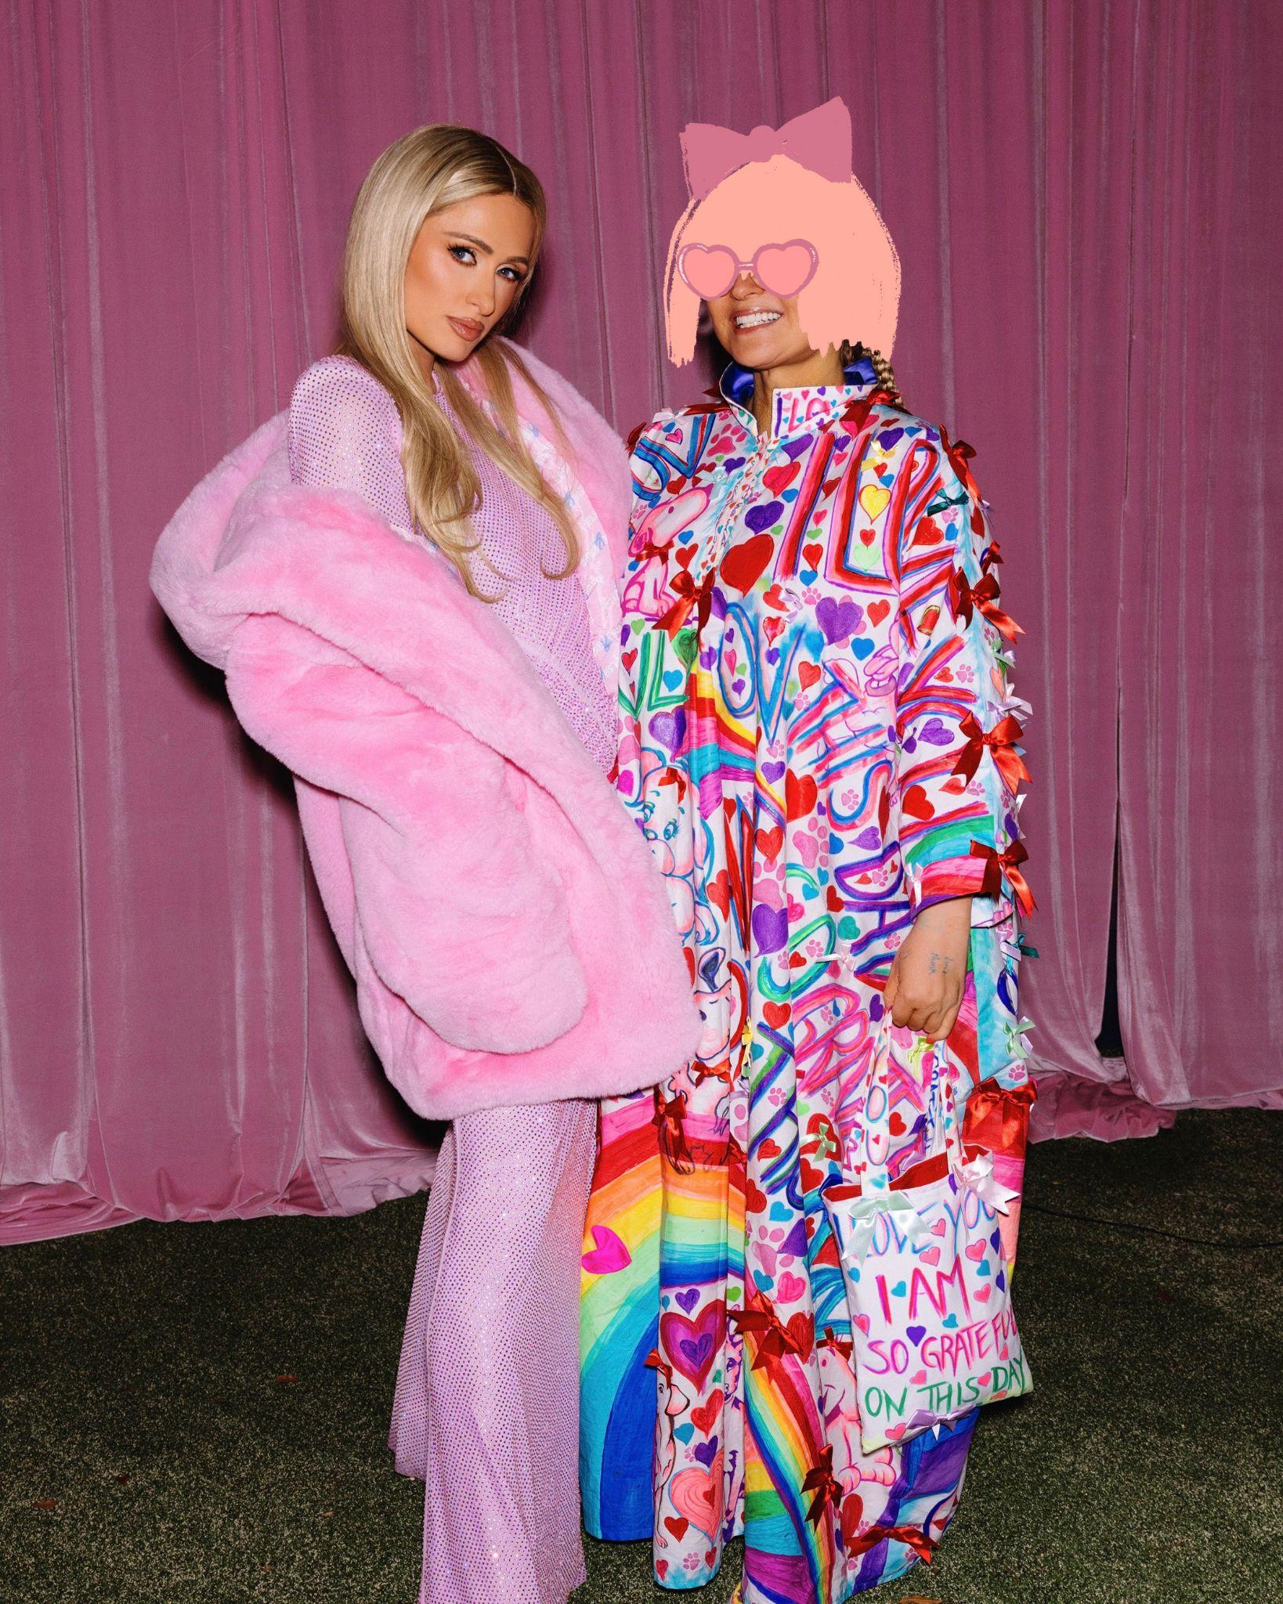
(Sia & Paris press photo, Courtesy of Sia — download HERE)

There is no artist in the world like Sia. Try to think about an artist who transformed from an in-demand indie pop vocalist and chanteuse into a global pop superstar more than a decade into their career. Try to imagine that same global pop superstar writing and producing music for many of the other most iconic stars of our time. And then let yourself think about how Sia Furler has racked up more worldwide streams and hits (6 in the “Billions Club” on Spotify, and counting...) all while never showing her face, never compromising her artistic vision, and never letting anyone else define pop stardom for her.

It’s staggering to imagine any artist doing just one of these things, let alone all of them, over the course of a career that continues to reach new heights. It’s worth repeating: there is no artist in the world like Sia.

Her career trajectory is itself a phenomenon. Starting out in Australia, Sia’s artistic life took a number of twists and turns to put her on the world stage, from singing with Zero 7 to soundtracking the finale scene of HBO’s beloved show Six Feet Under, to writing, co-writing, and featuring on songs for other artists, including Beyoncé, Rihanna, David Guetta, Flo Rida. (It should be noted: all of these artists had massive, chart-topping hits in collaboration with Sia.)

Her song “Chandelier,” from 2014’s Grammy-nominated 1000 Forms Of Fear, not only changed the way pop music sounds, but it revolutionized the art of music video with the groundbreaking clip starring Maddie Ziegler. More worldwide smashes followed in quick succession: “Elastic Heart,” “Big Girls Cry,” “Alive,” “Together,” “Dusk ’Til Dawn” with Zayn, and “Cheap Thrills” - a Billboard number one single for 8 nonconsecutive weeks.

Over 50 billion audio streams don’t lie. Her Christmas album, released in 2017, has one of the top 10 most streamed holiday songs of all time. She directed her first feature film, titled Music, in 2021, and in 2022, a song from 2016’s This Is Acting - “Unstoppable” - became a viral sensation, pushing it past a billion plays on Spotify and onto the charts again in multiple countries around the world seven years after its release. Meanwhile, Sia co-wrote songs for global artists like Miley Cyrus, Diljit, and more. Her songs continue to soundtrack film and TV across the world, and she even managed to reward Survivor contestants.

And now - there is Reasonable Woman, Sia’s first proper album since 2016. In addition to the guest vocalists, the album was created with a myriad of incredible collaborators, producers, co-writers, engineers, a who’s who of the pop landscape. The list includes: Jesse Shatkin, Greg Kurstin, benny blanco, Jim-E Stack, Rosalía, bülow, Mark “Spike” Stent, and more.

(Sia press photo, Courtesy of Sia — download HERE)

Reasonable Woman track listing:
- Little Wing
- Immortal Queen (feat. Chaka Khan)
- Dance Alone (Sia and Kylie Minogue)
- I Had A Heart
- Gimme Love
- Nowhere To Be
- Towards The Sun
- Incredible (feat. Labrinth)
- Champion (feat. Tierra Whack, Kaliii, Jimmy Jolliff)
- I Forgive You
- Wanna Be Known
- One Night
- Fame Won’t Love You (feat. Paris Hilton)
- Go On
- Rock and Balloon

SIA:
Instagram * TikTok * X * Facebook * Website

