FOR IMMEDIATE RELEASE
APRIL 19, 2024

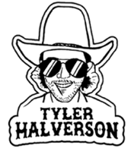

TYLER HALVERSON LIGHTS UP WESTERN AMERIJUANA (PART 1)

SOUTH DAKOTA TROUBADOUR FOLLOWS FIRST-EVER GRAND OLE OPRY PERFORMANCE
WITH EAGERLY AWAITED DEBUT EP

NONSTOP LIVE SCHEDULE FEATURES HEADLINE DATES, FESTIVAL APPEARANCES (INCLUDING BONNAROO),
AND SHOWS ALONGSIDE HANK WILLIAMS JR., TURNPIKE TROUBADOURS,
LUCERO, MUSCADINE BLOODLINE, AND MORE
LISTEN TO WESTERN AMERIJUANA (PART 1)

WATCH “GOOD GRACES” OFFICIAL VISUALIZER | WATCH “FLY OVER ME ANGEL” OFFICIAL VISUALIZER

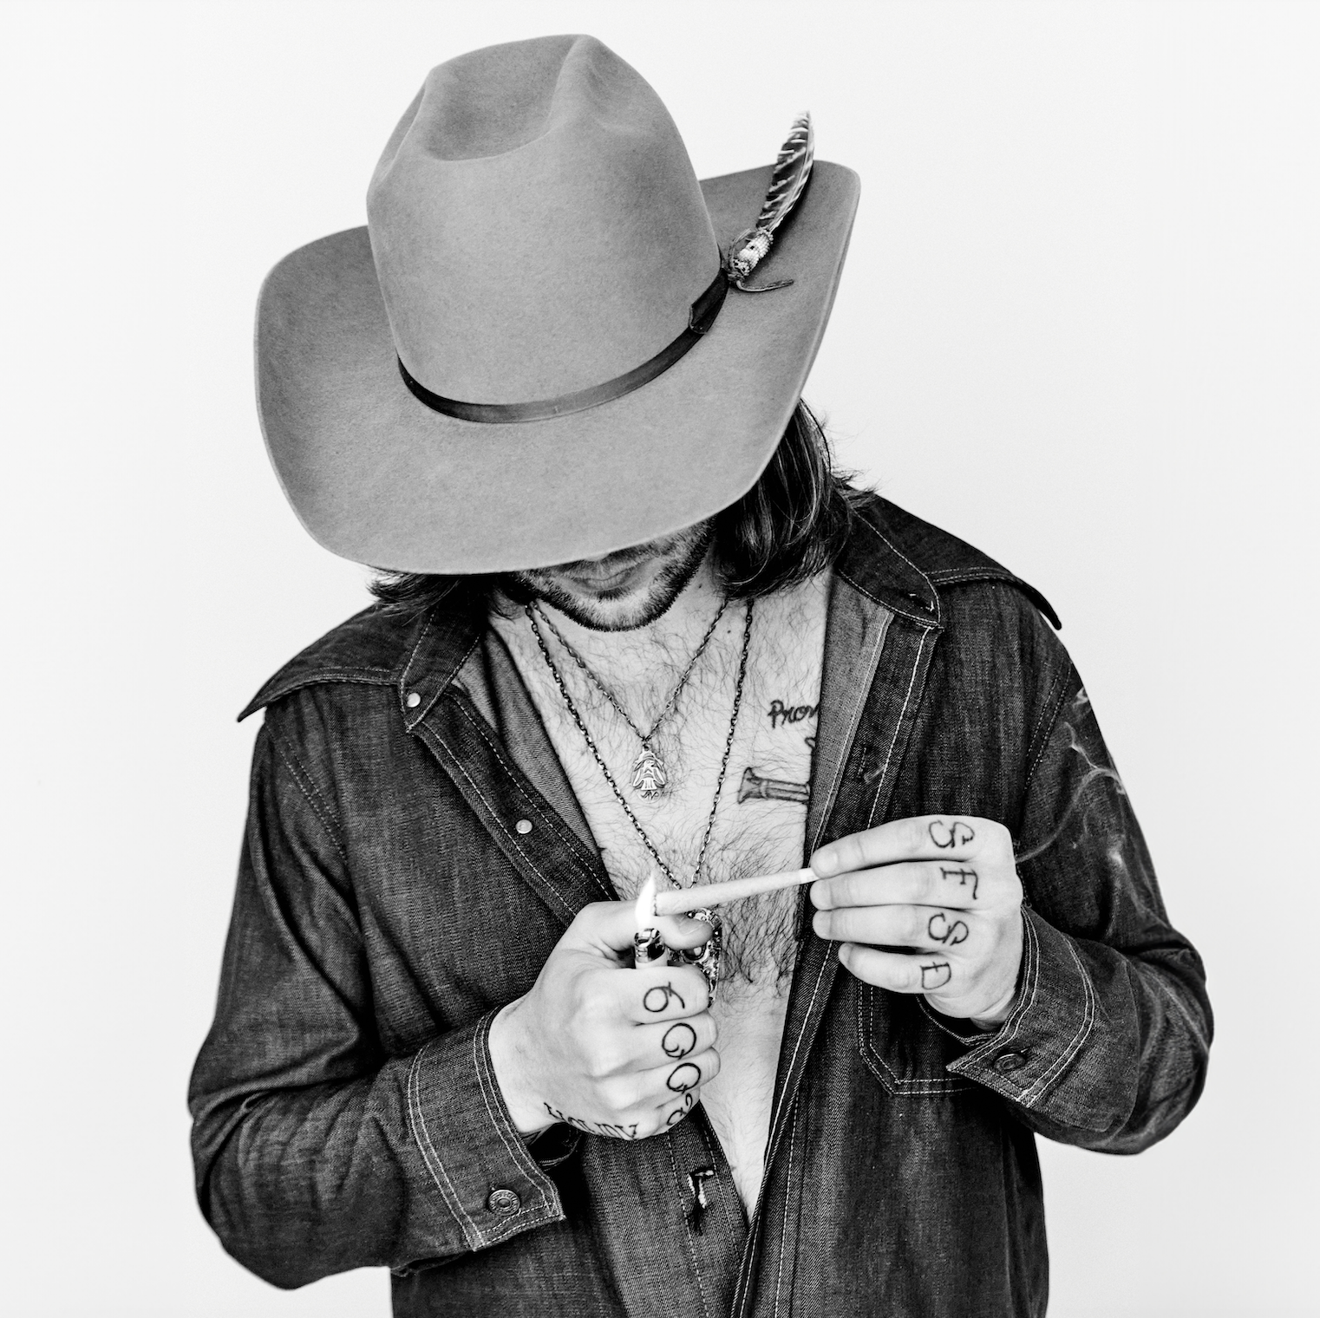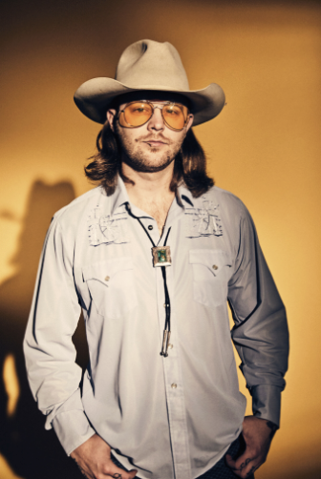
DOWNLOAD ASSETS HERE

“Tyler Halverson knows how to infuse his folk/country/rock songs with a little bit of psychedelia…This guy has been on a roll and he’s only gonna keep rising.” – BROOKLYN VEGAN

South Dakota troubadour Tyler Halverson has shared his eagerly awaited debut EP, Western Amerijuana (Part 1), available everywhere now via Atlantic Records HERE. The project includes such new songs as “Fly Over Me Angel” and “Good Graces,” both joined by official visualizers premiering today at YouTube HERE.

“‘Good Graces’ is one of those songs that came from conversation,” says Halverson of the latter. “I had asked an old guy at a bar once what he had been up to, and all he said was praying for rain. That rain waters his crops and livestock and lets him provide for his family. This one’s about the hard work, patience and prayers it takes to be a farmer and rancher.”

Western Amerijuana (Part 1) continues what is proving a banner year for Halverson, including his first-ever performance earlier this week at Nashville’s Grand Ole Opry alongside Jelly Roll, Kelsea Ballerini and country icons Terri Clark and Gary Mule Deer. 2024 has already seen such acclaimed singles as “Anybody But You” – co-written with the late singer-songwriter/musician Keith Gattis (Dwight Yoakam, George Strait, Kenny Chesney – and “Takes 8,” the latter praised by Whiskey Riff as “the ideal rodeo anthem” and joined by both an official music video (streaming HERE) and acoustic studio performance (streaming HERE). Last year saw such acclaimed releases as “Tiffany Blue” (his duet with rising country singer-songwriter Carter Faith), “Yella Rose,” “As They Did,” “Her,’ “Cut You Loose,” and the boisterous “Run Wild,” all joined by official music videos streaming HERE.

Hailed by Country Swag as “the real deal,” Halverson – who last month was among the stars performing at Willie Nelson’s annual Luck Reunion in Luck, TX – will continue to spend much of his life on the road, with headline dates, festival appearances (including Manchester, TN’s Bonnaroo on June 16) and shows along such like-minded artists as Hank Williams Jr., Turnpike Troubadours, Lucero, Muscadine Bloodline, and more. For updates, please visit tylerhalverson.com/shows.

ABOUT TYLER HALVERSON
Born and raised in the tiny town of Canton, SD (pop. 3054), Tyler Halverson isn’t just any cowboy. He’s got the hat and the boots, but he also plays a mean guitar and writes an even meaner tune. He has no problem bouncing around the country chasing adventure and is telling his different kind of cowboy tale with his self-described “Western Amerijuana Music,” bridging honest storytelling with songcraft inspired by country powerhouses Garth Brooks, George Strait, and Hayes Carll as much as Boyz II Men, Taking Back Sunday, and The Used.

Halverson fell in thrall to music at an early age, receiving his first guitar while in middle school. A local bluegrass festival convinced him to focus on music, throwing down at 4H and FFA festivals before heading to Nashville to attend the prestigious Belmont University. Upon graduation, he decided to hit the road and spent an extended run traveling around South Dakota, Montana, and Wyoming, all the while writing and playing his songs on social media. Halverson’s original approach caught fire with a string of independent releases including “Beer Garden Baby,” “Mac Miller,” and “Your Bar Now” (with Kylie Frey), amassing tens of millions of streams. Now, with Western Amerijuana (Part 1) and more new music still to come, Tyler Halverson is eager to take the next step on what has already proven an amazing journey.

“I’m finding myself,” says Tyler Halverson. “I feel like I’m an artist and I’m finally about to do something.”

# # #

TYLER HALVERSON
ON TOUR 2024

APRIL
19 – Durant, OK – Gilley's Stage, Choctaw Casino
20 – Manhattan, KS – The Hat
25 – Lubbock, TX – Blue Light
26 – Stephenville, TX – Larry Joe Taylor's Texas Music Festival †

MAY
4 – Indianola, IA – Spring Revelry †
11 – Sealy, TX – Cat Spring Hall *
17 – Raleigh, NC – Coastal Credit Union Music Park at Walnut Creek ^
18 – Bristow, VA – Jiffy Lube Live ^
30 – Nashville, TN – The Basement East *
31 – Chicago, IL – The Salt Shed Outdoors (Fairgrounds) #

JUNE
8 – Deadwood, SD – Holiday Inn Resort Deadwood Mountain Grand **
14 – Los Angeles, CA – The Regent ^^
16 – Manchester, TN – Bonnaroo Music & Arts Festival †
21 – Helotes, TX – John T. Floore’s Country Store
29 – Midlothian, TX – Union 28

JULY
19 – Wichita, KS – The Cotillion ^^
27 – Harrington, DE – Delaware State Fairgrounds ##

AUGUST
2 – Isle of Palms, SC – The Windjammer ^^
3 – Isle of Palms, SC – The Windjammer ^^
10 – Norfolk, VA – The NorVa ^^
15 – St Louis, MO – The Factory ##
16 – Bonner Springs, KS – Azura Amphitheater ##

† Festival Appearance
* w/ Carson Jeffrey
^ w/ Hank Williams Jr.
# w/ Turnpike Troubadours and Lucero
** w/ Ian Munsick
^^ w/ Muscadine Bloodline
## w/ Turnpike Troubadours

# # #

CONNECT WITH TYLER HALVERSON
OFFICIAL | FACEBOOK| INSTAGRAM | TIKTOK | TWITTER | YOUTUBE | LINKTREE

PRESS CONTACT
Jessica Nall // Jessica.Nall@atlanticrecords.com

