THE MARÍAS ANNOUNCE NEW ALBUM SUBMARINE OUT MAY 31ST
PRE-SAVE THE ALBUM HERE

NEW SINGLE “RUN YOUR MOUTH” OUT NOW
LISTEN HERE
WATCH OFFICIAL VIDEO HERE

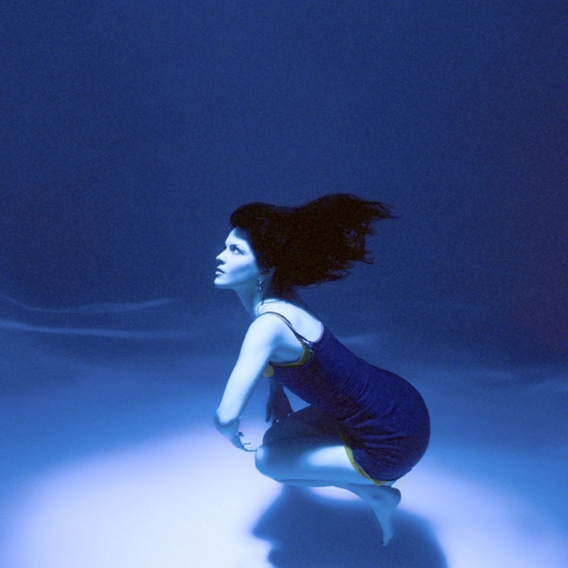
Photo credit: Bethany Vargas
(March 7, 2024) - Today, Grammy-nominated band The Marías announce their highly-anticipated return with sophomore album Submarine set for release on May 31st – pre-save the album here. Along with the special announcement, the band released their new single “Run Your Mouth'' from the forthcoming album via Nice Life Recording Company/Atlantic Records – listen here and watch the official video here. The video was directed by long-time collaborator Bethany Vargas with creative direction by Bethany Vargas, María Zardoya and Josh Conway.

Submarine represents themes of solitude and exploration for The Marías, delving into the complexities of human emotion and what it means to choose solitude, and the pain and beauty so inextricably interwoven within it. New single “Run Your Mouth” is just the first introduction into the band’s immersive world inspired by this album.

On the release of “Run Your Mouth” María shares, “This was one of the first songs Josh and I wrote on Submarine. I was conflict avoidant at the time and whenever someone wanted to talk about something serious, I’d run and hide. I learned that was a protective mechanism and I didn’t have the capacity to open up. There’s no other song on the album like it, hope you dance to this one.”

Submarine is a follow up to the band’s critically acclaimed GRAMMY-nominated debut album Cinema (2021), with lead single “Hush” going No.1 on Billboard’s Adult Alternative Airplay chart. Known for delivering striking visuals that compliment their dreamlike songs, the band continues to create a unique and transformative experience for fans and audiences alike.

*The “Run Your Mouth” video made its broadcast premiere on MTV Live, MTVU, MTV Biggest Pop and on the Paramount Times Square billboards today.

Listen/Watch “Run Your Mouth” and keep an eye out for more from The Marías soon!

Photos by Bethany Vargas
Click HERE to download hi-res

###

FOLLOW THE MARÍAS
INSTAGRAM
X
TIKTOK
YOUTUBE

About The Marías
The Marías are the Grammy-nominated psychedelic-soul lovechild of Puerto Rican-bred, Atlanta-raised María Zardoya and Los Angeles native, Josh Conway. The two are joined by their closest friends, Jesse Perlman on guitar and Edward James on keys. Their undeniably intuitive musical chemistry can be heard in the band’s smooth rendezvous of jazz percussion, hypnotic guitar riffs, smoke-velvet vocals and nostalgic horn solos. There’s something undeniably sensual in their dreamlike fusion of jazz, psychedelia, funk and lounge. Since the release of their critically acclaimed debut album, Cinema, The Marías have earned the reputation behind their impressive upward trajectory, including two Grammy nominations, a Billboard chart-topper and collaborations with some of the biggest names in Latin music, including Bad Bunny and Tainy. In the live show, The Marías are joined by Gabe Steiner on trumpet and Doron Zounes on bass. The detail that has defined their cinematic style off-stage is brought to life during their live performance as the group delivers striking visuals that beautifully compliment their dreamlike songs, creating an indisputably unique and seemingly transportive experience.

The Marías Contacts:
Kristin Somin
Kristin.Somin@ledecompany.com
Viveca Ortiz-Torres
Viveca.Ortiz-Torres@ledecompany.com
Libby Kober
Libby.Kober@atlanticrecords.com

