FOR IMMEDIATE RELEASE
APRIL 26, 2024

WALLOWS UNVEIL “BAD DREAM,”

THE LATEST SINGLE FROM THEIR EAGERLY AWAITED NEW ALBUM, MODEL,
ARRIVING VIA ATLANTIC RECORDS ON FRIDAY, MAY 24

PRE-ORDER/PRE-SAVE NOW HERE

MODEL TOUR GETS UNDERWAY AUGUST 6 IN PORTLAND, OR

LARGEST GLOBAL HEADLINE RUN TO DATE INCLUDES STOPS AT SUCH ICONIC VENUES AS
MADISON SQUARE GARDEN, RED ROCKS, KIA FORUM, ALEXANDRA PALACE,
ZÉNITH, AND MARGARET COURT ARENA

LISTEN TO “BAD DREAM” HERE

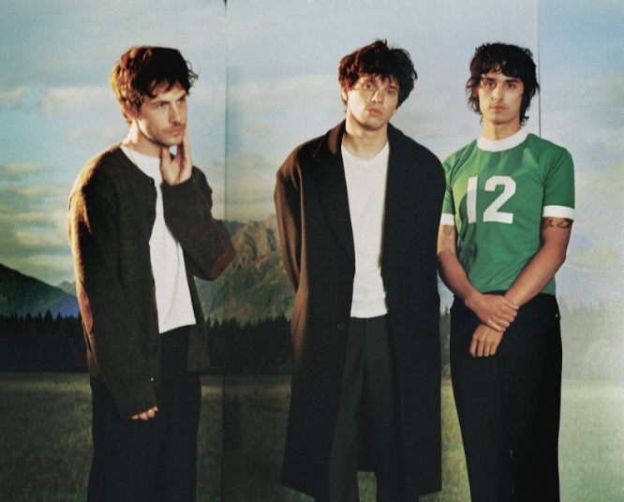
DOWNLOAD HI-RES PRESS PHOTO
CREDIT: AIDAN ZAMIRI

Multi-Platinum alt-rock trio Wallows have shared “Bad Dream,” the latest single from their eagerly awaited third studio album, Model – LISTEN HERE.

Produced by GRAMMY® Award-winner John Congleton, Model arrives Friday, May 24 via Atlantic Records. Pre-orders/pre-saves are available now HERE and an official album trailer is streaming HERE. Model was announced in February alongside “Your Apartment,” the band’s first single since 2022. It was co-written by Wallows and Nate Mercereau (André 3000, Shawn Mendes) and is joined by an official music video, directed by longtime collaborator Nina Ljeti (Phoebe Bridgers, Crowded House) – WATCH HERE.
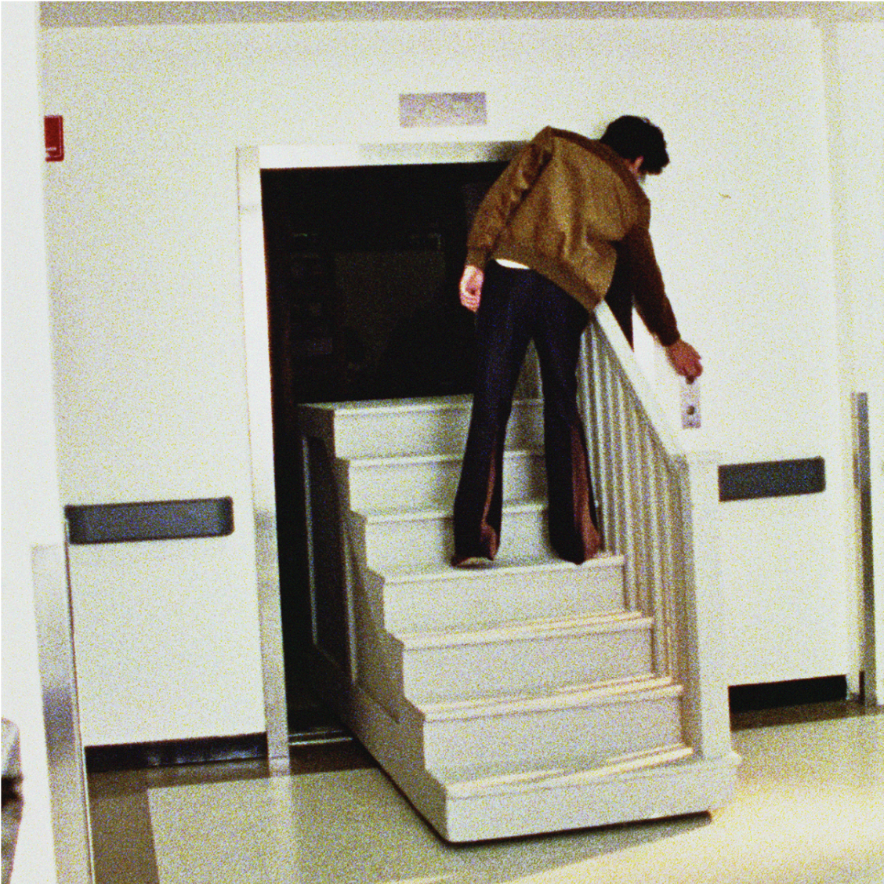
DOWNLOAD HI-RES ARTWORK
CREDIT: AIDAN ZAMIRI

Last month the band also released another Model track, “Calling After Me,” which is accompanied by an official music video directed by Bradley Calder (SZA, Justin Timberlake, Jean Dawson). The video is streaming HERE, following an exclusive broadcast premiere on MTV Live, MTVU, MTV Biggest Pop and on the Paramount Times Square billboards.

Model will be available alongside vinyl variants highlighted by three new web store exclusive variants with three alternate covers – each featuring one of the band members’ photos, an exclusive 7-inch with a different bonus track for all three, unique poster with the corresponding band members’ image, and a slipmat, as well as a different color vinyl record for each (either apple, lemon or tangerine). Wallows has also revealed “Horizon” colored vinyl (Solid Orchid & Translucent Orange Crush) available at Independent Record Stores, “Dusk” vinyl (Translucent Ruby & Translucent Grape) for Urban Outfitters, Translucent Sea Blue for Barnes & Noble, and Solid White with Sunset Image Labels for Amazon. All of this is in addition to the previously announced standard clear vinyl, limited edition “Sunset” vinyl (Lemon, Tangerine & Apple three-color mix) available exclusively in Wallows’ web store, CD, and clear cassette.

Last weekend saw Wallows celebrating the five-year anniversary of their 2019 breakthrough debut album, Nothing Happens, with a special Record Store Day 2-LP vinyl edition housed in a gatefold package featuring new artwork, an exclusive 12 x 24 poster, and a resequenced tracklist featuring every song from the original album session including the previously unreleased “Bad Remake.”

WALLOWS
Model
(Atlantic Records)

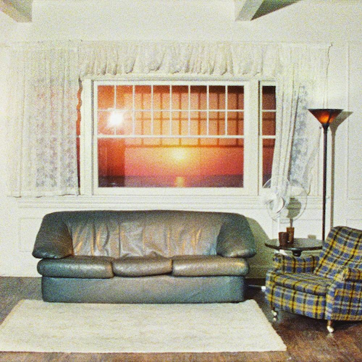

Tracklist:
1. Your Apartment
2. Anytime, Always
3. Calling After Me
4. Bad Dream
5. A Warning
6. I Wouldn’t Mind
7. You (Show Me Where My Days Went)
8. Canada
9. Don’t You Think It’s Strange?
10. She’s an Actress
11. Going Under
12. Only Ecstasy

# # #

Wallows will celebrate Model and much more on their biggest global headline tour thus far. The Model Tour gets underway August 6 at Alaska Airlines’ Theater of the Clouds in Portland, OR and travels throughout North America, Europe, the United Kingdom, Australia and New Zealand into December. The 45-city run will see Wallows making their debut performances at some of the world’s most famous venues, including New York City’s Madison Square Garden (August 23), Toronto, ON’s Budweiser Stage (August 30), Morrison, CO’s Red Rocks Amphitheatre (September 5), Los Angeles, CA’s Kia Forum (September 12), Amsterdam, Netherlands’ AFAS Live (October 4), Paris, France’s Zénith (October 5), London, England’s historic Alexandra Palace (October 22) and Melbourne, Australia’s Margaret Court Arena (December 9). Special guest BENEE supports on all North American dates. Model Tour was announced earlier this month with a spectacularly eerie short film, shot by Ljeti at Los Angeles’ Kia Forum and co-starring Wallows along with some of their closest friends, streaming HERE. For more information, please see wallowsmusic.com.

Two exclusive VIP packages are also available for fans to take their Model Tour experience to the next level. Gold and Silver packages vary based on offer selected but include premium tickets, signed screen printed poster, VIP tote bag, VIP playing card set, early entry to the venue, and more. For more information, visit www.vipnation.com/tour/model-tour-2024.

WALLOWS
MODEL TOUR 2024

AUGUST
6 – Portland, OR – Alaska Airlines’ Theater of the Clouds *
7 – Vancouver, BC – Doug Mitchell Thunderbird Sports Centre *
8 – Seattle, WA – WAMU Theater at Lumen Field *
9 – Boise, ID – Treefort Music Hall *
11 – Las Vegas, NV – The Chelsea at the Cosmopolitan *
12 – Phoenix, AZ – Arizona Financial Theatre *
13 – Albuquerque, NM – Revel Entertainment Center *
15 – Austin, TX – Moody Center *
16 – Irving, TX – The Pavilion At Toyota Music Factory *
17 – Houston, TX – Smart Financial Centre *
19 – Atlanta, GA – Cadence Bank Amphitheatre at Chastain Park *
20 – Nashville, TN – Ascend Amphitheater *
22 – Columbia, MD – Merriweather Post Pavilion *
23 – New York, NY – Madison Square Garden *
24 – Philadelphia, PA – TD Pavilion at The Mann *
26 – Boston, MA – MGM Music Hall at Fenway * (SOLD OUT)
27 – Boston, MA – MGM Music Hall at Fenway *
28 – Laval, QC – Place Bell *
30 – Toronto, ON – Budweiser Stage *
31 – Sterling Heights, MI – Michigan Lottery Amphitheatre *
SEPTEMBER
2 – Chicago, IL – Huntington Bank Pavilion at Northerly Island *
3 – Saint Louis, MO – Saint Louis Music Park *
5 – Morrison, CO – Red Rocks Amphitheatre *
6 – Sandy, UT – The Plaza at America First Field *
8 – San Francisco, CA – Bill Graham Civic Auditorium *
9 – Santa Barbara, CA – Santa Barbara Bowl *
10 – San Diego, CA – Cal Coast Credit Union Open Air Theater *
12 – Los Angeles, CA – Kia Forum *

OCTOBER
4 – Amsterdam, Netherlands – AFAS Live
5 – Paris, France – Zénith
7 – Brussels, Belgium – Ancienne Belgique (SOLD OUT)
8 - Brussels, Belgium – Ancienne Belgique
10 – Cologne, Germany – Palladium
11 – Berlin, Germany – Columbiahalle
12 – Luxembourg, Luxembourg – Den Atelier
14 – Birmingham, UK – O2 Academy
15 – Edinburgh, UK – O2 Academy (SOLD OUT)
16 – Edinburgh, UK – O2 Academy
18 – Newcastle, UK – O2 City Hall
19 – Manchester, UK – O2 Victoria Warehouse (SOLD OUT)
20 – Manchester, UK – O2 Victoria Warehouse
22 – London, UK – Alexandra Palace

DECEMBER
5 – Perth, Australia – Fremantle Arts Centre
7 – Adelaide, Australia – Adelaide Entertainment Centre Theatre
9 – Melbourne, Australia – Margaret Court Arena
12 – Sydney, Australia – Hordern Pavilion
14 – Brisbane, Australia – Riverstage
17 – Wellington, New Zealand – TSB Arena
18 – Auckland, New Zealand – Spark Arena

* w/ Special Guest BENEE

# # #

ABOUT WALLOWS:
Wallows – Dylan Minnette, Braeden Lemasters, and Cole Preston – have been best friends since they began playing music together at the age of 11 in the Los Angeles music program, Join the Band, almost two decades ago. The band made a blockbuster full-length debut with 2019’s Nothing Happens, which proved one of that year’s highest streamed debuts, fueled in part by the 2x RIAA platinum hit single, “Are You Bored Yet? (Feat. Clairo).” 2022 saw the arrival of Wallows’ sophomore album, Tell Me That It’s Over, produced by 3x GRAMMY® Award-winner Ariel Rechtshaid (Vampire Weekend, Haim, Adele). The album proved among the year’s highest streaming debut and made a top 5 debut on Billboard’s “Top Alternative Albums” chart while earning applause for its vast array of musical ideas, fusing lo-fi post-punk, indie-folk, early ’90s dance-pop psychedelia, and more into the band’s own one-of-a-kind creative vision. As ambitious and successful on stage as in the studio, Wallows traveled the world with sold-out headline shows in North America, Europe, the United Kingdom, Asia, and Australia/New Zealand, alongside top-billed festival sets at Bonnaroo, Lollapalooza, Reading & Leeds, Austin City Limits Music Festival, and more.

# # #

CONNECT WITH WALLOWS
WALLOWSMUSIC.COM | FACEBOOK | INSTAGRAM | TIK TOK | TWITTER | YOUTUBE | PRESS SITE

PRESS CONTACTS
Corey Brewer | corey.brewer@atlanticrecords.com
Kelly McWilliam | kelly.mcwilliam@atlanticrecords.com
Gabrielle Reese | gabrielle.reese@atlanticrecords.com

