WALLOWS PREMIERE OFFICIAL MUSIC VIDEO
FOR LATEST SINGLE “CALLING AFTER ME”

NEW ALBUM MODEL ARRIVES MAY 24TH
PRE-ORDER/PRE-SAVE NOW HERE

MODEL TOUR GETS UNDERWAY AUGUST 6 IN PORTLAND, OR

LARGEST GLOBAL HEADLINE TOUR TO DATE INCLUDES STOPS AT ICONIC VENUES SUCH AS
MADISON SQUARE GARDEN, RED ROCKS, KIA FORUM, ALEXANDRA PALACE, ZENITH & MARGARET COURT ARENA

WATCH OFFICIAL MUSIC VIDEO HERE

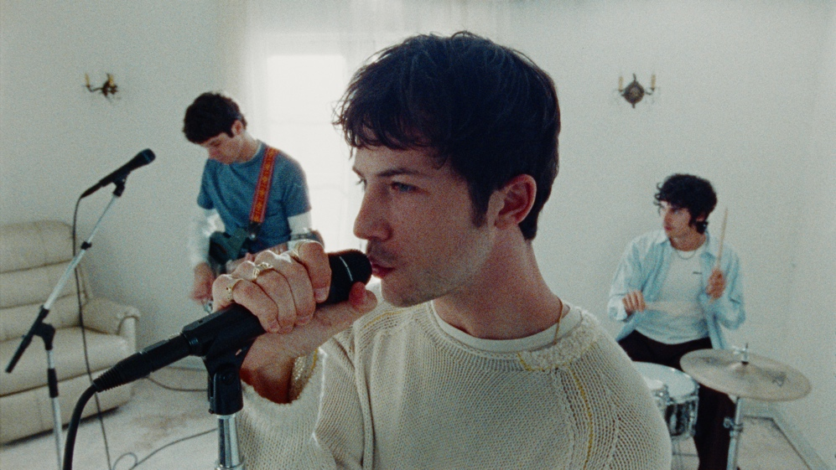

Multi-platinum alt-rock trio Wallows have shared the official music video for “Calling After Me,” the latest single from their eagerly awaited third studio album, Model - WATCH HERE. The video, directed by Bradley Calder (SZA, Justin Timberlake, Jean Dawson), made its broadcast premiere on MTV Live, MTVU, MTV Biggest Pop and on the Paramount Times Square billboards today.

The John Congleton-produced album, Model, arrives May 24th via Atlantic Records and is available for pre-order/pre-save now HERE and the official album trailer is available HERE. The album was introduced in February alongside the band’s release of “Your Apartment,” their first single since 2022. Co-written by Wallows and Nate Mercereau (André 3000, Shawn Mendes), the track is joined by an official music video, directed by longtime collaborator Nina Ljeti (Phoebe Bridgers, Crowded House) - Watch HERE.

Model
1. Your Apartment
2. Anytime, Always
3. Calling After Me
4. Bad Dream
5. A Warning
6. I Wouldn’t Mind
7. You (Show Me Where My Days Went)
8. Canada
9. Don’t You Think It’s Strange?
10. She’s an Actress
11. Going Under
12. Only Ecstasy

The album will release alongside vinyl variants highlighted by three new web store exclusive variants with three alternate covers - each featuring one of the band members’ photos, an exclusive 7-inch with a different bonus track for all three, unique poster with the corresponding band members’ image, and a slipmat, as well as a different color vinyl record for each too (either apple, lemon or tangerine). The band has also revealed “Horizon” colored vinyl (Solid Orchid & Translucent Orange Crush) available at Independent Record Stores, “Dusk” vinyl (Translucent Ruby & Translucent Grape) for Urban Outfitters, Translucent Sea Blue for Barnes & Noble, and Solid White with Sunset Image Labels for Amazon. All of this is in addition to the previously announced standard clear vinyl, limited edition “Sunset” vinyl (Lemon, Tangerine & Apple three-color mix) exclusively in Wallows’ web store, CD, and clear cassette.

Wallows will celebrate Model and much more on their biggest global headline tour thus far. The Model Tour gets underway August 6 at Alaska Airlines’ Theater of the Clouds in Portland, OR and travels throughout North America, Europe, the United Kingdom, Australia and New Zealand into December. The 45-city run will see Wallows making their debut performances at some of the world’s most famous venues, including New York City’s Madison Square Garden (August 23), Toronto, ON’s Budweiser Stage (August 30), Morrison, CO’s Red Rocks Amphitheatre (September 5), Los Angeles, CA’s Kia Forum (September 12), Amsterdam, Netherlands’ AFAS Live (October 4), Paris, France’s Zénith (October 5), London, England’s historic Alexandra Palace (October 22) and Melbourne, Australia’s Margaret Court Arena (December 9). Special guest BENEE supports on all North American dates. Model Tour was announced earlier this month with a spectacularly eerie short film, shot by Ljeti at Los Angeles’ Kia Forum and co-starring Wallows along with some of their closest friends, streaming HERE. For more information, please see wallowsmusic.com.

Two exclusive VIP packages are also available for fans to take their Model Tour experience to the next level. Gold and Silver packages vary based on offer selected but include premium tickets, signed screen printed poster, VIP tote bag, VIP playing card set, early entry to the venue, and more. For more information, visit www.vipnation.com/tour/model-tour-2024.

WALLOWS
MODEL TOUR 2024

AUGUST
6 – Portland, OR – Alaska Airlines’ Theater of the Clouds *
7 – Vancouver, BC – Doug Mitchell Thunderbird Sports Centre *
8 – Seattle, WA – WAMU Theater at Lumen Field *
9 – Boise, ID – Treefort Music Hall *
11 – Las Vegas, NV – The Chelsea at the Cosmopolitan *
12 – Phoenix, AZ – Arizona Financial Theatre *
13 – Albuquerque, NM – Revel Entertainment Center *
15 – Austin, TX – Moody Center *
16 – Irving, TX – The Pavilion At Toyota Music Factory *
17 – Houston, TX – Smart Financial Centre *
19 – Atlanta, GA – Cadence Bank Amphitheatre at Chastain Park *
20 – Nashville, TN – Ascend Amphitheater *
22 – Columbia, MD – Merriweather Post Pavilion *
23 – New York, NY – Madison Square Garden *
24 – Philadelphia, PA – TD Pavilion at The Mann *
26 – Boston, MA – MGM Music Hall at Fenway * (SOLD OUT)
27 – Boston, MA – MGM Music Hall at Fenway *
28 – Laval, QC – Place Bell *
30 – Toronto, ON – Budweiser Stage *
31 – Sterling Heights, MI – Michigan Lottery Amphitheatre *
SEPTEMBER
2 – Chicago, IL – Huntington Bank Pavilion at Northerly Island *
3 – Saint Louis, MO – Saint Louis Music Park *
5 – Morrison, CO – Red Rocks Amphitheatre *
6 – Sandy, UT – The Plaza at America First Field *
8 – San Francisco, CA – Bill Graham Civic Auditorium *
9 – Santa Barbara, CA – Santa Barbara Bowl *
10 – San Diego, CA – Cal Coast Credit Union Open Air Theater *
12 – Los Angeles, CA – Kia Forum *

OCTOBER
4 – Amsterdam, Netherlands – AFAS Live
5 – Paris, France – Zénith
7 – Brussels, Belgium – Ancienne Belgique (SOLD OUT)
8 - Brussels, Belgium – Ancienne Belgique
10 – Cologne, Germany – Palladium
11 – Berlin, Germany – Columbiahalle
12 – Luxembourg, Luxembourg – Den Atelier
14 – Birmingham, UK – O2 Academy
15 – Edinburgh, UK – O2 Academy (SOLD OUT)
16 – Edinburgh, UK – O2 Academy
18 – Newcastle, UK – O2 City Hall
19 – Manchester, UK – O2 Victoria Warehouse (SOLD OUT)
20 – Manchester, UK – O2 Victoria Warehouse
22 – London, UK – Alexandra Palace

DECEMBER
5 – Perth, Australia – Fremantle Arts Centre
7 – Adelaide, Australia – Adelaide Entertainment Centre Theatre
9 – Melbourne, Australia – Margaret Court Arena
12 – Sydney, Australia – Hordern Pavilion
14 – Brisbane, Australia – Riverstage
17 – Wellington, New Zealand – TSB Arena
18 – Auckland, New Zealand – Spark Arena

* w/ Special Guest BENEE

# # #

ABOUT WALLOWS:
Wallows (composed of Dylan Minnette, Braeden Lemasters and Cole Preston) have been best friends since the age of 11. They began playing music together in the LA music program Join the Band almost two decades ago and haven’t stopped since. In March 2022, the band released their Sophomore album, Tell Me That It’s Over, produced by 3x GRAMMY Award-winner Ariel Rechtshaid (Vampire Weekend, Haim, Adele). TMTIO saw Wallows continuing on their ever-evolving journey of sonic exploration, fusing a vast array of musical ideas – from lo-fi post-punk and indie-folk to early ’90s dance-pop psychedelia – into their own one-of-a-kind creative vision. TMTIO marked the full-length follow-up to Wallows’ hugely popular 2019 debut album, Nothing Happens, produced by GRAMMY Award-winner John Congleton (St. Vincent, Sharon Van Etten). The album proved to be one of that year’s highest streamed debuts. In the live space, Wallows have headlined sold out shows around the globe and have performed at marquee festivals such as Coachella, Lollapalooza, Reading and Leeds, and more.

# # #

CONNECT WITH WALLOWS
WALLOWSMUSIC.COM | FACEBOOK | INSTAGRAM | TIK TOK | TWITTER | YOUTUBE | PRESS SITE

PRESS CONTACTS
Corey Brewer | corey.brewer@atlanticrecords.com
Kelly McWilliam | kelly.mcwilliam@atlanticrecords.com
Gabrielle Reese | gabrielle.reese@atlanticrecords.com

