FOR IMMEDIATE RELEASE
MAY 31, 2024

RISING POWERHOUSE VOCALIST ALICIA CRETI RELEASES HER LATEST SINGLE “BLEEDING ME DRY”

SERVES AS THE FOLLOW-UP TO HER OFFICIAL COLORS DEBUT

FOLLOW-UP TO HER INTERVIEW AND PERFORMANCE ON KTLA’S ‘MUSIC FEST FRIDAYS’

COMES ON THE HEELS OF THE RELEASE OF HER DEBUT PROJECT SELF/LESS

DOWNLOAD/STREAM “BLEEDING ME DRY” | WATCH OFFICIAL MUSIC VIDEO

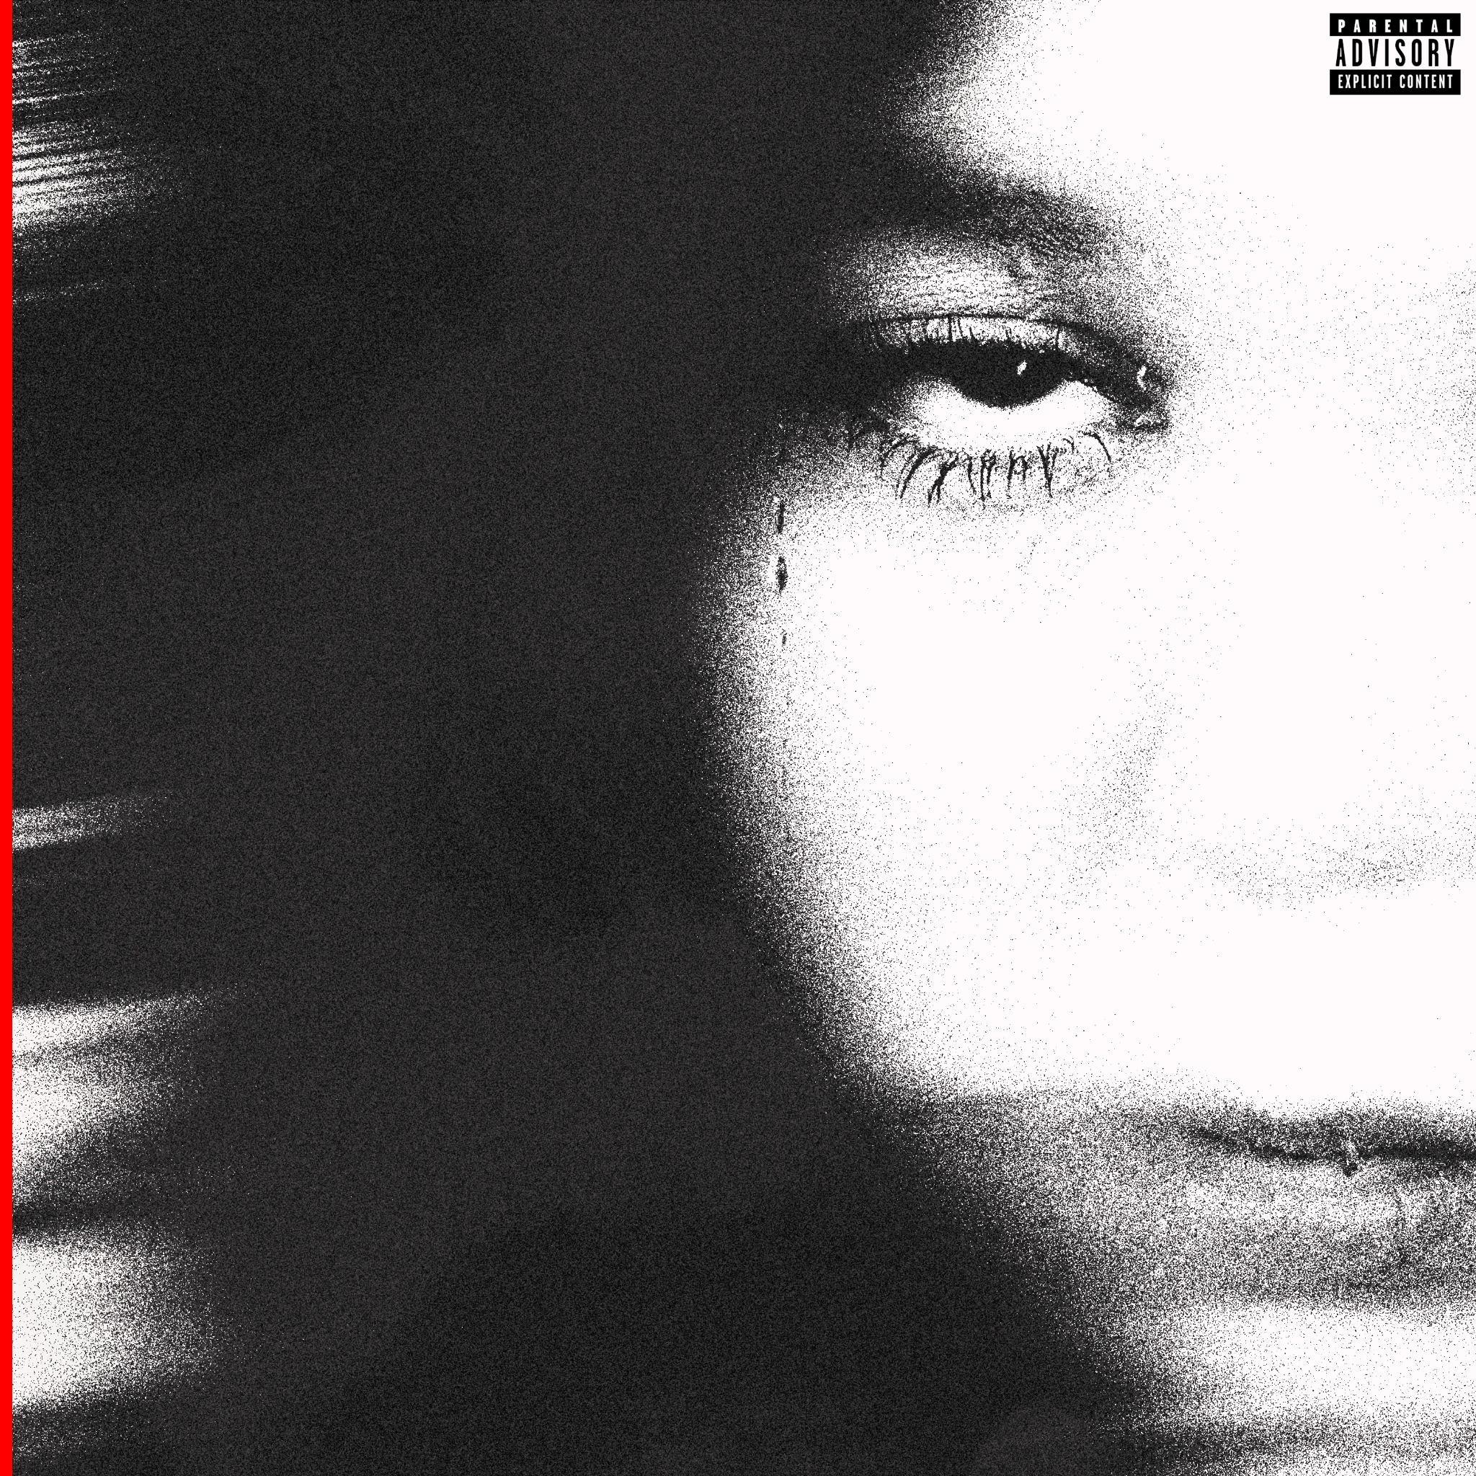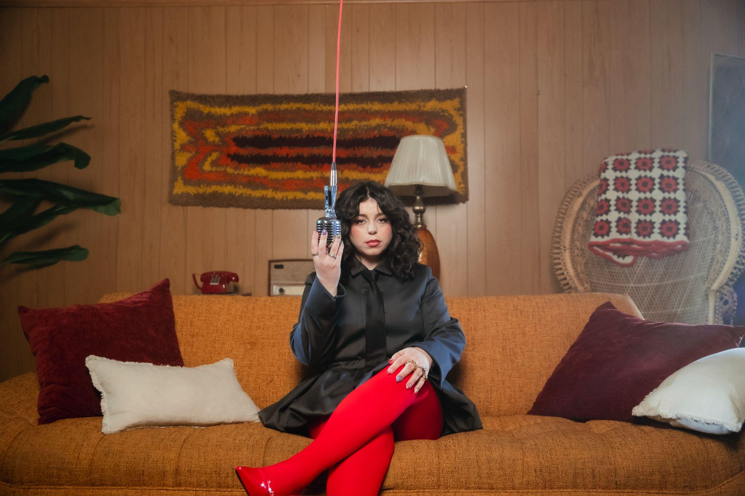
DOWNLOAD HI-RES ARTWORK
+
DOWNLOAD HI-RES PRESS IMAGE // PHOTO CREDIT: ANTHONY CAMPUSANO

Today, emerging songstress Alicia Creti, released her latest single, “Bleeding Me Dry” alongside an official music video HERE. The single is produced by two time GRAMMY-nominated producer, Pop Wansel (Lizzo, Kehlani, Renee Rapp) and co-written by Taylor Hill (Drake, Justin Bieber, Summer Walker). Earlier this month, Alicia performed “Bleeding Me Dry” live for KTLA’s ‘Music Fest Fridays’ accompanied by a brief interview. The song was originally released exclusively for COLORS earlier this year and serves as the follow-up to her debut project, Self/Less. The EP chronicles the journey of a young woman reclaiming her true self. Tired of being "less" and yearning to be "more" for herself, she invites fans to join her on a path of self-discovery.

ABOUT ALICIA CRETI
Alicia Creti is an unstoppable force in the world of music, pouring her heart and soul into every note with a delivery that is both distinct and dynamically charged. The Montreal-born and Los Angeles-based singer, songwriter, and pianist emerged as a rising sensation, captivating millions with a soulful rendition of Summer Walker’s "Session 32" and sustaining that momentum with captivating covers of Kehlani, Jazmine Sullivan, and Ari Lennox. With commanding soulful vocals and poignant songwriting, Alicia skillfully weaves a tapestry of self-reflection, heartbreak, and the myriad facets of the human experience, inviting listeners to immerse themselves in the pages of her personal journal. Her sound is a breath of fresh air, transcending genre boundaries with a compelling touch of nostalgic soul. Building on the triumph of her 2022 single “Congratulations” and 2023 releases "Strange," “Pity Party,” “Guilt Trip” and “Crazy,” “ Alicia officially unveiled her highly anticipated debut EP, Self/Less, offering a narrative journey of a young woman reclaiming her authentic self. Fatigued by the confines of being "less" and driven to become "more" for herself, she extends an open invitation for fans to accompany her on a profound path of self-discovery. Coming off the heels of Self/Less, Alicia made her debut performance of “Bleeding Me Dry” on A COLORS SHOW. Her top performing track to date, this COLORS rendition has earned 100K streams a week in the United States since its release on March 7th. The performance highlights Alicia's versatility as an artist, capable of delivering powerful ballads with a soulful edge. Coupled with her success off COLORS, Alicia’s socials have also grown a total of 38.5K across all social platforms within the past three months. Additionally, Alicia recently wrapped a 24-day tour across the United States and Canada, as direct support for Mahalia.

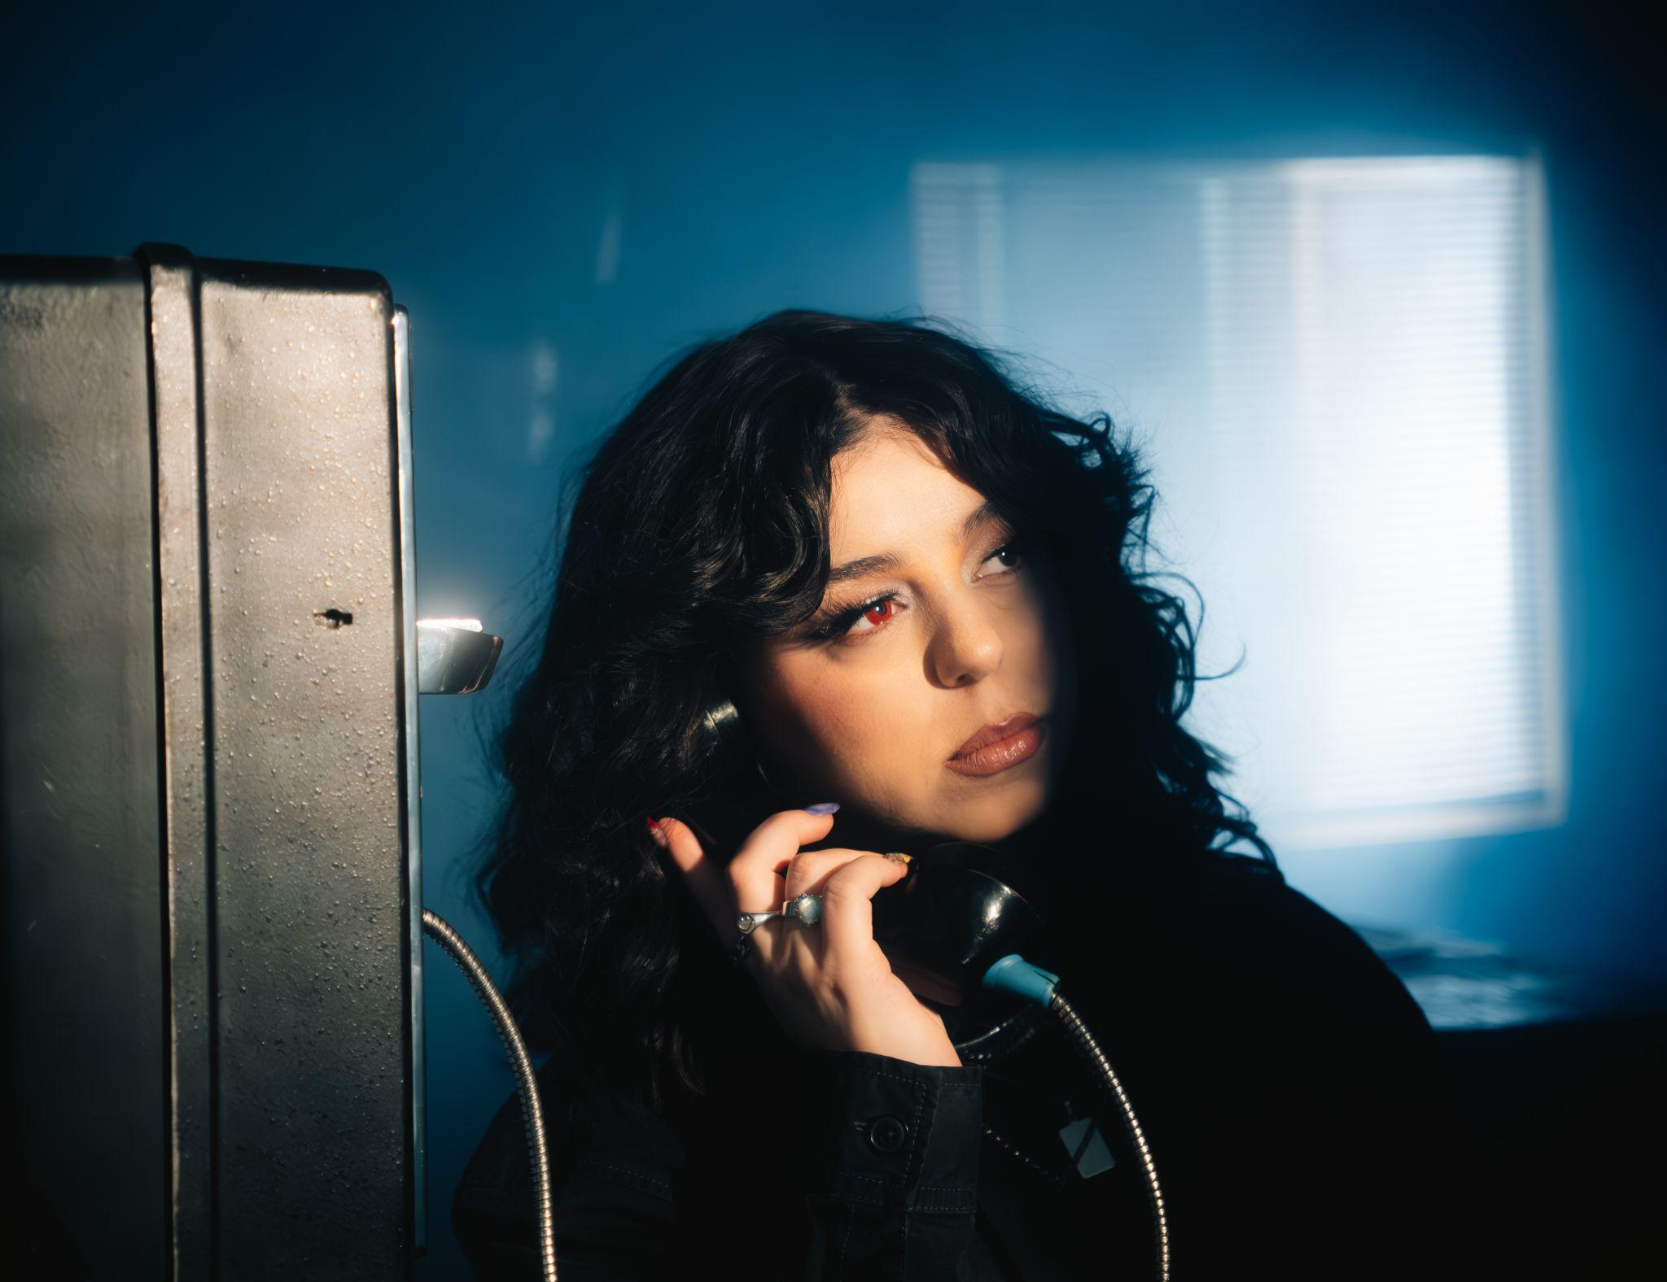
DOWNLOAD HI-RES PRESS IMAGE // PHOTO CREDIT: DIMES BURNER

CONNECT WITH ALICIA CRETI
INSTAGRAM | TIKTOK | TWITTER | YOUTUBE

PRESS INQUIRIES
ASHLEY KALMANOWITZ | ASHLEY.KALMANOWITZ@ATLANTICRECORDS.COM
FAIRLEY MCCASKILL | FAIRLEY.MCCASKILL@ATLANTICRECORDS.COM

