BRISTON MARONEY ANNOUNCES 2ND LEG OF SOLD-OUT ULTRAPURE TOUR

& 3RD ANNUAL PARADISE- 3 DAY FEST AT BROOKLYN BOWL NASHVILLE

NEW HEADLINE RUN BEGINS SEPTEMBER 22 IN ORLANDO, FL

PRESALES BEGIN WEDNESDAY, MAY 1 AT 10:00 AM (LOCAL)
GENERAL ON-SALE STARTS FRIDAY, MAY 3 AT 10:00 AM (LOCAL)

PARADISE SET FOR NOVEMBER 14-16 IN NASHVILLE
LINE-UP INCLUDES YOKE LORE, GUS DAPPERTON, THE MOSS & MORE

CRITICALLY ACCLAIMED SOPHOMORE ALBUM, ULTRAPURE, AVAILABLE NOW
VIA CANVASBACK MUSIC/ATLANTIC RECORDS HERE

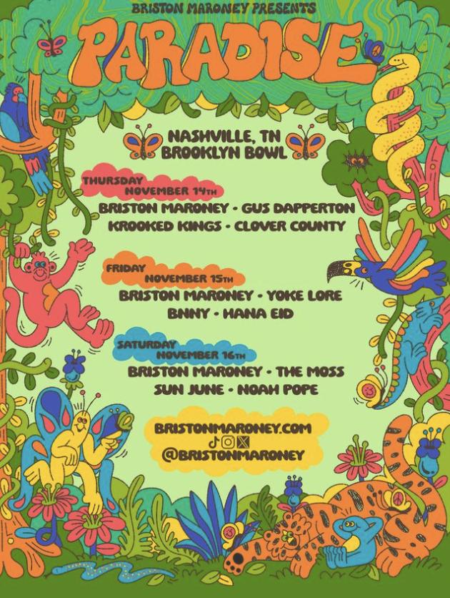
DL Paradise ad mat HERE /// DL Ultrapure Tour Part 2 ad mat HERE

Briston Maroney has announced the eagerly awaited second leg of his sold-out Ultrapure Tour, getting underway September 22 at Orlando, FL’s The Beacham Theatre and then traveling into late October.

Briston is also bringing back his self-curated festival Paradise for a 3rd year, set for November 14, 15, and 16th at Brooklyn Bowl Nashville. Maroney will headline all 3 nights and other
festival artists include Gus Dapperton, The Moss, Yoke Lore, Krooked Kings, Clover County,
Bnny, Hana Eid, Sun June, and Noah Pope.

Artist presales for tour begin Wednesday, May 1 at 10:00 am (local). Local presales begin Thursday, May 2 at 10:00 am (local). All presales end Thursday, May 2 at 10:00 pm (local). General on-sales start Friday, May 3 at 10:00 am (local). For complete details and ticket availability, please visit www.bristonmaroney.com/#tour.

In the meantime, Maroney is slated for top-billed appearances at a number of upcoming festivals, including Boston, MA’s Whale Jam (May 16), Milwaukee, WI’s Summerfest (June 28), Chicago, IL’s Lollapalooza (August 3), Montreal, QC’s Osheaga (August 4), and Columbia, MD’s just-announced All Things Go Festival (September 28).

# # #

BRISTON MARONEY
ULTRAPURE TOUR 2024

MAY
11 – San Diego, CA – Wonderfront Festival*
16 – Boston, MA – Whale Jam *

JUNE
28 – Milwaukee, WI – Summerfest *

AUGUST
3 – Chicago, IL – Lollapalooza *
4 – Montreal, QC - Osheaga *
SEPTEMBER
13 – Greenwood Village, CO – Fiddler’s Green Amphitheatre&
22 – Orlando, FL – The Beacham#
23 – Columbia, SC – The Senate#
24 – Wilmington, NC – Greenfield Lake Amphitheater#
26 – Charlotte, NC – The Fillmore#
27 – Pittsburgh, PA – Roxian Theatre#
28 – Columbia, MD – All Things Go Festival *
30 – Providence, RI – Fête Music Hall#

OCTOBER
1 – Portland, ME – State Theatre#
2 – New Haven, CT – College Street Music Hall#
4 – Grand Rapids, MI – The Intersection#
5 – Indianapolis, IN – HI-FI Annex#
6 – Cincinnati, OH – Bogart's#
8 – St. Louis, MO – The Hawthorn%
9 – Kansas City, MO – The Truman%
10 – Madison, WI – The Sylvee%
12 – West Des Moines, IA – Val Air Ballroom%
13 – Oklahoma City, OK – The Jones Assembly%
14 – San Antonio, TX – Stable Hall%
16 – El Paso, TX – Lowbrow Palace (Outdoors)%
18 – Albuquerque, NM – El Rey Theater%
19 – Aspen, CO – Belly Up Aspen%
20 – Salt Lake City, UT – The Depot%
23 – Phoenix, AZ – The Van Buren%
24 – San Diego, CA – The Observatory North Park%

NOVEMBER
14 – Paradise – Brooklyn Bowl Nashville *
15 – Paradise – Brooklyn Bowl Nashville *
16 – Paradise – Brooklyn Bowl Nashville *

# w/ Why Not
% w/ Annie DiRusso
* festival performance
& supporting Vance Joy

The newly announced dates follow the hugely successful first leg of Maroney’s North American headline tour celebrating his acclaimed sophomore album, Ultrapure, available everywhere now via Canvasback Music/Atlantic Records HERE. The tour proved an undeniable phenomenon, with sold-out shows at virtually all stops, including two-night stands at such famed venues as New York City’s Webster Hall and Los Angeles, CA’s The Fonda Theatre.

Recorded in Maroney’s former home base of Nashville, TN with 2x GRAMMY® Award-winning producer Daniel Tashian (Kacey Musgraves) and engineer Konrad Snyder (Noah Kahan, Rainbow Kitten Surprise), Ultrapure sees the multi-talented singer-songwriter playing every instrument on such singles as “Chaos Party” and “Body.”

Now based in Los Angeles, Maroney celebrated Ultrapure with a series of solo acoustic performances at record stores across the US as well his second annual Paradise festival at Brooklyn Bowl Nashville. In addition, Maroney made his national TV debut on CBS Saturday Morning, with performances of “Body,” “Chaos Party,” and the RIAA Platinum-certified hit, “Freakin’ Out On The Interstate.” Briston also recently performed “Body” on Jimmy Kimmel Live!

Maroney quickly followed Ultrapure with a brand new single, “I Told You So,” produced by Andrew Sarlo (Big Thief, Bon Iver, Weyes Blood), and available everywhere now HERE. An official music video (shot and edited by Natalie Hewitt) is streaming via YouTube HERE.

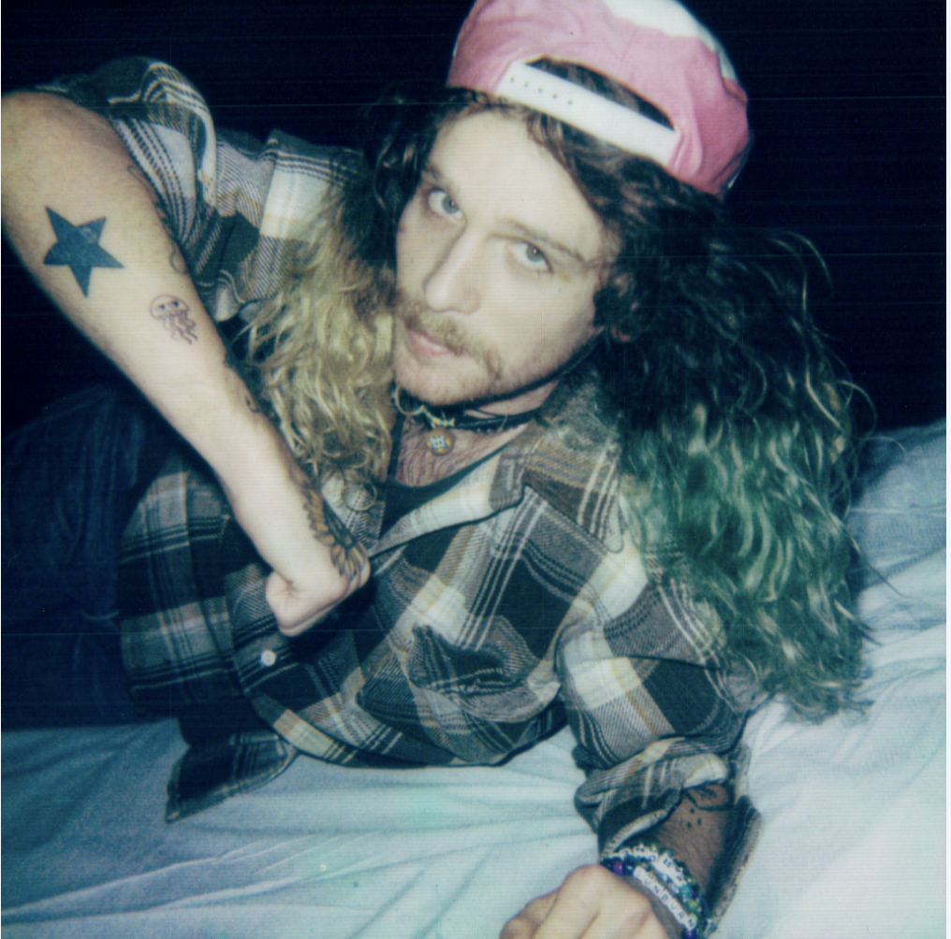
DOWNLOAD HI-RES PRESS PHOTO HERE // CREDIT: TYLER KRIPPAEHNE

CONNECT WITH BRISTON MARONEY:
OFFICIAL | FACEBOOK | INSTAGRAM | TIKTOK | X | YOUTUBE

FOR ALL PRESS INQUIRIES, PLEASE CONTACT:
Gabby Reese | Gabrielle.Reese@AtlanticRecords.com

