FOR IMMEDIATE RELEASE
MAY 31, 2024

FOSTER THE PEOPLE ARE BACK WITH NEW SINGLE
“LOST IN SPACE”

MULTI -GRAMMY NOMINATED
GROUP MAKE ATLANTIC RECORDS DEBUT

HIGHLY ANTICIPATED
FOURTH STUDIO ALBUM,
PARADISE STATE OF MIND
ARRIVING AUGUST 16

PRE-ORDERS AVAILABLE NOW HERE

LISTEN TO “LOST IN SPACE” | WATCH OFFICIAL MUSIC VIDEO

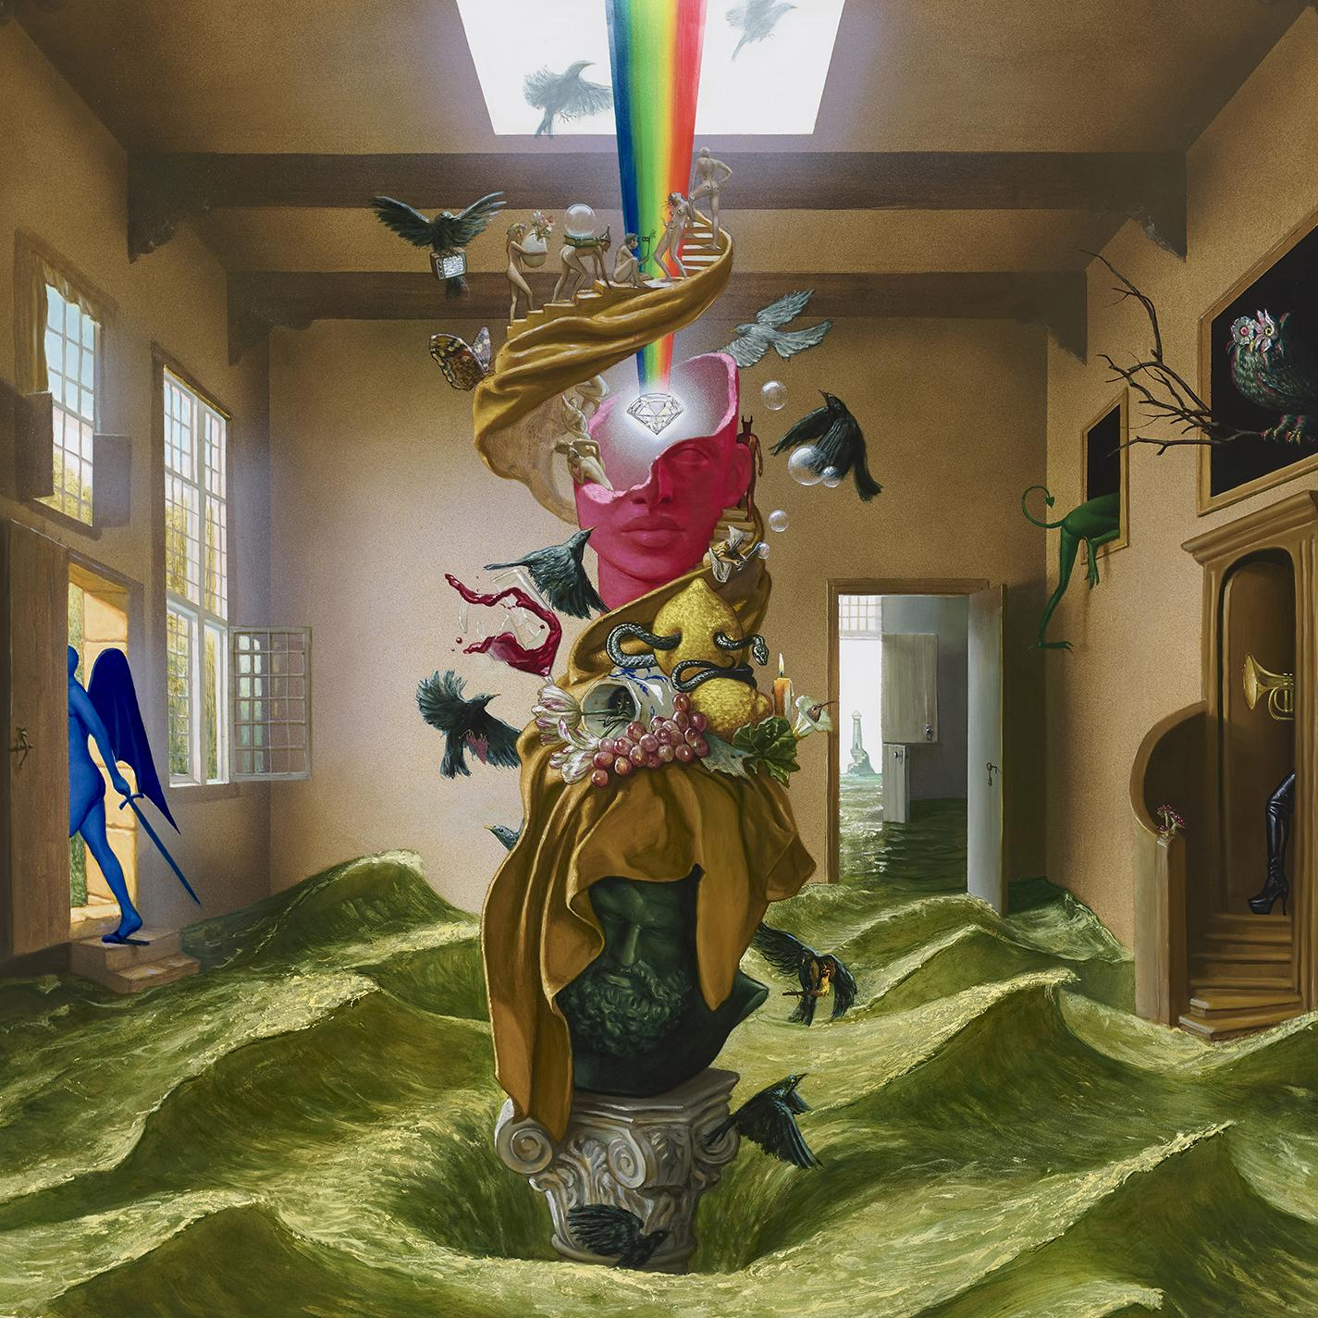
DOWNLOAD HI-RES ARTWORK

RIAA Diamond-certified multi-platinum group Foster The People make their eagerly anticipated Atlantic Records debut with today’s premiere of their ready-for-summer single, “Lost In Space,” available HERE. The 3x GRAMMY® Award-nominated band’s first new release in over three years, “Lost In Space”, is produced by lead singer, songwriter and multi-instrumentalist Mark Foster and co-produced by bandmate Isom Innis. The official music video streaming HERE, made its broadcast premiere on MTV Live, MTVU, MTV Biggest Pop and on the Paramount Times Square billboards.

“Lost In Space” heralds the arrival of Foster The People’s long awaited fourth studio album, Paradise State of Mind, arriving August 16. Pre-orders are available now HERE.

"The record started as a case study of the late Seventies crossover between disco, funk, gospel, jazz, and all those sounds. It was such a beautiful moment in time, when these different styles of music were cross-referencing each other – artists like Nile Rogers and Chic, the Tom Tom Club and Giorgio Moroder," says Mark Foster.

"I wanted to dive into that and figure out what they were doing. I was also thinking about how that era has musical and social parallels to the time that we're in now, with the giant recession in the Seventies, the political turmoil post-Vietnam, and other major tensions. But then you see these expressions of joy happening through music, and I started thinking about joy as an act of defiance."

The album’s artwork, commissioned by Foster, was originally an oil painting on panel, created by renowned Brooklyn based artist, Matt Hansel. It captures the essence of different spaces in the mind. Each space represents its current state and leads to another that may have a totally different feeling.

Foster The People will celebrate their new music and more with a live performance at Austin City Limits Music Festival (Oct 4-6 & 11-13). For more information, please visit www.fosterthepeople.com.

DOWNLOAD HI-RES PRESS IMAGE

Currently boasting close to 8 billion worldwide streams and almost 2.5 billion lifetime YouTube video views, Foster the People proved a worldwide sensation with their kaleidoscopic brand of dance-fueled pop music. Formed in Los Angeles in 2009 with multi-instrumentalist singer-songwriter Mark Foster at the helm, the band exploded with their 2010 debut single, “Pumped Up Kicks,” which topped Billboard’s “Alternative Songs” chart before spending eight consecutive weeks at #3 on the overall “Hot 100” and rising to the upper reaches of charts around the world. Currently RIAA Diamond-certified with 14x Platinum sales in the US, the track earned Foster The People their first GRAMMY® Award nomination (for “Best Pop Duo/Group Performance”) as well as the 2012 Billboard Music Award for “Top Rock Song.” Now with over 1 billion worldwide streams via Spotify alone, “Pumped Up Kicks” was joined by an equally phenomenal official music video which attained placement among YouTube‘s prestigious Billion Views Club.

2011 saw Foster The People unveil their 3x Platinum-certified debut album, Torches, which went to #1 on both Billboard’s “Top Rock Albums” and “Top Alternative Albums” while reaching #8 on the Billboard 200 and later receiving a GRAMMY® Award nomination as “Best Alternative Album.” What’s more, the album’s “Houdini” earned the band a third GRAMMY® nod for “Best Short Form Music Video.” Supermodel followed in 2014, which fueled in part by the Gold-certified “Coming of Age,” hit #1 on both Billboard’s “Top Rock Albums” and “Top Alternative Albums” while debuting at #3 on the overall Billboard 200.

Foster The People toured the world while working out material for their third album, 2017’s electronic soul-flavored Sacred Hearts Club. The Gold-certified LP delivered yet another blockbuster hit in the 4x Platinum “Sit Next To Me,” which scored over 200 million worldwide streams while spending 20 weeks on the Billboard “Hot 100.” A series of stand-alone singles were then followed in 2020 by the independent EP, In the Darkest of Nights, Let the Birds Sing, highlighted by such singles as “Lamb’s Wool.” 2021 saw Foster The People celebrate the tenth anniversary of Torches with the extended deluxe edition, Torches X, along with a series of special Torches live shows streamed around the world. In 2024, Foster The People returns with new music and so much more to come.

# # #

CONNECT WITH FOSTER THE PEOPLE
WEBSITE | FACEBOOK | INSTAGRAM | TWITTER | YOUTUBE

PRESS CONTACTS
SHEILA RICHMAN | Sheila.Richman@atlanticrecords.com
GABRIELLE REESE | Gabrielle.Reese@atlanticrecords.com

