FOR IMMEDIATE RELEASE
MAY 17, 2024

SINGER-SONGWRITER CAMERON WHITCOMB MAKES ATLANTIC RECORDS DEBUT WITH “ROCKING CHAIR”

DEEPLY PERSONAL TRACK ALREADY A MASSIVE FAN FAVORITE WITH OVER 40M VIEWS ACROSS SOCIALS

“ROCKING CHAIR” AVAILABLE NOW VIA ATLANTIC RECORDS

LISTEN HERE | WATCH VIDEO HERE

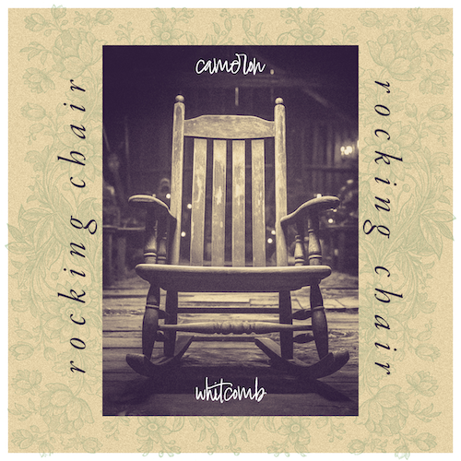
DOWNLOAD HI-RES ASSETS
PRESS PHOTO CREDIT: JIMMY FONTAINE

21-year-old singer-songwriter Cameron Whitcomb makes his eagerly awaited Atlantic Records debut with today’s release of his deeply personal new single, “Rocking Chair” - Listen HERE. The track has quickly become a fan favorite, with social teasers garnering a total of over 40M combined views, including a TikTok teaser with 12M views and an Instagram Reel teaser with 21M views prior to release. The track is released alongside a video – Watch HERE.

“I wrote this song about being an atheist hoping heaven exists so the people you’ve lost are still around in some way,” says Cameron Whitcomb. “In particular, I wrote this song about wondering where my grandpa went after he passed.”

Cameron Whitcomb brings a unique perspective to songwriting, deeply influenced by his own life experiences, including his battles with addiction and journey through the music industry. Having grown up in Nanaimo, British Columbia, he began working on a pipeline after leaving home at 17. Whitcomb’s life took a turn when he discovered singing at the age of 19, performing karaoke on weekends before his raw talent caught the attention of an American Idol executive through a video posted on Reddit, marking the beginning of his ascent in the music world. He began winning over fans as a contestant on Season 20 of American Idol, reaching the top 20.

Whitcomb carried on with increasingly popular independent releases including “The Devil I’ve Seen,” showcasing a raw and authentic songwriting style that draws listeners into his world through vivid storytelling and emotional honesty. Through his music, Whitcomb offers a glimpse into the complexities of his life and the darker aspects of human experiences, inviting audiences to connect with the more profound, often unspoken realities. His ability to weave personal tales into compelling musical narratives sets him apart in the songwriting landscape, resonating with listeners who find solace and understanding in his words.

CAMERON WHITCOMB ON TOUR 2024

MAY
31 – Kelowna, BC – Nash Bash at Revelry Food+Music Hub

JUNE
14 – Cranbrook, BC – Spirit of the Rockies Festival
21 – Vancouver, BC – Fox Cabaret

JULY
12 – Edmonton, AB – The Starlite Room
13 – Calgary, AB – The Palomino Smokehouse
20 – Fort St. John, BC – Energetic County Fair

CONNECT WITH CAMERON WHITCOMB
WEBSITE | FACEBOOK | INSTAGRAM | TIKTOK | YOUTUBE

PRESS CONTACT
Andrew George // andrew.george@atlanticrecords.com

