ARDEN JONES UNVEILS age tape 14

CALIFORNIA SINGER-SONGWRITER DROPS LATEST INSTALLMENT
IN CONTINUING SERIES OF 3-SONG PROJECTS

age tape 14 AVAILABLE NOW VIA VNCLM_ X ATLANTIC RECORDS

LISTEN TO age tape 14 HERE

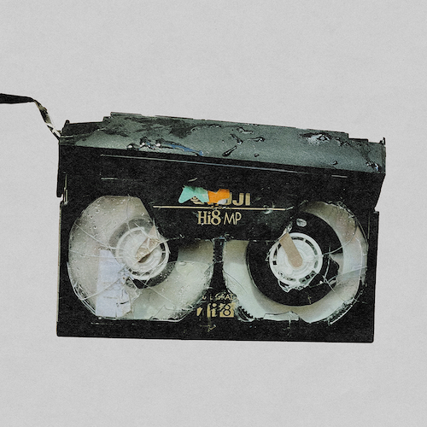
DOWNLOAD HI-RES ARTWORK HERE

California-based singer-songwriter Arden Jones is back with age tape 14, the newest chapter in his groundbreaking age tape series of three-song releases, available now via vnclm_ x Atlantic Records HERE. The project’s latest chapter includes the new single, “omg (guess i had it coming),” co-written and produced by frequent collaborator Sarcastic Sounds (Lil Wayne), alongside “lovesick” and “talk.”

The age tape series returned earlier this year with age tape 10, featuring “hard enough to stay alive,” produced by Captain Cuts (UPSAHL, Carly Rae Jepsen), as well as “indigo,” produced by Jason Suwito (Imagine Dragons, k.flay), and “count me in,” an exhilarating collaboration with California-based electronic trio Łaszewo (Matthew Ehrlich, Keeva Bouley, Justin De La Fuente). age tape 11 followed, highlighted by the anthemic “been here before,” along with “in between” and “living a lie.” age tape 12 includes the upbeat “confessions,” produced by Johnny Simpson (Lauv, Ava Max), alongside the new fan favorites, “switch” and “all about u,” while age tape 13 is highlighted by the energetic “not this time,” produced by Grant Sayler (Sueco, Charli XCX) and YOG$ (Healy, Quinn XCII), alongside “i’m fine i’m great” and “might be love.”

“we took a long time trying to figure out how we were gonna roll out all this new music and just couldn’t get away with how much fun age tapes were,” says Jones. “so here you go – age tapes are back for 2024.”

Jones recently marked the return of his acclaimed age tapes with a wide-ranging live schedule that saw both headline shows and dates alongside BoyWithUke’s Lucid Dreams Tour. Additional dates will be announced soon. For updates, please visit www.ardenjonesmusic.com/tour.

Known for an irresistible pop approach that bottles the sunshine of an endless California summer, Arden Jones has already earned over 353M worldwide streams, more than 25M video views, and 1.2M monthly Spotify listeners, jump started by hugely popular tracks such as his vnclm_ x Atlantic Records single, “SMILE,” as well as the viral hit, “Parallel Parking.” 2022 saw Jones kick off his groundbreaking age tape series, a string of ten unique releases shared on the first Thursday of every month throughout the year. Named among PEOPLE’s 2022 “Talented Emerging Artists You Should Be Listening to All Summer Long,” Jones – who has shared stages with fellow breakout stars such as JVKE, QUINN XCII, Tai Verdes, Thomas Headon, and Chelsea Cutler – continues to make waves in the industry.

# # #

CONNECT WITH ARDEN JONES
WEBSITE | INSTAGRAM | SPOTIFY | TIKTOK | TWITTER | YOUTUBE

For press inquiries, please contact:
Jessica Nall // Jessica.Nall@atlanticrecords.com
Gabrielle Reese // Gabrielle.Reese@atlanticrecords.com

