FOR IMMEDIATE RELEASE
APRIL 12, 2024
RISING STAR PAUL CAUTHEN UNVEILS “HOT DAMN”

ACCLAIMED EAST TEXAS OUTLAW MAKES ANEMOIA RECORDS/ATLANTIC RECORDS DEBUT WITH RAUCOUS NEW SINGLE

ONGOING LIVE RUN INCLUDES PERFORMANCE AT STAGECOACH FESTIVAL
WITH HEADLINE DATES AND FESTIVAL PERFORMANCES SLATED THROUGH OCTOBER

“HOT DAMN” AVAILABLE NOW VIA ANEMOIA RECORDS/ATLANTIC RECORDS

“HOT DAMN” AVAILABLE EVERYWHERE NOW
LISTEN | WATCH
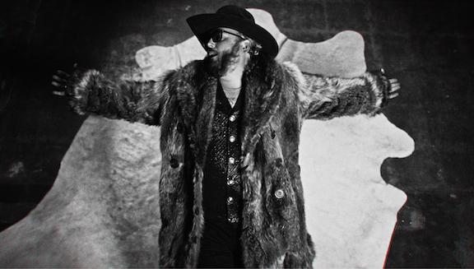
Photo credit: Jacob Butler
DOWNLOAD PRESS PHOTOS

“Paul Cauthen’s big ego (and big voice) may be just what country music needs…The East Texas singer injects the genre with brash bravado.” – ROLLING STONE
April 12, 2024—East Texas rising star Paul Cauthen unveils a new song, “Hot Damn,” alongside a Jacob Butler-directed video today—watch and listen here. The track is his first release with new label partner Anemoia Records/Atlantic Records, with much more from Cauthen imminent.
“It was an exciting ride making this song and it means so much to me,” says Cauthen. “I’ve been a soldier for the song for a long time. ‘Hot Damn’ is the first off this record that I feel is everything I love in music. You will get a little piece of all my records on this one.”
Cauthen has steadily risen through the ranks of country and Americana, first gaining notoriety with roots duo Sons of Fathers before embarking on a solo career with his debut album, My Gospel. He’s gone on to release two more much-lauded albums—Room 41 and 2022’s Country Coming Down—and toured the world over, collaborating and sharing stages with Margo Price, Orville Peck, Elle King, Midland, Cody Jinks and many more.
Celebrated for his remarkable baritone voice that has earned him the nickname Big Velvet, Cauthen grew up singing in the church choir and cut his chops as part of a tight knit creative community in East Texas.
“Hot Damn” kicks off a new era for the outlaw country powerhouse, the first release of many slated for this year. Produced and written with longtime collaborator Jason Burt (John Mayer, Leon Bridges), the track was recorded in Cauthen’s hometown of Tyler, TX The video, shot on location at Rosewood Studios in Tyler, features Cauthen strutting through a super-stylized and psychedelic studio in a massive, vintage fur coat.
“I feel like we always end up landing somewhere between Elvis Presley and Biggie Smalls,” says Cauthen’s wife and stylist Elizabeth Cauthen. “We draw inspiration from glitzy stagewear and traditional western wear while giving it a twist of hip-hop influence and a dose of modern luxury. We’d seen this vintage 1920’s Brooks Brothers coat in the window of a local menswear shop for years. The moment he tried that jacket on we knew it had been in that case waiting for him. With the custom look I designed and created and a pair of crocodile Gucci loafers, everything was meant to be over the top and larger than life.”
Known for his raucous, high energy live shows, Cauthen is currently touring North America, set to play Stagecoach later this month (including an appearance at Guy Fieri’s Smokehouse with Jelly Roll Friday evening) before a run of headline shows across the South in May and a slew of festival dates this summer. See below for full tour routing and visit paulcauthenmusic.com for more information.
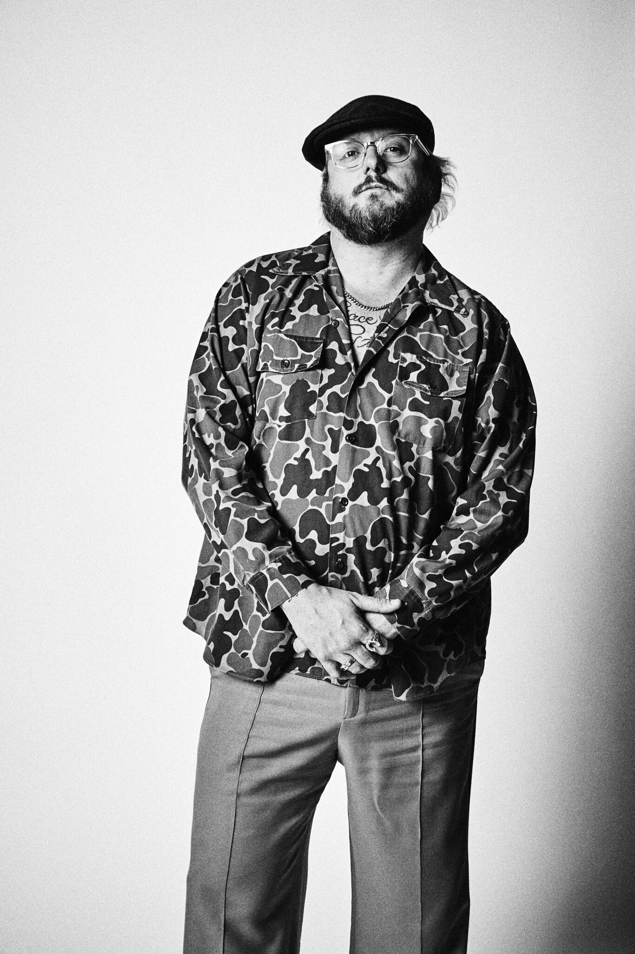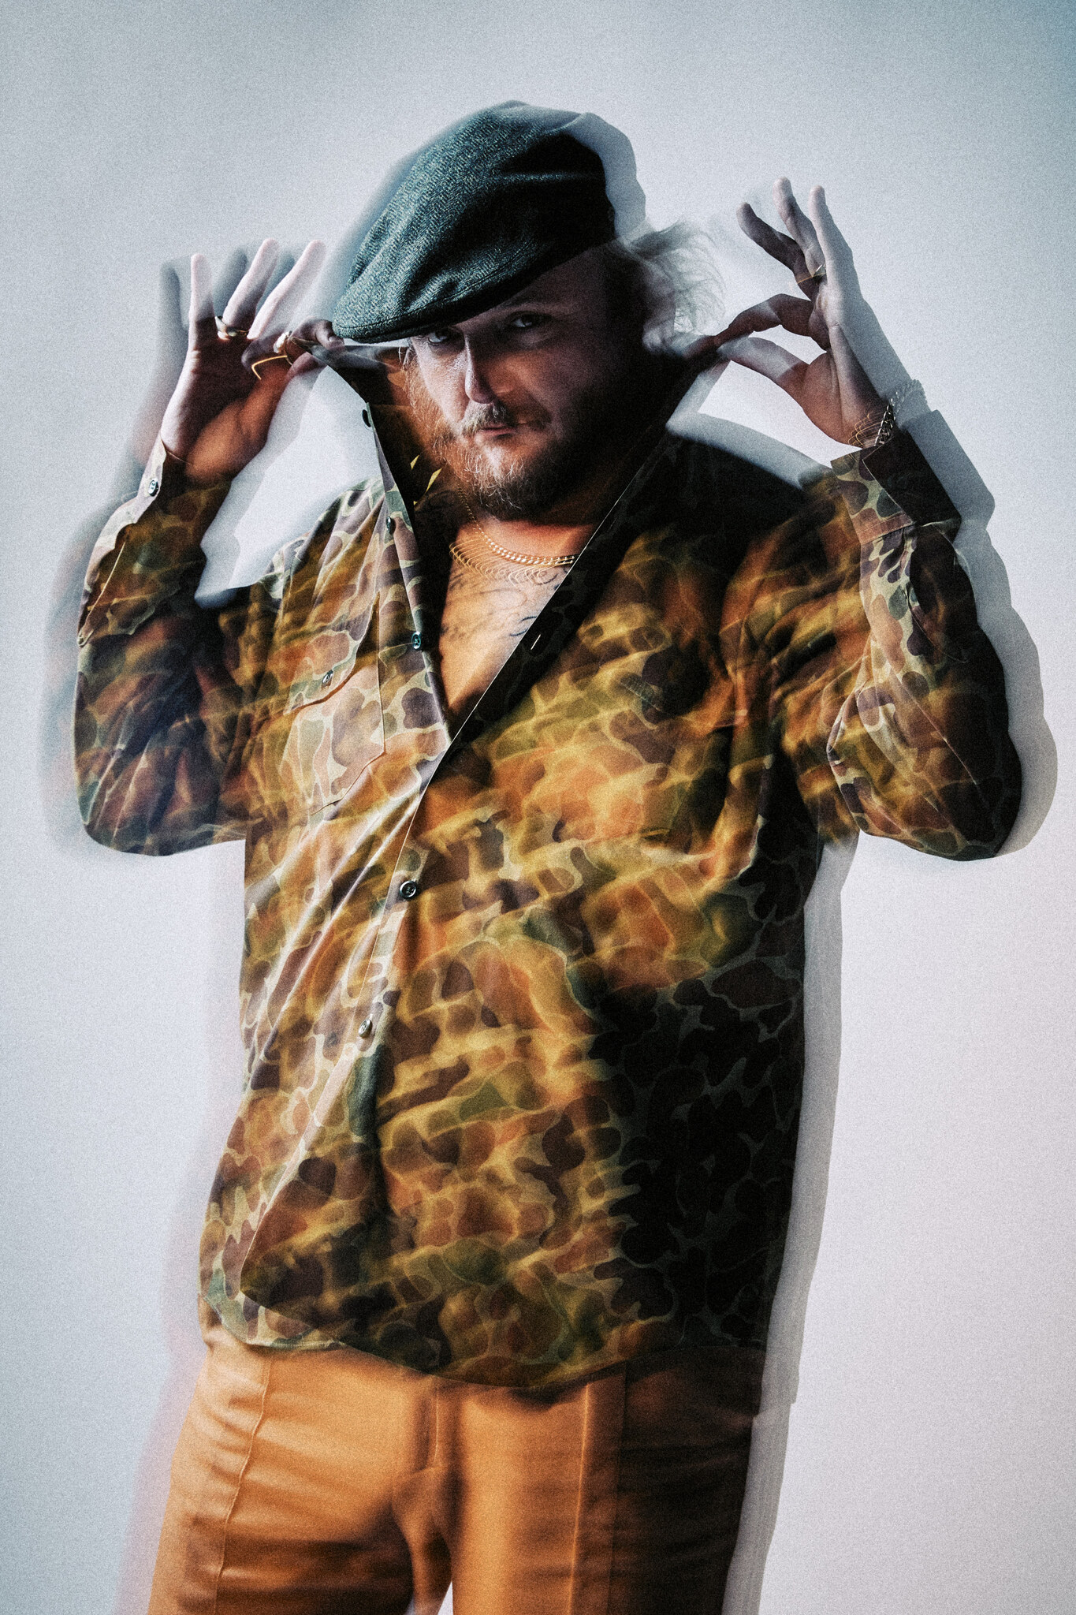
DOWNLOAD PRESS PHOTOS
Credit: Jimmy Fontaine

PAUL CAUTHEN LIVE
April 19—Silver Saloon—Terrell, TX
April 26—Stagecoach Festival—Indio, CA
May 3—Tannahill’s Tavern & Music Hall—Fort Worth, TX
May 18—House of Blues Myrtle Beach—North Myrtle Beach, SC
May 19—The Fillmore Charlotte—Charlotte, NC
May 21—The Ritz—Raleigh, NC
May 23—The Orange Peel—Asheville, NC
May 24—The Shed Smokehouse & Juke Joint—Maryville, TN
May 25—Radians Amphitheater—Memphis, TN
May 30—Iron City —Birmingham, AL*
May 31—Variety Playhouse —Atlanta, GA*
June 1—In The Pines—Bristol, TN
June 6-8—Fort Desolation Fest—Torrey, UT
June 13-16—Tailgate N' Tallboys—Bloomington, IL
June 18—Cincinnati, OH*
June 19—Mercury Ballroom—Bogarts —Louisville, KY*
June 21—The Intersection —Grand Rapids, MI*
June 22—House of Blues —Cleveland, OH*
June 23—Roxian Theatre—McKees Rocks, PA*
June 25—The Signal—Chattanooga, TN*
June 28—White Oak Music Hall – Outside Lawn—Houston, TX*
June 29-30—Coca-Cola Sips & Sounds Festival—Austin, TX
June 30—Houston, TX—White Oak Outdoors*
July 5—Summerfest—Milwaukee, WI
July 10—I Bar Ranch —Gunnison, CO*
July 12-14—Under the Big Sky Festival—Whitefish, MT
July 17—Knitting Factory—Boise, ID*
July 19—Old Saloon—Emigrant, MT*
July 20—Bridger Brewing Three Forks—Three Forks, MT*
August 1-3—WE Fest—Detroit Lakes, MN
August 8-10—XRoads41—Oshkosh, WI
October 5—Country Calling Festival—Ocean City, MD
October 20—Golden Sky Festival—Sacramento, CA
*newly added
For more information, please contact
Jessica Nall / jessica.nall@atlanticrecords.com

