FOR IMMEDIATE RELEASE
JUNE 14, 2024

SOPHIE POWERS UNLEASHES “AWESOME (FT. BABY TATE)”

TRIUMPHANT NEW SINGLE HERALDS EAGERLY AWAITED EP, GLITCH: LVL 1

GLITCH TOUR BEGINS AUGUST 2 IN LOS ANGELES,
FOLLOWED BY HEADLINE DATES IN SAN FRANCISCO, PHILADELPHIA,
NEW YORK CITY, AND TORONTO

GLITCH: LVL 1 EP ARRIVES VIA ATLANTIC RECORDS/TAG MUSIC
ON FRIDAY, JULY 12

LISTEN TO “AWESOME (FT. BABY TATE)” | WATCH OFFICIAL MUSIC VIDEO

PRE-SAVE/PRE-ADD GLITCH: LVL 1

DOWNLOAD HI-RES IMAGE // PHOTO CREDIT: BISHOP ELEGINO

Hyperpop-punk artist Sophie Powers returns with her latest single “Awesome (ft. Baby Tate),” available now via Atlantic Records/TAG Music HERE. An official visualizer premieres today HERE.

“Awesome (ft. Baby Tate)” heralds the eagerly awaited release of Powers’ new EP, Glitch: Lvl 1, arriving everywhere on Friday, July 12. Pre-saves/pre-adds are available now HERE. The upcoming project also includes the supercharged “Woah!! (ft. kets4eki),” joined by an explosive companion video streaming HERE. The track was met by instant praise from such outlets as Ones To Watch, which raved, “‘Woah!!’ is a thrilling blend of playful lyrics, digi-core synths, and lively beats reminiscent of a neon-lit arcade game…The candy-coated track explodes into an endorphin-rushing, heart-racing chorus, with the smitten singer serenading the listener and pushing them down a rabbit hole of kaleidoscopic sonics.”

“If Vanellope Von Schweetz from ‘Wreck-It Ralph’ had a playlist, it would be this EP,” says Sophie Powers. “Full of fast paced hyperpop, industrial and pop-punk sounds, it’s the perfect record for summer ’24! The listener needs to be ready to hear this EP, as it tackles topics such as ARFID, depression, anxiety, breakups, ADHD, love, and navigating life as a teen today. With technology having changed so much in the past 15 years, the visuals and aesthetics tie in nostalgic and pixelated graphics from my childhood, alongside the tech we see today. That’s where the ‘player ready?’ pixelated video-game storyline fits in. The listener should be ready for a blast from the past, and launch into the future. This is my last year of being a teen. I might as well go out with a bang!”

Powers will celebrate Glitch: Lvl 1 with a much anticipated North American summer headline run. The Glitch Tour kicks off August 2 at Los Angeles, CA’s Moroccan Lounge and then makes stops in San Francisco, Philadelphia, New York City, and Toronto. The upcoming dates follows a stacked schedule that included a UK triple bill alongside PVRIS and Scene Queen, as well as a stage-stealing set at Fort Worth, TX’s So What?! Music Festival. For more information, please visit www.sophiepowers.com/tour.

Glitch: Lvl 1 continues a spectacular series of gripping new releases from Powers, including “Obsessed (Feat. Ashley Sienna)” and the scathing “Better On Mute.” The latter track was preceded by the deeply personal “Bathroom Floor,” joined by an official music video streaming now HERE. Hailed by Alternative Press as a “stirring single which captures her struggles with self-hatred and body dysmorphia,” Powers further called attention to the mental health issues raised in “Bathroom Floor” by pledging to help raise money in donations supporting The National Alliance for Eating Disorders Organization in correspondence with the release.

# # #

ABOUT BABY TATE:
Baby Tate represents the most vibrant among us. The 27-year-old classically trained singer, songwriter, rapper, producer, engineer, and dancer has always channeled her energy into creating music that reflects the Technicolor recesses of her mind. Her discography thus far consists of concept projects like ROYGBIV, BOYS, and GIRLS, all of which saw her exercising full creative control, and more flexible bodies of work like 2020’s After the Rain, which features her empowering hit “I Am.” Her latest EP, Baby Tate Presents – Sexploration: The Musical, takes listeners on a theatrical expedition through sexual identity, relationships, and self-confidence. Baby Tate’s move from her birthplace of Atlanta to Los Angeles has motivated her to experiment within more sonic landscapes than ever before. She has also been inspired to delve further into her sexual identity: after previously coming out as bisexual on social media, she now identifies as pansexual. The result of opening up her artistic and personal worlds is Baby Tate Presents – Sexploration: The Musical, a five-track pop&B production on which she shares her experiences in greater detail. Through everything she does, but especially in her music, Baby Tate strives to create a safe space that challenges sexual norms and embraces gender diversity. By boldly defying stereotypes, she serves as an inspiration for everyone—especially marginalized people—to express themselves authentically.

# # #

SOPHIE POWERS
GLITCH TOUR 2024

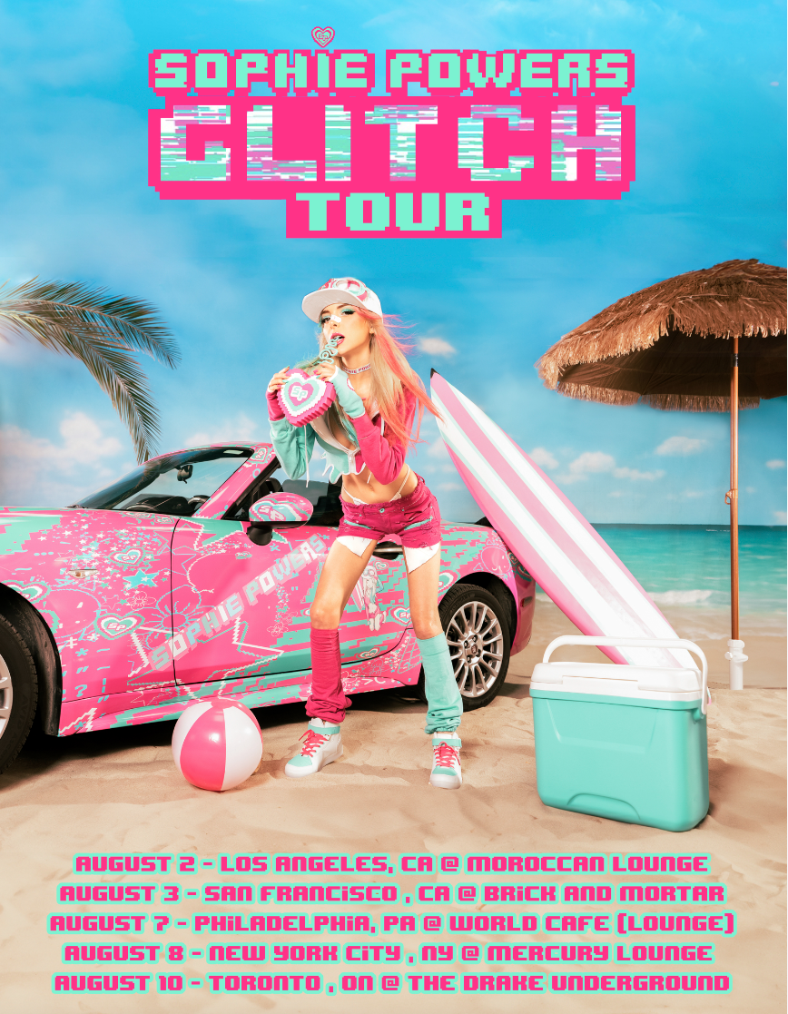

AUGUST
2 – Los Angeles, CA – The Moroccan Lounge
3 – San Francisco, CA – Brick and Mortar
7 – Philadelphia, PA – The Lounge at World Cafe Live
8 – New York, NY – Mercury Lounge
10 – Toronto, ON - The Drake Underground

# # #

DOWNLOAD HI-RES PRESS PHOTO HERE // PHOTO CREDIT: BISHOP ELEGINO

DOWNLOAD HI-RES PRESS PHOTO HERE // PHOTO CREDIT: BISHOP ELEGINO

# # #

CONNECT WITH SOPHIE POWERS
WEBSITE | INSTAGRAM | TIKTOK | X | YOUTUBE

CONNECT WITH BABY TATE
WEBSITE | INSTAGRAM | TIKTOK | X | YOUTUBE

PRESS CONTACT
PAIGE ROSOFF | Paige.Rosoff@atlanticrecords.com

