COLDPLAY PREMIERE feelslikeimfallinginlove VIDEO FOLLOWING RAPTUROUSLY-RECEIVED GLASTONBURY FESTIVAL SET

Watch at https://youtu.be/V3IVdLo-2NM

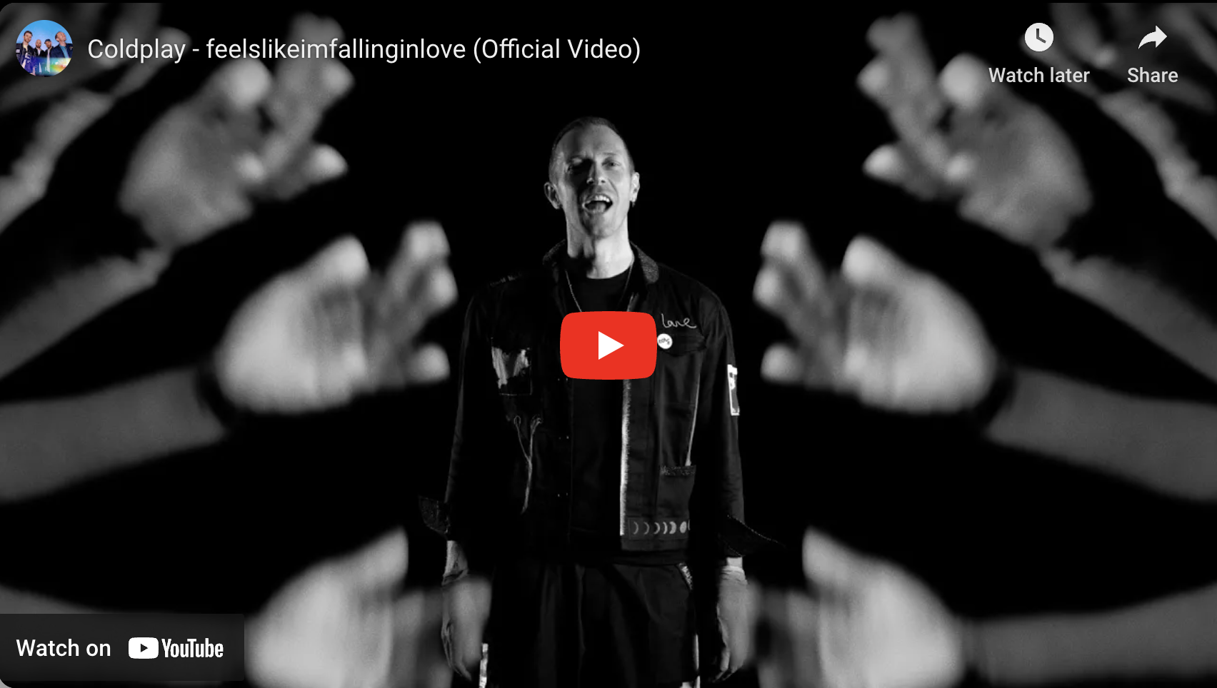

Coldplay have today premiered the music video for their new single, feelslikeimfallinginlove. The video - which can be seen at https://youtu.be/V3IVdLo-2NM - was shot on location at Athens’ stunning 2,000-year-old Odeon of Herodes Atticus, in front of an audience invited via the band’s social media. It was directed by Ben Mor, who previously helmed the band’s video for Hymn For The Weekend with Beyoncé.

The video stars actress, writer and storyteller, Natasha Ofili (Principal Karen Vaughn in Ryan Murphy's Netflix series, The Politician) who was also responsible for the video’s story and creative direction. Ofili created her own American Sign Language interpretation of the song which runs throughout the video.

The video also features the Deaf members of the Venezuelan Sign Language (LSV) section from El Sistema Venezuela's Coro de Manos Blancas (White Hands Choir) a world-renowned performing arts ensemble from Barquisimeto, supported in collaboration with the Dudamel Foundation.

The premiere follows the band’s rapturously-received Glastonbury Festival headline set on Saturday night, which was given glowing five-star reviews by publications including The Times, The Independent, The Guardian, The i and The Telegraph, with the latter publication calling it “one of the great Glastonbury sets”. The set, which was broadcast live worldwide by the BBC, is available on-demand at bbc.com/pages/glastonbury-live.

feelslikeimfallinginlove is the first single to be taken from Coldplay’s upcoming tenth album, Moon Music, which is out October 4, 2024. The album, which will set new standards for sustainability, with each LP made from 100% recycled plastic bottles (nine bottles per record). It is available to pre-order now on EcoCD, EcoRecord LP and digital.

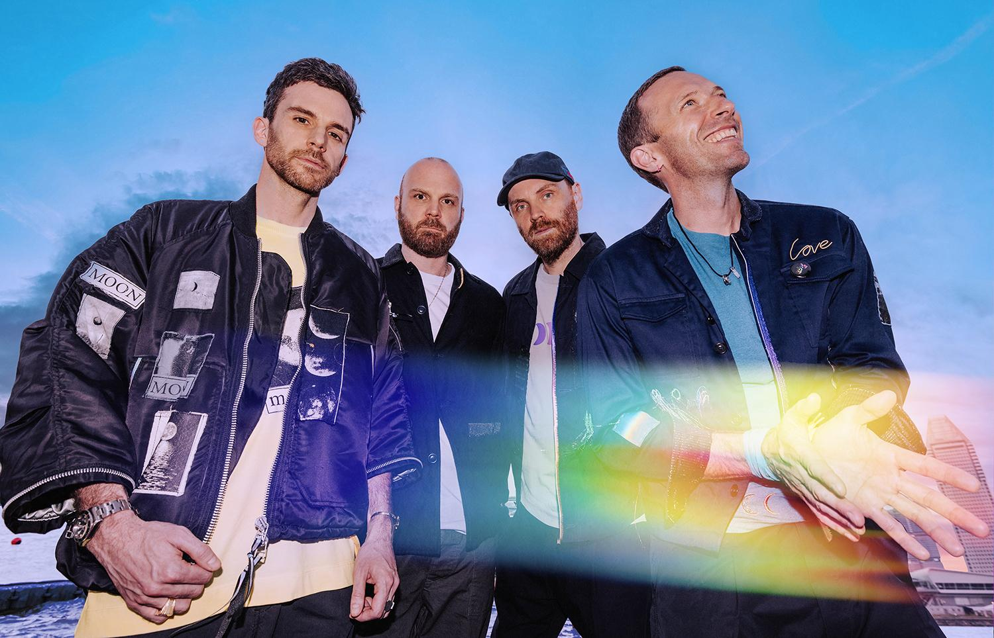
Photo credit: Anna Lee. Download image here

