**JOE P IS THE *GARDEN STATE VAMPIRE***

**DEBUT ALBUM INCLUDES SUCH RECENT SINGLES AS**

**“LILY,” “SHE GOT ME,” AND THE LONG AWAITED FAN FAVORITE**

“**BIRTHDAY BABY (THE GIRL WITH NO SMILE)”**

**BIGGEST NORTH AMERICAN HEADLINE TOUR TO DATE BEGINS**

**SEPTEMBER 19 IN FERNDALE, MI**

**+ ON EUROPEAN TOUR WITH GOOD NEIGHBOURS IN OCTOBER**

**FESTIVAL APPEARANCES INCLUDE ASBURY PARK, NJ’S SEA.HEAR.NOW. (SEPTEMBER 14)**

**AND AUSTIN, TX’S AUSTIN CITY LIMITS MUSIC FESTIVAL (OCTOBER 12)**

**LISTEN TO *GARDEN STATE VAMPIRE*** [**HERE**](https://joep.lnk.to/GardenStateVampire)

**WATCH THE MUSIC VIDEO FOR “VIOLET”** [**HERE**](https://www.youtube.com/watch?v=SO62PBg0zww)  **(premieres at 5pm ET)**

 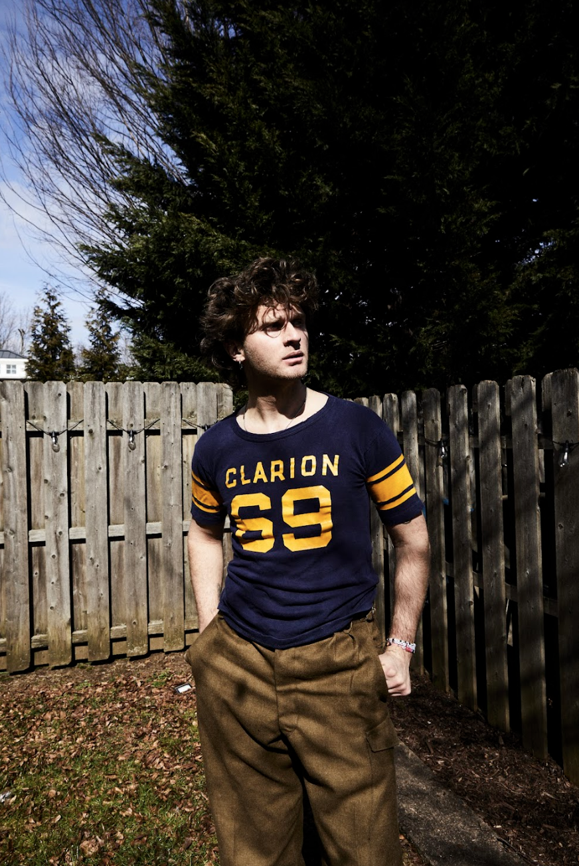

DOWNLOAD HI-RES ALBUM ARTWORK [HERE](https://warnermusicgroup.box.com/s/k1yy4gik2cc3547dk8ufs1zg7c2oa6h5) // DOWNLOAD HI-RES PRESS PHOTOS [HERE](https://warnermusicgroup.box.com/s/8x64824dm4z4nefb17omi886brqm9um7) (credit Jimmy Fontaine)

Alternative artist/producer/multi-instrumentalist **Joe P** has released his long awaited debut album, [***Garden State Vampire***](https://joep.lnk.to/GardenStateVampire), available now via Neon Gold/Atlantic Records [HERE](https://joep.lnk.to/GardenStateVampire). Album single “Violet” also gets an official music video today, featuring Joe and directed by long term collaborator Anthony Yebra. Watch [HERE](https://www.youtube.com/watch?v=SO62PBg0zww) (premieres at 5pm ET)

Largely recorded late at night in his own New Jersey basement studio, *Garden State Vampire* expertly captures Joe P’s trademark brand of frenetic alt-rock songcraft, including such recent singles as “[She Got Me](https://joep.lnk.to/shegotme)” and the tender “[Lily](https://joep.lnk.to/lily),” both joined by cinematic official music videos streaming now at YouTube [HERE](https://www.youtube.com/channel/UCypYTnHs0_4qWS1h7IutOcA). Both visuals were filmed on location in New Jersey, echoing Joe’s deep affection for his beloved home state – an element that extends to both the album’s title and evocative cover art (shot on one of the most notorious stretches of the Garden State Parkway).

“*One of the reasons I named the album Garden State Vampire is that I really thrive in being in a place that no one pays much attention to,*” says Joe P, “*instead of living in Nashville or L.A. or New York like a lot of people in the music business. It’s kind of nice to feel like I’m alone on a different planet, where the only thing that matters is staying true to whatever these songs want to be.*”

Joe released album single “[Birthday Baby (The Girl With No Smile)](https://joep.lnk.to/birthdaybaby)” in May, which longtime fans have been eagerly awaiting since the NJ-based artist first debuted a glimpse of the song on [TikTok](https://www.tiktok.com/@joep/video/6993029170196434181?_r=1&_t=8mWEUuc1UzO) in 2021. The single was met with instantaneous critical acclaim, with [*Ones To Watch*](https://www.onestowatch.com/en/blog/joe-p-announces-debut-album-garden-state-vampire) hailing it as “*an alternative heartstopper…Joe P is a master at inviting you into his world and creating a transcendentally universal story, all the while retaining a sonic view and narrative that is entirely his own.*”

Joe will kick off his biggest North American headline tour to date, getting underway September 19 at Ferndale, MI’s The Magic Bag and then traveling into early December. Highlights include shows at such vaunted venues as Los Angeles, CA’s The Roxy (October 7), Nashville, TN’s Exit/In (October 15), New York City’s Bowery Ballroom (October 21) and a home state tour finale at Asbury Park, NJ’s The Stone Pony (December 13).

Joe is also slated to open for good neighbours on several of their European dates in October, with stops in Brussels, Paris, Amsterdam, Copenhagen, and Berlin. More info and tickets can be found here: <https://www.wearegoodneighbours.com/>

Joe’s busy touring schedule will also see a number of festival performances including an appearance at Asbury Park, NJ’s sold-out Sea.Hear.Now. (Saturday, September 14 and Austin, TX’s Austin City Limits Music Festival (Saturday, October 12). For complete details and ticket information, please visit [joepthehyena.com](https://joepthehyena.com/).

**JOE P**

**FALL TOUR 2024**

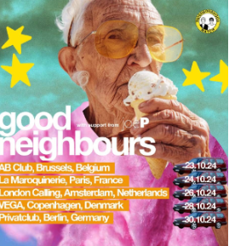

[DL good neighbours tour ad mat](https://www.dropbox.com/scl/fo/wstlj2xbs8f6ru2znhzyt/AK0LRySE1CDMoK4H8Atkjak?rlkey=qqngarvs8two149okwg9wxhuy&e=2&st=07bwua8p&dl=0)

**SEPTEMBER**

14 – Asbury Park, NJ – Sea.Hear.Now *

19 – Ferndale, MI – The Magic Bag

20 – Cleveland Heights, OH – Grog Shop

21 – Columbus, OH – A&R Music Bar

23 – Madison, WI – High Noon Saloon

24 – Chicago, IL – Lincoln Hall

25 – St. Louis, MO – Off Broadway

27 – Denver, CO – Marquis Theater

29 – Boise, ID – The Shredder

30 – Portland, OR – Polaris Hall

**OCTOBER**

2 – Seattle, WA – Chop Suey

4 – San Francisco, CA – The Chapel

5 – Anaheim, CA – The Parish at House of Blues Anaheim

7 – Los Angeles, CA – The Roxy

8 – Phoenix, AZ – The Rebel Lounge

11 – Fort Worth, TX – Tulips

12 – Austin, TX – Austin City Limits Music Festival *

14 – Birmingham, AL – Saturn

15 – Nashville, TN – Exit/In

16 – Atlanta, GA – Hell at The Masquerade

17 – Durham, NC – Motorco Music Hall

19 – Washington, DC – Union Stage

21 – New York, NY – Bowery Ballroom

23 – Brussels, Belgium – AB Club ^

24 – Paris, France – La Maroquinerie ^

26 – Amsterdam, Netherlands – London Calling ^

28 – Copenhagen, Denmark – VEGA ^

30 – Berlin, Germany – privatclub ^

**DECEMBER**

1 – Toronto, ON – The Garrison

3 – South Burlington, VT – Higher Ground Showcase Lounge

4 – Portland, ME – Portland House of Music and Events

5 – Boston, MA – Brighton Music Hall

6 – Philadelphia, PA – Brooklyn Bowl Philadelphia

13 – Asbury Park, NJ – The Stone Pony

* FESTIVAL APPEARANCE

^ OPENING FOR GOOD NEIGHBOURS

**ABOUT JOE P:**

When the onset of the pandemic brought about the dissolution of the band he’d fronted since eighth grade, Joe P found himself in isolation with time to step out and experiment on his own. From the refuge of his New Jersey basement studio, he threw himself into writing, recording and producing his most personal material to date. Posting homegrown ideas to TikTok, Joe P watched as his raw acoustic videos drew millions of views and over 300K followers in just a few months. Among those new fans was Apple Music’s Zane Lowe, who kicked Joe’s career into hyperdrive by duetting alongside his self-made “[Fighting In The Car](https://nam04.safelinks.protection.outlook.com/?url=https%3A%2F%2Furldefense.com%2Fv3%2F__https%3A%2F%2Fwww.google.com%2Furl%3Fq%3Dhttps%3A**Awww.google.com*url*q*3Dhttps%3A**Awww.google.com*url*q*253Dhttps%3A**Awww.tiktok.com*%40zanelowe*video*6924812426630237445*2526source*253Dgmail-imap*2526ust*253D1652919094000000*2526usg*253DAOvVaw2Fk7AJ06IxDyvBz1L2jCa4*26source*3Dgmail-imap*26ust*3D1683051420000000*26usg*3DAOvVaw2HMjvh_ILOliftrZL5TUBy%26source%3Dgmail-imap%26ust%3D1683056043000000%26usg%3DAOvVaw3UOiPr33s5Z51Z1apVT3Pi__%3BLy8vPyUvLy8_JS8vLy8vJSUlJSUlJSUlJSUl!!FBl7RhjNdtJEi0k!sFL671qHsrwo9WveVSxRPMZIUK05mCnWGs-DwHdsUuZOWtIPMbR--RojSo54rSkncUDVLxgd7_NWra9QdUBcO0h79XZSGVuQtw%24&data=05%7C01%7CGabrielle.Reese%40atlanticrecords.com%7Ce2a3851cfe684e916aad08db990e1f3c%7C8367939002ec4ba1ad3d69da3fdd637e%7C0%7C0%7C638272058158338209%7CUnknown%7CTWFpbGZsb3d8eyJWIjoiMC4wLjAwMDAiLCJQIjoiV2luMzIiLCJBTiI6Ik1haWwiLCJXVCI6Mn0%3D%7C3000%7C%7C%7C&sdata=oDttRb7ayzCICia6S89%2BCEFcCwNW0c%2ByS3cjSfXhoSk%3D&reserved=0)“ video.

A deal with Neon Gold/Atlantic was quickly followed by the release of Joe P’s acclaimed debut EP, *Emily Can’t Sing*, highlighted by the viral hit single “[Off My Mind](https://www.youtube.com/watch?v=yCzn6V2nfNE),” which spent two weeks at #1 at Triple A Radio, followed by “[All Day I Dream About](https://nam04.safelinks.protection.outlook.com/?url=https%3A%2F%2Furldefense.com%2Fv3%2F__https%3A%2F%2Fwww.google.com%2Furl%3Fq%3Dhttps%3A**Awww.google.com*url*q*3Dhttps%3A**Aatlantic.lnk.to*joepAllDayIDreamAboutID*26source*3Dgmail-imap*26ust*3D1683051420000000*26usg*3DAOvVaw0_4e4wccJ2m_wP1x8q4IYx%26source%3Dgmail-imap%26ust%3D1683056043000000%26usg%3DAOvVaw3KySR5YcwwMXHaU_-CfjRX__%3BLy8vPyUvLy8lJSUlJSU!!FBl7RhjNdtJEi0k!sFL671qHsrwo9WveVSxRPMZIUK05mCnWGs-DwHdsUuZOWtIPMbR--RojSo54rSkncUDVLxgd7_NWra9QdUBcO0h79XYrXwvVfQ%24&data=05%7C01%7CGabrielle.Reese%40atlanticrecords.com%7Ce2a3851cfe684e916aad08db990e1f3c%7C8367939002ec4ba1ad3d69da3fdd637e%7C0%7C0%7C638272058158338209%7CUnknown%7CTWFpbGZsb3d8eyJWIjoiMC4wLjAwMDAiLCJQIjoiV2luMzIiLCJBTiI6Ik1haWwiLCJXVCI6Mn0%3D%7C3000%7C%7C%7C&sdata=nmEqNgoGbDsCtNxkrrVY8Rpgw9kr%2BU4ZIdw6gCiCHpU%3D&reserved=0) (first introduced as “Adidases” in a hugely popular [TikTok teaser](https://nam04.safelinks.protection.outlook.com/?url=https%3A%2F%2Furldefense.com%2Fv3%2F__https%3A%2F%2Fwww.google.com%2Furl%3Fq%3Dhttps%3A**Awww.google.com*url*q*3Dhttps%3A**Awww.tiktok.com*%40joep*video*7074674879735369006*26source*3Dgmail-imap*26ust*3D1683051420000000*26usg*3DAOvVaw0MaIlbuJPF8A5jPpoqBW8w%26source%3Dgmail-imap%26ust%3D1683056043000000%26usg%3DAOvVaw1qPcXoWVAIaDN34ZxTwKtW__%3BLy8vPyUvLy8vLyUlJSUlJQ!!FBl7RhjNdtJEi0k!sFL671qHsrwo9WveVSxRPMZIUK05mCnWGs-DwHdsUuZOWtIPMbR--RojSo54rSkncUDVLxgd7_NWra9QdUBcO0h79XaWbKmBOA%24&data=05%7C01%7CGabrielle.Reese%40atlanticrecords.com%7Ce2a3851cfe684e916aad08db990e1f3c%7C8367939002ec4ba1ad3d69da3fdd637e%7C0%7C0%7C638272058158338209%7CUnknown%7CTWFpbGZsb3d8eyJWIjoiMC4wLjAwMDAiLCJQIjoiV2luMzIiLCJBTiI6Ik1haWwiLCJXVCI6Mn0%3D%7C3000%7C%7C%7C&sdata=3tZJYefYn4qz8XDzA3c7j5bg15ouwyJ3VxD7nGtjkZE%3D&reserved=0)).

Joe P released his seven-song project *French Blonde*in October 2022*.*The official live performance video for [“French Blonde”](https://nam04.safelinks.protection.outlook.com/?url=https%3A%2F%2Furldefense.com%2Fv3%2F__https%3A%2F%2Fwww.google.com%2Furl%3Fq%3Dhttps%3A**Awww.google.com*url*q*3Dhttps%3A**Awww.youtube.com*watch*v*253DeLho5xTolV4*26source*3Dgmail-imap*26ust*3D1683051420000000*26usg*3DAOvVaw3WMyPHYAitz_xXZdHuX-jg%26source%3Dgmail-imap%26ust%3D1683056043000000%26usg%3DAOvVaw2Us4cWkOha9Yfte2OlqaVe__%3BLy8vPyUvLy8_JSUlJSUlJQ!!FBl7RhjNdtJEi0k!sFL671qHsrwo9WveVSxRPMZIUK05mCnWGs-DwHdsUuZOWtIPMbR--RojSo54rSkncUDVLxgd7_NWra9QdUBcO0h79XbThHEFNQ%24&data=05%7C01%7CGabrielle.Reese%40atlanticrecords.com%7Ce2a3851cfe684e916aad08db990e1f3c%7C8367939002ec4ba1ad3d69da3fdd637e%7C0%7C0%7C638272058158338209%7CUnknown%7CTWFpbGZsb3d8eyJWIjoiMC4wLjAwMDAiLCJQIjoiV2luMzIiLCJBTiI6Ik1haWwiLCJXVCI6Mn0%3D%7C3000%7C%7C%7C&sdata=X8PDwK1IRdwLewuHvROwwl1buo%2BIVIHV3DJIyCoqCBg%3D&reserved=0) also serves as the opening scene of Joe P’s short horror film, “[If We Run](https://nam04.safelinks.protection.outlook.com/?url=https%3A%2F%2Furldefense.com%2Fv3%2F__https%3A%2F%2Fwww.google.com%2Furl%3Fq%3Dhttps%3A**Awww.google.com*url*q*3Dhttps%3A**Awww.youtube.com*watch*v*253DhHaLC1Pofac*2526feature*253Dyoutu.be*26source*3Dgmail-imap*26ust*3D1683051420000000*26usg*3DAOvVaw3rXGmrrGBUoa0W2__yDPiX%26source%3Dgmail-imap%26ust%3D1683056043000000%26usg%3DAOvVaw1aAgZtJs3A8hfvV3e0hzeR__%3BLy8vPyUvLy8_JSUlJSUlJSUl!!FBl7RhjNdtJEi0k!sFL671qHsrwo9WveVSxRPMZIUK05mCnWGs-DwHdsUuZOWtIPMbR--RojSo54rSkncUDVLxgd7_NWra9QdUBcO0h79XY7y5sz4A%24&data=05%7C01%7CGabrielle.Reese%40atlanticrecords.com%7Ce2a3851cfe684e916aad08db990e1f3c%7C8367939002ec4ba1ad3d69da3fdd637e%7C0%7C0%7C638272058158338209%7CUnknown%7CTWFpbGZsb3d8eyJWIjoiMC4wLjAwMDAiLCJQIjoiV2luMzIiLCJBTiI6Ik1haWwiLCJXVCI6Mn0%3D%7C3000%7C%7C%7C&sdata=ocKp2PZs0YDPNIdzajQqSgDr%2BesTOS2y9K6J1N5UICI%3D&reserved=0),” starring Michael Gandolfini (*The Many Saints of Newark*), which won the award for Best Homegrown Short at the 2023 Garden State Film Festival. The 2023 single, “Don’t Wanna Love You” saw Joe P earn his second top 10 spot in two years at Triple A radio.

Having spent much of 2022 on the road, including dates with beabadoobee, Middle Kids, Spacey Jane, and Joywave, Joe embarked on his debut headline tour in 2023, with sold out dates all over the US. Joe kept up the busy schedule in 2024, highlighted by a series of sold-out UK dates, a special guest run with Cold War Kids’ *20 Years Tour*, shows supporting Rainbow Kitten Surprise at Austin, TX’s ACL Live at The Moody Theater, and festival appearances including Boise, ID’s Treefort Music Fest and Brighton, England’s The Great Escape.

# # #

**CONNECT WITH JOE P**

[WEBSITE](https://joepthehyena.com/) | [FACEBOOK](https://www.facebook.com/joepthehyena) | [INSTAGRAM](https://www.instagram.com/joepthehyena/) | [SOUNDCLOUD](https://soundcloud.com/joepthehyena) | [TIKTOK](https://www.tiktok.com/@joep?) | [TWITTER](https://twitter.com/joepthehyena) | [YOUTUBE](https://www.youtube.com/channel/UCypYTnHs0_4qWS1h7IutOcA)

PRESS CONTACTS

[corey.brewer@atlanticrecords.com](mailto:corey.brewer@atlanticrecords.com)

[gabrielle.reese@atlanticrecords.com](mailto:gabrielle.reese@atlanticrecords.com)